NAME: OYEBOADE R. Kiitan
MATRIC NO: 17/ENG08/004
DEPARTMENT: Biomedical Engineering
COURSE CODE: ENG382
COUSE TITLE: Engineering Mathematic IV

ASSIGNMENT IV

CODES

- Function Ode code
function f= oyinodefun(t,q)
f(1)=(((-15/500)*q(1))+((5/1000)*q(2))+1);
f(2)=(((15/500)*q(1))-((18/1000)*q(2))+((3/400)*q(3)));
f(3)=(((13/1000)*q(2))-((13/400)*q(3)));
f=f';

- Matlab graph code
commandwindow
clear
clc
close all
[t,q]=ode45('oyinodefun',[0:40:1200], [0 0 0 ]);
figure(1)
subplot(3,1,1)
plot(t,q(:,1),'o-g')
xlabel('Time(min)')
ylabel('Volume(Litre)')
legend('Tank')
grid on
subplot(3,1,2)
plot(t,q(:,2),'*-b')
xlabel('Time(min)')
ylabel('Volume(Litre)')
legend('Tank2')
grid on
subplot(3,1,3)
plot(t,q(:,1),'*-r')
xlabel('Time(min)')
ylabel('Volume(Litre)')
legend('Tank3')
grid on

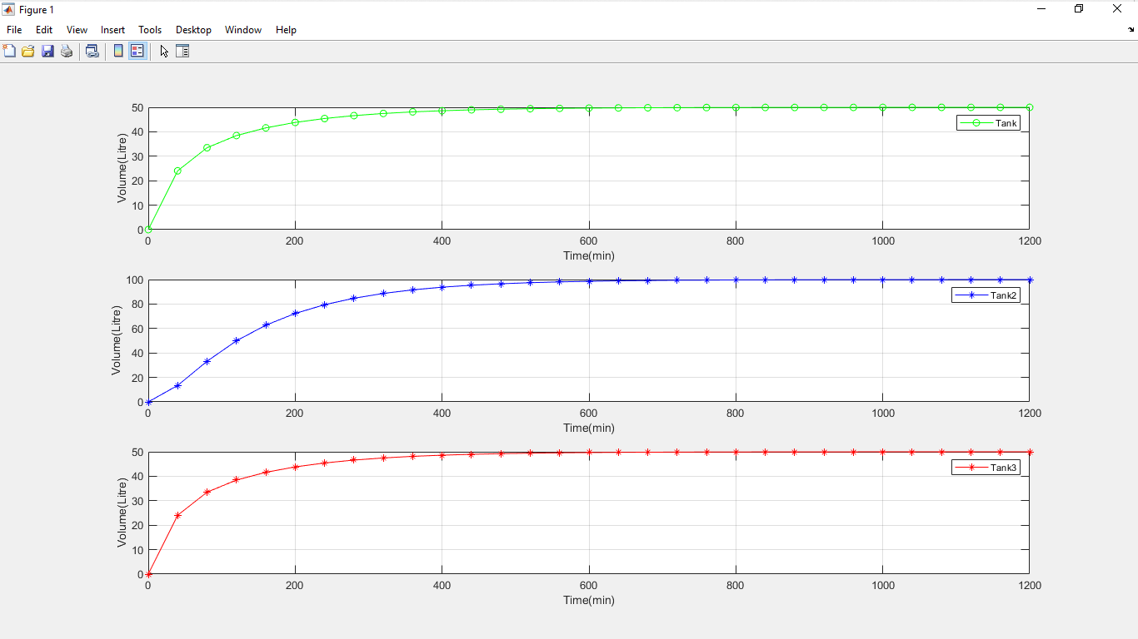

Figure 1: Dynamic response of the tanks

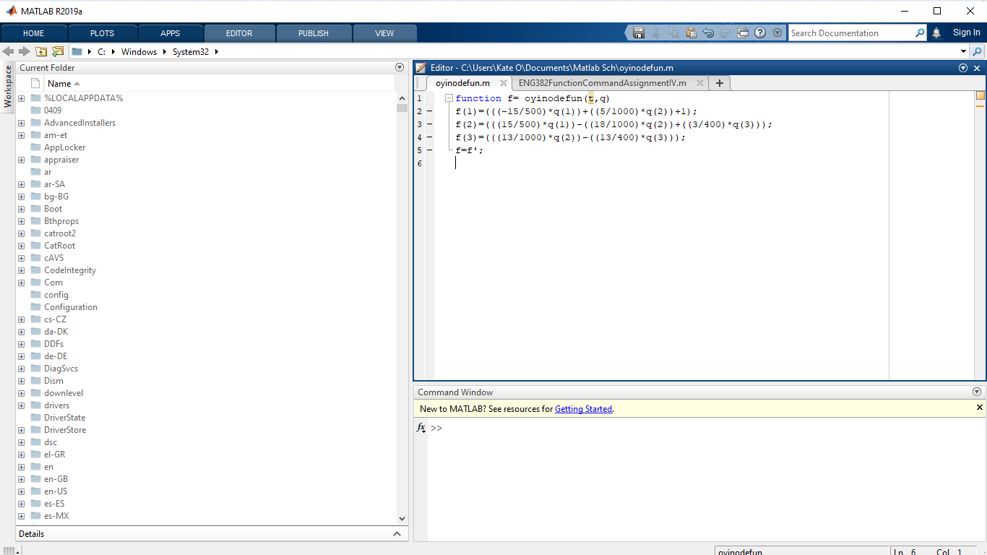

Function Ode code

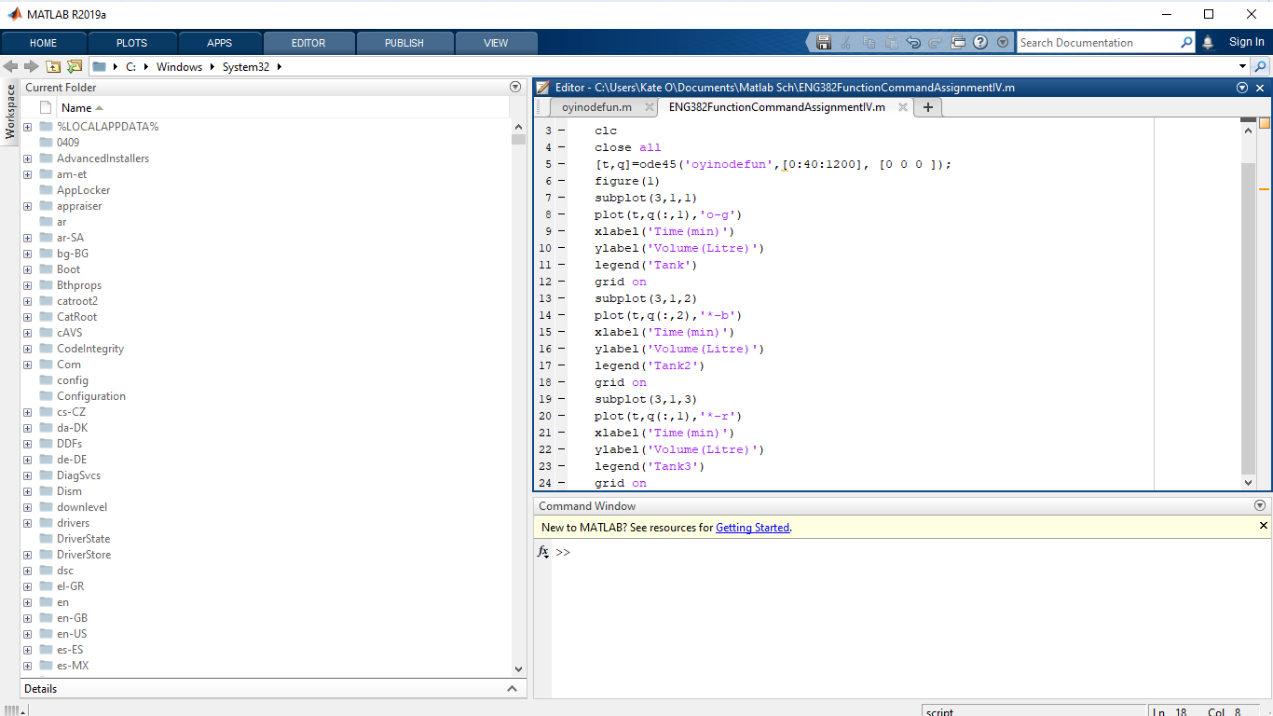

Matlab graph code

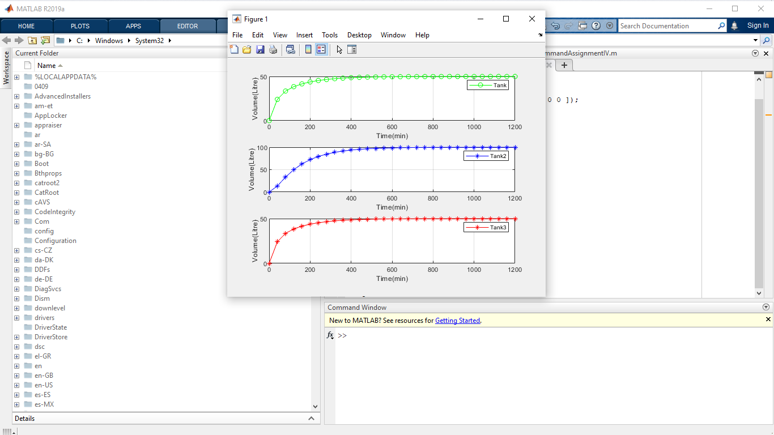
Dynamic Response of the tanks

