NAME: SHITTU IBRAHIM ADEDAMOLA

MATRIC NO: 16/SCI01/O42

COURSE: CSC 408

TITLE: PROJECT MANAGEMENT

ANSWER

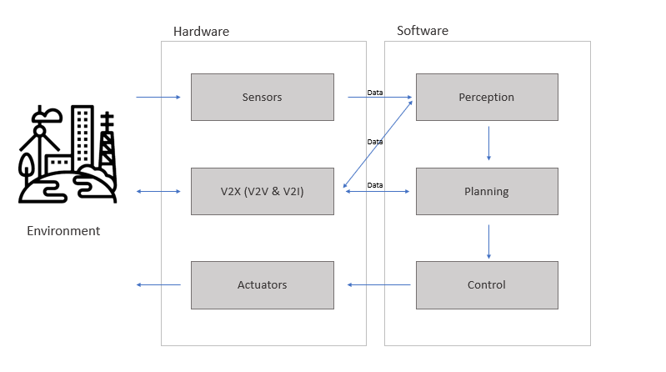
WORK BASED STRUCTURE OF AN AUTONOMOUS CAR

