NAME: AUN JAMES IORUNGWA
MATRIC NO: 15/ENG05/004
DEPT: MECHATRONICS ENGINEERING
COURSE: POWER ELECTRONICS AND DRIVES

1. Differentiate between a controlled and Uncontrolled Rectifier.
Answer: The rectifier circuit using diodes only are called uncontrolled rectifier circuit. When SCRs (thyristor) are used to convert AC to DC, they have a controlled output voltage so it is called a Controlled rectifier output. Unlike diodes, SCR does not become conducting immediately after its voltage has become positive.

2. Differentiate between Single phase half- wave Rectifier and a Single phase full wave Rectifier.
Answer: The crucial difference between Half Wave and Full Wave Rectifier is that a half wave rectifier converts only one-half cycle of the AC input supplied into pulsating DC signal. As against a full wave, rectifier converts both halves of the applied input signal into pulsating DC. Another major difference between the two is that the rectification efficiency of half wave rectifier is somewhat less as compared to the full wave rectifier.
A circuit of half wave rectifier requires only 1 diode. While 2 or even 4 diodes are also utilized in the circuit of full wave rectifier. A half wave rectifier has good voltage regulation. However, full wave rectifiers provide better voltage regulation as compared to half wave rectifiers.

3. Explain the operational characteristics of a DIAC.
Answer: The V-I characteristic curve of the DIAC will be in the shape of a Z and the curve will be lying on the first and third quadrants because they conduct in both the positive and negative polarity. The First quadrant represents the positive half cycle where the current will be flowing from MT1 to MT2 and the second quadrant represents the negative half cycle where the current will be flowing from MT2 to MT1.
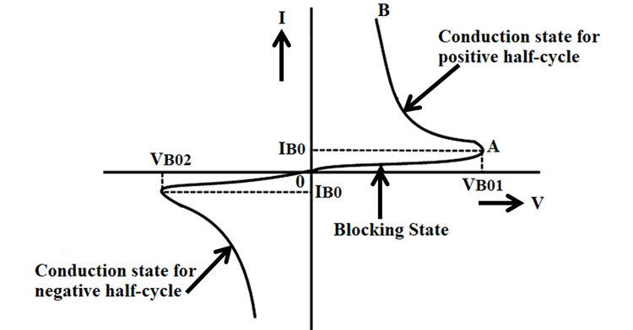

Initially, the resistance of the DIAC will be higher because of the Reverse Bias junction between the layers so there will be small leakage current flowing through the DIAC, it is mentioned as the blocking state in the curve. Once the applied voltage reaches the breakdown voltage the resistance of the DIAC drops abruptly and then it starts conducting which leads to a sharp decrease in voltage and the current starts increasing, which is mentioned as a conduction state in the curve. Most of the DIACs will be having the breakdown voltage around 30 Volts, the exact breakdown voltage will be based on the type of the device. The DIAC will be in the conducting state until the current reaches the particular value called the holding current, where holding current is the minimum current that required for a device to keep it in the ON state.

4. Explain the operational characteristics of a TRIAC.
Answer: The triac has on and off state characteristics similar to SCR but now the characteristic is applicable to both positive and negative voltages. This is expected because triac consists of two SCRs connected in parallel but opposite in directions. 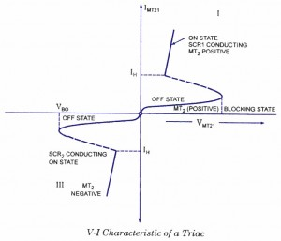
MT₂ is positive with respect to MT_{X} in the first quadrant and it is negative in the third quad rant. As already said in previous blog posts, the gate triggering may occur in any of the following four modes.
Quadrant I operation : V_{MT2}, positive; V_{G1} positive
Quadrant II operation : V_{MT21} positive; V_{Gl} negative
Quadrant III operation : V_{MT21} negative; V_{Gl} negative
Quadrant IV operation : V_{MT21} negative; V_{G1} positive
where V_{MT21} and V_{Gl} are the voltages of terminal MT₂ and gate with respect to terminal MT₁.
The device, when starts conduction permits a very heavy amount of current to flow through it. This large inrush of current must be restricted by employing external resistance, otherwise the device may get damaged.
The gate is the control terminal of the device. By applying proper signal to the gate, the firing angle of the device can be controlled. The circuits used in the gate for triggering the device are called the gate-triggering circuits. The gate-triggering circuits for the triac are almost same like those used for SCRs. These triggering circuits usually generate trigger pulses for firing the device. The trigger pulse should be of sufficient magnitude and duration so that firing of the device is assured. Usually, a duration of 35 us is sufficient for sustaining the firing of the device.

