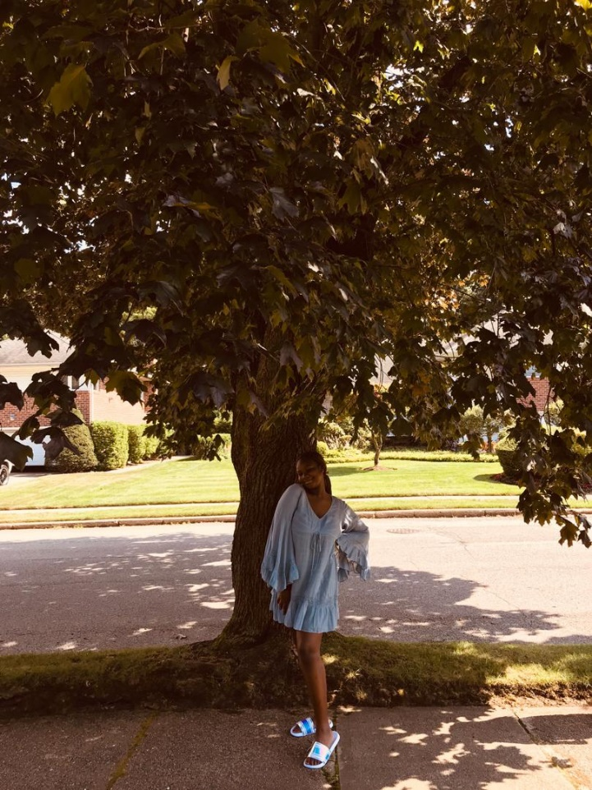LANDSCAPE PHOTOGRAPHY
Caption: NATURE ALWAYS WEARS THE COLORS OF THE SPIRIT
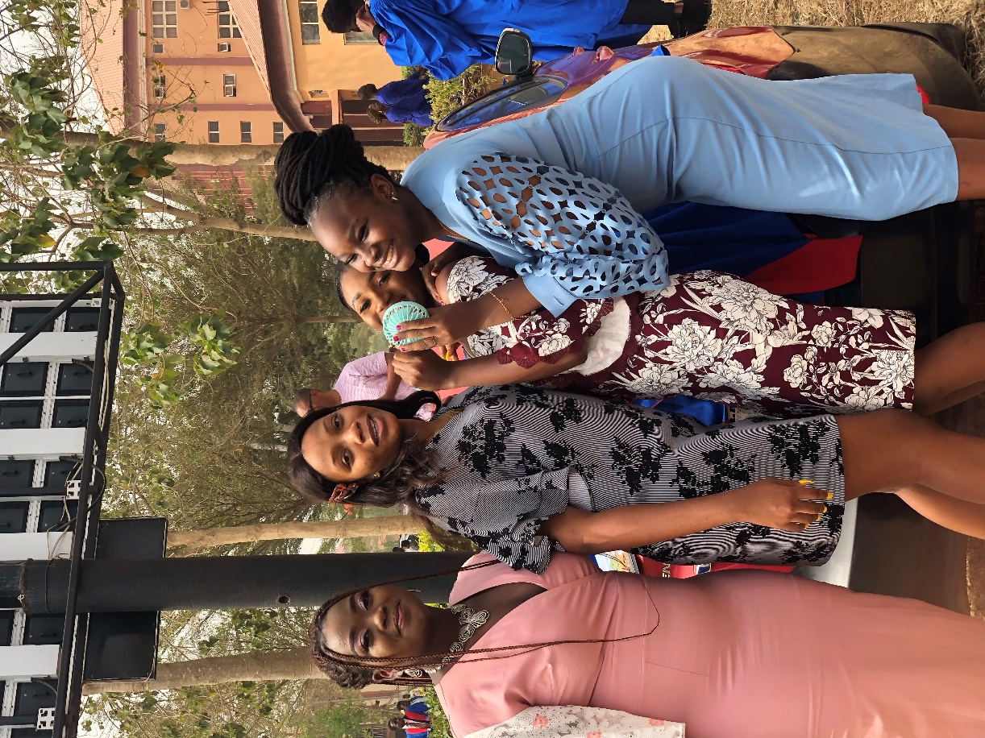FASHION PHOTOGRAPHY
STUDENTS SHOWCASING THEIR BEAUTIFUL CLOTHES DURING MATRICULATION

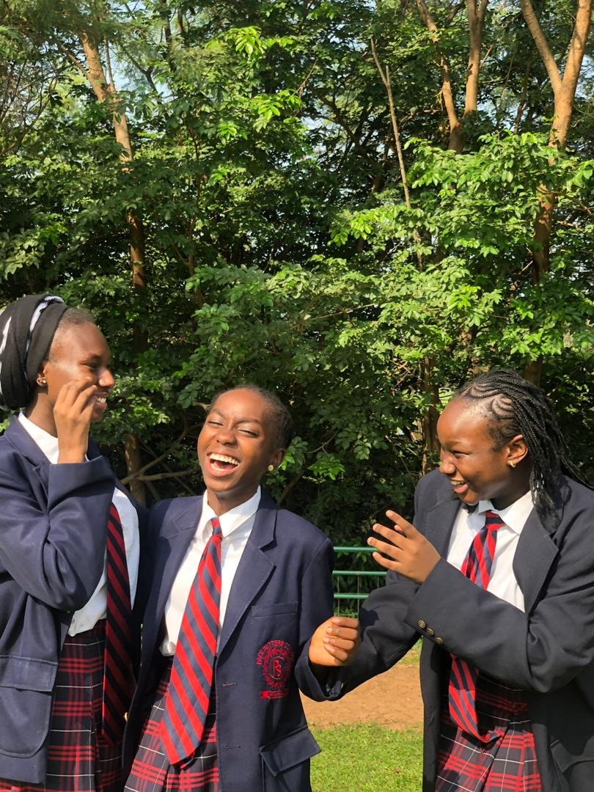NATURE PHOTOGRAPHY
STUDENTS EXPRESSING THEIR LOVE FOR NATURE
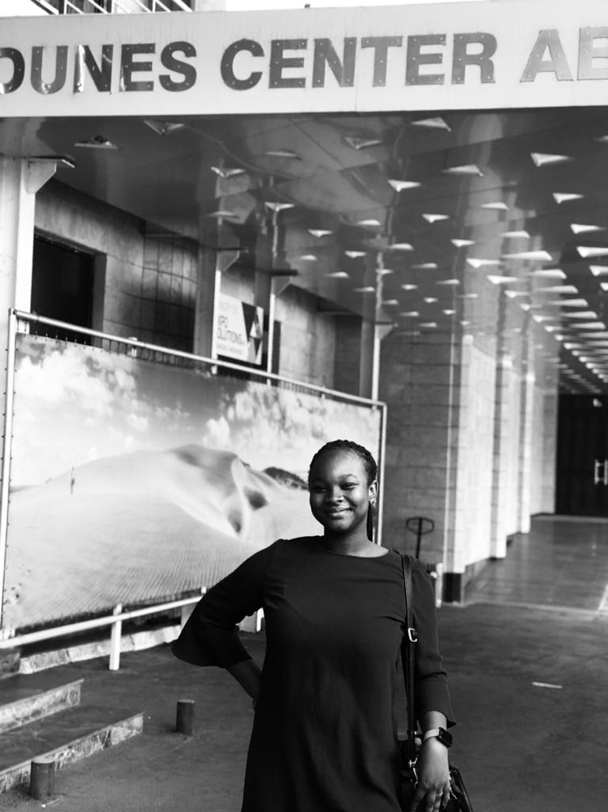POTRAIT PHOTOGRAPH
POTRIAT OF A YOUNG GIRL

