NAME: AGWANIRU ROSEMARY ONYINYECHI
MATRIC NO: 17/ENG01/003
COURDE CODE: CHE 312
COURSE TITLE: PROCESS INSTRUMENTATION

ASSIGNMENT:
PART ONE
- What is instrumentation?

Instrumentation is a collective term for measuring instruments that are used for indicating, measuring and recording physical quantities. It is a branch of engineering that deals with measurement and control.

- Explain succinctly the mobile and stationary phases in Gas Chromatography.

Gas chromatography is a term used to describe the group of analytical separation techniques used to analyze volatile substances in the gas phase. In gas chromatography, the components of a sample are dissolved in a solvent and vaporized in order to separate the analytes by distributing the sample between two phases: a stationary phase and a mobile phase.

Stationary Phase: The stationary phase is either a solid adsorbent, termed gas-solid chromatography (GSC), or a liquid on an inert support, termed gas-liquid chromatography (GLC).
Mobile Phase or (moving phase): is a carrier gas, usually an inert gas such as helium or an unreactive gas such as nitrogen. The mobile phase is a chemically inert gas that serves to carry the molecules of the analyte through the heated column

- Why is moisture measurement germane in process industries

- Moisture is an unwanted contaminant that exists in industrial gases and the atmosphere, and is able to penetrate virtually any surface including such metals as copper, bronze and carbon steel. Therefore, it is important to first accurately measure the moisture content in order to subsequently control or remove the unwanted moisture to prevent corrosion
- By understanding when to measure moisture content we are able to improve product quality, minimize equipment damage
- To save energy and meet contractual obligations
- To reduce cost since clearly moisture has the capacity to cause expensive problems and potentially catastrophic failures.

MOISTURE MEASUREMENT METHOD
- Absolute measurement method
- Capacitance measurement method
- Sensor oxides
- Relative humidity method

PART TWO
- State four cogent reasons for measuring and controlling process variables

- The value of the process variable is continuously monitored so that control may be exerted.
- One of the biggest benefits of measuring process variables is automated efficiency. In fact, it’s possible that after you implement your process control instrumentation and rework your operations, you’ll see less of a need for your existing machine or human labor. There will be more income to go around, which means an increase in general performance.
- Process control systems are central to maintaining product quality. Using proper instrumentation, control systems maintain the proper ratio of ingredients, regulate temperatures and monitor outputs. Without this standard of control, products would vary and quality would be impaired.
- To be obtain errors and with errors proper design and processing can take place leading to the earlier reason stated.

- Magnetic flow meters are highly important in process industries. Mention three typical applications of magnetic flow meters.

- THEY CAN BE USED AT CONSTRUCTION SITES OF THE FLOW MEASUREMENT OF SLURRIES
- THEY ARE USEFUL AT PETROLEUM PLANTS TO MEASURE THE FLOW RATE OF COMBUSTIBLE FUELS

- HAZARDOUS ENVIRONMENTS
Magnetic flow meters can be used to measure flow rates for combustible or explosive liquids, often under hazardous conditions. Explosion-resistant flowmeter housings are vital for these projects, and the design specifications and safety parameters for the housings are usually regulated by presiding authorities. Remote electronic controls may be used to increase flowmeter reliability in hazardous circumstances, and integrated controls are also available. Some magnetic flowmeters are equipped with a dividing housing that separates field wiring from electronic circuitry. A backlit LCD interface can help improve operator use.

- PIPING SYSTEM DESIGN
Magnetic flowmeters are more easily applied to a circular arrangement than to rectangular pipe networks, and usually offer more effective measurements. While fluid velocity is usually unaffected by the pipe symmetry in this sort of network, the circular shape can sometimes distort the magnetic field, creating a need for recalibration. In straight piping situations, the upstream and downstream requirements are often different for each type of flowmeter

- Manometer
Barometer
Bourdon gauge
Bell-gauge

MANOMETER: A manometer is a scientific instrument used to measure gas pressures. Open manometers measure gas pressure relative to atmospheric pressure. A mercury or oil manometer measures gas pressure as the height of a fluid column of mercury or oil that the gas sample supports.

Working Principle: All manometers work on the effect of the hydrostatic pressure exerted by a liquid column. In manometer unknown pressure is determined by balancing it against some known pressure or vacuum. The U-tube manometer consists of glass U-tube partially filled with a suitable liquid like water, mercury etc. one of the arms or legs of the manometer, is connected to unknown pressure tap to be measured while other is connected to other pressure tap or it is left open to atmosphere.

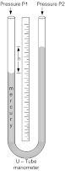Image of a manometer
When there is a difference of pressure between two arms of the manometer, liquid levels in the two arms of the manometer, liquid levels in the two arms do not match. This level difference in the two arms of the manometer represents differential pressure (P1-P2). The static balance equation is
- P2-P1=h ρ g
h=height difference
ρ=mass density of manometer liquid

Bourdon Gauge: Bourdon tube pressure gauges. Bourdon tube pressure gauges are the most common type in many areas and are used to measure medium to high pressures.
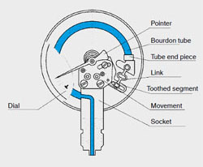 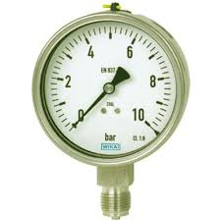Image of Bourdon Gauge
Working Principle:
According to Bourdon theory a tube having internal cross-section that is not a perfect circle if bent or distorted has the property of changing its shape with internal pressure variation, this cause the free end deflection of the tube which can be taken as the measurement of change in pressures inside it.

When fluid under pressure to be measured enters the bourdon tube, its cross-section tries to become more and more circular that caused straightening of the tube. Since one end of the tube is fixed straightening cause the free end to deflect that is called a tip travel. The amount of tip travel for given rise in pressure is a function of tube length wall thickness cross-section geometry and elastic module of the tube material. This linear tip travel is guided and amplified by adjustable link and segment lever and then it is given to sector and pinion arrangement. Sector and pinion convert the amplified tip travel into proportional rotary motion of the pointer connected to the pinion. The pointer defection can be read on the scale calibrated in terms of pressure.
Helical and spiral types bourdon tubes have many numbers of turns hence the tops movements for give change in pressure is more than that for single turn C- shaped tube.

Barometer: A barometer is a scientific instrument that is used to measure air pressure in a certain environment
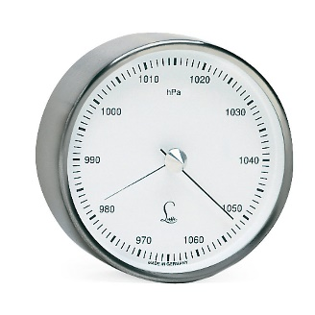
Working Principles:
Barometric liquid balances the atmospheric pressure against vacuum and pressure head reading is obtained in the absolute units.
The barometer has a glass tube closed at one end and opened at the other; the length of the tube must be greater than 76.2 cm. the tube is first completely filled with mercury and the open end is temporarily plugged. Then the tube is inverted so that plugged end is immersed in a mercury pan. When the plug is removed, the mercury in the tube drops by a certain amount, creating a vacuum at the top of the tube and then reading ‘h’ is noted. The reading ‘h’ is proportional to atmospheric pressure acting on mercury in the pan. Note that this atmospheric pressure reading is in absolute units.
We have stated that vacuum is present the top of the tube above mercury, but actually there is vapour pressure of mercury acting on mercury pressure ’P’ kg/cm2 is given by P= 6.66 X 10⁻³h

Bell Gauge:
The bell gauge is a type of pressure transducer that measures differential pressure between 0.06 Pa and 4 KPa. The static pressure may be as high as 4 to 6 MPa.
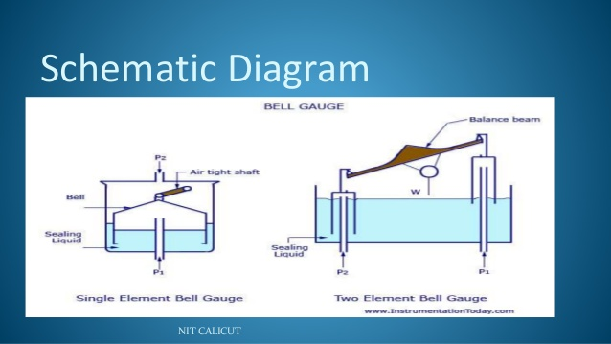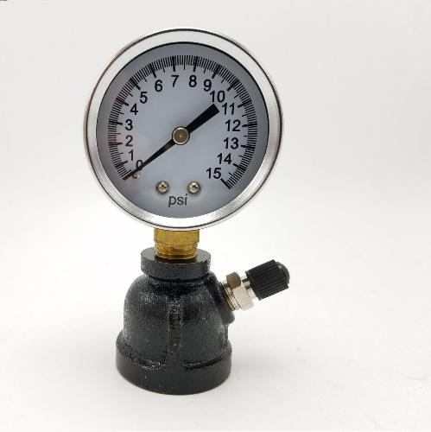

Working Principle: In a bell type of pressure gauge the force produced by the difference of pressures on the outside and the inside of a bell is balanced against a weight, or against the force produced by the compression of a spring.
REFERENCES
- https://www.ncbi.nlm.nih.gov/pmc/articles/PMC6388373/.32
- https://en.wikipedia.org/wiki/Gas_chromatography
- https://www.aci-controls.com/blog/4-big-benefits-of-process-control-instrumentation/
- http://www.industrialdynamics.com/blog/advantages-applications-electromagnetic-liquid-flow-meter/
- http://enggyd.blogspot.com/2011/05/pressure-measuring-instruments.html

