Name : Mgbeze Emmanuel
Mat no: 15/eng05/013

Corona home Assignment 1
- Differentiate between a controlled and uncontrolled rectifier

Controlled Rectifier:
These are rectifier circuits using thyristors. It is evident due to the fact that by changing the firing angle of the thyristor, the output DC voltage can be controlled. Controlled rectifiers are available in high voltage and high current ratings and are used in high power devices. A controlled rectifier may be single face or 3 phase depending on whether the input supplies a single phase or 3 phase.

Uncontrolled rectifier:
These are Diode rectifiers circuits because for a fixed value of AC input voltage, the output DC voltage is fixed and cannot be changed. This is usually used in low power devices and has the advantage of low cost and simple circuitory.

- Differentiate between single phase half-wave rectifier and a single phase full wave rectifier

Half wave rectifier:
They convert only one half cycle of the AC input supplied into pulsating DC signal. The circuits requires only 1 diode.

Full wave rectifier:
It converts both halves of the applied input signal into pulsating DC. Rectification efficiency is higher than that of half wave. The circuit requires 2 or more diodes. The full wave also has better voltage regulation.

- Explain the operational characteristics of DIAC.
Basically, the DIAC is a two terminal device; it is a combination of parallel semiconductor layers that allows activating in one direction. This device is used to activating device for the triac. The basic construction of diac consist of two terminals namely MT1 and MT2. When the MT1 terminal is designed +Ve with respect to the terminal MT2, the transmission will take place to the p-n-p-n structure that is another four layer diaode. The diac can be performing for both the direction. Then symbol of the diac look like a transistor.
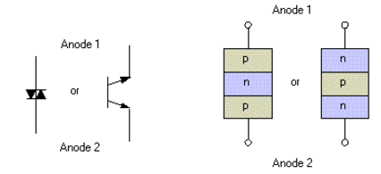Construction of DIAC
The DIAC is basically a diode that conducts after a ‘break-over’ voltage, selected VBO, and is exceeded. When the diode surpasses the break-over voltage, then it goes into the negative dynamic resistance of region. This causes in a reduce in the voltage drop across the diode with rising voltage. So there is a quick increase in the current level that is mannered by the device.

Working of DIAC
As soon as the supply voltage whether positive or negative is applied across the terminals of a diac, only a small leakage current flows through the device. So the device operates in either forward or reverse blocking modes. When the applied voltage is increased to a value such that it is equal to the breakover voltage, an avalanche breakdown occurs at the reverse biased junction.
Then, it starts conducting and exhibits negative resistance characteristics, i.e., the current increases with decreasing values of applied voltage. The voltage drop during the conduction is very less and is equal to the ON state drop of the diac. The current flow increases quickly when it comes into the conduction mode. Therefore, for a safe operating level of this conduction current in either direction, a resistance is connected in series with the diac.
Volt-ampere characteristic of a diac is shown in figure below. Its looks like a letter Z due to symmetrical switching characteristics for each polarity of the applied voltage.
The diac performs like an open-circuit until its switching is exceeded. At that position the diac performs until its current decreases toward zero. Because of its abnormal construction, doesn’t switch sharply into a low voltage condition at a low current level like the triac or SCR, once it goes into transmission, the diac preserves an almost continuous –Ve resistance characteristic, that means, voltage reduces with the enlarge in current. This means that, unlike the triac and the SCR, the diac cannot be estimated to maintain a low voltage drop until its current falls below the level of holding current.
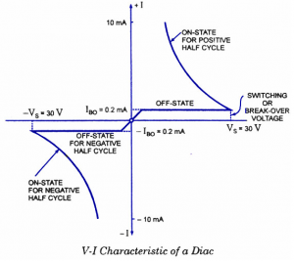

4 Explain the operational characteristics of TRIAC.

Construction and Operation of TRIAC
Traic is a three terminal device and the terminals of the triac are MT1, MT2 and Gate. Here the gate terminal is the control terminal. The flow of current in the triac is bi directional that means current can flow in both the directions. The structure of triac is shown in the below figure. Here, in the structure of triac, two SCRs are connected in the anti parallel and it will acts like a switch for both the directions. In the above structure, the MT1 and gate terminals are near to each other. When the gate terminal is open, the triac will obstruct the both the polarities of the voltage across the MT1 & MT2.
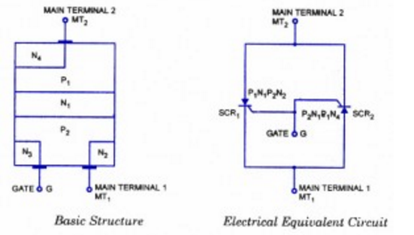

Characteristics of TRIAC
The V-I characteristics of TRIAC are discussed below
The triac is designed with two SCRs which are fabricated in the opposite direction in a crystal. Operating characteristics of triac in the 1st and 3rd quadrants are similar but for the direction of flow of current and applied voltage.
The V-I characteristics of triac in the first and third quadrants are basically equal to those of an SCR in the first quadrant.
It can be functioned with either +Ve or –Ve gate control voltage but in typical operation generally the gate voltage is +Ve in first quadrant and -Ve in third quadrant.
The supply voltage of the triac to switch ON depends upon the gate current. This allows utilizing a triac to regulate AC power in a load from zero to full power in a smooth and permanent manner with no loss in the device control.
.
