Name:Onyechefuna Rachael Chioma
Matrix number:19/sms04/040
College:Social and management sciences
Department:Media and Communication
Course code: GST 112
The international community has come a long way in coordinating its response to new infectious disease outbreaks since SARS and MeRS, but as the current outbreak of coronavirus 2019n-CoV dominates the media, how is our preparedness for mitigating outbreaks affecting citizens?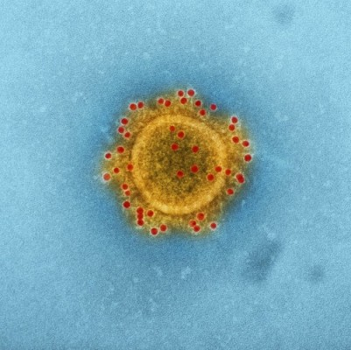
Dr Elisa Pieri, Lecturer in Sociology at The University of Manchester’s School of Social Sciences, has shared her view on the impact our response to public health emergencies of this kind has on the welfare of civilians.
While progress in responding to outbreaks has undeniably been made, all too often the social effect on citizens is overlooked when response measures are implemented, and these measures vary from country to country.
“…These measures have had very differential effects on citizens and on different demographics amongst the population targeted,” said Dr Pieri. “They have often created inequalities, as well as exacerbating existing social inequalities that were already experienced in pre-pandemic times.”
Dr Pieri commended China’s rapid response to the current Coronavirus outbreak and for sharing information with the international community, but too little is understood of the social impact this response is having on the 56 million people of Wuhan, who have been held in a state of lockdown since 23 January 2020.
“There is no time like the present,” she said, “[to] learn of the impacts that the measures implemented by China are having on its citizens.” Calling on the collaborative efforts that help contain and manage outbreaks medically, to include social scientists in the discussion.
“While enormous progress has been made in responding to public health emergencies of communicable disease and coordinating action internationally, much more needs to be done to better understand the repercussions of the measures taken on citizens and ensure their welfare.”
To read ‘Cities in lockdown over the 2019n-CoV outbreak: the social impacts of pandemic preparedness on citizens’.
The corona virus has also resulted to social distancing but the youths can find ways to curb the boredom by reading books,cooking,chatting with friends,making videos etc.

