ASSIGNMENT ON CSC 314- OPERATIONS RESEARCH
- The waiting line or queue management is a critical part of service industry. It deals with issue of treatment of customers in sense reduce wait time and improvement of service. Queue management deals with cases where the customer arrival is random; therefore, service rendered to them is also random.
A service organization can reduce cost and thus improve profitability by efficient queue management. A cost is associated with customer waiting in line and there is cost associated with adding new counters to reduce service time. Queue management looks to address this trade off and offer solutions to management.
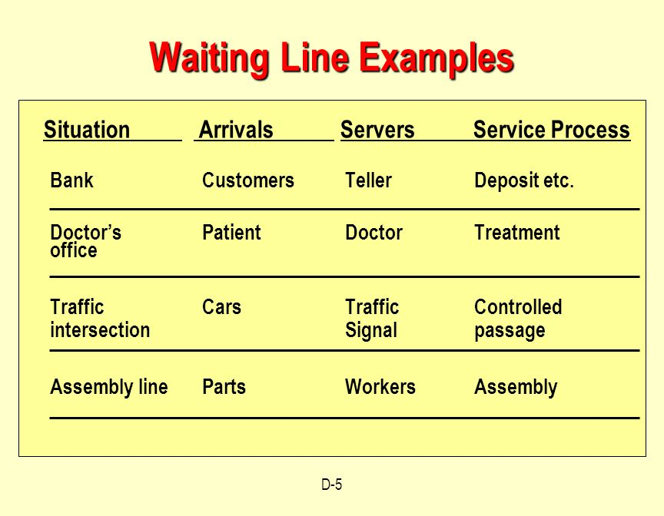
- Poisson Arrival Process
A commonly used model for random, mutually independent message arrivals is the Poisson process. The Poisson distribution can be obtained by evaluating the following assumptions for arrivals during an infinitesimal short period of time delta t
- The probability that one arrival occurs between t and t+delta t is t + o( t), where is a constant, independent of the time t, and independent of arrivals in earlier intervals. is called the arrival rate.
- The number of arrivals in non-overlapping intervals are statistically independent.
- The probability of two or more arrivals happening during t is negligible compared to the probability of zero or one arrival, i.e., it is of the order o( t).
Combining the first and third assumption, the probability of no arrivals during the interval t, t+ delta t is found to be 1- t + o( t).

The arrival rate
The arrival rate is expressed in the average number of arrivals during a unit of time.

QUESTIONS 4-14
