JOLAADE AYUBA ADENIYI

16/SCI01/021

COMPUTER SCIENCE

400 LEVEL

CSC 408

ANSWERS
Work breakdown structure for Modelling of ABUAD Shuttle Buses and Emergency Vehicles Using Transportation Algorithm.

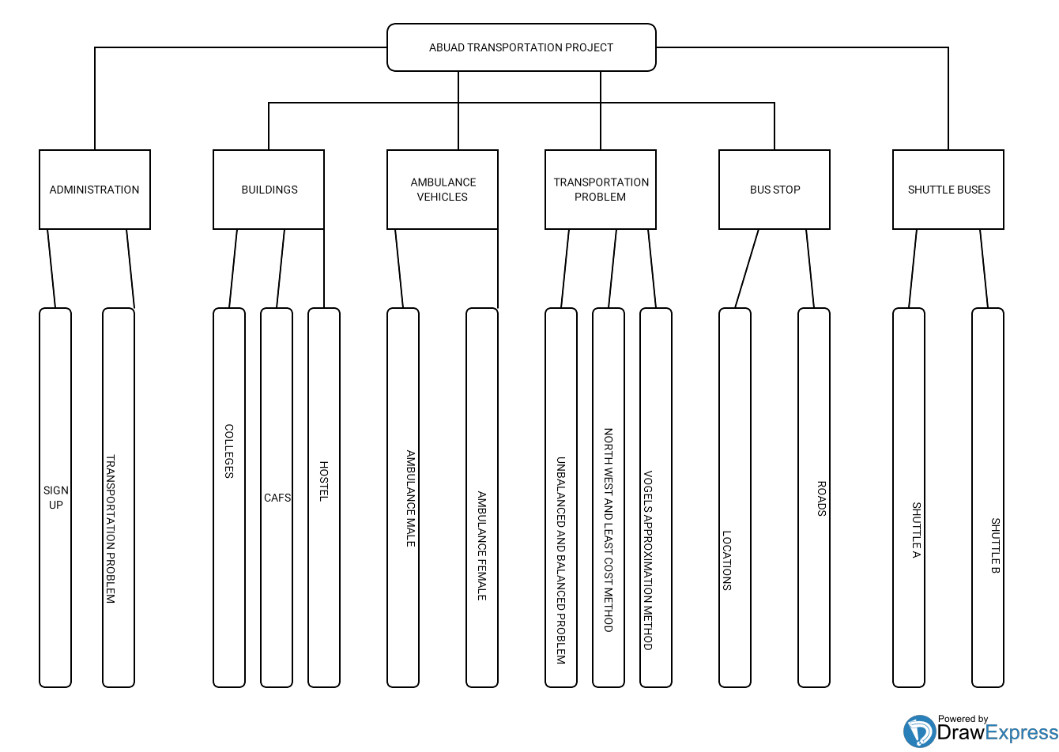

FIRST LEVEL
- SHUTTLE BUSES.
- AMBULANCE VEHICLES.
- BUS STOPS.
- TRANSPORTATION PROBLEM.
- BUILDINGS.
- ADMINSTRATION.

SECOND LEVEL
- SHUTTLE BUSES- Shuttle A and Shuttle B.
- AMBULANCE VEHICLES- Ambulance Male and Ambulance Female.
- BUS STOPS- Location and Roads.
- TRANSPORTATION PROBLEM- Unbalanced and Balanced Problem, North West Corner Method, Least Cost Method and Vogels Approximation Method.
- BUILDINGS- Colleges, Cafs and Hostels.
- ADMINSTRATION- Sign Up and Transportation Algorithm.

