TERM PAPER
ON
ENGINEERING STRATEGIES FOR HANDLING COVID-19 FOR ENVIRONMENTAL HEALTH AND ECONOMIC SUSTAINABILITY
BY
ONYENIKE UGO PROMISE
LEVEL: 300
COURSE CODE: ENG 384
MATRIC NUMBER: 17/ENG07/061
SUBMITTED TO:
DEPARTMENT OF ELECTRICAL ENGINEERING
AFE BABALOLA UNIVERSITY
ADO-EKITI
IN PARTIAL FULFILLMENT OF [ENG384] ENG. LAW AND MANAGERIAL ECONOMICS

AFE BABALOLA UNIVERSITY, ADO-EKITI,
EKITI STATE, NIGERIA.
IN PARTIAL AGREEMENT OF THE COURSE ENG 384; ENGINEERING LAW AND MANAGERIAL ECONOMICS
11th April, 2020.

ABSTRACT
Networking is a good aspect in engineering that can help our governments solve problems and assist the public health response. There is a need to encourage innovation and ideas across all areas, including healthcare systems, critical infrastructure, business management and supply chain. With covid-19 as a major world problem, the people in higher authorities should call on engineers across the world to help out.

Introduction
Coronavirus disease (COVID-19) is an infectious disease caused by a newly discovered coronavirus.
Most people infected with the COVID-19 virus will experience mild to moderate respiratory illness and recover without requiring special treatment. Older people, and those with underlying medical problems like cardiovascular disease, diabetes, chronic respiratory disease, and cancer are more likely to develop serious illness.
The best way to prevent and slow down transmission is be well informed about the COVID-19 virus, the disease it causes and how it spreads. Protect yourself and others from infection by washing your hands or using an alcohol based rub frequently and not touching your face.
The COVID-19 virus spreads primarily through droplets of saliva or discharge from the nose when an infected person coughs or sneezes, so it’s important that you also practice respiratory etiquette (for example, by coughing into a flexed elbow).
At this time, there are no specific vaccines or treatments for COVID-19. However, there are many ongoing clinical trials evaluating potential treatments. WHO will continue to Coronaviruses are a family of viruses that can cause illnesses such as the common cold, severe acute respiratory syndrome (SARS) and Middle East respiratory syndrome (MERS). In 2019, a new coronavirus was identified as the cause of a disease outbreak that originated in China.
The virus is now known as the severe acute respiratory syndrome coronavirus 2 (SARS-CoV-2). The disease it causes is called coronavirus disease 2019 (COVID-19). In March 2020, the World Health Organization (WHO) declared the COVID-19 outbreak a pandemic.
Public health groups, including the U.S. Centers for Disease Control and Prevention (CDC) and WHO, are monitoring the pandemic and posting updates on their websites. These groups have also issued recommendations for preventing and treating the illness.

Symptoms
Signs and symptoms of COVID-19 may appear two to 14 days after exposure and can include:
- Fever
- Cough
- Shortness of breath or difficulty breathing
Other symptoms can include:
- Tiredness
- Aches
- Runny nose
- Sore throat
Some people have experienced the loss of smell or taste.
The severity of COVID-19 symptoms can range from very mild to severe. Some people may have no symptoms at all. People who are older or who have existing chronic medical conditions, such as heart disease, lung disease or diabetes, or who have compromised immune systems may be at higher risk of serious illness. This is similar to what is seen with other respiratory illnesses, such as influenza.

Causes
Infection with the new coronavirus (severe acute respiratory syndrome coronavirus 2, or SARS-CoV-2) causes coronavirus disease 2019 (COVID-19).
It's unclear exactly how contagious the new coronavirus is. Data has shown that it spreads from person to person among those in close contact (within about 6 feet, or 2 meters). The virus spreads by respiratory droplets released when someone with the virus coughs, sneezes or talks.
It can also spread if a person touches a surface with the virus on it and then touches his or her mouth, nose or eyes.

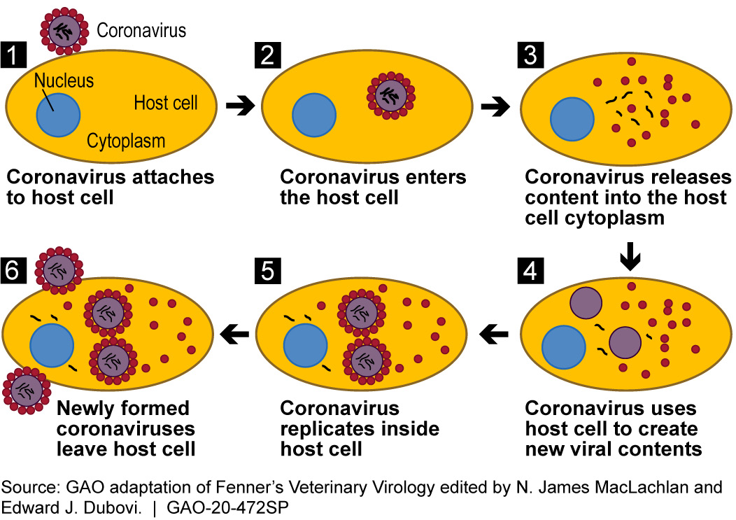

Risk factors
Risk factors for COVID-19 appear to include:
- Recent travel from or residence in an area with ongoing community spread of COVID-19 as determined by CDC or WHO
- Close contact with someone who has COVID-19 — such as when a family member or health care worker takes care of an infected person

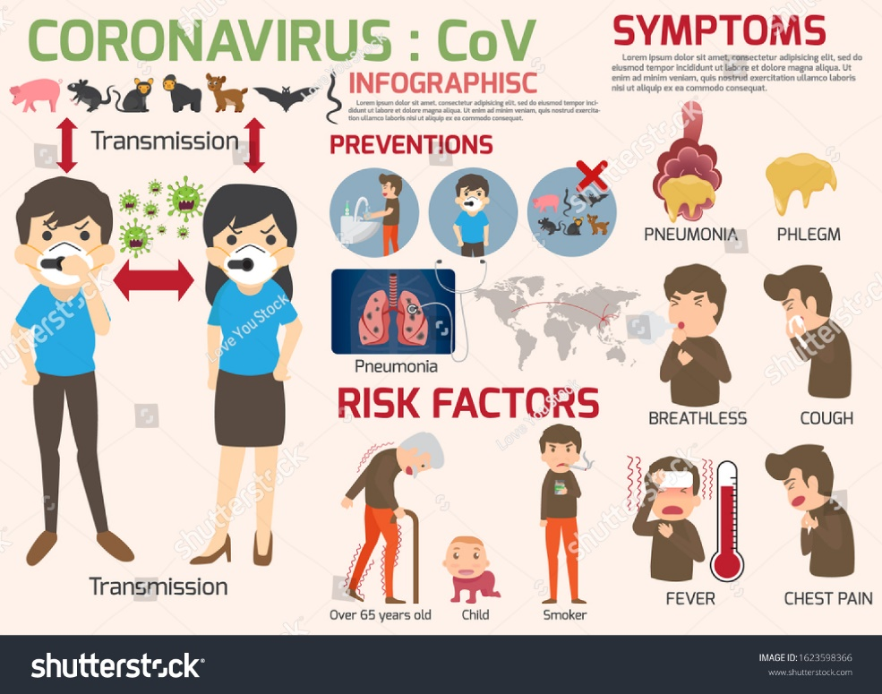

Complications
Although most people with COVID-19 have mild to moderate symptoms, the disease can cause severe medical complications and lead to death in some people. Older adults or people with existing chronic medical conditions are at greater risk of becoming seriously ill with COVID-19.
Complications can include:
- Pneumonia in both lungs
- Organ failure in several organs

Prevention
Although there is no vaccine available to prevent infection with the new coronavirus, you can take steps to reduce your risk of infection. WHO and CDC recommend following these precautions for avoiding COVID-19:
- Avoid large events and mass gatherings.
- Avoid close contact (within about 6 feet, or 2 meters) with anyone who is sick or has symptoms.
- Wash your hands often with soap and water for at least 20 seconds, or use an alcohol-based hand sanitizer that contains at least 60% alcohol.
- Cover your mouth and nose with your elbow or a tissue when you cough or sneeze. Throw away the used tissue.
- Avoid touching your eyes, nose and mouth.
- Clean and disinfect high-touch surfaces daily.
- Stay home from work, school and public areas if you're sick, unless you're going to get medical care. Avoid taking public transportation if you're sick.
The CDC recommends wearing cloth face coverings in public places, such as the grocery store, where it's difficult to avoid close contact with others. It's especially suggested in areas with ongoing community spread. This updated advice is based on data showing that people with COVID-19
If you have a chronic medical condition and may have a higher risk of serious illness, check with your doctor about other ways to protect yourself.
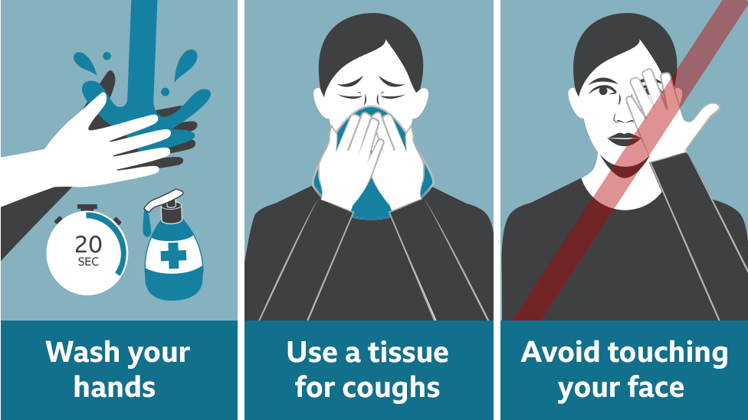
Challenges about COVID-19
1. The stacks are obviously not in our favor and as things get worse for the oil markets, so will they be for the economy. The Federal Government will struggle to fund its statutory capital and recurrent expenditures, state governments will struggle to pay salaries, and oil companies could default on their loans, thereby piling pressure on commercial banks.
2. Small businesses, which rely heavily on foreign imports to augment their value chains, will suffer from supply shortages while looming job cuts will intensify. The aviation sector could suffer, as businesses will cut down on travel plans. The struggling service sector will feel most of the heat, as the manufacturers will cut back budget to survive.

Solutions associated with health care for suspected COVID-19
Solutions to prevent or limit transmission in health care settings include the following:
1. ensuring triage, early recognition, and source control (isolating patients with suspected COVID-19);
2. applying standard precautions for all patients;
3. implementing administrative controls;
4. using engineering controls.
- Ensuring triage, early recognition, and source control.
Clinical triage includes a system for assessing all patients at admission, allowing for early recognition of possible COVID-19 and immediate isolation of patients with suspected disease in an area separate from other patients (source control). To facilitate the early identification of cases of suspected COVID-19, health care facilities should:
encourage HCWs to have a high level of clinical suspicion;
- establish a well-equipped triage station at the entrance to the facility, supported by trained staff;
- institute the use of screening questionnaires according to the updated case definition. Please refer to the Global Surveillance for human infection with coronavirus disease (COVID-19) for case definitions, and
- post signs in public areas reminding symptomatic patients to alert HCWs. Hand hygiene and respiratory hygiene are essential preventive measures.
2 Applying standard precautions for all patients
Standard precautions include hand and respiratory hygiene, the use of appropriate personal protective equipment (PPE) according to a risk assessment, injection safety practices, safe waste management, proper linens, environmental cleaning, and sterilization of patient-care equipment.
Ensure that the following respiratory hygiene measures are used:
- ensure that all patients cover their nose and mouth with a tissue;
- offer a medical mask to patients with suspected COVID-19 while they are in waiting/public areas;
- perform hand hygiene after contact with respiratory secretions. HCWs should apply WHO’s My 5 Moments for Hand Hygiene approach before touching a patient, before any clean or aseptic procedure is performed, after exposure to body fluid, after touching a patient, and after touching a patient’s surroundings.
- hand hygiene includes either cleansing hands with an alcohol-based hand rub;
- alcohol-based hand rubs are preferred if hands are not visibly soiled;
- Wash hands with soap and water when they are visibly soiled.
The rational, correct, and consistent use of PPE also helps reduce the spread of pathogens. PPE effectiveness depends strongly on adequate and regular supplies, adequate staff training, appropriate hand hygiene, and appropriate human behavior.
It is important to ensure that environmental cleaning and disinfection procedures are followed consistently and correctly. Thoroughly cleaning environmental surfaces with water and detergent and applying commonly used hospital level disinfectants (such as sodium hypochlorite) are effective and sufficient procedures.8 Medical devices and equipment, laundry, food service utensils, and medical waste should be managed in accordance with safe routine procedures.2,9

3.2 Airborne precautions for aerosol-generating procedures.
Some aerosol-generating procedures, such as tracheal intubation, non-invasive ventilation, tracheotomy, cardiopulmonary resuscitation, manual ventilation before intubation, and bronchoscopy, have been associated with an increased risk of transmission of coronaviruses.
Ensure that HCWs performing aerosol-generating procedures:
- Perform procedures in an adequately ventilated room – that is, natural ventilation with air flow of at least 160 L/s per patient or in negative- pressure rooms with at least 12 air changes per hour and controlled direction of air flow when using mechanical ventilation;
- Use a particulate respirator at least as protective as a US National Institute for Occupational Safety and Health (NIOSH)-certified N95, European Union (EU) standard FFP2, or equivalent. When HCWs put on a disposable particulate respirator, they must always perform the seal check. Note that facial hair (e.g. a beard) may prevent a proper respirator fit;
- Use eye protection (i.e. goggles or a face shield);
- Wear a clean, non-sterile, long-sleeved gown and gloves. If gowns are not fluid-resistant, HCWs should use a waterproof apron for procedures expected to create high volumes of fluid that might penetrate the gown;
- limit the number of persons present in the room to the absolute minimum required for the patient’s care and support.
3. Implementing administrative controls
Administrative controls and policies for the prevention and control of transmission of COVID-19 within the health care setting include, but may not be limited to: establishing sustainable IPC infrastructures and activities; educating patients’ caregivers; developing policies on the early recognition of acute respiratory infection potentially caused by COVID-19 virus; ensuring access to prompt laboratory testing for identification of the etiologic agent; preventing overcrowding, especially in emergency departments; providing dedicated waiting areas for symptomatic patients; appropriately isolating hospitalized patients; ensuring adequate supplies of PPE; and ensuring adherence to IPC policies and procedures for all aspects of health care.
3.1 Administrative measures related to health care workers.
- Provision of adequate training for HCWs;
- Ensuring an adequate patient-to-staff ratio;
- Establishing a surveillance process for acute respiratory infections potentially caused by COVID-19 virus among HCWs;
- Ensuring that HCWs and the public understand the importance of promptly seeking medical care;
- Monitoring HCW compliance with standard precautions and providing mechanisms for improvement as needed.
4. Using engineering controls
These controls address the basic infrastructure of the health care facility and aim to ensure adequate ventilation in all areas in the health care facility, as well as adequate environmental cleaning. Additionally, separation of at least 1 meter should be maintained between all patients. Both spatial separation and adequate ventilation can help reduce the spread of many pathogens in the health care setting. Ensure that cleaning and disinfection procedures are followed consistently and correctly. Cleaning environmental surfaces with water and detergent and applying commonly used hospital disinfectants (such as sodium hypochlorite) is effective and sufficient. Manage laundry, food service utensils and medical waste in accordance with safe routine procedures

Preventive measures for COVID-19 disease for environmental health and economic sustainability
Based on the available evidence, the COVID-19 virus is transmitted between people through close contact and droplets, not by airborne transmission. The people most at risk of infection are those who are in close contact with a COVID-19 patient or who care for COVID-19 patients.
Preventive and mitigation measures are key in both healthcare and community settings. The most effective preventive measures in the community include:
- performing hand hygiene frequently with an alcohol-based hand rub if your hands are not visibly dirty or with soap and water if hands are dirty;
- avoiding touching your eyes, nose and mouth;
- practicing respiratory hygiene by coughing or sneezing into a bent elbow or tissue and then immediately disposing of the tissue;
- wearing a medical mask if you have respiratory symptoms and performing hand hygiene after disposing of the mask;
- maintaining social distance (a minimum of 1 m) from individuals with respiratory symptoms.
Additional precautions are required by healthcare workers to protect themselves and prevent transmission in the healthcare setting. Precautions to be implemented by healthcare workers caring for patients with COVID-19 disease include using PPE appropriately; this involves selecting the proper PPE and being trained in how to put on, remove and dispose of it.
PPE is only one effective measure within a package that comprises administrative and environmental and engineering controls, as described in WHO’s Infection prevention and control of epidemic- and pandemic-prone acute respiratory infections in health care (1). These controls are summarized here.
1. Administrative controls include ensuring the availability of resources for infection prevention and control measures, such as appropriate infrastructure, the development of clear infection prevention and control policies, facilitated access to laboratory testing, appropriate triage and placement of patients, adequate staff-to-patient ratios and training of staff.
2. Environmental and engineering controls aim at reducing the spread of pathogens and reducing the contamination of surfaces and inanimate objects. They include providing adequate space to allow social distance of at least 1 m to be maintained between patients and between patients and healthcare workers and ensuring the availability of well-ventilated isolation rooms for patients with suspected or confirmed COVID-19 disease.
COVID-19 is a respiratory disease that is different from Ebola virus disease, which is transmitted through infected bodily fluids. Due to these differences in transmission, the PPE requirements for COVID-19 are different from those required for Ebola virus disease. Specifically, coveralls (sometimes called Ebola PPE) are not required when managing COVID-19 patients.

What engineers could do
Let’s pause for a moment and think about what could have been done to help slow the spread of COVID-19, without also shutting down the whole of society, with potentially huge, long-term economic and social consequences. If virologists can give some insight into the main sources of transmission, could engineers design specific, deployable responses to that?
I’m not an engineer or a virologist, but I study how science, technology and engineering can be used in policy to change the world for the better. So while I don’t have the answers, I can start the ball rolling.
What about focusing on the mass production and distribution of on-street hand sanitiser, or gloves treated with new, safe anti-viral coatings? There may also be new ways of opening doors without grabbing the handle, or indeed pressing lift buttons. Could we design better protective infrastructure for shop workers facing customers at tills? What about bring-your-own trolley handles? Or new kinds of easy-to-make and deploy protective face gear for the elderly and vulnerable?
Engineering solutions would have been especially effective early on during the outbreak, before measures like lockdown were introduced. But even during lockdown, they could help minimise the spread of the virus in the parts of society that are still open, such as banks and supermarkets.
Sat here on my own, I can’t solve the problem, but put a virologist, a social scientist and an engineer in the same room (or videoconference), and new ideas to delay transmission and safely allow wider elements of day-to-day life continue could emerge.
When you look at the potential that engineering can bring to this in a public health (preventive) rather than a medical (restorative) setting, it shows how much we’re actually missing. It may be that these particular (disinfectant) solutions are not workable at scale, but the point is that engineers could probably come up with other design solutions that would work. It’s their job.
The problem is, often social scientists just don’t speak to or mix with engineers very much. It’s a deep-rooted problem, like two parts of a family that fell out years ago over some obscure argument that nobody remembers, but everyone repeats.
I work at the Science, Technology, Engineering and Public Policy department at University College London. We see it as part of our mission to bring scientists and engineers together so everyone can benefit. The coronavirus case study shows now more than ever how much we need that kind of collaboration.

ENGINEERING STRATEGIES FOR HANDLING COVID-19 FOR ENVIRONMENTAL HEALTH AND ECONOMIC SUSTAINABILITY
Many manufacturing and engineering companies should put ordinary production procedures on hold and alternative ways should be given hand for them to utilise their materials and resources in order to build equipment for the medical industry and to help save lives. In order to beat the virus as quickly and effectively as possible, it’s important for businesses outside of the healthcare industry to help out.
Below I’ll be going through ways the engineering industry can help fight COVID-19;
- Help build hospital ventilators: Currently there’s a shortage of ventilators for corona virus patients and engineering companies, no matter how big or small, engineers have a role to provide more of these facilities to help out.
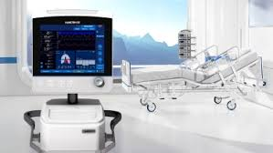
- Equipment for healthcare staff: Hospital staffs around the world are putting themselves on the front line to help treat patients with corona virus. But, unfortunately, there’s currently a shortage of these equipment to help keep medical staff safe. That’s why engineering companies should offer their expertise and facilities to help out.
- Innovative ideas and design: The internet have made billions of lives easier; it has become an important factor since we are not allowed to go outside due to the pandemic. Engineers should use this opportunity to announce their designs and production of medically approved visors and release their designs online so other engineering and manufacturing companies can follow suit.
CONCLUSION
There’ll be no need for any investigation because it is very obvious that the medical system plays a vital role in handling the corona virus, so there is a higher possibility that engineers can be well overlooked and treated inadequately. Engineers to doctors is a major role that should be considered not only by the government but by the people. Economic sustainability and environmental health are important for a good population, on the ground, engineers have their own strategies in making such to exist.

REFERENCES
https://theconversation.com/coronavirus-why-we-need-to-consult-engineers-as-well-as-scientists-for-solutions-134460

https://www.imeche.org/news/news-article/6-ways-engineers-can-help-fight-coronavirus

