JOLAADE AYUBA ADENIYI
16/SCI01/021
CSC402
COMPUTER SCIENCE
ANSWERS
1. File transfer protocols (FTP)-
FTP has been around for more than 40 years, but it has changed significantly during that time. The original specification for it was written by Abhay Bhushan and published on April 16, 1971, as RFC 114. RFC stands for “Request for Comments”. A protocol is a system of rules that networked computers use to communicate with one another. FTP is a client-server protocol that may be used to transfer files between computers on the internet. The client asks for the files and the server provides them. You can exchange any kind of file, including music, videos and documents. If it’s a single file, you might even get it faster than you would with HTTP, unless the server is far away. If tuned properly, FTP maybe better for large files.

2. Simple mail transfer protocol (SMTP)-
One of our most common forms of communication is email. This blog will be a dive into how that works. One thing the emailing system follows is the Simple Mail Transfer Protocol or SMTP, a connection-oriented text-based protocol. The internet is set up in protocols in order to link up networks everywhere and transfer information. SMTP is just one piece in how we send and receive email and is an internet standard that was defined in 1982.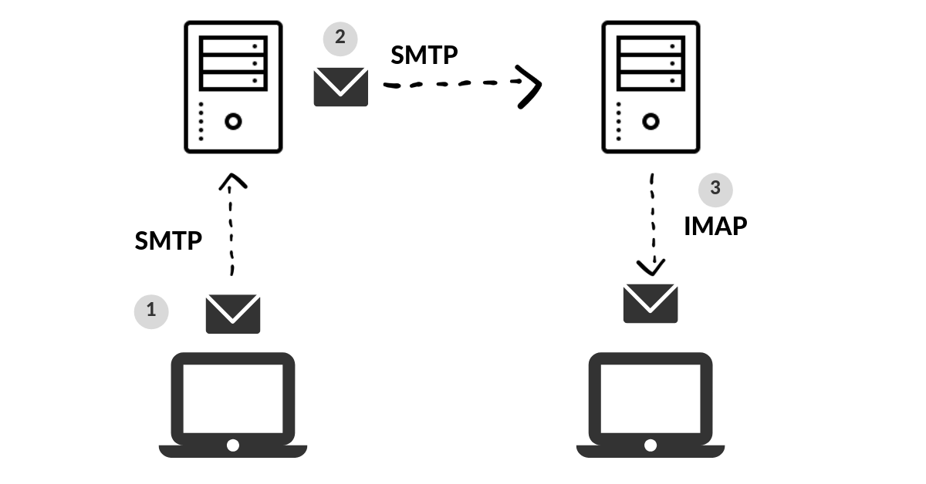
3. Internet protocol-
The Internet Protocol (IP) is a protocol, or set of rules, for routing and addressing packets of data so that they can travel across networks and arrive at the correct destination. Data traversing the Internet is divided into smaller pieces, called packets. IP information is attached to each packet, and this information helps routers to send packets to the right place. Once the packets arrive at their destination, they are handled differently depending on which transport protocol is used in combination with IP. The most common transport protocols are TCP and UDP. When you send or receive data (for example, an e-mail note or a Web page), the message gets divided into little chunks called packets. Each of these packets contains both the sender's Internet address and the receiver's address. Any packet is sent first to a gateway computer that understands a small part of the Internet. The gateway computer reads the destination address and forwards the packet to an adjacent gateway that in turn reads the destination address and so forth across the Internet until one gateway recognizes the packet as belonging to a computer within its immediate neighborhood or domain. That gateway then forwards the packet directly to the computer whose address is specified.

4. User datagram protocol UDP-
The User Datagram Protocol, or UDP, is another widely used transport protocol. It's faster than TCP, but it is also less reliable. UDP does not make sure all packets are delivered and in order, and it doesn't establish a connection before beginning or receiving transmissions. UDP/IP is usually utilized for streaming audio or video, as these are use cases where the risk of dropped packets (meaning, missing data) is outweighed by the need to keep the transmission real-time. For instance, when users are watching a video online, not every pixel has to be present for every frame of the video. Users would rather have the video play at normal speed than sit and wait for every bit of data to be delivered.

