NAME: OLORUNTOBA OLAJUBU
MATRIC NO.: 15/ENG05/019
COURSE: MCT 510 (POWER ELECTRONICS & DRIVES)
DEPT.: MECHATRONICS ENGINEERING
ASSIGNMENT
- Differentiate between a controlled and Uncontrolled Rectifier.
Answer:
Uncontrolled rectifier | Controlled rectifier
The triggering circuit is not required in uncontrolled rectifier | The triggering circuit is required in controlled rectifier.
Only diodes are used in uncontrolled rectifier. | The SCR and diodes are used in controlled rectifier.
The continuous control of the output is not obtained. | The continuous control of the output is obtained.
The freewheeling diode is not necessary in uncontrolled rectifier. | The freewheeling diode is necessary in controlled rectifier.
The direction of power flow is form source to load only. | The direction of power flow is from source to load and sometimes vice versa.
Wastage of power in uncontrolled rectifier. | No wastage of power in controlled rectifier.
It is used in power supplies. | It is used for speed control of DC motors.

- Differentiate between Single phase half- wave Rectifier and a Single phase full wave Rectifier
Answer: The Half Wave and Full Wave Rectifier have significant differences. A rectifier converts AC voltage into Pulsating DC voltage. A Half-Wave rectifier is an electronic circuit which converts only one-half of the AC cycle into pulsating DC. It utilizes only half of AC cycle for the conversion process. On the other hand, Full wave rectifier is an electronic circuit which converts entire cycle of AC into Pulsating DC.

The Half-Wave Rectifier is unidirectional; it means it will allow the conduction in one direction only. That’s why either it can convert positive half only or negative half only into DC voltage. This is the reason that it is called Half Wave Rectifier. While Full-wave Rectifier is bi-directional, it conducts for positive half as well as negative half of the cycle. Thus, it is termed as full wave rectifier.
- Explain the operational characteristics of a DIAC
Answer: Basically, the DIAC is a two terminal device; it is a combination of parallel semiconductor layers that allows activating in one direction. This device is used to activating device for the triac. The basic construction of diac consist of two terminals namely MT1 and MT2. When the MT1 terminal is designed +Ve with respect to the terminal MT2, the transmission will take place to the p-n-p-n structure that is another four layer diode. The diac can be performing for both the direction. Then symbol of the diac look like a transistor.
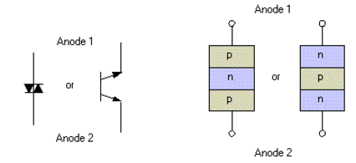
Construction of DIAC
The DIAC is basically a diode that conducts after a ‘break-over’ voltage, selected VBO, and is exceeded. When the diode surpasses the break-over voltage, then it goes into the negative dynamic resistance of region. This causes a reduction in the voltage drop across the diode with rising voltage. So there is a quick increase in the current level that is mannered by the device. The diode leftovers in its transmission state until the current through it falls below, what is termed the holding current, which is usually chosen by the letters IH. The holding current, the DIAC reverts to its non-conducting state. Its behaviour is bidirectional and thus its function takes place on both halves of an alternating cycle.
Volt-ampere characteristic of a diac is shown in figure. Its looks like a letter Z due to symmetrical switching characteristics for each polarity of the applied voltage.
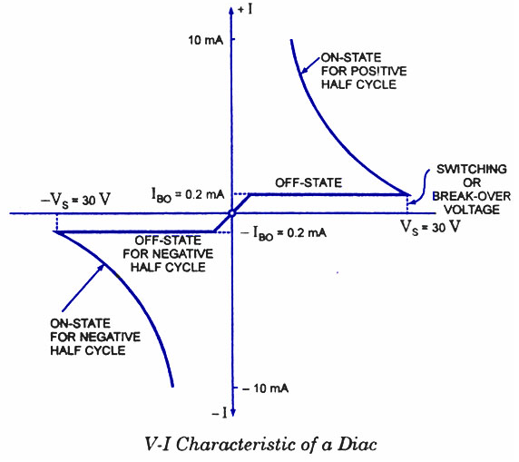
Characteristics of DIAC
The diac performs like an open-circuit until its switching is exceeded. At that position the diac performs until its current decreases toward zero. Because of its abnormal construction, doesn’t switch sharply into a low voltage condition at a low current level like the triac or SCR, once it goes into transmission, the diac preserves an almost continuous –Ve resistance characteristic, that means, voltage reduces with the enlarge in current. This means that, unlike the triac and the SCR, the diac cannot be estimated to maintain a low voltage drop until its current falls below the level of holding current.
- Explain the operational characteristics of a TRIAC.
Answer: Traic is a three terminal device and the terminals of the triac are MT1, MT2 and Gate. Here the gate terminal is the control terminal. The flow of current in the triac is bi directional that means current can flow in both the directions. The structure of triac is shown in the below figure. Here, in the structure of triac, two SCRs are connected in the anti-parallel and it will acts like a switch for both the directions. In the above structure, the MT1 and gate terminals are near to each other. When the gate terminal is open, the triac will obstruct the both the polarities of the voltage across the MT1 & MT2.
The triac is designed with two SCRs which are fabricated in the opposite direction in a crystal. Operating characteristics of triac in the 1st and 3rd quadrants are similar but for the direction of flow of current and applied voltage.
The V-I characteristics of triac in the first and third quadrants are basically equal to those of an SCR in the first quadrant.
It can be functioned with either +Ve or –Ve gate control voltage but in typical operation generally the gate voltage is +Ve in first quadrant and -Ve in third quadrant.
The supply voltage of the triac to switch ON depends upon the gate current. This allows utilizing a triac to regulate AC power in a load from zero to full power in a smooth and permanent manner with no loss in the device control.
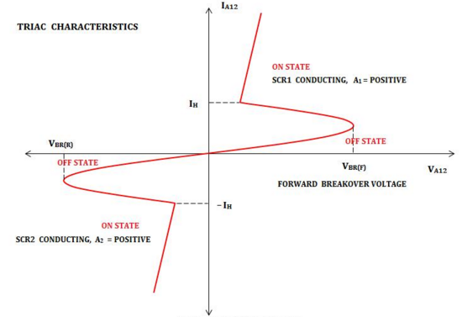
Characteristics of TRIAC

