AFE BABALOLA UNIVERSITY ADO EKITI

TERM PAPER
ON
SOIL PERMEABILITY AND CAPILLARITY

BY
OZIORO DOUTIMI PEACE
17/ENG03/048
CIVIL ENGINEERING

Soil mechanics is a branch of soil physics and applied mechanics that describes the behavior of soils. It differs from fluid mechanics and solid mechanics in the sense that soils consist of a heterogeneous mixture of fluids (usually air and water) and particles (usually clay, silt, sand, and gravel) but soil may also contain organic solids and other matter, Along with rock mechanics, soil mechanics provides the theoretical basis for analysis in geotechnical engineering,a sub discipline of civil engineering, and engineering geology, a subdiscipline of geology. Soil mechanics is used to analyze the deformations of and flow of fluids within natural and man-made structures that are supported on or made of soil, or structures that are buried in soils.
Example applications are building and bridge foundations, retaining walls, dams, and buried pipeline systems. Principles of soil mechanics are also used in related disdisciplines such as engineering geology, geophysical engineering, coastal engineering, agricultural engineering, hydrology and soil physics.
This article describes the genesis and composition of soil, the distinction between pore water pressure and inter-granular effective stress, capillary action of fluids in the soil pore spaces, soil classification, seepage and permeability, time dependent change of volume due to squeezing water out of tiny pore spaces, also known as consolidation, shear strength and stiffness of soils. The shear strength of soils is primarily derived from friction between the particles and interlocking, which are very sensitive to the effective stress. The article concludes with some examples of applications of the principles of soil mechanics such as slope stability, lateral earth pressure on retaining walls, and bearing capacity of foundations.
Genesis and composition of soils

Genesis
The primary mechanism of soil creation is the weathering of rock. All rock types (igneous rock, metamorphic rock and sedimentary rock) may be broken down into small particles to create soil. Weathering mechanisms are physical weathering, chemical weathering, and biological weathering , Human activities such as excavation, blasting, and waste disposal, may also create soil. Over geologic time, deeply buried soils may be altered by pressure and temperature to become metamorphic or sedimentary rock, and if melted and solidified again, they would complete the geologic cycle by becoming igneous rock.
Physical weathering includes temperature effects, freeze and thaw of water in cracks, rain, wind, impact and other mechanisms. Chemical weathering includes dissolution of matter composing a rock and precipitation in the form of another mineral. Clay minerals, for example can be formed by weathering of feldspar, which is the most common mineral present in igneous rock.
The most common mineral constituent of silt and sand is quartz, also called silica, which has the chemical name silicon dioxide. The reason that feldspar is most common in rocks but silica is more prevalent in soils is that feldspar is much more soluble than silica.
Silt, Sand, and Gravel are basically little pieces of broken rocks.
According to the Unified Soil Classification System, silt particle sizes are in the range of 0.002 mm to 0.075 mm and sand particles have sizes in the range of 0.075 mm to 4.75 mm.
Gravel particles are broken pieces of rock in the size range 4.75 mm to 100 mm. Particles larger than gravel are called cobbles and boulders.

Permeability in fluid mechanics and the Earth sciences (commonly symbolized as k) is a measure of the ability of a porous material (often, a rock or an unconsolidated material) to allow fluids to pass through it.
The permeability of a medium is related to the porosity, but also to the shapes of the pores in the medium and their level of connectedness.
Permeability is the property of rocks that is an indication of the ability for fluids (gas or liquid) to flow through rocks. High permeability will allow fluids to move rapidly through rocks. Permeability is affected by the pressure in a rock. The unit of measure is called the darcy, named after Henry Darcy (1803–1858). Sandstones may vary in permeability from less than one to over 50,000 millidarcys (md). Permeabilities are more commonly in the range of tens to hundreds of millidarcies. A rock with 25% porosity and a permeability of 1 md will not yield a significant flow of water. Such “tight” rocks are usually artificially stimulated (fractured or acidized) to create permeability and yield a flow.

Units
The SI unit for permeability is m². A practical unit for permeability is the darcy (d), or more commonly the millidarcy (md) (1 darcy 10⁻¹²m²). The name honors the French Engineer Henry Darcy who first described the flow of water through sand filters for potable water supply. Permeability values for sandstones range typically from a fraction of a darcy to several darcys. The unit of cm² is also sometimes used (1 cm² = 10⁻⁴ m² 10⁸ d).

Applications
This section needs expansion. You can help by adding to it. (February 2016)
The concept of permeability is of importance in determining the flow characteristics of hydrocarbons in oil and gas reservoirs^{[1]}, and of groundwater in aquifers ^{[2]}.
For a rock to be considered as an exploitable hydrocarbon reservoir without stimulation, its permeability must be greater than approximately 100 md (depending on the nature of the hydrocarbon – gas reservoirs with lower permeabilities are still exploitable because of the lower viscosity of gas with respect to oil). Rocks with permeabilities significantly lower than 100 md can form efficient seals (see petroleum geology). Unconsolidated sands may have permeabilities of over 5000 md.
The concept also has many practical applications outside of geology, for example in chemical engineering (e.g., filtration), as well as in Civil Engineering when determining whether the ground conditions of a site are suitable for construction.

Description
Permeability is part of the proportionality constant in Darcy's law which relates discharge (flow rate) and fluid physical properties (e.g. viscosity), to a pressure gradient applied to the porous media ^{[3]}:
(for linear flow)
Therefore:

where:
is the superficial fluid flow velocity through the medium (i.e., the average velocity calculated as if the fluid were the only phase present in the porous medium) (m/s)
is the permeability of a medium (m²)
is the dynamic viscosity of the fluid (Pa·s)
is the applied pressure difference (Pa)
is the thickness of the bed of the porous medium (m)
In naturally occurring materials, the permeability values range over many orders of magnitude (see table below for an example of this range).

Relation to hydraulic conductivity
The proportionality constant specifically for the flow of water through a porous media is called the hydraulic conductivity; permeability is a portion of this, and is a property of the porous media only, not the fluid. Given the value of hydraulic conductivity for a subsurface system, the permeability can be calculated as follows:

where
- is the permeability, m²
- is the hydraulic conductivity, m/s
- is the dynamic viscosity of the fluid, Pa·s
- is the density of the fluid, kg/m³
- is the acceleration due to gravity, m/s².

Determination
Permeability is typically determined in the lab by application of Darcy's law under steady state conditions or, more generally, by application of various solutions to the diffusion equation for unsteady flow conditions.^{[4]}
Permeability needs to be measured, either directly (using Darcy's law), or through estimation using empirically derived formulas. However, for some simple models of porous media, permeability can be calculated (e.g., random close packing of identical spheres).

Permeability model based on conduit flow
Based on the Hagen–Poiseuille equation for viscous flow in a pipe, permeability can be expressed as:

where:
is the intrinsic permeability [length²]
is a dimensionless constant that is related to the configuration of the flow-paths
is the average, or effective pore diameter [length].

Absolute permeability (aka intrinsic or specific permeability)
Absolute permeability denotes the permeability in a porous medium that is 100% saturated with a single-phase fluid. This may also be called the intrinsic permeability or specific permeability. These terms refer to the quality that the permeability value in question is an intensive property of the medium, and that it is a function of the material structure only (and not of the fluid). They explicitly distinguish the value from that of relative permeability.

Permeability to gases
Sometimes permeability to gases can be somewhat different than those for liquids in the same media. One difference is attributable to "slippage" of gas at the interface with the solid^{[5]} when the gas mean free path is comparable to the pore size (about 0.01 to 0.1 μm at standard temperature and pressure). See also Knudsen diffusion and constrictivity. For example, measurement of permeability through sandstones and shales yielded values from 9.0×10⁻¹⁹ m² to 2.4×10⁻¹² m² for water and between 1.7×10⁻¹⁷ m² to 2.6×10⁻¹² m² for nitrogen gas.^{[6]} Gas permeability of reservoir rock and source rock is important in petroleum engineering, when considering the optimal extraction of shale gas, tight gas, or coalbed methane.

Tensor permeability
To model permeability in anisotropic media, a permeability tensor is needed. Pressure can be applied in three directions, and for each direction, permeability can be measured (via Darcy's law in 3D) in three directions, thus leading to a 3 by 3 tensor. The tensor is realised using a 3 by 3 matrix being both symmetric and positive definite (SPD matrix):
- The tensor is symmetric by the Onsager reciprocal relations.
- The tensor is positive definite as the component of the flow parallel to the pressure drop is always in the same direction as the pressure drop.
The permeability tensor is always diagonalizable (being both symmetric and positive definite). The eigenvectors will yield the principal directions of flow, meaning the directions where flow is parallel to the pressure drop, and the eigenvalues representing the principal permeabilities.

Ranges of common intrinsic permeabilities
These values do not depend on the fluid properties; see the table derived from the same source for values of hydraulic conductivity, which are specific to the material through which the fluid is flowing.^{[7]}
Permeability | Pervious |  |  |  | Semi-pervious |  |  |  | Impervious
Unconsolidated sand and gravel | Well sorted gravel |  | Well sorted sand or sand and gravel |  |  | Very fine sand, silt, loess, loam
Unconsolidated clay and organic |  |  |  |  | Peat |  | Layered clay |  |  | Unweathered clay
Consolidated rocks | Highly fractured rocks |  |  |  | Oil reservoir rocks |  |  | Fresh sandstone |  | Fresh limestone, dolomite |  | Fresh granite
k (cm²) | 0.001 | 0.0001 | 10⁻⁵ | 10⁻⁶ | 10⁻⁷ | 10⁻⁸ | 10⁻⁹ | 10⁻¹⁰ | 10⁻¹¹ | 10⁻¹² | 10⁻¹³ | 10⁻¹⁴ | 10⁻¹⁵
 | ⁺⁸ | 10⁺⁷ | 10⁺⁶ | 10⁺⁵ | 10,000 | 1,000 | 100 | 10 | 1 | 0.1 | 0.01 | 0.001 | 0.0001

SOIL PERMEABILITY

Why is it important to determine soil permeability?
Soil permeability is the property of the soil to transmit water and air and is one of the most important qualities to consider for fish culture. |  | 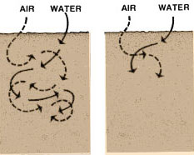

A pond built in impermeable soil will lose little water through seepage. |  | 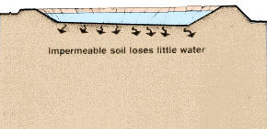
The more permeable the soil, the greater the seepage. Some soil is so permeable and seepage so great that it is not possible to build a pond without special construction techniques. You will learn about these techniques in a later volume in this series. |  | 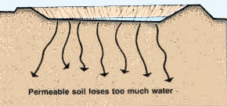

Soils are generally made up of layers and soil quality often varies greatly from one layer to another. Before pond construction, it is important to determine the relative position of the permeable and impermeable layers. The design of a pond should be planned to avoid having a permeable layer at the bottom to prevent excessive water loss into the subsoil by seepage. |  | 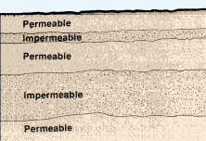
The dikes of the pond should be built with soil which will ensure a good water retention. Again, soil quality will have to be checked with this in mind.
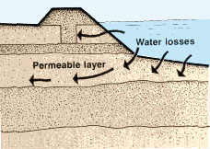 |  | 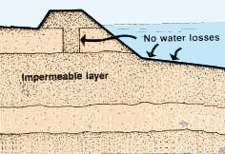

Which factors affect soil permeability?
Many factors affect soil permeability. Sometimes they are extremely localized, such as cracks and holes, and it is difficult to calculate representative values of permeability from actual measurements. A good study of soil profiles provides an essential check on such measurements. Observations on soil texture, structure, consistency, colour/mottling, layering, visible pores and depth to impermeable layers such as bedrock and clay pan* form the basis for deciding if permeability measurements are likely to be representative.
Note: you have already learned that soil is made up of a number of horizons, each of them usually having different physical and chemical properties. To determine the permeability of soil as a whole, each horizon should be studied separately.

Soil permeability relates to soil texture and structure
The size of the soil pores is of great importance with regard to the rate of infiltration (movement of water into the soil) and to the rate of percolation (movement of water through the soil). Pore size and the number of pores closely relate to soil texture and structure, and also influence soil permeability.

Permeability variation according to soil texture
Usually, the finer the soil texture, the slower the permeability, as shown below:
Soil | Texture | Permeability
Clayey soils | Fine | From very slow to very rapid
Loamy soils | Moderately fine
 | Moderately coarse
Sandy soils | Coarse

Example
Average permeability for different soil textures in cm/hour
Sand | 5.0
Sandy loam | 2.5
Loam | 1.3
Clay loam | 0.8
Silty clay | 0.25
Clay | 0.05

Permeability variation according to soil structure
Structure may greatly modify the permeability rates shown above, as follows:
Structure type |  | Permeability¹
Platy | - Greatly overlapping | From very slow to very rapid
 | - Slightly overlapping
Blocky
Prismatic
Granular
¹ This may vary according to the degree to which the structure is developed.
It is common practice to alter the soil structure to reduce permeability, for example, in irrigated agriculture through the puddling of rice fields and in civil engineering through the mechanical compaction* of earthen dams. Similar practices may be applied to fish-ponds to reduce water seepage.

Soil permeability classes  Permeability is commonly measured in terms of the rate of water flow through the soil in a given period of time. It is usually expressed either as a permeability rate in centimetres per hour (cm/h), millimetres per hour (mm/h), or centimetres per day (cm/d), or as a coefficient of permeability k in metres per second (m/s) or in centimetres per second (cm/s). |  | Example  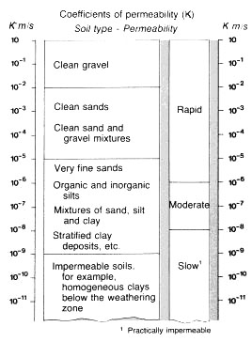
For agriculture and conservation uses, soil permeability classes are based on permeability rates, and for civil engineering, soil permeability classes are based on the coefficient of permeability (see Tables 15 and 16).
For fish culture, two methods are generally used to determine soil permeability. They are:
- The coefficient of permeability;
- The seepage rate.
For the siting of ponds and the construction of dikes, the coefficient of permeability is generally used to qualify the suitability of a particular soil horizon:
- Dikes without any impermeable clay core may be built from soils having a coefficient of permeability less than
K = 1 x 10⁻⁴ m/s;
- Pond bottoms may be built into soils having a coefficient of permeability less than K = 5 x 10⁻⁶ m/s.
For pond management, the seepage rate is generally used:
- In commercial pond culture, an average seepage rate of 1 to 2 cm/d is considered acceptable, but corrective measures should be taken to reduce soil permeability when higher values exist, particularly when they reach 10 cm/d or more.

Measurement of soil permeability in the laboratory
When you take an undisturbed sample to a testing laboratory, to measure permeability, a column of soil is placed under specific conditions such as water saturation and constant head of water. The result will be given to you either as a permeability rate (see Table), or as a coefficient of permeability (see Table ).
TABLE  Soil permeability classes for agriculture and conservation  Soil permeability classes Permeability rates¹  cm/hour cm/day  Very slow Less than 0.13 Less than 3  Slow 0.13 - 0.3 3 - 12  Moderately slow 0.5 - 2.0 12 - 48  Moderate 2.0 - 6.3 48 - 151  Moderately rapid 6.3 - 12.7 151 - 305  Rapid 12.7 - 25 305 - 600  Very rapid More than 25 More than 600 |  | TABLE  Soil permeability classes for civil engineering  Soil permeability classes Coefficient of permeability (K in m/s)  Lower limit Upper limit  Permeable 2 x 10⁻⁷ 2 x 10⁻¹  Semi-permeable 1 x 10⁻¹¹ 1 x 10⁻⁵  Impermeable 1 x 10⁻¹¹ 5 x 10⁻⁷

Measurement of soil permeability in the field
To measure soil permeability in the field, you can use one of the following tests:
- The visual evaluation of the permeability rate of soil horizons;
- A simple field test for estimating soil permeability;
- A more precise field test measuring permeability rates.

The visual evaluation of the permeability rate of soil horizons
The permeability of individual soil horizons may be evaluated by the visual study of particular soil characteristics which have been shown by soil scientists to be closely related to permeability classes. The most significant factor in evaluating permeability is structure: its type, grade, and aggregation characteristics, such as the relationship between the length of horizontal and vertical axes of the aggregates and the direction and amount of overlap.
Although neither soil texture nor colour mottling alone are reliable clues, these soil properties may help to estimate permeability when considered together with the structural characteristics. To evaluate visually the permeability of soil horizons:

Visual indicators of permeability: structural characteristics of soil
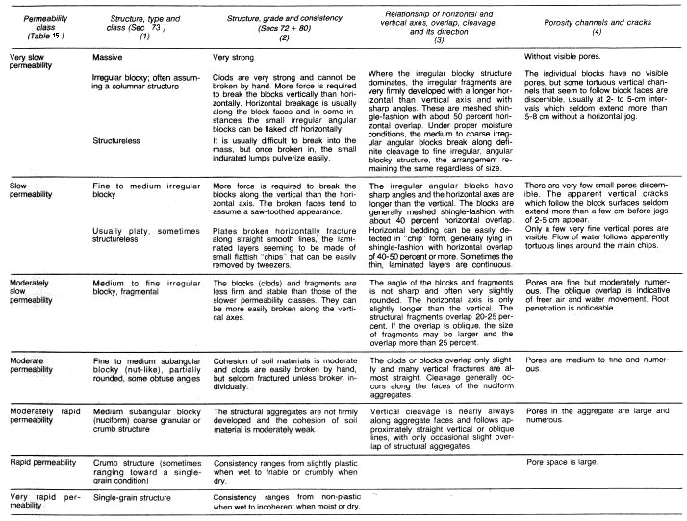

TABLE 17 B
Visual Indicators of permeability: texture, physical behaviour and colour of soil
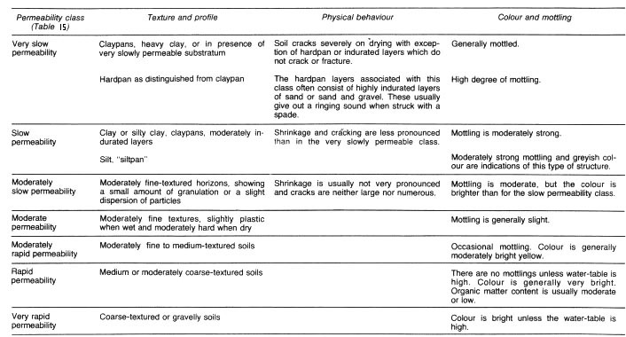

A simple field test for estimating soil permeability
- Dig a hole as deep as your waist;  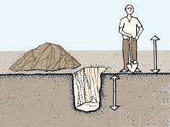 |  | - Early in the morning, fill it with water to the top;  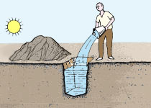
- By the evening, some of the water will have sunk into the soil; |  | 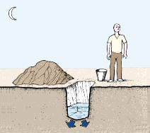

- Fill the hole with water to the top again, and cover it with boards or leafy branches;  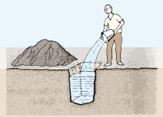 |  | 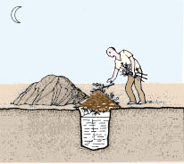
- If most of the water is still in the hole the next morning, the soil permeability is suitable to build a fish-pond here; |  | 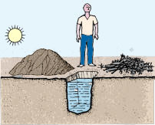
- Repeat this test in several other locations as many times as necessary, according to the soil quality.

A more precise field test for measuring permeability rates
- Carefully examine the drawings you have made when studying your soil profiles; |  | - On the basis of texture and structure, determine which soil horizons seem to have the slowest permeability;
- Mark the soil horizons on your drawings which seem to have the slowest permeability. Use a coloured pencil; |  | 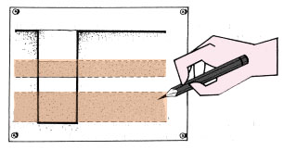

Capillarity of Soils

Purpose
To compare the rise of water by capillarity in sandy, clayey, and loamy soil

Additional information
Capillarity is the phenomenon by which water rises in a cylindrical column. The narrower the column the higher the capillarity; similarly, the denser the substratum present in the column, the higher the capillary effect.
This is the reason why clayey and loamy soils are better options when it comes to growing healthy plants; along with being rich in nutrients it also retains moisture and helps water reach the transport channels of plants thereby helping them grow well.

Required materials
- Sandy soil sample
- Clayey soil sample
- Loamy soil sample
- Water
- Beaker to hold the glass tubes
- Glass wool to plug one end of each of the glass tubes

Estimated Experiment Time
Approximately 10 minutes to set up the apparatus and 1-2 days to carry out the observations

Step-By-Step Procedure
1. Plug one end of the glass tubes using glass wool.
2. Pack 3 long glass tubes tightly with dry sandy, clayey and loamy soil; clearly label each tube.
3. Fill the beaker with water.
4. Immerse the tubes vertically in the beaker with the plugged end towards its base.
5. Make note of the levels of the water as it rises in the glass tubes containing each type of soil.

Observation And Conclusion

Initially the water rises fastest in the sand, followed by the loamy soil, and clayey soil. However, after a day or two, the water fails to rise any higher in the tube containing sand, whereas in those containing clay and loam continue to rise until it reaches the top of the tube. The level in the loam may rise and drop but usually stabilizes very close to the water level in the tube containing clayey soil.

