NAME: OGOMUEGBUNAM FAVOUR CHIDI
MATRIC NO: 17/ENG01/021
CHE 888 ASSIGNMENT
Question 1
- Instrumentation is defined as the art and science of measurement and control of process variables within a production or manufacturing area. The process variables used in industries are Level, Pressure, Temperature, Humidity, Flow, pH, Force, Speed etc. Instrumentation is the branch of engineering that deals with measurement and control.
- In gas chromatography, the mobile phase (or "moving phase") is a carrier gas, usually an inert gas such as helium or an unreactive gas such as nitrogen. Helium remains the most commonly used carrier gas in about 90% of instruments although hydrogen is preferred for improved separations.
The stationary phase is a microscopic layer of liquid or polymer on an inert solid support, inside a piece of glass or metal tubing called a column (a homage to the fractionating column used in distillation).
- The reasons for moisture measurement are:
- For effective process control: Moisture control is an important aspect of the manufacturing processes. Identifying a target moisture range and taking steps to achieve that target range will optimize the process control of virtually any manufactured product. Having a real-time moisture measurement of a product as it is being manufactured will allow the producer to adjust their process to achieve the target range and effectively control their manufacturing process with minimal down-time and maximum efficiency.
- To increase product consistency: Real-time moisture control is a key performance indicator for manufacturers whose goal is to increase their product consistency. Variations in product moisture during the manufacturing process can impair the quality of the product. Implementing moisture measurement and control technology provides the manufacturer the ability to spot product inconsistencies in real-time and make process adjustments before the finished products are damaged or produced with poor quality.
- To reduce energy cost: Having a real-time measurement of moisture can prevent over-drying and unnecessary energy usage. Additionally, energy costs in producing poor quality product that is not fit for the customer and must be reprocessed or disposed are other sources of energy costs that can be avoided by implementing moisture measurement and control technology. Energy costs are a significant source of operational expenses and reducing these costs can mean significant cost savings.
- To reduce product waste: This real-time measurement gives the producer the ability to make immediate adjustments in their process and to avoid the pitfall of manufacturing product that is unfit for the customer. Without knowing the moisture content, in real-time, a producer may continue to manufacture unfit product and learn of its poor quality only after a significant quantity has been produced.
Methods of moisture measurement include:
- Electrical Moisture Meter Method: There are numerous ways to use electricity to measure moisture. These include capacitance, conductance, radio frequency (RF). However, they all rely on the dielectric principle. The dielectric constant of a material is proportional to the capacitance of the material and is a measure of its specific polarization or electric dipole moment per unit volume. For most common solid materials, the dielectric constant ranges from 2 to 4. Water, however, has a much higher dielectric constant than these materials (77 - 84), varying slightly with temperatures above 0oC. With this large variance, the water content of the solid can be calculated by measuring the dielectric constant of the solid. When looking at capacitance, the capacitance of the solid increases with an increase in the number of water molecules per unit volume of the solid. Probes can be affected by salt concentrations. Dielectric and capacitance monitors measure free water molecules. Examples include Capacitance moisture meters, Conductance moisture meters, Resistance moisture meters, Radio frequency moisture meters.
- Microwave Moisture Meter Method (MW): Microwave is another measurement technology that takes advantage of the dramatic differences in the dielectric constant of water versus solids. Microwave energy is emitted from the instrument and passed through the sample. Some of the energy is absorbed (signal attenuation) and the signal may have a velocity change (phase shift), these changes are measured by the detector. Based on a product calibration, the microwave energy changes are converted into a moisture content measurement. Samples may be static desktop samples or moving online/inline samples. Generally, at least 20 samples are needed for calibration. In some case the instrument is then bias-adjusted with a single point calibration at the customer facility to adjust for local effects (in particular, interference from the physical process line). Depending on the implementation, measurements may be refreshed every couple second to provide a continuous control point. Examples of such technology that can be used include: Desktop analyser, Online analyser, Inline analyser.
One advantage of the Microwave method (MW) is the fact that it generally is transmitted completely through the samples. For products that have multiple layers (think plywood) that may have very different moisture levels, this capability is needed. However, MW moisture meters are density dependent, so some sort of compensation must be used if the product sample or process has variable density.
- Nuclear Moisture Meter Method (NUC): In the Nuclear Moisture Meter (NUC) technology, energy is radiated into (or through) the sample and the amount of energy absorbed by the sample measured. Beta radiation (neutrons) is used for moisture and sometimes Gamma radiation is used to simultaneously measure sample density. The relationship between absorbed energy (high energy or “fast” neutrons) and moisture content is then calculated to create a calibration curve. Once calibrated for a specific product, this method provides instant, non-contact, non-destructive moisture measurement. Generally, 10-20 samples are needed for a valid calibration. However, the calibration can be faulty if other hydrogen atoms are present (other than H20). From the description it’s apparent that the measurement principles and advantages are similar to the microwave moisture measurement technology.
Given the inherent additional safety concerns of the nuclear sources needed, why would this be selected over the MW technology? NUC meters provide a higher usable energy source. This is important in two instances. One is where the sample is very thick or dense (imagine a moving belt containing dense mineral or soil samples). The other example where this signal might be an advantage is on a single sheet web product, especially one that had multiple layers of different products. The limited product seen by the meter (since the product is thin) requires maximum sensitivity to see differences in moisture content. Examples of such technology that can be used include: Online moisture meter, Portable moisture meter, Transmission method, Backscatter method.
- Near-Infrared Moisture Meter Method (NIR): Near-infrared (NIR) moisture meters utilize a measurement principle that is completely different from the conventional methods. Near infrared measurement uses reflectance & absorbance principles for calculating the moisture content of an item. This meter bounces a beam of light off the product (in some cases transmits the light through the sample). The light is filtered to a wavelength (or multiple wavelengths) that excite the moisture molecules. The higher the moisture content, the higher the amount of light absorbed. The instrument measures the light reflected back and an algorithm determines the light absorbed by the sample. As with the other ‘secondary’ methods, a calibration is initially determined by the relationship between absorbed light and moisture content. Generally, 7-10 samples are needed for a valid calibration.
The major drawback of NIR moisture meters is the inability (in many situations) to measure through the entire product. While some NIR moisture meters are transmittance meters, most are reflectance configurations. The surface issue can be addressed because there is typically a relationship between the middle of the product and the outside. If this is the case, NIR can accurately detect the moisture on the interior of a product. An example where this would not work is a coated candy product. The NIR analyser would measure the coating moisture but not the candy inside. The candy would need to be broken, chopped, or ground to get an accurate assessment of total moisture content. Examples of such technology that can be used include: Portable handheld moisture meter, Desktop moisture meter, Online/inline moisture meter.
Question 2
- Reasons for measuring and controlling process variables:
- level measurement
- Flow measurement
- Temperature gradient
- Gauge pressure
- Typical applications of magnetic flow meters
- Size and Capacity Factors: The physical characteristics of an electromagnetic flowmeter, particularly its size, affect its processing abilities and the velocity range that it can effectively handle. The larger a flowmeter’s size and the higher its velocity capacity, the greater the flow rate it can measure. Some magnetic flowmeters can provide measurements of velocities below the standard range, but the accuracy decreases to some degree.
- Piping system design: Circular configurations are fairly common in piping systems because they offer a comparatively simple construction design. Magnetic flowmeters are more easily applied to a circular arrangement than to rectangular pipe networks, and usually offer more effective measurements. While fluid velocity is usually unaffected by the pipe symmetry in this sort of network, the circular shape can sometimes distort the magnetic field, creating a need for recalibration.
- Hazardous Environment: Magnetic flow meters can be used to measure flow rates for combustible or explosive liquids, often under hazardous conditions. Explosion-resistant flowmeter housings are vital for these projects, and the design specifications and safety parameters for the housings are usually regulated by presiding authorities.
- Working principle of pressure measuring devices
- Digital Anemometer: A tachometer is an electromechanical device which converts mechanical energy into electrical pulses to give a digital readout of the speed of a motor. A digital anemometer works on the same principle. Spinning cups turn a paddle wheel inside a metal canister under a digital anemometer. Each time the paddle wheel rotates, it breaks a light beam and generates a pulse of current. An electronic circuit times the pulses and uses them to calculate the wind speed.
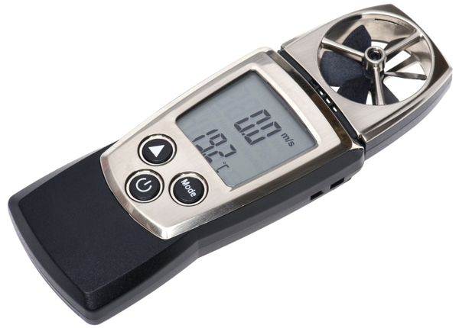

- Torricellian Barometer: The simplest kind of barometer is a tall closed tube standing upside down in a bath of mercury (a dense liquid metal at room temperature) so the liquid rises partly up the tube a bit like it does in a thermometer. We use mercury in barometers because it's more convenient than using water. Water is less dense (less heavy, in effect) than mercury so air pressure will lift a certain volume of water much higher up a tube than the same volume of mercury. In other words, if you use water, you need a really tall tube and your barometer will be so enormous as to be impractical. But if you use mercury, you can get by with a much smaller piece of equipment.
A piece of apparatus like this is called a Torricellian barometer for Italian mathematician Evangelista Torricelli (1608–1647), a pupil of Galileo's, who invented the first instrument of this kind in 1643. He took a long glass tube, sealed at one end, filled it with mercury from a bowl, put his finger over the open end, tipped it upside down, and stood it upright in the mercury bowl. Since he was careful not to let any air into the tube, the space that formed above the mercury column was a vacuum. Indeed, this was the first time anyone had ever produced a vacuum in a laboratory (and a vacuum made this way is called a Torricellian vacuum in honor of its inventor).
At sea level, the atmosphere will push down on a pool of mercury and make it rise up in a tube to a height of approximately 760mm (roughly 30in). We call this air pressure one atmosphere (1 atm). Go up a mountain, and take your Torricellian barometer with you, and you'll find the pressure falls the higher you up go. The atmosphere no longer pushes down on the mercury quite so much so it doesn't rise so far in the tube. Maybe it'll rise to more like 65cm (25 in). The pressure on top of Mount Everest is slightly less than a third of normal atmospheric pressure at sea level (roughly 0.3 atm).
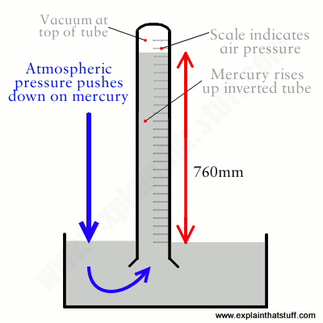
- Diaphragm Pressure Gauge: A diaphragm pressure gauge is a device that uses a diaphragm with a known pressure to measure pressure in a fluid. It has many different uses, such as monitoring the pressure of a canister of gas, measuring atmospheric pressure, or recording the strength of the vacuum in a vacuum pump. The diaphragm pressure gauge consists of a circular membrane made from sheet metal of precise dimensions, which can either be flat or corrugated. The diaphragm is mechanically connected to the transmission mechanism which will amplify the small deflections of the diaphragm and transfer them to the pointer. The animation below shows the pressure gauge working principle.
The process pressure is applied to the lower side of the diaphragm, while the upper side is at atmospheric pressure. The differential pressure arising across the diaphragm lifts up the diaphragm and puts the pointer in motion. The deflection of the diaphragm is very small (+/- 1 mm) making it necessary to use a high-ratio multiplying movement to rotate the pointer along the full length of the scale. The actuation of such a high-ratio transmission mechanism is possible because diaphragm deflection is able to generate large forces.
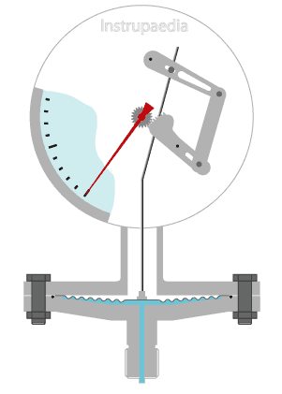

Reference
https://www.quora.com/What-is-Definition-of-Instrumentation
https://en.wikipedia.org/wiki/Gas_chromatography
https://sensortech.com/moisture-measurement/why-moisture-measurement-and-control/
https://blog.kett.com/hs-fs/hub/173270/file-2496654055-pdf/docs/kett_six_different_moisture_methods_ebook.pdf
www.prezi.com/mbd9rxj50_b3/measurement-of-other-process-variables/
https://www.thomasnet.com/articles/instruments-controls/magnetic-flowmeter-applications/
https://www.drurylandetheatre.com/si-d100-diaphragm-pressure-gauge/
https://www.explainthatstuff.com/barometers.html
https://sciencestruck.com/anemometer-history-working-principle

