NAME: OKOSUN MAUREEN .O.
COURSE CODE: PHA312
MATRIC NO: 17/MHS07/021

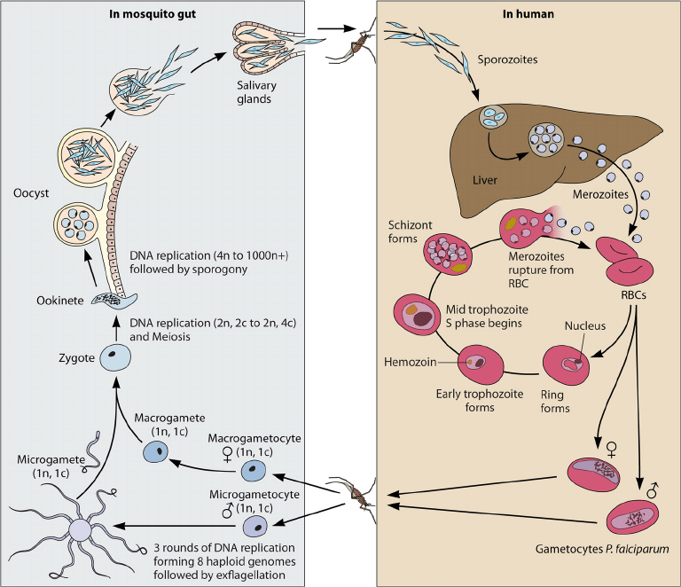
FIGURE 1
The malaria parasite life cycle involves two hosts. During a blood meal, a malaria-infected female Anopheles mosquito inoculates sporozoites into the human host. Sporozoites and mature into schizonts, which rupture and release merozoites. (Of note, in P. vivax and P. ovale a dormant stage [hypnozoites] can persist in the liver and cause relapses by invading the bloodstream weeks, or even years later.) After this initial replication in the liver (exo-erythrocytic schizogony), the parasites undergo asexual multiplication in the erythrocytes (erythrocytic schizogony). Merozoites infect red blood cells. The ring stage trophozoites mature into schizonts, which rupture releasing merozoites. Some parasites differentiate into sexual erythrocytic stages (gametocytes). Blood stage parasites are responsible for the clinical manifestations of the disease.
The gametocytes, male (microgametocytes) and female (macrogametocytes), are ingested by an Anopheles mosquito during a blood meal. The parasites’ multiplication in the mosquito is known as the sporogonic cycle C. While in the mosquito's stomach, the microgametes penetrate the macrogametes generating zygotes. The zygotes in turn become motile and elongated (ookinetes) which invade the midgut wall of the mosquito where they develop into oocysts. The oocysts grow, rupture, and release sporozoites, which make their way to the mosquito's salivary glands. Inoculation of the sporozoites into a new human host perpetuates the malaria life cycle.
- CLASSIFICATION OF ANTI AMEOBIC DRUGS
- Luminal amebicies (acts on parasites in the lumen bowel)
- Systemic amebicides (against amebas in intestinal wall and liver)
- Tissue ambecides:
Intestinal ambecides: metronidazole, tinidazole
Alkaloids: dehydroimitin, imitin
For extra intestinal: choloroquin.
Mechanism of action of metronidazole
Metronidazole is a potent prodrug. It requires reductive activation of nitro group y susceptible organism. Its selective toxicity towards anaerobic and microaerophillic pathogens such as E. Histolytica, G.Lambia, etc. these organisms contains electron transport components such as Ferridoxin, small Fe – S proteins that sufficiently negative redox potential to donate electrons to metronidazole. The single electron transfer forms a highly reactive nitroradical anion that kills susceptible organisms by radical – medicated mechanisms that target DNA resulting in cell death.
