Isokariari alma owapirite
Dentistry
19/MHS09/011
CHEM 102 ASSIGNMENT
1)CH3OCH3 -Methoxymethane CH3CH2OCH2CH3 -Ethoxyethane
(CH3CH2CH2CH2)2O-Butoxymethane CH3CH2OH3 -Methoxyethane
CH3CH2CH2OCH2CH3 -Ethoxypropane

2) Physical Properties of Ethers
- An ether molecule has a net dipole moment. We can attribute this to the polarity of C-O bonds.
- The boiling point of ethers is comparable to the alkanes. However, it is much lower compared to that of alcohols of comparable molecular mass. This is despite the fact of the polarity of the C-O bond.
- The miscibility of ethers with water resembles those of alcohols.
- Ether molecules are miscible in water. We can attribute this to the fact that like alcohols, the oxygen atom of ether can also form hydrogen bonds with a water molecule.
- Cleavage of C-O bond: Ethers are generally very unreactive in nature. When we add an excess of hydrogen halide to the ether, cleavage of C-O bond takes place. It leads to the formation of alkyl halides. The order of reactivity is as follows:
HI > HBr > HCl
R-O-R + HX → RX + R-OH
- Electrophilic substitution: The alkoxy group in ether activates the aromatic ring at ortho and para positions for electrophilic substitution. Common electrophilic substitution reactions are halogenation, Friedel Craft’s reaction etc.
- Halogenation reaction of ethers: Aromatic ethers undergo halogenation, for example, bromination, when we add a halogen in the presence or absence of a catalyst.
- Friedel Craft’s reaction of ethers: Aromatic ethers undergo Friedel Craft’s reaction for example addition of alkyl or acyl group when we introduce it to an alkyl or acyl halide in the presence of a Lewis acid as catalyst.
3 Preperation of Ethers
Williamson Ether Synthesis: This proceeds by an SN2 reaction of an lakeside nucleophile with an ally hailed to give an ether. The reaction occurs with inversion of configuration at choral centres and can be limited by possible competing elimination reaction.
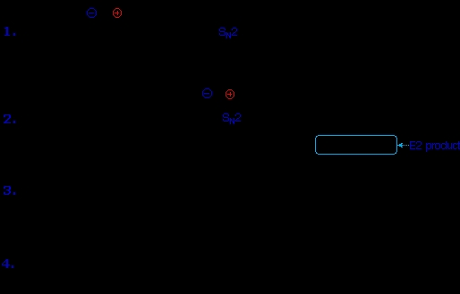
Ethylene oxide is used as an intermediate in the hydrolytic manufacture of ethylene glycol
Ethylene oxide is used in the preparation of nonionic emulsifying agents, plastics, plasticizers and several synthetic
textiles
Ethylene oxide is used as a gaseous sterilizin
ii)Alkoxymercuration:The alcohol reactant is used as the solvent and a hifluoroacetate mercury (ii) salt is used in preference to the acetate (hifluorocetate anon is a poorer nucleophile than aceteta). The mechanism of alkoxymercuration is similar to that of oxymercuration with an initial anti addition of the mercury species and alcohol being followed by reductive demercuration.
2CH3CH2OH+H2SO4----CH3CH2-O+CH2CH3+H2O(130°C)
At higher temperature over 150°C E2 elimination takes place
CH3CH2—OH +H2SO4--‐>CH2=CH2+H2O(150°C)
4 -Ethylene oxide is used as an intermediate in the hydrolytic manufacture of ethylene glycol
-Ethylene oxide is used in the preparation of nonionic emulsifying agents, plastics, plasticizers and several synthetic
textiles
-Ethylene oxide is used as a gaseous sterilizing

