DIMOKO KEVIN
16/SMS04/007
CMS 414

COVID-19 MEMES AND PICTURES
Coronavirus disease 2019 (COVID-19) is an infectious disease caused by severe acute respiratory syndrome coronavirus 2 (SARS-CoV-2). The disease was first identified in December 2019 in Wuhan, the capital of China's Hubei province, and has since spread globally, resulting in the ongoing 2019–20 coronavirus pandemic. Common symptoms include fever, cough and shortness of breath.
Other symptoms may include fatigue, muscle pain, diarrhea, sore throat, loss of smell and abdominal pain. The time from exposure to onset of symptoms is typically around five days, but may range from two to fourteen days. While the majority of cases result in mild symptoms, some progress to viral pneumonia and multi-organ failure. As of 11 April 2020, more than 1.72 million cases have been reported in more than 200 countries and territories ,resulting in more than 104,000 deaths.[7] More than 390,000 people have recovered, although the possibility of reinfection of those who have recovered has been reported.
The virus is mainly spread between people during close contact, often via small droplets produced during coughing, sneezing, or talking. While these droplets are produced when breathing out, they usually fall to the ground or surfaces rather than being infectious over large distances. People may also become infected by touching a contaminated surface and then their face .The virus can survive on surfaces for up to 72 hours. Coronavirus is most contagious during the first three days after onset of symptoms, although spread may be possible before symptoms appear and in later stages of the disease.
The virus has spread to almost all parts of the world within a short period of time and as such it has also gained considerable attention not only in the health organizations worldwide, but also in the area of national security as well as it is making countries close their internal and external borders. As with all things that are popular in this day and age it has gotten significant social media attention and by extension a plethora of pictures and memes which can either be used to effectively pass a message or be humorous. The more popular the topic the more pictures and memes that circulate on the subject matter, below are several examples of Covid-19 era memes and pictures:
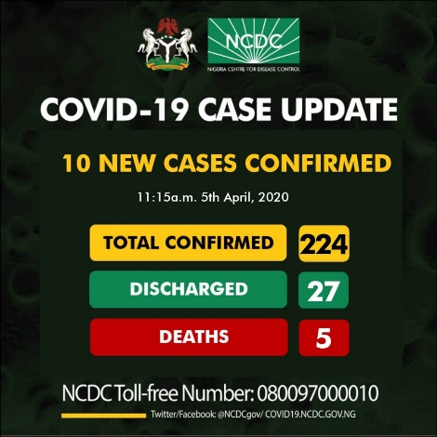
- These pictures have been used to raise awareness on the issue: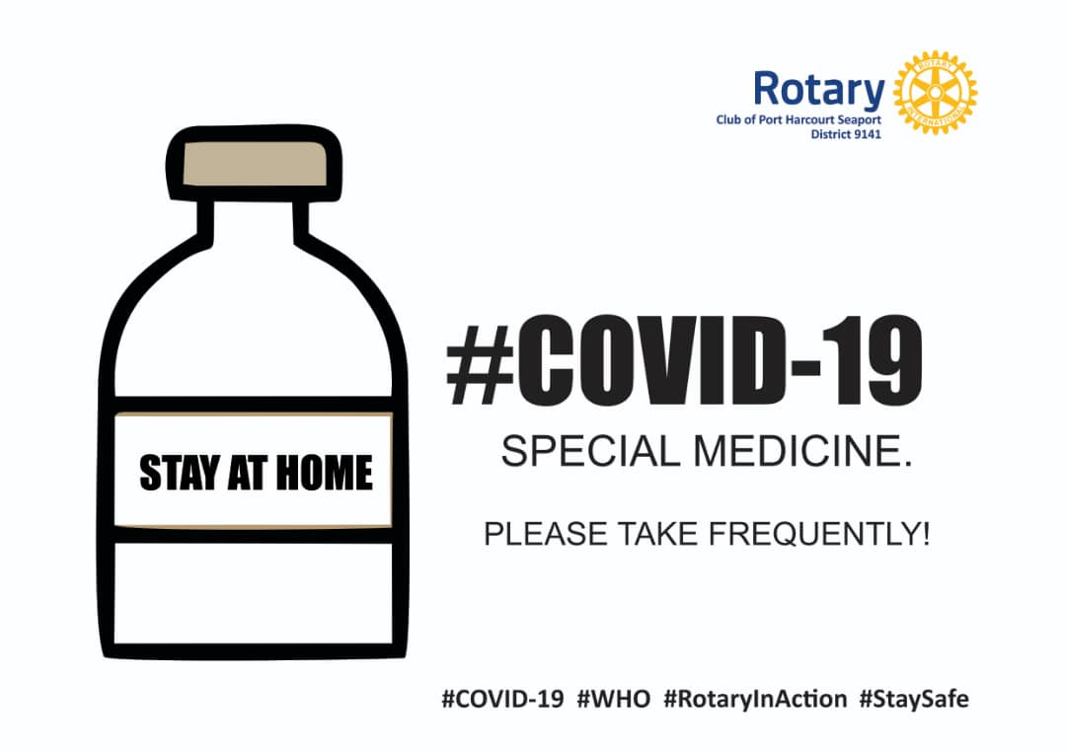

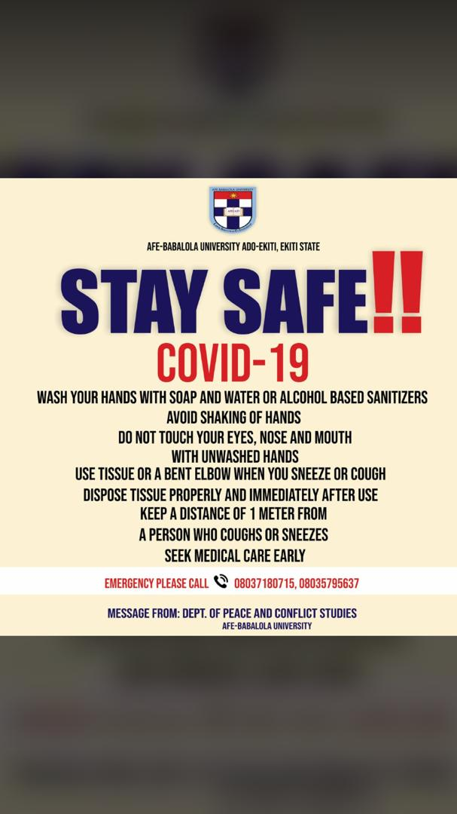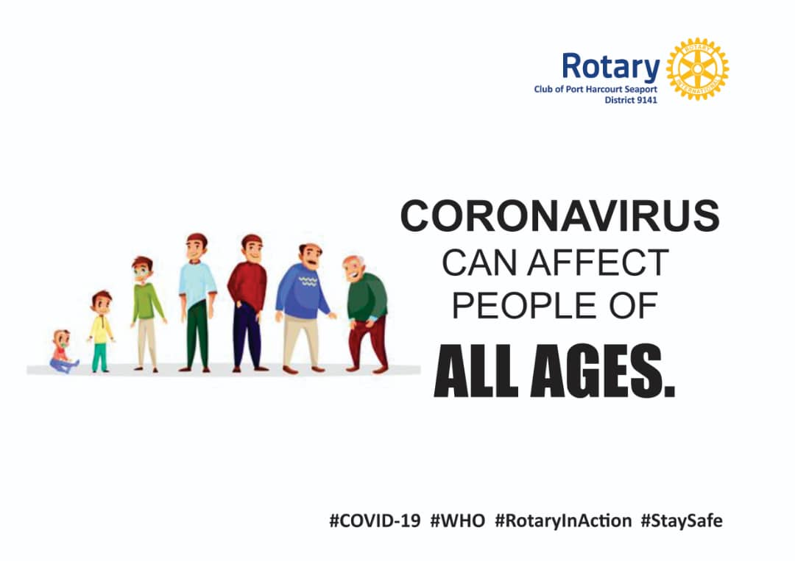

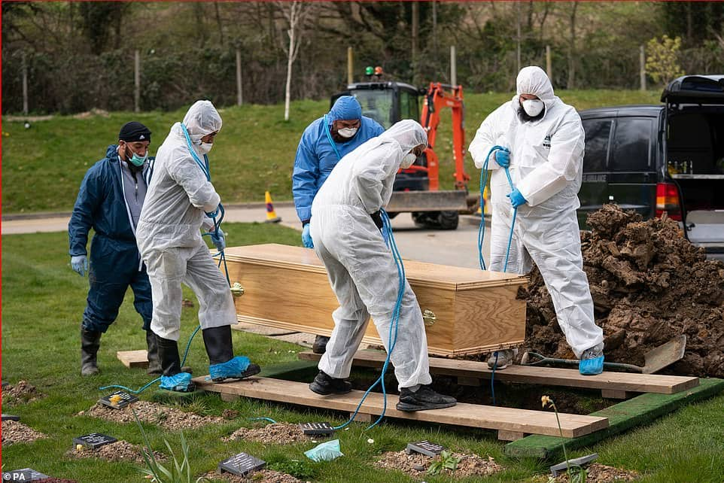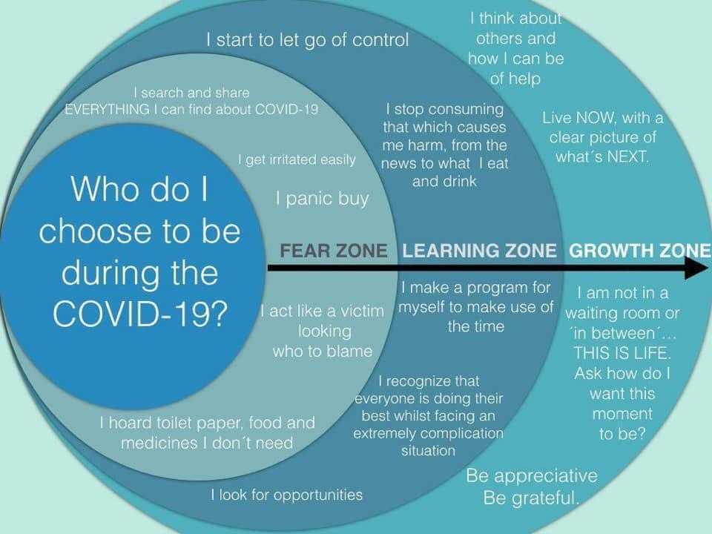
Memes are humorous pictures usually with a caption that are either used explicitly for jokes or to pass across information on a particular subject matter in a humorous way, the following memes were used to spread awareness on the disease:
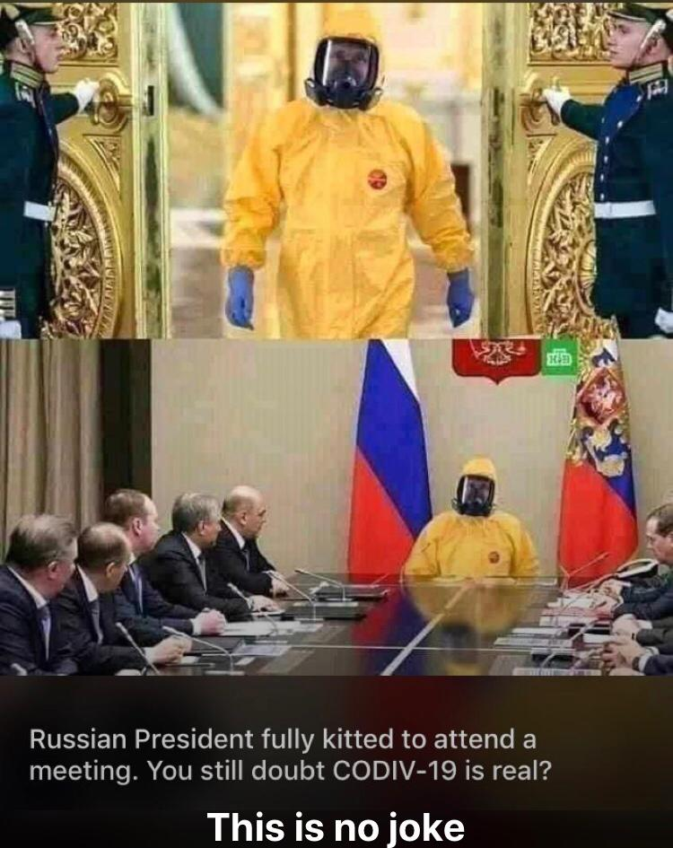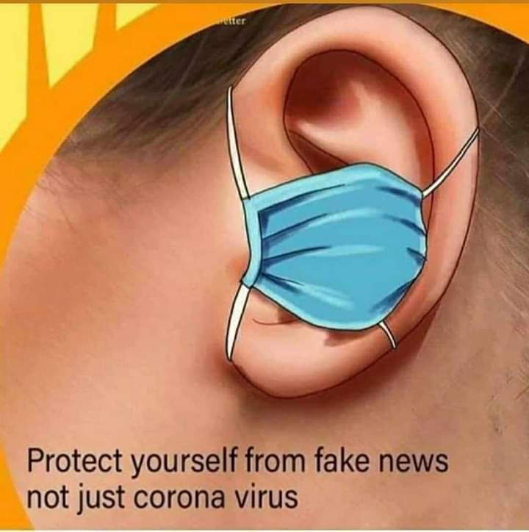

The pictures and memes can however also be used to circulate negative information that could lead to widespread panic:
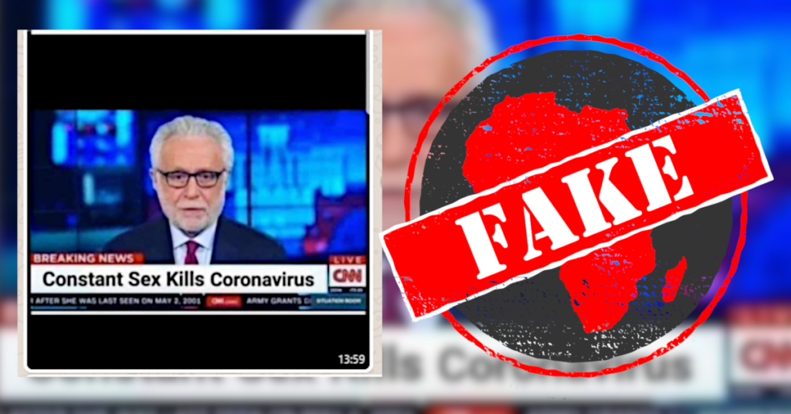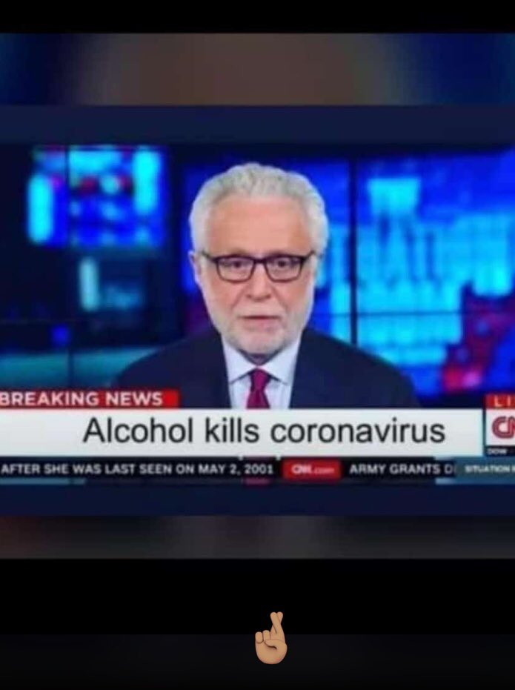
These pictures and memes that have been circulated around the world have assisted in spreading awareness and aiding in the fight against Covid-19 as well as helping to debunk false rumors, claims, pictures and memes that go around spreading false information and bringing some joy during this period.

