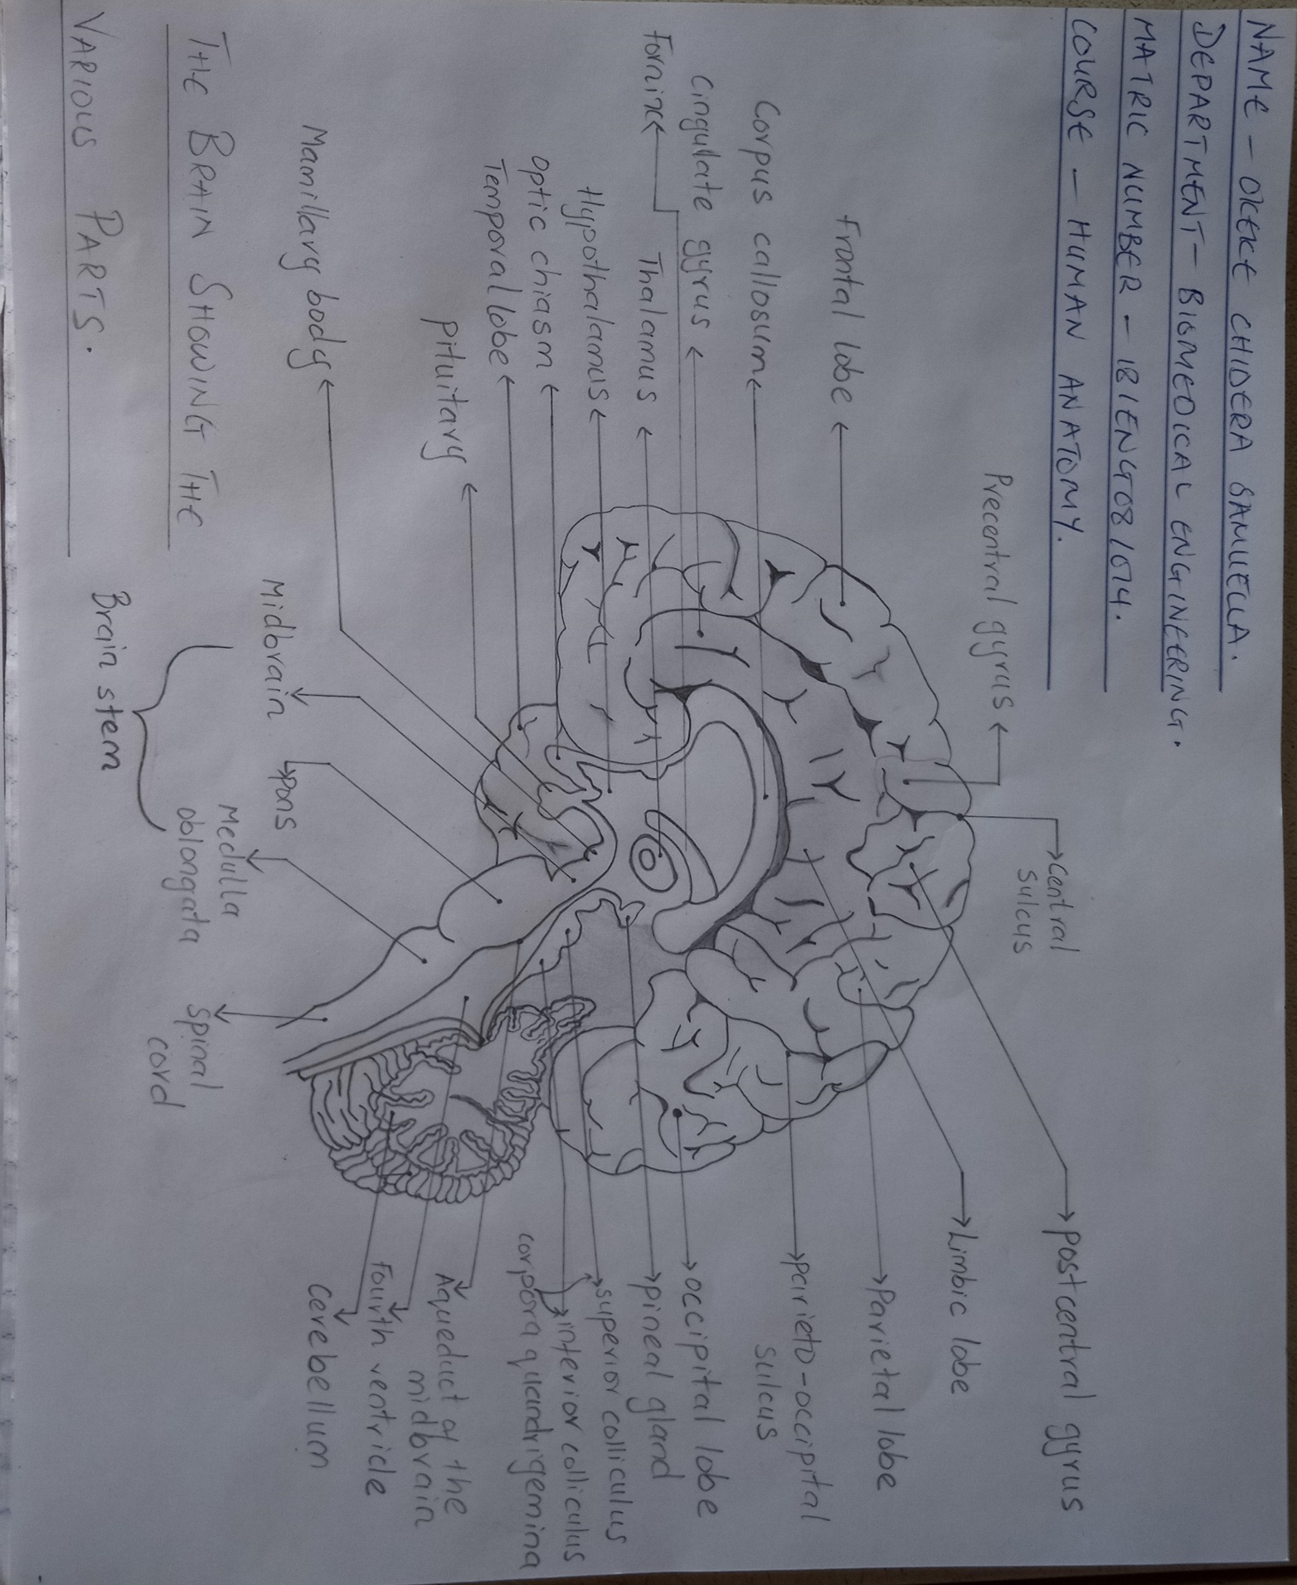
OKEKE CHIDERA SAMUELLA 18/ENG09/014. BIOMEDICAL ENGINEERING
