NAME: IKOMI WEYINMI
MATRIC NO: 18/sms04/027
COURSE CODE: CMS204
SPECIALIZE REPORTING
DATE: 15/4/20

SANITATION,HYGIENE AND PREVENTIONS OF CORONAVIRUS.
Stay home and help fight COVID-19.
18/sms04/027.

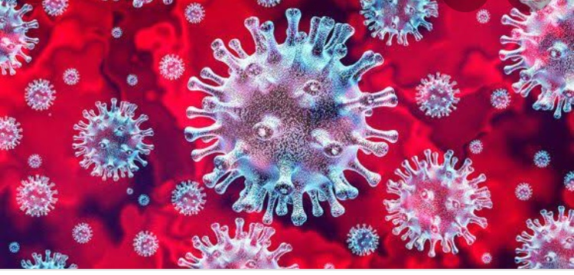
Coronavirus disease (CONVID-19) is an infectious disease caused by a new virus.
The disease causes respiratory illness ‘like flu’ with symptoms such as cough, fever and in more severe cases difficulty in breathing.
The protective method against Coronavirus are:
• washing hands frequently, and thoroughly using alcohol based hand sanitizer or wash hands with soap and water.
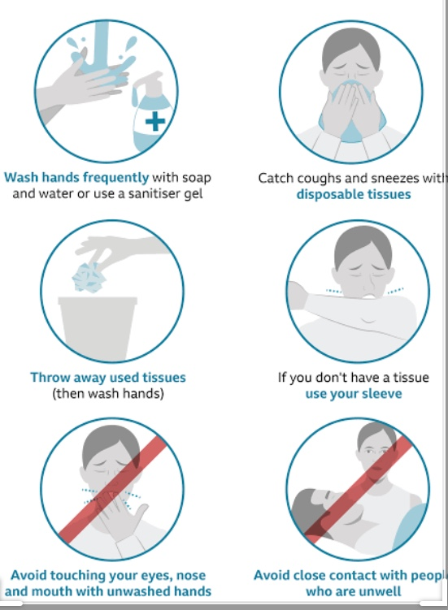
• maintain social distancing, at least 1 meter(3 feet) distancing between yourself and anyone who is coughing or sneezing.
• follow the guidelines listed above.

According to World Health Organization (WHO), COVID- 19 has infected more than 119,000 world wide, and has affected 210 countries and territories. The President of the United State Of American, Donald Trump. Shutdown all borders, to reduce the spread of the deadly Coronavirus.
As at now, the total number of affected persons worldwide is Three thousand short of Two million.
There are Fifty-Two thousand people in intensive care unit
479 thousand persons worldwide have recovered from the virus
So far, 126,599 deaths have been recorded worldwide.
The President Of Nigeria, Muhammadu Buhari, has issued a one month Lockdown for the safety of the citizens. In Nigeria the total confirmed cases are: Three-hundred and Seventy three cases, ninety-nine deaths and Eleven recoveries.
We can help fight this virus, if we all stay safe and stay home.

REFERENCE:
• Cambridge University Press
•European Center for disease prevention control (ECDC)
• NCDC – Nigeria Center for disease control.

