NAME: OBERHIRHI ,FAVOUR OGHENENYORE
MAT NO: 17/ENG01/019
DEPARTMENT: CHEMICAL ENGINEERING
COURSE CODE: CHE 312
COURSE TITLE: PROCESS INSTRUMENTATION

QUESTION 1
- Instrumentation is a branch of engineering that studies the measurement and control of process variables, and the design and implementation of systems that incorporate them. Process variables include pressure, temperature, humidity, flow, pH, force and speed.

- Gas chromatography is a common type of chromatography used in analytical chemistry for separating and analyzing compounds that can be vaporized without decomposition. Typical uses of GC include testing the purity of a particular substance, or separating the different components of a mixture.
In gas chromatography, the mobile phase (or "moving phase") is a carrier gas, usually an inert gas such as helium or an unreactive gas such as nitrogen. Helium remains the most commonly used carrier gas in about 90% of instruments although hydrogen is preferred for improved separations.
Stationary phase, in analytical chemistry, the phase over which the mobile phase passes in the technique of chromatography. The stationary phase can be articulated according to its state, such as a solid stationary phase or a liquid stationary phase. In gas chromatography, the stationary phase typically consists of tightly packed beads, whereas in liquid chromatography, it can consist of paper, beads, or other material. High-performance liquid chromatography or gas chromatography/mass spectrometry are typically used in confirmatory urine drug testing.
- The reasons for moisture measurement in process industries are;
- Power Generation and Distribution: In electric power generation facilities, whether fueled by coal, natural gas, oil or nuclear power, measuring the compressed air dewpoint is an operational requirement for the plant’s pneumatic controls and instrumentation.
In certain power plants, another major concern is the measurement of moisture content of hydrogen used to cool an electric power generator. Because hydrogen can be explosive when mixed with air, a dewpoint sensor must be intrinsically safe or explosion proof.
- Furnaces/Metal Heat Treating: Failure to properly monitor and control moisture in heat treat furnaces (anodizing, annealing, hardening) risks poor metal quality and potential equipment failure. The presence of metallic particulates and combustion byproducts in these processes requires a sampling system with appropriate filtration to protect the dewpoint sensor and obtain accurate readings.
- Pipelines and Natural Gas Production: For oil and natural gas pipelines, water is used to pressure test during initial construction and following any pipeline repairs. After pressure testing, water is purged from the pipeline through hot air drying where moisture is evaporated into vapor and pushed out the pipeline by flowing air. To verify the dryness of the pipeline, two hygrometers are used. One is typically installed at the inlet of the pipe while the other is installed at the outlet. These instruments allow engineers to determine if the pipe is sufficiently dry for the flow of oil or gas.
- Air Separation and Ozone Purification: A typical air-separation plant separates atmospheric air into such primary components as nitrogen, argon, oxygen, hydrogen, carbon dioxide and helium. Bottled separately, the gases are used in a variety of industrial processes. Permanently installed as well as spot-check hygrometers are used to measure moisture content. Kahn products appropriate for this use include the Cermet II Hygrometer, Easidew Dewpoint Transmitter, and for portable spot-check measurements, the Easidew Plus Portable or HygroPort Portable solutions.
The methods of moisture measurement include;
- Absolute measurement method
- Relative humidity
- Capacitance method
- Oxide Sensors

QUESTION 2
- Reasons for measuring process variables include;
- Measurement of process variables are essential in control systems to controlling a process.
- To receive the actual measured value of the variable being measured.
- To compare that value with a reference or desired value.
- To determine the deviation with the help of comparator.
- Applications of magnetic flow meters include;
- Magnetic flowmeters are used in water treatment plants to measure treated and untreated sewage, process water, water and chemicals.
- They can be used to measure flow rates for combustible or explosive liquids, often under hazardous conditions.
- Circular configurations are fairly common in piping systems because they offer a comparatively simple construction design. Magnetic flowmeters are more easily applied to a circular arrangement than to rectangular pipe networks, and usually offer more effective measurements.
- Magnetic flowmeters can be highly effective for applications involving corrosive conditions and for measuring the flow rate of corrosive materials, such as abrasives or slurries.
- Pressure measurement devices include;

Working Principle of a Pressure Transducer
Pressure transducers have a sensing element of constant area and respond to force applied to this area by fluid pressure. The force applied will deflect the diaphragm inside the pressure transducer. The deflection of the internal diaphragm is measured and converted into an electrical output. This allows the pressure to be monitored by microprocessors, programmable controllers and computers along with similar electronic instruments.
Most Pressure transducers are designed to produce linear output with applied pressure.

Differential Pressure Transmitter Working Principle
Another common electrical pressure sensor design works on the principle of differential capacitance. In this design, the sensing element is a taut metal diaphragm located equidistant between two stationary metal surfaces, comprising three plates for a complementary pair of capacitors. An electrically insulating fill fluid (usually a liquid silicone compound) transfers motion from the isolating diaphragms to the sensing diaphragm, and also doubles as an effective dielectric for the two capacitors:
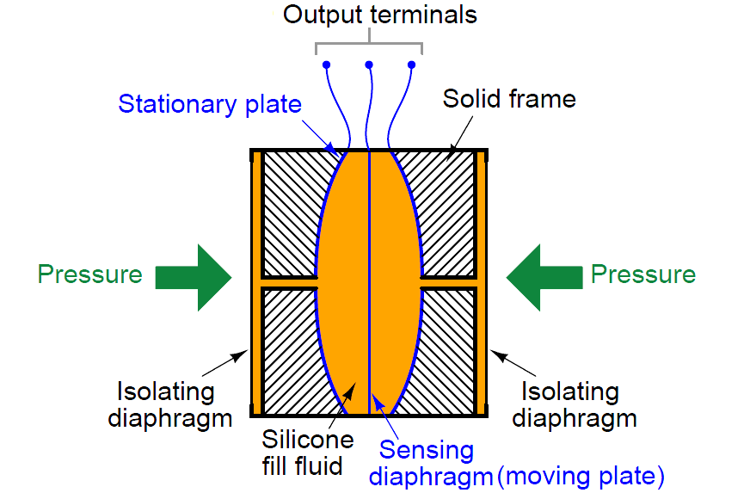
Any difference of pressure across the cell causes the diaphragm to flex in the direction of least pressure. The sensing diaphragm is a precision-manufactured spring element, meaning that its displacement is a predictable function of applied force. The applied force in this case can only be a function of differential pressure acting against the surface area of the diaphragm in accordance with the standard force-pressure-area equation F = PA.
In this case, we have two forces caused by two fluid pressures working against each other, so our force-pressure-area equation may be rewritten to describe resultant force as a function of differential pressure (P1 − P2) and diaphragm area: F = (P1 − P2)A. Since diaphragm area is constant, and force is predictably related to diaphragm displacement, all we need now in order to infer differential pressure is to accurately measure displacement of the diaphragm.

,

The Diaphragm Pressure Gauge:
This device is based on the same principle as that of the Bourdon gauge. In this case a corrugated diaphragm is provided instead of the Bourdon tube. When the device is fitted to any gauge point, the diaphragm will undergo an elastic deformation.
This deformation is communicated to a pointer which moves on a graduated scale indicating the pressure. It may be noted that this device works on the same principle as that of the aneroid barometer. This device is found suitable for measuring relatively low pressures.
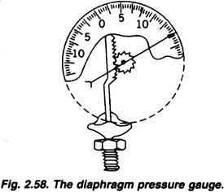

- Sphygmomanometer: A sphygmomanometer, also known as a blood pressure meter, blood pressure monitor, or blood pressure gauge, is a device used to measure blood pressure, composed of an inflatable cuff to collapse and then release the artery under the cuff in a controlled manner,[1] and a mercury or mechanical manometer to measure the pressure. It is always used in conjunction with a means to determine at what pressure blood flow is just starting, and at what pressure it is unimpeded. Manual sphygmomanometers are used in conjunction with a stethoscope.
A sphygmomanometer consists of an inflatable cuff, a measuring unit (the mercury manometer, or aneroid gauge), and a mechanism for inflation which may be a manually operated bulb and valve or a pump operated electrically.

Schematic diagram of a sphygmomanometer
The cuff is normally placed smoothly and snugly around an upper arm, at roughly the same vertical height as the heart while the subject is seated with the arm supported. Other sites of placement depend on species and may include the flipper or tail. It is essential that the correct size of cuff is selected for the patient
With a manual instrument, listening with a stethoscope to the brachial artery at the elbow, the examiner slowly releases the pressure in the cuff. As the pressure in the cuffs falls, a "whooshing" or pounding sound is heard (see Korotkoff sounds) when blood flow first starts again in the artery. The pressure at which this sound began is noted and recorded as the systolic blood pressure. The cuff pressure is further released until the sound can no longer be heard.

- Hygrometer: A hygrometer is an instrument used to measure the amount of humidity and water vapour in the atmosphere, in soil, or in confined spaces. Humidity measurement instruments usually rely on measurements of some other quantity such as temperature, pressure, mass, a mechanical or electrical change in a substance as moisture is absorbed. By calibration and calculation, these measured quantities can lead to a measurement of humidity.

Schematic Diagram of Hygrometer
For applications where cost, space, or fragility are relevant, other types of electronic sensors are used, at the price of a lower accuracy. In capacitive hygrometers, the effect of humidity on the dielectric constant of a polymer or metal oxide material is measured. With calibration, these sensors have an accuracy of ±2% RH in the range 5–95% RH. Without calibration, the accuracy is 2 to 3 times worse. Capacitive sensors are robust against effects such as condensation and temporary high temperatures.[6] Capacitive sensors are subject to contamination, drift and aging effects, but they are suitable for many applications.

- Bourden Gauge: The Bourdon Guage has a coiled tube whose one end is connected to the system under consideration and other end is sealed. With the application of the pressure in the tube it straightens up causing deflection of the sealed end. The sealed end is connected to the indicating needle through a gear and linkage mechanism. The deflection of the sealed end results in movement of the needle which moves on a calibrated dial. Bourdon gauges can be used to measure a wide range of pressures.

Schematic Diagram of Bourden Gauge

REFERENCES
- KYTOLA INSTRUMENTS flow meters - Flow measurement technologyhttps://www.thomasnet.com/articles/instruments-controls/magnetic-flowmeter-applications/
- https://instrumentationtools.com/differential-pressure-transmitter-working-principlehttps://automationforum.in/t/what-is-process-variable-and-types-of-process-variables/2818
- https://www.flowmeters.com/product-list.php?page=magnetic-technology/pg1-cid95.html=/asc_action=SetCurrCat/category_id=95
- https://prezi.com/mbd9rxj50_b3/measurement-of-other-process-variables/
- https://insights.globalspec.com/article/5842/why-measure-moisture
- https://www.workplacetesting.com/definition/1349/stationary-phase
- https://www.sciencedirect.com/topics/engineering/stationary-phase\

- https://instrumentationtools.com/process-control-instrumentation-engineering-interview-questions/

