TERM PAPER
ON
ENGINEERING STRATEGIES FOR HANDLING COVID-19
FOR
ENVIROMENTAL HEALTH AND ECONOMIC SUSTAINABILITY

PREPARED BY
OKU KARESEN ENITEN
17/ENG04/053
DEPARTMENT OF ELECTRICAL/ELECTRONICS ENGINEERING
AFE BABALOLA UNIVERSITY.

9th April, 2020.

CERTIFICATION
This is to certify that all information and data compiled throughout the content of this report/project was carried out by Oku Karesen Eniten. Bearer of matric number 17/Eng04/053 of the department of Electrical/Electronics, college of Engineering, Afe Babalola University Ado-Ekiti.

ABSTRACT
The coronavirus, (other known aliases being the covid-19 and the Wuhan virus). Broke out into scene on the 6th of December, 2019. In a small Chinese province of Wuhan. It is said that the patient zero (the first person to contact the virus) was a local farmer who caught the coronavirus from wild bush rodents and ever since then the virus has gone on to spread and infect over 125 countries, thereby rendering the World Health Organization to declare it a global pandemic. Since the virus has displayed rapid means of infection and transmission, as it is believed to be an air-borne disease, several countries have limited and/ or nullified events that condone public gatherings such as schools, churches and recreational activities. And due to such protocols to curtail the spread of the covid-19 virus, this has caused a huge imbalance on economic, financial and societal activities. This report explores the strategies for handling the pandemic as well as managing environmental and economic conditions so as to prevent further depreciation.

ACKNOWLEDGEMENTS
I truly would like to appreciate all the doctors, nurses and other medical practitioners who have been working tirelessly to help manage and control the spread of the virus as well as magnify their bravery and nobility in taking care and aiding those infected by it. You all are truly heroes and your efforts are well appreciated.

LIST OF FIGURES
Figure 1: corona virus 6
Figure 2: signs and symptoms 8
Figure 3:How can you protect yourself 9
Figure 4: toxicology 10
Figure 6: Environmental engineering 11
Figure 7: Engineering law 12
Figure 8: environmental health 14
Figure 10: electricaly powered ventilation 20

TABLE OF CONTENTS
CERTIFICATION i
ABSTRACT ii
ACKNOWLEDGEMENTS iii
LIST OF FIGURES v
INTRODUCTION 6
1.1 WHAT IS CORONA VIRUS (COVID-19)? 6
1.1.1 SIGNS AND SYMPTOMS 7
1.1.2 CAUSES AND TRANSMISSION 7
1.1.3 PREVENTION 7
2 LITERATURE REVIEW 9
2.1 ENVIRONMENTAL HEALTH 9
2.1.1 DISCIPLINES 9
2.1.2 CONCERNS 12
2.2 ECONOMIC SUSTAINABILITY 14
3 METHODOLOGY 16
3.1 ENGINEERING STRATEGIES 16
4 RESULTS 19
CONCLUSION 21
5 CONCLUSION AND RECOMMENDATION 21
5.1 RECOMMENDATION 21
6 REFERENCE 1

CHAPTER ONE: INTRODUCTION
1.1 What is Coronavirus?
According to the World Health Organization (WHO), coronaviruses are a family of virus that cause illnesses ranging from the common cold to more Severe acute respiratory syndrome (SARS) and the Middle East Respiratory syndrome (MERS).
These viruses were originally transmitted from animals to people. SARS, for instance, was transmitted from civet cats to humans while MERS moved to humans from a type of camel.
Several known coronaviruses are circulating in animals that have not yet infected humans.
The Covid-19 spreads primarily through droplets of saliva or discharge from the nose when an infected person sneezes or coughs. It has also been noted that the virus can do well to survive on artificial surfaces and bodies. The duration of its sustainability on them however, vary from surface to type to surface type.
Fig 1. A diagram explaining the meaning of “COVID-19”

1.2 Signs and Symptoms
According to WHO, signs of infection include fever, cough, shortness of breath and difficulties in breathing.
In more severe cases, it can lead it pneumonia, multiple organ failure and even death.
Current estimates of the incubation period (the time between infection and onset of symptoms) range from 1 to 14 days. The average incubation period for most infected people is 6 days.
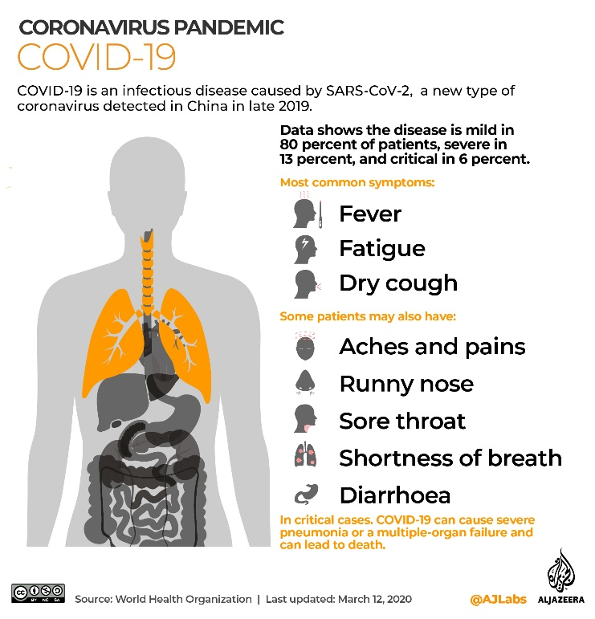
Fig 2. A diagram illustrating the symptoms of the coronavirus and the areas it affects.

However, infected patients can also be asymptomatic, meaning they do not display any symptoms despite having the virus in their system.

I.2 Causes and Transmission
Human-to-human transmission has been confirmed during the 2019-20 coronavirus pandemic. Transmission occurs primarily via respiratory droplets from coughs and sneezes within a range of about 1.8 meters (6ft).
Indirect contact via contaminated surfaces is another possible cause of infection. Preliminary research indicates that the virus may remain viable on plastic and steel for up to three days, but does not survive on cardboard for more than one day or on copper for more than four hours; the virus is inactivated by soap, which destabilizes its lipid bilayer. Viral RNA has also been found in stool samples from infected people.
1.3 Mortality rate
The number of fatalities from the new coronavirus has overwhelmingly surpassed the toll of the 2002 -2003 SARS outbreak which also originated in China.
While the new coronavirus is more widespread than the SARS in terms of case numbers, its mortality rate still remains lower at approximately 3.4% of all reported and confirmed cases, according to WHO. According to the Centers of Disease Control (CDC), older people are at a higher risk for severe illness from COVID-19 which may result in increased stress during a
crisis. People who as well have sever underlying medical conditions like heart of lung disease or diabetes also seem to be at a high risk for developing more serious complications from COVID-19 illness.

1.4 Prevention
To prevent infection and to slow transmission of COVID-19, do the following:
- Wash your hands regularly with soap and water, or clean them with alcohol-based hand rub.
- Maintain at least 1 metre distance between you and people coughing or sneezing.
- Avoid touching your face.
- Cover your mouth and nose when coughing or sneezing.
- Stay home if you feel unwell.
- Refrain from smoking and other activities that weaken the lungs.
- Practice physical distancing by avoiding unnecessary travel and staying away from large groups of people.
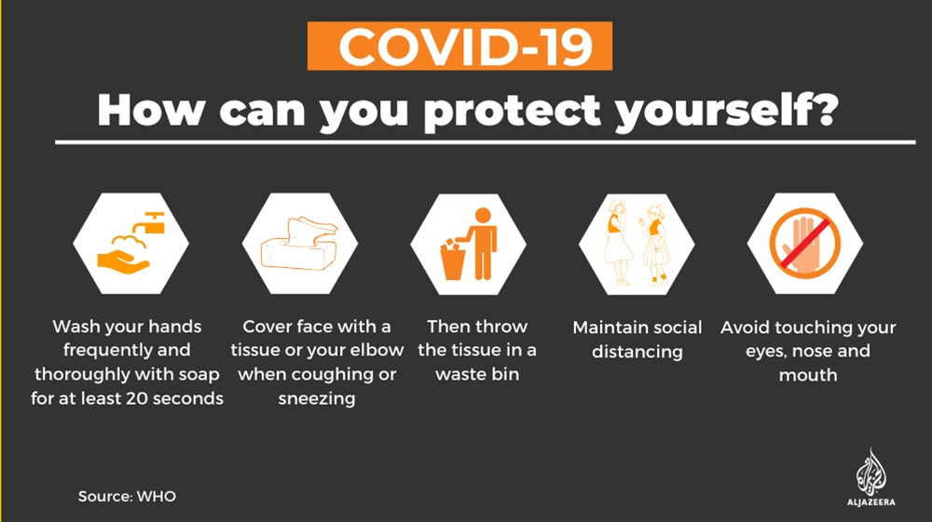
Fig. Diagram illustrating various means one can undertake in order to prevent contacting the virus

CHAPTER TWO: LITERATURE REVIEW

LITERATURE REVIEW

ENVIRONMENTAL HEALTH
Environmental health is the branch of public health concerned with all aspects of the natural and built environment affecting human health. Environmental health is focused on the natural and built environments for the benefit of human health. The major sub disciplines of environmental health are: environmental science; environmental and occupational medicine, toxicology and epidemiology.

DISCIPLINES
Five basic disciplines generally contribute to the field of environmental health: environmental epidemiology, toxicology, exposure science, environmental engineering, and environmental law. Each of these disciplines contributes different information to describe problems and solutions in environmental health, but there is some overlap among them.
- Environmental epidemiology is a branch of epidemiology concerned with determining how environmental exposures impact human health. This field seeks to understand how various external risk factors may predispose to or protect against disease, illness, injury, developmental abnormalities, or death. These factors may be naturally occurring or may be introduced into environments where people live, work, and play.

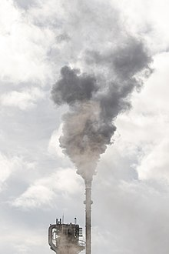
Figure 3:Air pollution is an example of an exposure that has been linked with negative health outcomes.
- Toxicology studies how environmental exposures lead to specific health outcomes, generally in animals, as a means to understand possible health outcomes in humans. Toxicology has the advantage of being able to conduct randomized controlled trials and other experimental studies because they can use animal subjects.

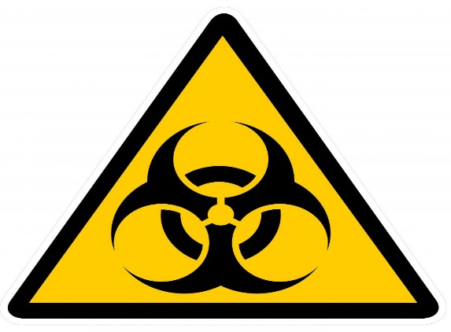
Figure 4: toxicology

Exposure science studies human exposure to environmental contaminants by both identifying and quantifying exposures

CONCERNS
Environmental health addresses all human-health-related aspects of the natural environment and the built environment. Environmental health concerns include:
- Air quality, including both ambient outdoor air and indoor air quality, which also comprises concerns about environmental tobacco smoke.
- Biosafety
- Disaster preparedness and response.
- Climate change and its effects on health.
- Environmental racism, wherein certain groups of people can be put at higher risk for environmental hazards, such as air, soil, and water pollution. This often happens due to marginalization, economic and political processes, and ultimately, racism. Environmental racism disproportionately affects different groups globally, however generally the most marginalized groups of any given region/nation.
- Food safety, including in agriculture, transportation, food processing, wholesale and retail distribution and sale.
- Hazardous materials management, including hazardous waste management, contaminated site remediation, the prevention of leaks from underground storage tanks and the prevention of hazardous materials releases to the environment and responses to emergency situations resulting from such releases.
- Housing, including substandard housing abatement and the inspection of jails and prisons.
- Childhood lead poisoning prevention.
- Land use planning, including smart growth.

ECONOMIC SUSTAINABILITY
Economic sustainability refers to practices that support long-term economic growth without negatively impacting social, environmental, and cultural aspects of the community.
Economic sustainability is the term used to identify various strategies that make it possible to use available resources to their best advantage. The idea is to promote the use of those resources in a way that is both efficient and responsible, and likely to provide long-term benefits. In the case of a business operation, it calls for using resources so that the business continues to function over a number of years, while consistently returning a profit.
On one account, sustainability "concerns the specification of a set of actions to be taken by present persons that will not diminish the prospects of future persons to enjoy levels of consumption, wealth, utility, or welfare comparable to those enjoyed by present persons". Sustainability interfaces with economics through the social and ecological consequences of economic activity.
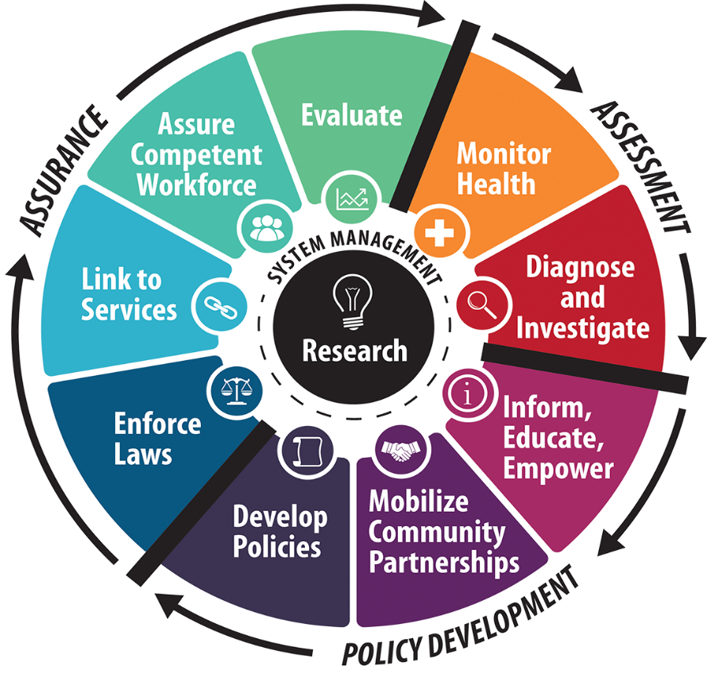

METHODOLOGY

ENGINEERING STRATEGIES

The basic strategies in the control of an outbreak are containment and mitigation. Containment may be undertaken in the early stages of the outbreak, including contact tracing and isolating infected individuals to stop the disease from spreading to the rest of the population, other public health interventions on infection control, and therapeutic countermeasures such as vaccinations which may be effective if available. When it becomes apparent that it is no longer possible to contain the spread of the disease, management will then move on to the mitigation stage, in which measures are taken to slow the spread of the disease and mitigate its effects on society and the healthcare system. In reality, containment and mitigation measures may be undertaken simultaneously.
Another strategy, suppression, requires more extreme long-term non-pharmaceutical interventions so as to reverse the pandemic by reducing the basic reproduction number to less than 1. The suppression strategy, which includes stringent population-wide social distancing, home isolation of cases, and household quarantine, was undertaken by China during the 2019–20 coronavirus pandemic where entire cities were placed under lockdown, but such strategy carries with it considerable social and economic costs.
Some of the engineering strategies employed in this current situation are:
- Epidemiology is the study and analysis of the distribution (who, when, and where), patterns and determinants of health and disease conditions undefined populations. Major areas of epidemiological study include disease causation, transmission, outbreak investigation, disease surveillance, environmental epidemiology, forensic epidemiology, occupational epidemiology, screening, biomonitoring, and comparisons of treatment effects such as in clinical trials. Epidemiologists rely on other scientific disciplines like biology to better understand disease processes, statistics to make efficient use of the data and draw appropriate conclusions, social sciences to better understand proximate and distal causes, and engineering for exposure assessment.
- MANUFACTURING:
Due to capacity limitations in the standard supply chains, some digital manufacturers are printing healthcare material such as nasal swabs and ventilator parts.

- EXPERIMENTAL TESTING: No medications are approved to treat the disease by the WHO although some are recommended by individual national medical authorities. Research into potential treatments started in January 2020, and several antiviral drugs are in clinical trials. Although new medications may take until 2021 to develop, several of the medications being tested are already approved for other uses or are already in advanced testing.

CHAPTER FOUR

RESULTS
- GOOGLE, APPLE NEW CORONA VIRUS TRACKING SYSTEM: Apple and Google have announced they are developing a new system to track the spread of the novel coronavirus, which will help users share data via Bluetooth Low Energy (BLE) transmissions, and other apps approved by health organizations.
The new tracking system will use short-range communications via Bluetooth to establish voluntary networks that trace recent contacts and archive extensive data on phones that have been in close proximity to one another, reports The Verge. Apps put out by public health authorities will also have full access to the data, and users who download the apps may report if they have been diagnosed with the COVID-19 illness. The new tracking system will also alert those who downloaded them to check if they've been in close contact with an infected person
- ELECTRICALY POWERED VENTILATION: Most cases of COVID-19 are not severe enough to require mechanical ventilation (artificial assistance to support breathing), but a percentage of cases do. It has been recommended for the use of invasive mechanical ventilation because this technique limits the spread of aerosolized transmission vectors.

CONCLUSION
I think the virus were to be completely eradicated then we as people need to unwaveringly adhere to the paramount guidelines that have been put in place. As for raising strategies to help the fall it has caused on fields like the economy and the society. I believe if the ideas in this report were to be practicalized on a larger scale. Then it would be immensely beneficial.
RECOMMENDATION
I would like to recommend that more effort be putting by the world’s leading technological giants to come up with innovative means of managing the virus for the foreseeable future. Thus can be made possible by creating and donating high functioning ventilators, machines that can detect if possible the presence of the virus in the air. I know it sounds tasking but it is for the good of the future.

REFERENCES
- Coronavirus disease 2019. (4th April, 2020.) Retrieved April 9th 2020, https://www.aljazeera.com/news/2020/01/coronavirus-symptoms-vaccines-risks-200122194509687.html
- environmental health. (2020, april 8). Retrieved april 10, 2020, from wikipedia: https://en.wikipedia.org/wiki/Environmental_health
- industry: interesting engineering. (2020, april 4). Retrieved april 11, 2020, from interesting engineering: https://interestingengineering.com

