NAME: IKEMEFUNA DUMEBI
MATRIC NUMBER: 18/MHS02/092
LEVEL: 200LVL
DEPARTMENT: NURSING SCIENCE
COURSE: ANA 210 (GROSS ANATOMY)

QUESTIONS
- Describe the importance of vasculature in relation to immune system and outbreak of Pandemic Covid-19 on the human body.
- Sub sartorial canal is an important area in the lower limb, Discuss.
- Describe the Extra ocular and intraocular Muscles with their nerve supply.
ANSWERS
- The immune system is the body’s multi-level defense network that protects us from disease caused by harmful bacteria, viruses and toxins, and helps remove foreign bodies and malignant cells from our system. The immune system is made up of mostly;
- white blood cells
- antibodies
- complement system
- lymphatic system
- spleen
- bone marrow
- thymus
Until a vaccine is available, our immune systems will need to adapt unaided to COVID-19. The coronavirus pandemic has turned the world’s attention to the immune system. When a virus enters the human body, it’s in a race against time to hijack cells, reproduce and spread. Its survival depends on it, because once the body’s immune system detects the intruder an all-out microscopic war follows. This is also the same for coronavirus. When this virus enters the body the body responds with ferocity to obliterate the invader, led by armies of killer T-cells. But before the war at the cellular level, the virus (COVID-19) slips into the body, navigating past defenses in the mucus that gathers in noses and throats, on the hunt for cells it can attack. At the same time, it’s trying to disguise its presence to avoid tripping the chemical alarm system of the immune system.
Once the immune system is triggered and a T-cell finds a body cell that has been affected and is under control by the virus, it typically latches on and fires molecules that punch through the cell’s membrane, killing it and everything inside. But as COVID-19 is a newly discovered virus, researchers have not had enough time to determine the specifics of how the battle plays out. That leaves questions like why some healthy people infected with COVID-19 become severely ill and others do not.
As the body’s immune response can be so aggressive, researchers say that the war against the virus can do damage that causes fatal repercussions in the body. In particular, this virus attacks the lungs, an especially sensitive battleground. Also, as the immune system tries to fight a virus that it has never encountered before, it can go into overdrive, causing excessive damage to adjoining cells and tissue. An abnormality inside a cell would typically trigger a “cascade” of cell signals which leads to the production of “alarm bell” proteins that warns surrounding cells about the presence of the virus and triggers a flood of immune molecules, creating an “antiviral state”.
As more alarms sound throughout the body, the virus races to propagate and attack more cells. .Meanwhile, antibodies, Y-shaped proteins, also arrive and swarm onto the virus, smothering the spikes it uses to attach to healthy cells. Larger white blood cells called macrophages also sweep in, swallowing big clusters of dead virus particles. As this cellular carnage spreads, dead cells pile up in the lungs which causes clogging of the airways and reducing oxygen flow. The tissue needs to be able to stretch and fill with oxygen, but at the same time you’re filling it with immune cells and fluids which prevents someone who is trying to breathe from getting enough oxygen. Some patients who recover from this stage, their lungs can heal. Others may recover, but suffer lasting damage.
Another Researcher stated that, the coronavirus is — like any other virus — not much more than a shell around genetic material and a few proteins. To replicate, it needs a host in the form of a living cell. Once infected, this cell does what the virus commands it to do: copy information, assemble it, and release it. But this does not go unnoticed. Within a few minutes, the body's immune defense system intervenes with its innate response: Granulocytes, scavenger cells and killer cells from the blood and lymphatic system stream in to fight the virus. They are supported by numerous plasma proteins that either act as messengers or help to destroy the virus. For many viruses and bacteria, this initial activity of the immune system is already sufficient to fight an intruder. It often happens very quickly and efficiently. We often notice only small signs that the system is working: We have a cold, a fever. At a certain point, however, the host response is so strong that its effect can be counterproductive. For example, numerous immune cells can enter our lungs and cause the membrane through which oxygen normally passes from the air into the blood to thicken. The exchange of gases is restricted, and in the worst case, ventilation may be necessary. Sometimes the reaction can overshoot and be directed against healthy cells as well. This could also be the case with the coronavirus. So drugs are also being tested that suppress an excessive immune reaction and that are already known from the treatment of autoimmune diseases. The balance between protective and overly aggressive immune processes in dealing with the coronavirus is currently a big mystery. After a time delay, the acquired immune system finally sets itself in motion. It is different for every person and depends on what we have experienced and with which pathogens we have come into contact. While T cells help destroy infected cells, B cells form antibodies that can keep the virus in check. In the case of the coronavirus, these are neutralizing antibodies that bind to the spike protein of the virus. This is the site of attack of the virus, with which it enters the host, i.e. our human cell. Neutralizing antibodies specifically incapacitate the spike protein. Our immune system remembers the antibodies it has produced and is thus prepared for a new infection with the same intruder.

- SUB SARTORIAL CANAL AND ITS IMPORTANCE TO THE LOWER LIMB
The adductor canal or sub sartorial canal is a narrow conical tunnel located on the medial side of the middle one-third of the thigh. It is an important area in the lower limb because it serves as a passageway for structures moving between the anterior thigh and posterior compartment of the leg. It also transmits the femoral artery, femoral vein (posterior to the artery), nerve to the vastus medialis and the saphenous nerve – the largest cutaneous branch of the femoral nerve. It is approximately 15cm long, extending from the apex of the femoral triangle to the adductor hiatus which is a gap between the adductor and hamstring attachments of the adductor magnus muscle.
BOUNDARIES
The adductor canal is triangular in cross section. Its boundaries are as follows:
- Anterolateral wall: created by vastus medialis.
- Posterior (floor): The posterior wall of adductor canal is created by adductor longus above and adductor magnus below.
- Medial (roof): It is created by a powerful fibrous membrane stretching across the anterolateral and posterior borders. The roofing is overlapped by the Sartorius muscle.
The sub sartorial plexus of nerves is located on the roofing underneath the Sartorius. The plexus is composed by branches from the medial cutaneous nerve of the thigh, the saphenous nerve, and the anterior section of the obturator nerve. It supplies the overlying fascia lata and the skin.
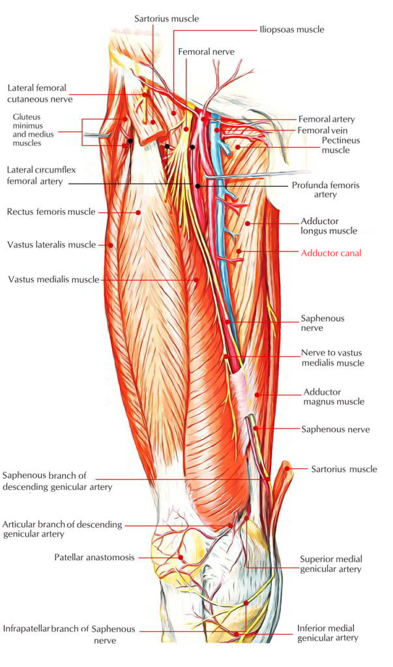
CONTENTS
The contents of the adductor canal are as follows:
- Femoral artery.
- Femoral vein.
- Saphenous nerve.
- Nerve to vastus medialis.
- Anterior and posterior sections of the obturator nerve (occasionally).
- Descending genicular artery which is a branch of the femoral artery.

CLINICAL IMPORTANCE OF ADDUCTOR CANAL
- ADDUCTOR CANAL BLOCK-
In the adductor canal block, local anesthetic is administered in the adductor canal to block the saphenous nerve in isolation, or together with the nerve to the vastus medialis. The block can be used to provide sensory anesthesia for procedures involving the distal thigh and femur, knee and lower leg on the medial side. The Sartorius and femoral artery are used as anatomical landmarks to locate the saphenous nerve.

- ADDUCTOR CANAL COMPRESSION SYNDROME-
Adductor canal compression syndrome describes entrapment of the neurovascular bundle within the adductor canal. A rare condition, it is usually caused by hypertrophy of adjacent muscles such as vastus medialis. It is most common in young males, who may present with claudication symptoms due to femoral artery occlusion (more common) or neurological symptoms due to entrapment of the saphenous nerve.

- THE EXTRAOCULAR MUSCLES AND INTRAOCULAR MUSCLES

- THE EXTRAOCULAR MUSCLES-

The extra ocular muscles are located within the orbit of the eye, but are extrinsic and separate from the eyeball itself. They act to control the movements of the eyeball and the superior eyelid. The extra ocular muscles (also extrinsic muscles of eyeball) are a set of seven muscles located within each orbit and connected with the eye. There are six extra ocular muscles responsible for the eye movements and one providing the elevation of the upper eyelid.
- Responsible for eye movement – Recti and oblique muscles.
The 4 rectus muscles include the; superior rectus, inferior rectus, medial rectus and the lateral rectus. The oblique muscles are the superior oblique and inferior oblique.
- Responsible for superior eyelid movement – Levator palpebrae superioris.

LEVATOR PALPEBRAE SUPERIORIS
The levator palpebrae superioris (LPS) is the only muscle involved in raising the superior eyelid. A small portion of this muscle contains of a collection of smooth muscle fibers – known as the superior tarsal muscle. In contrast to the LPS, the superior tarsal muscle is innervated by the sympathetic nervous system.
Attachments: Originates from the lesser wing of the sphenoid bone, immediately above the optic foramen. It attaches to the superior tarsal plate of the upper eyelid (a thick plate of connective tissue).
Actions: Elevates the upper eyelid.
Innervation: The levator palpebrae superioris is innervated by the oculomotor nerve (CN III). The superior tarsal muscle (located within the LPS) is innervated by the sympathetic nervous system.

MUSCLES OF THE EYE MOVEMENT
- RECTI MUSCLES-
The 4 recti muscles- superior rectus, inferior rectus, medial rectus and lateral rectus originates from the common tendinous ring. This is a ring of fibrous tissue, which surrounds the optic canal at the back of the orbit. From their origin, the muscles pass anteriorly to attach to the sclera of the eyeball. The recti muscles have a direct path from origin to attachment. This is in contrast with the oblique eye muscles, which have an angular approach to the eyeball.

SUPERIOR RECTUS
Attachments: Originates from the superior part of the common tendinous ring, and attaches to the superior and anterior aspect of the sclera.
Actions: Main movement is elevation. Also contributes to adduction and medial rotation of the eyeball.
Innervation: Oculomotor nerve (CN III).
INFERIOR RECTUS
Attachments: Originates from the inferior part of the common tendinous ring, and attaches to the inferior and anterior aspect of the sclera.
Actions: Main movement is depression. Also contributes to adduction and lateral rotation of the eyeball.
Innervation: Oculomotor nerve (CN III)
MEDIAL RECTUS
Attachments: Originates from the medial part of the common tendinous ring, and attaches to the anteromedial aspect of the sclera.
Actions: Adducts the eyeball.
Innervation: Oculomotor nerve (CN III).
LATERAL RECTUS
Attachments: Originates from the lateral part of the common tendinous ring, and attaches to the anterolateral aspect of the sclera.
Actions: Abducts the eyeball.
Innervation: Abducens nerve (CN VI).
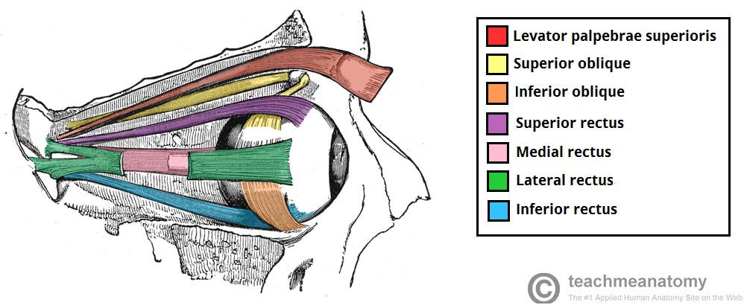

- OBLIQUE MUSCLES-
There are two oblique muscles – the superior and inferior obliques. Unlike the recti group of muscles, they do not originate from the common tendinous ring. From their origin, the oblique muscles take an angular approach to the eyeball (in contrast to the straight approach of the recti muscles). They attach to the posterior surface of the sclera.

SUPERIOR OBLIQUE
Attachments: Originates from the body of the sphenoid bone. Its tendon passes through a trochlear, and then attaches to the sclera of the eye, posterior to the superior rectus.
Actions: Depresses, abducts and medially rotates the eyeball.
Innervation: Trochlear nerve (CN IV).

INFERIOR OBLIQUE
Attachments: Originates from the anterior aspect of the orbital floor. Attaches to the sclera of the eye, posterior to the lateral rectus
Actions: Elevates, abducts and laterally rotates the eyeball.
Innervation: Oculomotor nerve (CN III).
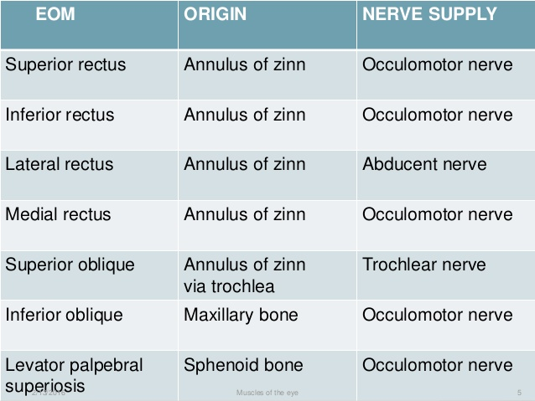

BLOOD SUPPLY AND LYMPHATICS
The primary blood supply for all of the extra ocular muscles are the muscular branches of the ophthalmic artery, the lacrimal artery, and the infraorbital artery. The ophthalmic artery has two muscular branches, which are the superior and inferior muscular branches. The lateral rectus receives blood from a branch of the lacrimal artery, and the other rectus muscles receive blood via two anterior ciliary arteries that communicate with a structure called the anterior circle of the ciliary body. Venous drainage is similar to the arterial system and empties into the superior and inferior orbital veins. Usually, there are a total of four vortex veins, and these are found at the lateral and medial sides of the superior and inferior rectus muscles. These vortex veins drain into to the orbital venous system.

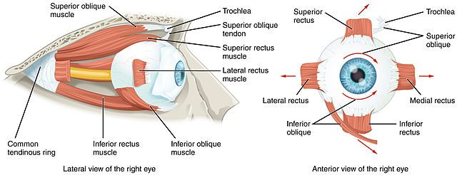

CLINICAL RELEVANCE
- CRANIAL NERVE PALSIES
The extra ocular muscles are innervated by three cranial nerves. Damage to one of the cranial nerves will cause paralysis of its respective muscles. This will alter the resting gaze of the affected eye. Thus, a lesion of each cranial nerve has its own characteristic appearance:
Oculomotor nerve (CN III) – A lesion of the oculomotor nerve affects most of the extra ocular muscles. The affected eye is displaced laterally by the lateral rectus and inferiorly by the superior oblique. The eye adopts a position known as ‘down and out’.
Trochlear nerve (CN IV) – A lesion of CN IV will paralyze the superior oblique muscle. There is no obvious effect of the resting orientation of the eyeball. However, the patient will complain of diplopia (double vision), and may develop a head tilt away from the site of the lesion.
Abducens nerve (CN VI) – A lesion of CN VI will paralyze the lateral rectus muscle. The affected eye will adducted by the resting tone of the medial rectus.

- HORNER’S SYNDROME
Horner’s syndrome refers to a triad of symptoms produced by damage to the sympathetic trunk in the neck:
Partial ptosis (drooping of the upper eyelid) – Due to denervation of the superior tarsal muscle.
Miosis (pupillary constriction) – Due to denervation of the dilator pupillae muscle.
Anhydrosis (absence of sweating) on the ipsilateral side of the face – Due to denervation of the sweat glands.
Horner’s syndrome can represent serious pathology, such as a tumor of the apex of the lung (Pancoast tumor), aortic aneurysm or thyroid carcinoma.

- THE INTRAOCULAR MUSCLES-

The intraocular muscles include the ciliary muscle, the sphincter pupillae, and the dilator pupillae. The ciliary muscle is a smooth muscle ring that controls accommodation by altering the shape of the lens, as well as controlling the flow of aqueous humor into Schlemm's canal. These muscles changes shape of lens and size of pupil.
CILIARY MUSCLE- is a smooth muscle of the ciliary body which changes the shape of the crystalline lens to provide clear vision at different distances. It radiates backwards in three directions;
- longitudinal/meridional- more or less parallel to the sclera and inserts into the trabecular meshwork to influence its pore size
- Oblique/radial- lies deep in the longitudinal fibers and often very difficult to separate from circular muscles.
- Circular/Muller- occupy the anterior and inner portion of the ciliary body and run parallel to the limbus. It contracts and relaxes the zonular fibers.
THE SPINCHTER PUPILLAE- is responsible for constricting the pupil. This forms a circular muscle around the pupil. When it contracts, the pupil becomes smaller which decreases the amount of light entering the eye. It is parasympathetic via the 3rd CN.
DILATOR PUPILLAE- is responsible for dilating the pupil. This forms a radial muscle extending from the ciliary body to the sphincter pupillae. When it contracts the pupils enlarges which increases the amount of light entering the eye. It is sympathetic via 5th CN.
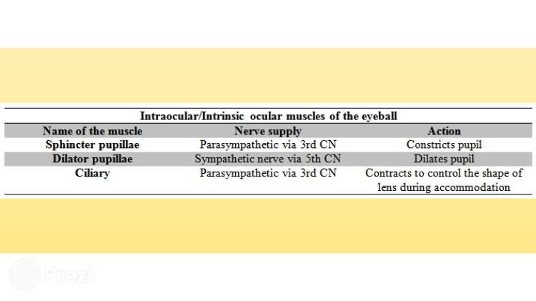

SYNKINETIC ACTIONS
- CONSTRICTION- contraction of the pupil or condition in which the pupil is very small in response to focusing on a near target.
- ACCOMODATION- adjustment of the dioptric power of the eye. It is the ability to adjust the strength of the lens by changing its shape which in turn is regulated by the ciliary muscle. It is generally involuntary and made to see objects clearly at any distance.
- When the ciliary muscle is relaxed the ligaments attached to the lens pull the lens flat and therefore less curved and weakly refractive.
- When the ciliary muscle is contracted the ligaments attached to the lens pull the lens round and therefore more curved and highly refractive.
- Therefore in far vision, the ciliary muscle is relaxed and the lens is flat but during near vision the muscle contracts and allows the lens to become more convex.
- CONVERGENCE- movement of the eyes turning inward or towards each other in response to a change in accommodation.

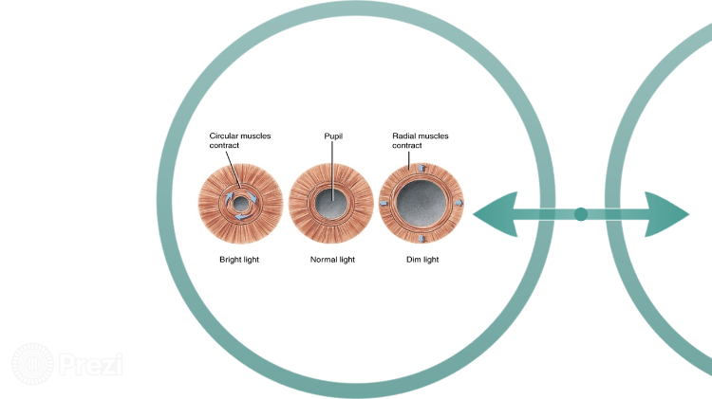

EFFECTS OF AGING ON CILIARY MUSCLE AND ACCOMODATION
- As age progresses ciliary muscle and crystalline lens gradually lose their elasticity and ability to accommodate giving rise to a condition called presbyopia.
- Starts occurring at the age of 40.

