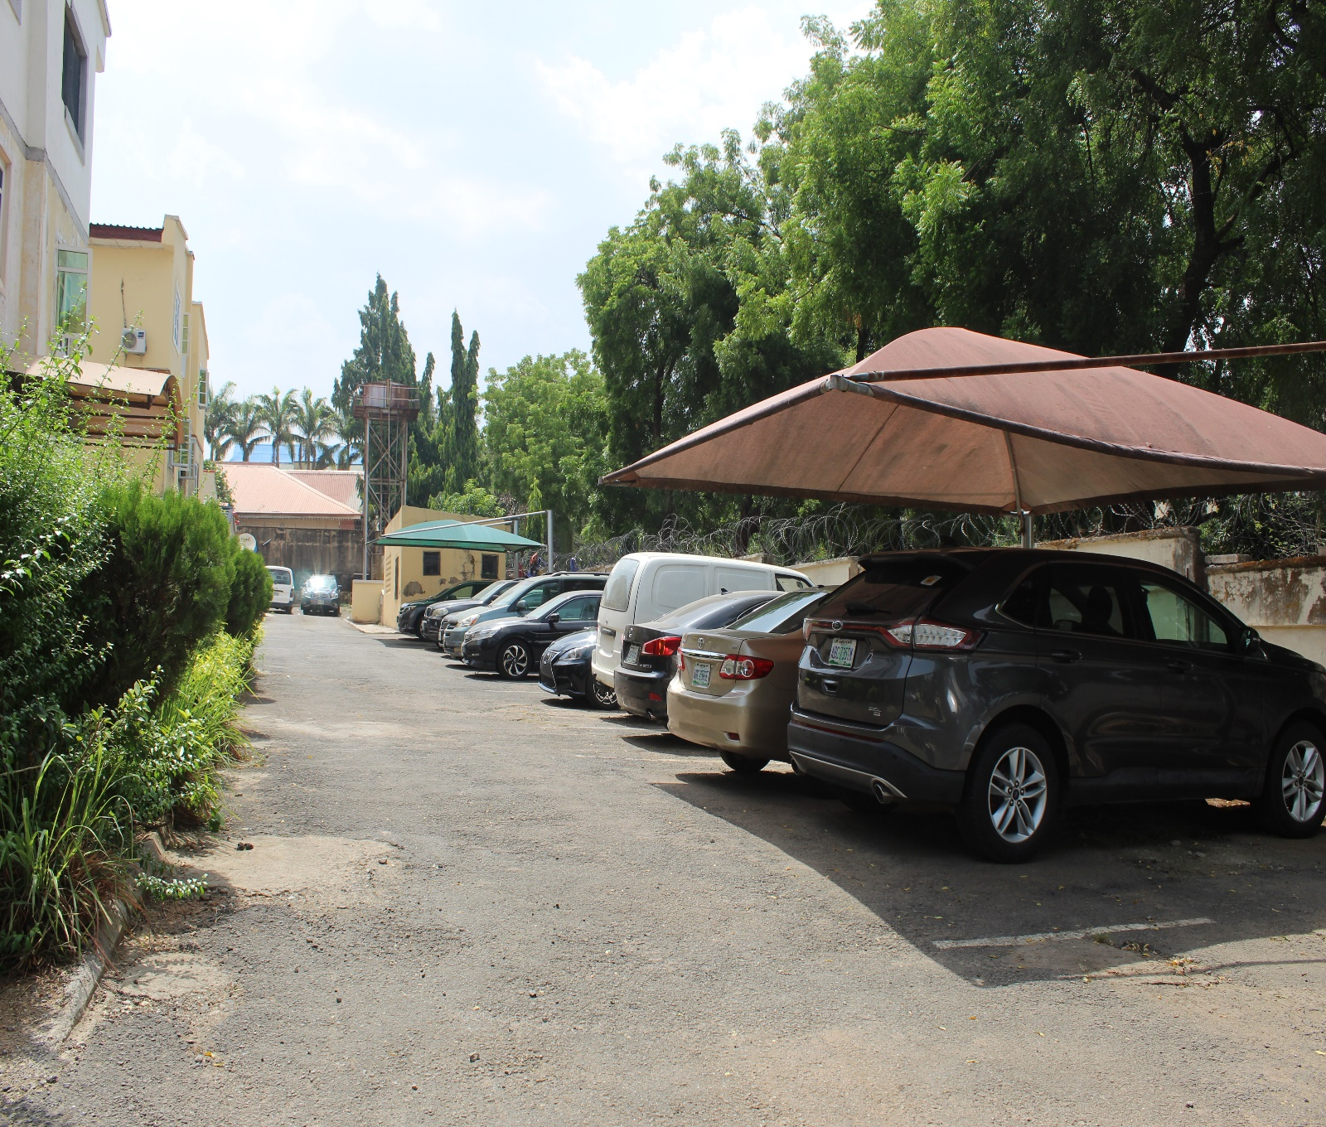
4. MOBILE PHOTOGRAHY.

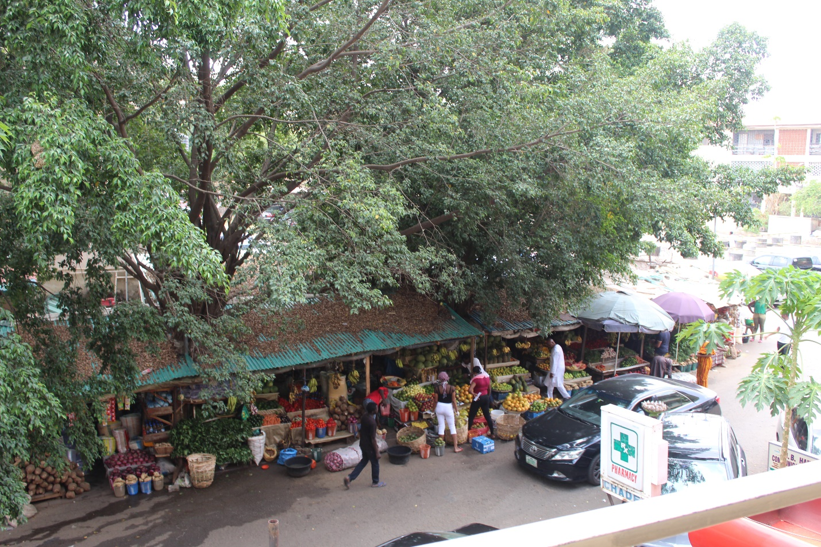
5. MARKET PHOTOGRAHY.

ORJI IFEOMA PERPETUA.

19/sms04/041.

