TOPIC: SOIL PERMEABILITY AND CAPILARITY

PREPARED BY:
ONIHA ROBERT AGBONIGHALE
17/ENG03/046

A TERM PAPER SUBMITTED TO:
DEPARTMENT OF CIVIL ENGINEERING, ABUAD.

IN PARTIAL FULFILMENT TO:
CVE 306: SOIL MECHANICS

DATE: 8TH MARCH, 2020

ACKNOWLEDGMENTS
We thank all the copious individuals for their important contribution and notable impact to the success of this research.

ABSTRACT
This report explores the relationship between sediment shape and size with respect to the ability of water to travel through and in between sediments as well as the ability of pore spaces between sediments to hold water.

TABLE OF CONTENTS
INTRODUCTION.……………...……………………….……………….………………………..………Page 5
1. PERMEABILITY……….………………………………………………………………………………..Page 6
1.1 FACTORS AFFECTING PARMEABILITY…………………………………………………….Page 6
1.2 TEST AND CALCULATONS FOR PARMEABILITY……….…………………………….Page 8
1.2.1 APPARATUS FOR CONSTANT HEAD PERMEABILTY PARMEABILITY……Page 8
1.2.2 PROCEDURE……………………………………………………………………….……………….Page 9
1.2.2.1 SPECIMEN PREPARATION…………………………………………….………………….Page 9
1.2.2.2 TEST PROCEDURE…………………………………………………………………………….Page 9
1.2.3 OBERVATION AND CONCLUSION………..……………………………………………Page 10
2. CAPILLARITY……………..………………………………………………………………..…………Page 10
2.1 FACTORS AFFECTING CAPILLARITY ………………………………………………….....Page 11
2.2 CALCULATION FOR CAPILLARITY……………………………………………..………….Page 12
7. CONCLUSION ………………………………………………………….…………………………….Page 13

Introduction
Capillarity and permeability are very important physical concepts especially to a civil engineer. They are major and very important attributes of soil that determine what can be built on it and what method of building should be used. The knowledge of these concepts is very crucial to the civil engineer and we shall be discussing them extensively.

- Permeability
Permeability measures the material’s ability to transmit fluids and can be termed in different ways depending on the field. Permeability depends only on the pore structure of the material and has units with dimensions of area (m2). A practical unit for permeability is the darcy (D), or more commonly the millidarcy (mD). Hydraulic conductivity is usually referred to permeability or coefficient of permeability and it is related to intrinsic permeability (pore structure) and to the properties of the fluid.
Optimum permeability exists where sediments are rounded and large. Because the pore spaces are large, water easily passes in between sediments. Permeability is poorest when sediments are of mixed sizes and shapes.
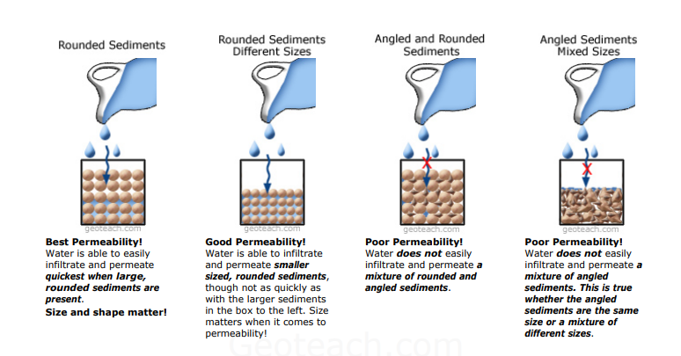
1.1 Factors affecting permeability
- Particle Size-It was studied by Allen Hazen that the coefficient of permeability (k) of a soil is directly proportional to the square of the particle size (D). Thus permeability of coarse grained soil is very large as compared to that of fine grained soil. The permeability of coarse sand may be more than one million times as much that of clay.

- Impurities in water-the presence of impurities in soil decreases the permeability of soil

- Void ratio (e)-The coefficient of permeability varies with the void ratio as e/sup>/(1+e). For a given soil, the greater the void ratio, the higher the value of the coefficient of permeability. Here 'e' is the void ratio.

Based on other concepts it has been established that the permeability of a soil varies as e2 or e2/(1+e). Whatever may be the exact relationship, all soils have e versus log k plot as a straight line.

- Degree of Saturation-If the soil is not fully saturated, it contains air pockets. The permeability is reduced due to the presence of air which causes a blockage to the passage of water [2]. Consequently, the permeability of a partially saturated soil is considerably smaller than that of fully saturated soil. In fact, Darcy's Law is not strictly applicable to such soils.

- Absorbed Water-Fine grained soils have a layer of adsorbed water strongly attached to their surface. This adsorbed layer is not free to move under gravity. It causes an obstruction to the flow of water in the pores and hence reduces the permeability of soils. According to Casagrande, it may be taken as the void ratio occupied by absorbed water and the permeability may be roughly assumed to be proportional to the square of the net voids ratio of (e - 0.1)

- Entrapped air and organic Matter-Air entrapped in the soil and organic matter block the passage of water through soil, hence permeability considerably decreases. In permeability tests, the sample of soil used should be fully saturated to avoid errors.

1.2 Test and calculations for soil permeability
The test used to for soil permeability is called constant head permeability test. The objective of the test is to determine the coefficient of permeability of a soil.
The coefficient of permeability, k is defined as the rate of flow of water under laminar flow conditions through a porous medium area of unit cross section under unit hydraulic gradient.

The coefficient of permeability (k) is obtained from the relation;
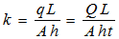
Where q= discharge, Q=total volume of water, t=time period, h=head causing flow, L= length of specimen, A= cross-sectional area.
1.2.1 Apparatus for Constant Head Permeability Test
- Permeameter mould, internal diameter = 100mm, effective height =127.3 mm, capacity = 1000ml.
- Detachable collar, 100mm diameter, 60mm height
- Dummy plate, 108 mm diameter, 12mm thick,
- Drainage base, having porous disc
- Drainage cap having porous disc with a spring attached to the top.
- Compaction equipment such as Proctor’s rammer or a static compaction equipment, as specified in IS:2720 (Part VII)-1965.
- Constant head water supply reservoir
- Vacuum pump
- Constant head collecting chamber
- Stop watch
- Large funnel
- Thermometer
- Weighing balance accuracy 0.1g
- Filter paper.
1.2.2 Procedure
1.2.2.1 Specimen Preparation
- Remove the collar of the mould. Measure the internal dimensions of the mould. Weigh the mould with dummy plate to the nearest gram.
- Apply a little grease on the inside to the mould. Clamp the mould between the base plate and the extension collar and place the assembly on a solid base.
- Take about 2.5kg of the soil sample, from a thoroughly mixed wet soil, in the mould. Compact the soil at the required dry density using a suitable compacting device.
- Take a small specimen of the soil in a container for the water content determination.
- Remove the collar and base plate. Trim the excess soil level with the top of the mould.
- Clean the outside of the mould and the dummy plate. Find the mass of the soil in the mould.
- The mould with the sample is now placed over the permeameter. This will have drainage and cap discs properly saturated
1.2.2.2 Test Procedure
- Through the top inlet of the constant head reservoir, the specimen is connected.
- The bottom outlet is opened and a steady flow is established
- For a particular time interval, the quantity of flow can be collected.
- Measure the difference of head (h) in levels between the constant head reservoir and the outlet in the base.
- For the same interval, this is repeated three times.
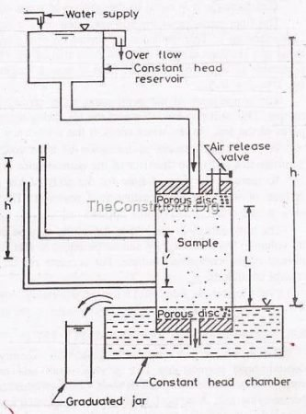
1.2.3 Observation and Calculations
Initially, the flow is very slow. It later increases and will become constant. The constant head permeability test is best for cohesionless soils.

- Capillarity
The ability of various soils and rocks to allow water to move up through them is capillarity. Capillarity is somewhat dependent upon a rock’s porosity and permeability. The forces involved in capillarity are gravity pulling downward on the water, and attraction between water molecules and the molecules of the rock.
Capillary-driven liquid flow is the main transport mechanism in the soil system of which the water erodes continuously by capillary rise from a lower elevation to higher elevation.
2.1 Factors affecting capillarity
- Diameter of the capillary tube (representing the diameter of the pores in a soil)- The diameter of the capillary is inversely related to the capillary rise; as one increases, the other decreases. For this reason, the tube diameter has the largest effect on capillary rise. Pore size is controlled by grain-size distribution of the porous medium, as well as packing. A sand, silt, or clay can be packed to different bulk densities, which along with the grain-size distribution controls the pore-size distribution.
- Contact angle between the liquid and the surface to which it adheres- If the angle is 0 degrees, then the liquid perfectly wets the surface. An angle of 180 degrees would show that no wetting occurred, and the liquid drop remained in a spherical shape resting upon the surface. Wetting must occur for capillary rise to take place. There should be no capillary rise when the wetting 4 angle is 180 degrees, and in general as the wetting angle approaches zero, the capillary rise height increases.
- Density of the liquid- increased density of the liquid will cause it to rise to a lesser degree. The force with which water is held by capillary action varies with the quantity of water being held. The higher the density, the less the capillary rise
- Viscosity of the liquid- The viscosity of a liquid is its resistance to flow. Liquids that have strong intermolecular forces tend to have high viscosities. The higher the viscosity, the lesser the rise in capillarity.
- Surface tension- Greater surface tension and increased ratio of adhesion to cohesion also result in greater rise.
- Whether or not the capillary surface is hydrophobic, or water repellent- In hydrophobic porous media, with high wetting angles, the capillary rise actually becomes negative. Put in a different way, in hydrophobic media, air is attracted downward by capillary forces, displacing water.

2.2 Calculation for capillarity
Capillarity can simply be calculated by applying this formula below;
$$h=\frac{2Tcosθ}{rρg}$$

$$h=height of liquid level in capillarity$$
$$T=surface tention$$
$$θ=angle of contact$$
$$r=radius of bore of capillarity tube\left(radius of pores\right)$$
$$ρ=density of liquid$$
$$g=acceleration due to gravity$$

Conclusion
From this report it is clear to see the importance of the knowledge these terms, capillarity and permeability. It would be Impossible for any structure to be built on any soil without an engineer examining these properties of the soil.

