Name: NNACHETTA Kenechukwu

Matric Number: 18/ENG03/040

College: College of Engineering

Department: Civil Engineering

Course: ENG 284 – Engineering In Society

- Project’s Name : Alfa Belgore Rehabilitation Project
Project Location: Afe Babalola University, Ado-Ekiti
Project Objective:
- Expansion of the maximum capacity

Procedure
The preliminary stages achieved before the Rehabilitation of Alfa Belgore Project are;
- Approval of rehabilitation by the local government
- Draft building plans of desired structure of Alfa Belgore
- Planning with construction company, the approved bill of cost
- Approval of Bill of Cost and Building plan by Afe Babalola University Board of Directors
- Site surveying
- Clearing of site
- Placing of fences around site

Construction steps of Alfa Belgore

Phase I: Site Work
Site Work is the commencement of construction when existing structures, not part of permanent construction, are cleared from the site. Initial Site Work allows for soils to be excavated to facilitate installation of building foundations and underground utilities services for the building.
Phase II: Foundations
After soils have been removed to the required depth, Foundations are formed and reinforcement steel is placed in position. When this is complete, concrete is placed to create the Foundations.

Phase III: Superstructure
During this phase steel columns beams and bracing are erected on top of the foundations to form the structural “skeleton” for the entire building and the concrete floors are put in place.
Phase IV: Façade
As each section of Superstructure is completed, the building facade components are added to form what is considered the “envelope” of the building. These include the glass and finished materials and glass that make up the exterior walls and roof. It is at this point, before the building is completely enclosed, that large pieces of equipment necessary to operate the building are put in place while there are still exterior openings large enough to fit them through.
Phase V: Interior Construction
As the façade is completed, the interior “fit out” begins with the construction of the interior walls and ceiling framework. Concurrently, the initial “rough” mechanical piping, ductwork, and electrical wiring is put in place before the finished materials are applied to the rough.
Phase VI: Commissioning
During the Commissioning phase all the equipment systems needed to operate the entire building are put through a series of rigorous testing procedures before the building can be occupied. The planning for this process begins during the design phase, and the actual testing begins as the equipment is installed and connected and continues through the early stages of the initial operation of the building. Commissioning is the final step to confirm that all the systems are designed and installed properly and function as they were intended.
Phase VII: Grading, Improvements, and Landscaping
When building is in the final stages of completion, the site is given its final grade, topcoats of roadways, drives, pedestrian walkways/spaces, site furniture, lighting, and landscaping are put in place and the doors are ready to be opened.

2.
Life Cycle of Alfa Belgore Rehabilitation
- Site work – 7 days
- Foundations – 6 days
- Superstructure – 8 days
- Façade – 4 days
- Interior Construction – 10 days
- Commissioning – 5 days
- Grading, Improvements and Landscaping – 9 days

The Gantt chart of The Rehabilitation of Alfa Belgore
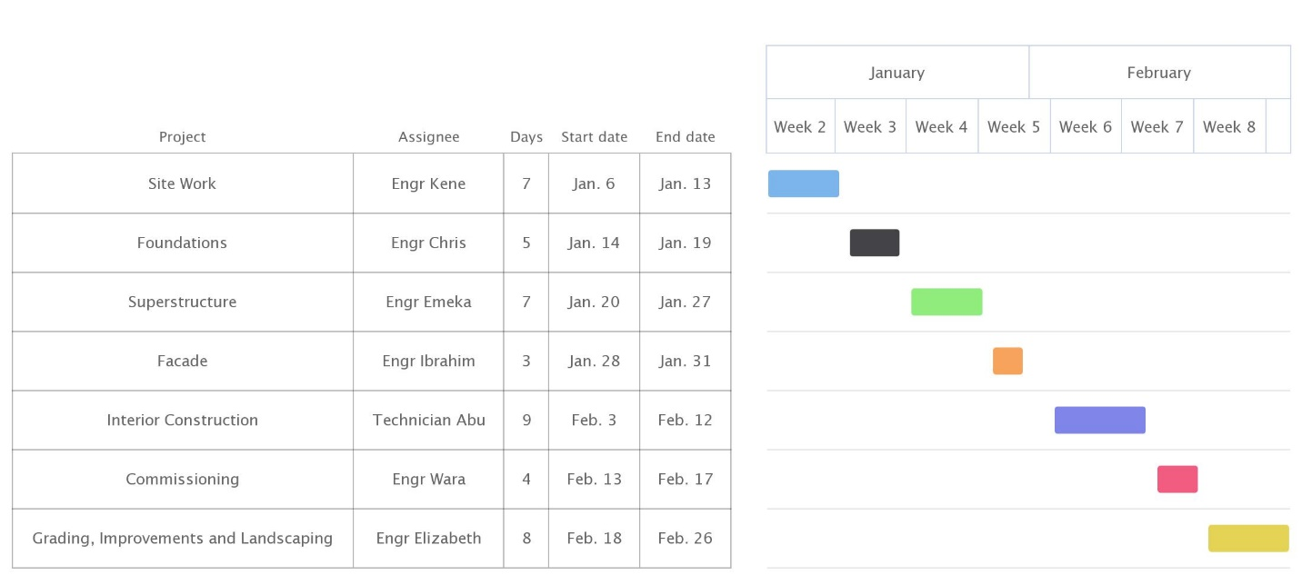

3)
Professional Team
Architect
Aids the client in giving sketches of the client’s requested building, further gives detailed plans and visual representation of the building.
Quantity Surveyor
He gives the estimated cost for each of the materials used in the construction and drafts up payments of each of the other construction team members.
Land Surveyor
Tests the site for any abnormities and other minerals. During floods, the land surveyor ensures the building won’t sink on the sand.
Project Manager
He coordinates all activities done on the site and supervises all other construction team members’ area of supervision.
Engineering Consultant
He provides engineering advice and technical solutions on different projects. This job involves a range of tasks, including coordinating teams, preparing documentation, and developing project plans.

4.) Buildings in construction are well known to be hotspots for criminal activities. These criminal activities may cause loss of life and properties, which will cost severely the company in charge of the construction .The site being secured will hinder criminal activities around the site. Measures of keeping the site secured are:
- Fences & Barriers
- Locks
- CCTV
- Alarm systems
- Security guards etc.

5.) The BEME used for this project
Material | Cost
Tiling of Walls & Floors | ₦500, 000.00
Windows & Doors | ₦1,200,00.00
Painting of Walls | ₦850,00.00
Electrical Works | ₦700,000.00
Mechanical Works | ₦450,000.00
Roofing works, Timber and Roof Coverings | ₦1,800,000.00
External Works | ₦1,100,000.00
Total | ₦ 5,800,000.00
`Add-Ons
Components | Cost
Miscellaneous (10%) | ₦ 580,000.00
Consultancy Fee (15%) | ₦ 870,000.00
Site Preparations & Clearing after completion (5%) | ₦ 290,000.00
Transportation of workers & Materials (12%) | ₦ 696,000.00
Profit (20%) | ₦ 1,160,000.00
Grand Cost of Project | ₦ 9,396,000.00

6.) Payment Schedule
30% Tec for mobilization | ₦1,740,000.00
30% Tec for 50% completion | ₦ 1,566,000.00
40% at completion of Project & Hand over | ₦ 2.088,000.00
Retention 10% of Tec | ₦ 580,000
Total Payment | ₦ 5,800,000.00

7a.) BEME: The full meaning is Bill of Engineering Measurement and Evaluation, it is used before, during and post-construction to assess and value the cost of construction works. This includes the cost of materials, labor, equipment and all/any other resource(s) required for the success of any construction endeavor based on a pre-determined scope and specification.
b.) Defect Liability Period: The Defect Liability Period (now called the 'rectification period’ in Joint Contract Tribunal (JCT)) begins upon certification of practical completion and typically lasts six to twelve months. During this period, the client reports any defects that arise to the contract administrator who decides whether they are defects (i.e. works that are not in accordance with the contract), or whether they are in fact maintenance issues. If the contract administrator considers they are defects, then they may issue instructions to the contractor to make them within a functional reasonable time.
c.) Lead consultant: The lead consultant is the consultant that directs the work of the consultant team and is the main point of contact for communication between the client and the consultant team.
d.) Project Life Cycle: A project life cycle is the sequence of phases that a project goes through from its initiation to its closure. The number and sequence of the cycle are determined by the management and various other factors like needs of the organization involved in the project, the nature of the project, and its area of application. The phases have a definite start, end, and control point and are constrained by time.
e.) Environmental Impact Assessment (EIA): Environmental Impact Assessment (EIA) is a process to assess the environmental consequences of any project and design proper mitigation plans to minimize the possible adverse impacts. Environmental Impact Assessment is usually considered as the appraisal of impacts that any developmental activity may effect on the environment. Environmental impacts may be positive or negative, harmful of beneficial.

