SOIL PERMEABILITY AND CAPILLIARITY

BY: EBOSA OFEORITSE ORITSETSERUNDEDE
MATRIC NO: 17/ENG03/017

A TERM PAPER SUBMITTED TO: CIVIL ENGINEERING DEPARTMENT OF THE COLLEGE OF ENGINEERING, ABUAD, IN PARTIAL FUFILMENT TO ENG 307,
SOIL MECHANICS

DATE: 12TH APRIL, 2020

Table of Contents
Abstract 3
1.0 Introduction 4
1.1 Permeability 4
1.2 Factors affecting the permeability of soil 4
1.2.1 Particle size 4
1.2.2 Impurities in water 5
1.2.3 Void ratio(E) 5
1.2.4 Degree of saturation 5
1.2.5 Absorbed water 5
1.3 Soil permeability test 6
1.3.1 Constant head permeability test 6
1.3.2 Coefficient of permeability 7
1.3.3 Test procedure 7
1.3.4 Observations 8
2.0 Capillarity 9
2.1 Surface tension 9
2.2 Capillary rise in soils 10
2.3 Calculating the capillarity rise height of soils 11
3.0 Relationship between permeability and capillarity 12

Table of figures
Figure 1 4
Figure 2 5
Figure 3 6
Figure 4 8
Figure 5 9
Figure 6 10
Figure 7 12

Abstract
Permeability and capillarity are both important phenomena that needs to be understood to ease engineering works and human livelihood. Their properties are discussed to understand their importance.
1.0 INTRODUCTION
The movement of fluid through porous
systems in rocks has been widely
studied in several fields of research such
as ground water, petroleum engineering,
engineering geology, soil physics and
building materials.
The movement of fluid through porous
systems in rocks has been widely
studied in several fields of research such
as ground water, petroleum engineering,
engineering geology, soil physics and
building materials.
The movement of fluid through porous
systems in rocks has been widely
studied in several fields of research such
as ground water, petroleum engineering,
engineering geology, soil physics and
building materials.
The movement of fluid through porous
systems in rocks has been widely
studied in several fields of research such
as ground water, petroleum engineering,
engineering geology, soil physics and
building materials.
The movement of fluid through porous
systems in rocks has been widely
studied in several fields of research such
as ground water, petroleum engineering,
engineering geology, soil physics and
building materials.
The movement of fluid through porous
systems in rocks has been widely
studied in several fields of research such
as ground water, petroleum engineering,
engineering geology, soil physics and
building materials.
The movement of fluid through porous
systems in rocks has been widely
studied in several fields of research such
as ground water, petroleum engineering,
engineering geology, soil physics and
building materials.
The movement of fluid through porous
systems in rocks has been widely
studied in several fields of research such
as ground water, petroleum engineering,
engineering geology, soil physics and
building materials.
The movement of fluid through porous
systems in rocks has been widely
studied in several fields of research such
as ground water, petroleum engineering,
engineering geology, soil physics and
building materials.
The movement of fluid through porous
systems in rocks has been widely
studied
The movement of fluid through porous
systems in rocks has been widely
studied
The movement of fluid through porous systems in rocks has been widely studied in several fields of research such as ground water, petroleum engineering, engineering geology, soil physics and building materials.

1.1 PERMEABILITY
Permeability measures the material’s ability to transmit fluids and can be termed in different ways depending on the field. Permeability depends only on the pore structure of the material and has units with dimensions of area (m²). A practical unit for permeability is the Darcy (D), or more commonly the millidarcy (mD). Hydraulic conductivity is usually referred to permeability or coefficient of permeability and it is related to intrinsic permeability (pore structure) and to the properties of the fluid. Hydraulic conductivity has units with dimensions of length per time or speed. Thus, for pure water at 20 ºC, 1D is ∼10⁻¹²m² or ∼10⁻⁵ m/s.
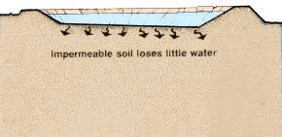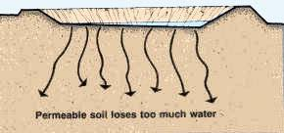
Figure1 a and b; permeabiliry in soil types
Soil permeability is important for many reasons. A primary reason is that soil pores contain the groundwater that many of us drink. Another important aspect of soil permeability concerns the oxygen found within these pore spaces. All plants need oxygen for respiration, so a well-aerated soil is important for growing crops.

1.2 FACTORS INFLUENCING THE PERMEABILITY OF SOIL
1.2.1 PARTICLE SIZE
It was studied by Allen Hazen that the coefficient of permeability (k) of a soil is directly proportional to the square of the particle size (D). Thus permeability of coarse grained soil is very large as compared to that of fine grained soil. The permeability of coarse sand may be more than one million times as much that of clay.
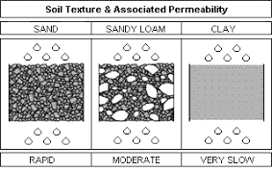
Figure 2

1.2.2 IMPURITIES IN WATER
The presence of impurities in soil decreases the permeability of soil.

1.2.3 VOID RATIO (E)
The coefficient of permeability varies with the void ratio as e/sup>/(1+e). For a given soil, the greater the void ratio, the higher the value of the coefficient of permeability. Here 'e' is the void ratio.
Based on other concepts it has been established that the permeability of a soil varies as e² or e²/(1+e). Whatever may be the exact relationship, all soils have e versus log k plot as a straight line.

1.2.4 DEGREE OF SATURATION
If the soil is not fully saturated, it contains air pockets. The permeability is reduced due to the presence of air which causes a blockage to the passage of water. Consequently, the permeability of a partially saturated soil is considerably smaller than that of fully saturated soil. In fact, Darcy's Law is not strictly applicable to such soils.

1.2.5 ABSORBED WATER
Fine grained soils have a layer of adsorbed water strongly attached to their surface. This adsorbed layer is not free to move under gravity. It causes an obstruction to the flow of water in the pores and hence reduces the permeability of soils. According to Casagrande, it may be taken as the void ratio occupied by absorbed water and the permeability may be roughly assumed to be proportional to the square of the net voids ratio of (e - 0.1)
Entrapped air and organic matter
Air entrapped in the soil and organic matter block the passage of water through soil, hence permeability considerably decreases. In permeability tests, the sample of soil used should be fully saturated to avoid errors.

1.3 SOIL PERMEABILITY TEST
The permeability of soil can be tested in various ways but the constant head permeability test is the most widely accepted method.

1.3.1 CONSTANT HEAD PERMEABILITY TEST
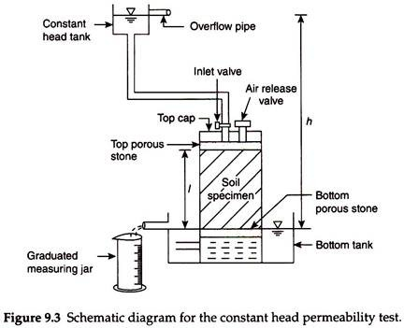
Figure 3: schematic diagram for the constant heat permeability test
The constant head permeability test is a laboratory experiment conducted to determine the permeability of soil. The soils that are suitable for this tests are sand and gravels. Soils with silt content cannot be tested with this method. The test can be employed to test granular soils either reconstituted or disturbed.
The objective of constant head permeability test is to determine the coefficient of permeability of a soil.
Coefficient of permeability helps in solving issues related to:
- Yield of water bearing strata
- Stability of earthen dams
- Embankments of canal bank
- Seepage in earthen dams
- Settlement Issues

1.3.2 COEFFICIENT OF PERMEABILITY
The coefficient of permeability, k is defined as the rate of flow of water under laminar flow conditions through a porous medium area of unit cross section under unit hydraulic gradient.
The coefficient of permeability (k) is obtained from the relation:
$$K=\frac{qL}{Ah}=\frac{QL}{Aht}$$
Where q= discharge, Q=total volume of water, t=time period, h=head causing flow, L= length of specimen, A= cross-sectional area.

1.3.3 TEST PROCEDURE
- Through the top inlet of the constant head reservoir, the specimen is connected.
- The bottom outlet is opened and a steady flow is established
- For a particular time interval, the quantity of flow can be collected.
- Measure the difference of head (h) in levels between the constant head reservoir and the outlet in the base.
- For the same interval, this is repeated three times.
Figure 4: Constant head permeability test
1.3.4 OBSERVATIONS
Initially, the flow is very slow. It later increases and will become constant. The constant head permeability test is best for cohesion less soils.

2.0 CAPILLIARITY
Capillary flow is the most common water transport mechanism in porous building rocks, since they tend to be unsaturated water. It is the rise or depression of a liquid in a small passage such as a tube of small cross-sectional area, like the spaces between the openings of a porous material. This parameter is essentially equivalent to the sorptivity parameter physics in soil and building and depends on pore structure and to the properties of the fluid.
Water molecules behave in two ways:
- Cohesion Force: Because of cohesion forces, water molecules are attracted to one another. Cohesion causes water molecules to stick to one another and form water droplets.
- Adhesion Force: This force is responsible for the attraction between water and solid surfaces. For example, a drop of water can stick to a glass surface as the result of adhesion.

2.1 SURFACE TENSION
Figure 5: an insect appears to stand on water because of surface tension
Water surfaces behave in an unusual way because of cohesion. Since water molecules are more attracted to other water molecules as opposed to air particles, water surfaces behave like expandable films. This phenomenon is what makes it possible for certain insects to walk along water surfaces.
Capillarity is the primary force that enables the soil to retain water, as well as to regulate its movement.
The phenomenon of capillarity also occurs in the soil. In the same way that water moves upwards through a tube against the force of gravity; water moves upwards through soil pores, or the spaces between soil particles.

2.2 CAPILLIARY RISE IN SOILS
The height to which the water rises is dependent upon pore size. As a result, the smaller the soil pores, the higher the capillary rise.
Finely-textured soils, like in Maui, typically have smaller pores than coarsely-textured soils. Therefore, finely-textured soils have a greater ability to hold and retain water in the soil in the inter-particle spaces. We refer to the pores between small clay particles as micro pores. In contrast, the larger pore spacing between lager particles, such as sand, are called macro pores.
In addition to water retention, capillarity in soil also enables the upward and horizontal movement of water within the soil profile, as opposed to downward movement caused by gravity. This upward and horizontal movement occurs when lower soil layers have more moisture than the upper soil layers and is important because it may be absorbed by roots.
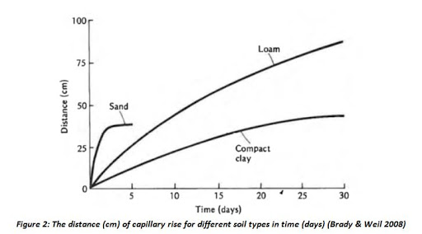
Figure 6: diagrammatic representation of capillary action in various soils

2.3 CALCULATING THE CAPILLIARITY RISE HEIGHT OF SOILS
To arrive at his solution for the rate of capillary rise, Terzaghi (1943) made two major assumptions: (1) that Darcy’s law for saturated fluid flow is roughly applicable to unsaturated flow, and (2) that the hydraulic gradient responsible for capillary rise can be approximated as follows:
$i=\frac{hc-z}{z}$ (1)
where h_{c}=ultimate height of capillary rise; and _{z}=distance measured positive upward from the elevation of the water table. Physically, h_{c} represents the drop in pressure head across the air–water interface at the wetting front in the soil pores. Terzaghi’s other assumption, Darcy’s law is valid for capillary rise, can be expressed in familiar mathematical terms as follows:
$q=$ k_{s}i=n$\frac{dz}{dt}$ (2)
where q=discharge velocity; k_{s}=saturated hydraulic conductivity of the soil; and n=soil porosity. Solving equations. (1) and (2) and imposing an initial condition of zero capillary rise at zero time, Terzaghi arrived at the following solution describing the location of the capillary wetting front z as an implicit function of time:
$t=\frac{nhc}{ks}(\ln{\frac{hc}{hc-z}}-\frac{z}{hc})$ (3)

3.0 RELATIONSHIP BETWEEN SOIL PERMEABILITY AND CAPILLIARITY
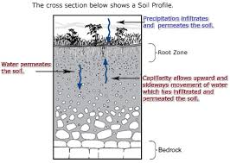
Figure 7
Permeability and capillarity share a unique relationship as show in figure 7. One cannot exist without the other and the understanding of both need to be properly researched to produce infrastructures that would benefit from these phenomena.
CONCLUSION
Permeability and capillarity are both important phenomena that needs to be understood to ease engineering works and human livelihood.
REFERENCES
- Arora, K. R. Soil Mechanics and Foundation Engineering.
- "Civil Engineering Scientists". Retrieved 11 November 2014.
- Li, S (2018). "Dynamics of Viscous Entrapped Saturated Zones in Partially Wetted Porous Media". Transport in Porous Media. 125 (2): 193–210. arXiv:1802.07387. doi:10.1007/s11242-018-1113-3.
- Sitharam, T G (2008). Geotechnical Engineering. S. Chand Publishing. p. 89. ISBN 812192457X. Retrieved August 14, 2019 – via GoogleBooks.
- Permeability of Soil by Constant Head Permeameter – Objectives & Procedure,
https://theconstructor.org/geotechnical/soil-permeability-test-constant-head/2993/
- Terzaghi, K. (1943). Theoretical soil mechanics, John Wiley and Sons, New York.

