EGBOCHUKWU EBENEZER UZOCHIWARA
17/ENG01/008
CHEMICAL ENGINEERING
CHE 312 - PROCESS INSTRUMENTATION ASSIGNMENT

Question One
- What is instrumentation?
- Explain succinctly the mobile and stationary phases in Gas Chromatography.
- Highlight four reasons why moisture measurements are germane in process industries and list four methods of moisture measurement.
Question Two
- State four cogent reasons for measuring and controlling process variables.
- Magnetic flow meters are highly important in process industries. Mention three typical applications of magnetic flow meters.
- With the aid of diagram briefly describe the working principle of any three pressure measuring devices.

Answer
Question 1a: Instrumentation is a collective term for measuring instruments that are used for indicating, measuring and recording physical quantities.
Question 1b:
Mobile Phase in gas chromatography is the phase with which a carrier gas peculates or penetrate the stationary phase. The mobile phase is an inert gas that the sample is injected into that which would carry it through the stationary phase and is normally a solid, it moves the sample so that it is mobile. The mobile phase is responsible for collecting the compounds to be tested during its interactions. The analysis of the sample solution takes into account the interactions between these two phases moves through the stationary phase. This is a liquid or gas that flows through a chromatography system that moves the materials to be separated at different rates over the stationary phase.
Stationary Phase in gas chromatography is the absorbents surface, it’s also the phase in which the sample solution enters into during testing. This stationary phase is a porous solid (example: glass, silica, or alumina) that is packed into a glass or metal tube or that constitutes the walls of an open-tube capillary. A stationary phase is a medium used in gas chromatography which could be a solid or liquid phase of a chromatography system on which the materials are to be separated or selectively adsorbed. The stationary phase is one of two phases that exist in a chromatographic system.
Question 1c: Four reasons why moisture measurements are germane in process industries includes because:
  - Moisture can affect product
  - Poison reactions
  - Damage equipment
  - And cause explosions.
Four methods of moisture measurement are listed below:
- Absolute measurement method
- Relative Humidity method
- Capacitance Method
- Oxide Sensors

Question 2a: State four cogent reasons for measuring and controlling process variables.
In identifying the reasons for measuring and controlling process variables, which involves obtaining values for the current conditions within the process and making it available in a form useable by either the control system, process operation or any other entity. These produces the reasons which includes:
- To obtain or measure temperature
- To obtain the level or level measurement
- To measure moisture
- To obtain pressure value required or pressure measurement.

Question 2b: Three typical applications of magnetic flow meters include:
- Metering of viscous fluids
- Metering of slurries
- Metering of highly corrosive chemicals

Question 2c: With the aid of diagram briefly describe the working principle of any three-pressure measuring device
- BAROMETER- MERCURY BAROMETER
A barometer is an instrument for measuring atmospheric pressure. Two kinds of barometers are in common use, a mercury barometer and an aneroid barometer. The first makes use of a long narrow glass tube filled with mercury supported in a container of mercury, and the second makes use of an elastic disk whose size changes as a result of air pressure.
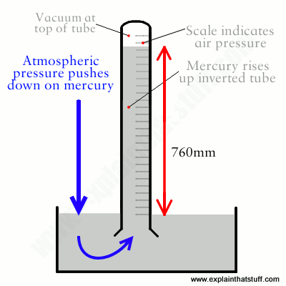
Mercury barometers
Figure 1: MERCURY BAROMETER
The principle of the mercury barometer was discovered by the Italian physicist Evangelista Torricelli in about 1643. That principle can be illustrated as follows: a long glass tube is sealed at one end and then filled with liquid mercury metal. The filled tube is then turned upside down and inserted into a bowl of mercury, called a cistern. When this happens, a small amount of mercury runs out of the tube into the cistern, leaving a vacuum at the top of the tube. Vacuums, by nature, exert very little or no pressure on their surrounding environment. As atmospheric pressure pushes down on the surface of the mercury in the cistern, that mercury in turn pushes up with an equal pressure on the mercury in the glass tube. The height of the mercury in the tube, therefore, reflects the total pressure exerted by the surrounding atmosphere. Under normal circumstances, the column of mercury in the glass tube stands at a height of about 30 inches (76 centimeters) when measured at sea level.

- SPHYGMOMANOMETER
A sphygmomanometer is a device that measures blood pressure. It composes of an inflatable rubber cuff, which is wrapped around the arm. A measuring device indicates the cuff’s pressure. A bulb inflates the cuff and a valve releases pressure. A stethoscope is used to listen to arterial blood flow sounds.

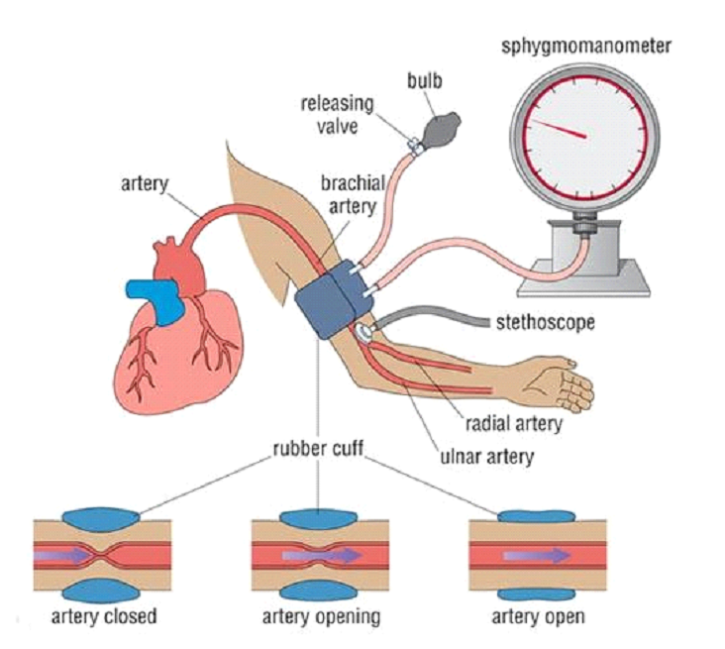
As the heart beats, blood forced through the arteries cause a rise in pressure, called systolic pressure, followed by a decrease in pressure as the heart’s ventricles prepare for another beat. This low pressure is called the diastolic pressure.
FIGURE 2: SPHYGMOMANOMETER
The sphygmomanometer cuff is inflated to well above expected systolic pressure. As the valve is opened, cuff pressure (slowly) decreases. When the cuff’s pressure equals the arterial systolic pressure, blood begins to flow past the cuff, creating blood flow turbulence and audible sounds. Using a stethoscope, these sounds are heard and the cuff’s pressure is recorded. The blood flow sounds will continue until the cuff’s pressure falls below the arterial diastolic pressure. The pressure when the blood flow sounds stop indicates the diastolic pressure.

Systolic and diastolic pressures are commonly stated as systolic ‘over’ diastolic. For example, 120 over 80. Blood flow sounds are called Korotkoff sounds.

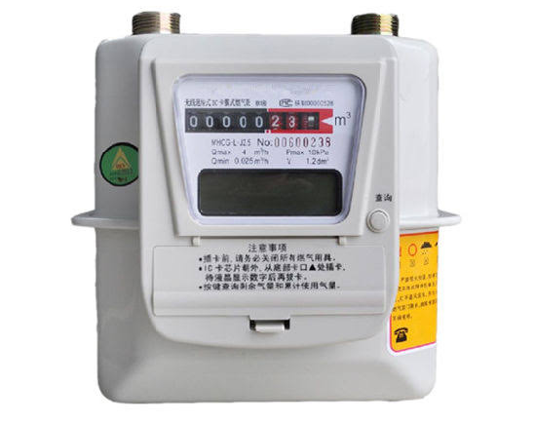
- DIAPHRAGM GAS METERS
Figure 3: DIAPHRAGM GAS METER
These are the most common type of gas meter, seen in almost all residential and small commercial installations. Within the meter there are two or more chambers formed by movable diaphragms. With the gas flow directed by internal valves, the chambers alternately fill and expel gas, producing a nearly continuous flow through the meter. As the diaphragms expand and contract, levers connected to cranks convert the linear motion of the diaphragms into rotary motion of a crank shaft which serves as the primary flow element. This shaft can drive an odometer-like counter mechanism or it can produce electrical pulses for a flow computer.

CITATIONS/ REFRENCES
      - American Gas Association Transmission Measurement Committee (2007). AGA Report No. 9: Measurement of gas by multipath ultrasonic meters (2 ed.). Washington, DC: American Gas Association.
      - American Gas Association Transmission Measurement Committee (2007). AGA Report No. 9: Measurement of gas by multipath ultrasonic meters (2 ed.). Washington, DC: American Gas Association.
      - Booth, J (1977). "A short history of blood pressure measurement". Proceedings of the Royal Society of Medicine. 70 (11): 793–9. doi:10.1177/003591577707001112. PMC 1543468. PMID 341169.
      - Pavia, L., Gary M. Lampman, George S. Kritz, Randall G. Engel (2006). Introduction to Organic Laboratory Techniques (4th Ed.). Thomson Brooks/Cole. pp. 797–817. ISBN 978-0-495-28069-9.
      - Multhauf, Robert P. (1961), The Introduction of Self-Registering Meteorological Instruments, Washington, D.C.: Smithsonian Institution, pp. 95–116 United States National Museum, Bulletin 228. Contributions from The Museum of History and Technology: Paper 23. Available from Project Gutenberg.
      - Lynn, L.H. (1998). "The commercialization of the transistor radio in Japan: The functioning of an innovation community". IEEE Transactions on Engineering Management. 45 (3): 220–229. doi:10.1109/17.704244.
      - Anderson, Norman A. (1998). Instrumentation for Process Measurement and Control (3 ed.). CRC Press. pp. 254–255. ISBN 978-0-8493-9871-1.

