NAME: SAMPSON SOPHIA
MATRIC NO: 19/ENGO8/009
DEPARTMENT: BIOMEDICAL ENGINEERING
COURSE CODE: ANA 226
COURSE TITLE: HUMAN ANATOMY II

ASSIGNMENT:
1. DRAW THE BRAIN SHOWING THE VARIOUS LOBES OF IT.
2. DRAW THE BRAIN SHOWING THE VARIOUS PARTS OF IT (CEREBRUM, BRAIN STEM, THALAMUS, HYPOTHALAMUS ETC)

1. DRAW THE BRAIN SHOWING THE VARIOUS LOBES OF IT.

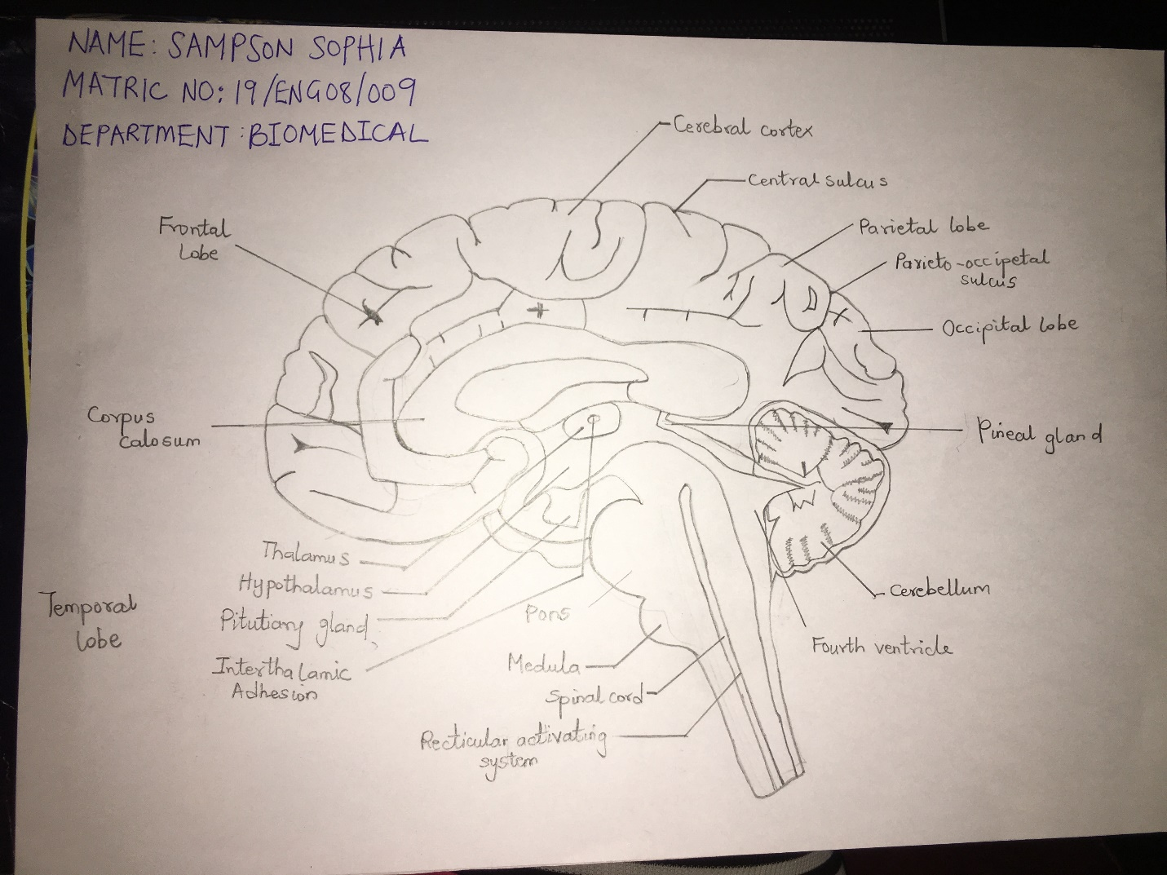

2. DRAW THE BRAIN SHOWING THE VARIOUS PARTS OF IT (CEREBRUM, BRAIN STEM, THALAMUS, HYPOTHALAMUS ETC)

