NAME; ITUA EHIAGHE E
MATRIC NUMBER; 18/ENG01/012
DEPARTMENT; CHEMICAL ENGINEERING
COURSE CODE; ENG 282
COURSE TITLE; ENGINEER IN THE SOCIETY

- The Scope of Work usually includes;
- The title of the project.
- The client’s contact
- The contractor’s contact
- The project description
- The project deadline
- Dates associated with various tasks
- Signatures.
- Deliverables .etc

A SAMPLE OF A SCOPE OF WORK FOR THE RENOVATION OF ALFA BELGORE HALL IN AFEBABALOLA UNIVERSITY ADO-EKITI BY ITUA EHIAGHE E.
ORGANIZATIONAL INFORMATION
CLIENT NAME; AFEBABALOLA UNIVERSITY ADO-EKITI
CLIENT PHONE; +234 803 - 350 - 9150
CLIENT EMAIL; info[at]abuad.edu.ng
CLIENT MAILING ADDRESS; PMB657. KM8.5 Olusegun Obasanjo way.
PROVIDER NAME; EMERALD CONSTRUCTION COMPANY
PROVIDER PHONE;08180568002
PROVIDER EMAIL; emeraldcc@gmail.com
PROVIDER MAILING ADDRESS; PMB784, Tafewa street, Off Ajayi Crescent, Ikeja Lagos state
DATE; 2nd December, 2019.

PROJECT INFORMATION
PROJECT NAME; RENOVATION OF THE ALFA BELGORE HALL IN AFEBABALOLA UNIVERSITY
CLIENT; AFEBABALOLA UNIVERSITY ADO-EKITI
BRAND; -
PRODUCT; -
DESCRIPTION; To Renovate the existing Alfa Belgore Hall in the school. The renovation is to bring about a bigger hall to contain more people. As well as improve the air conditioning of the facility. And bring about ease access in and out of the hall.
PROJECT DEADLINE; The project should be over by August.
SPECIFIC DELIVERABLES;
1. Revolving doors.
2. Roofing sheets.
3.Air conditioning units
4.Chairs.
5.Tables
6.Mirrors
7.Hand dryers (for the toilets).
TIMELINE; The project is not to exceed a period of 9 months and these deliverables should be available by the 8 month.
DATES ASSOCIATED TASKS;
- Clearing of the hall (i.e removal chairs, doors, fans etc tings already present in the hall) in the first week.
- Removal of the roofing sheets and roofing beams by the second week.
- The building and reconstructing within the first 5months (maximum) as well as plumbing work
- The wiring by the electricians following next
- By the first week of August, the entire building should be completed.
- And by second week all the necessary accessories like the chairs and all should have been put in place.

TASKS | WEEKS | DUARTION(DAYS)
CLEARING OF THE HALL. | 21-Jan-20 | 2
REMOVAL OF THE DOORS AND WINDOWS | 23-Jan-20 | 3
REMOVING ALL ELECTRICAL CONNECTIONS. | 26-Jan-20 | 3
SECURING OF THE SITE. | 29-Jan-20 | 5
REMOVAL OF THE ROOF. | 03-Feb-20 | 9
BREAKING OF UNREQUIRED WALLS | 12-Feb-20 | 16
BUILDING AND RECONSTRUCTING | 28-Feb-20 | 87
ROOFING | 25-May-20 | 17
PLUMBING WORK FOR THE TOILETS | 11-Jun-20 | 19
FIXING DOORS AND WINOWS | 01-Jul-20 | 15
INTERIOR PAINITING. | 13-Jul-20 | 13
TILING | 30-Jul-20 | 17
ELECTRICAL WIRING | 12-Aug-20 | 13
FIXING OF ELECTRICAL APPLIANCES. | 19-Aug-20 | 5
CLEANING OF THE HALL | 23-Aug-20 | 2
PUTTING OF CHAIRS. | 25-Aug-20 | 2
CLEARING OF THE SITE. | 27-Aug-20 | 2

SIGN-OFF/SIGNATURE BY THE CLIENT
_________________________________________
SIGN-OFF/SIGNATURE BY THE ENGINEER (PROVIDER)
_________________________________________
SIGN-OFF SIGNATURE BY THE CONTRACTOR
____________________________________________

- Prepare a project Gant Chart
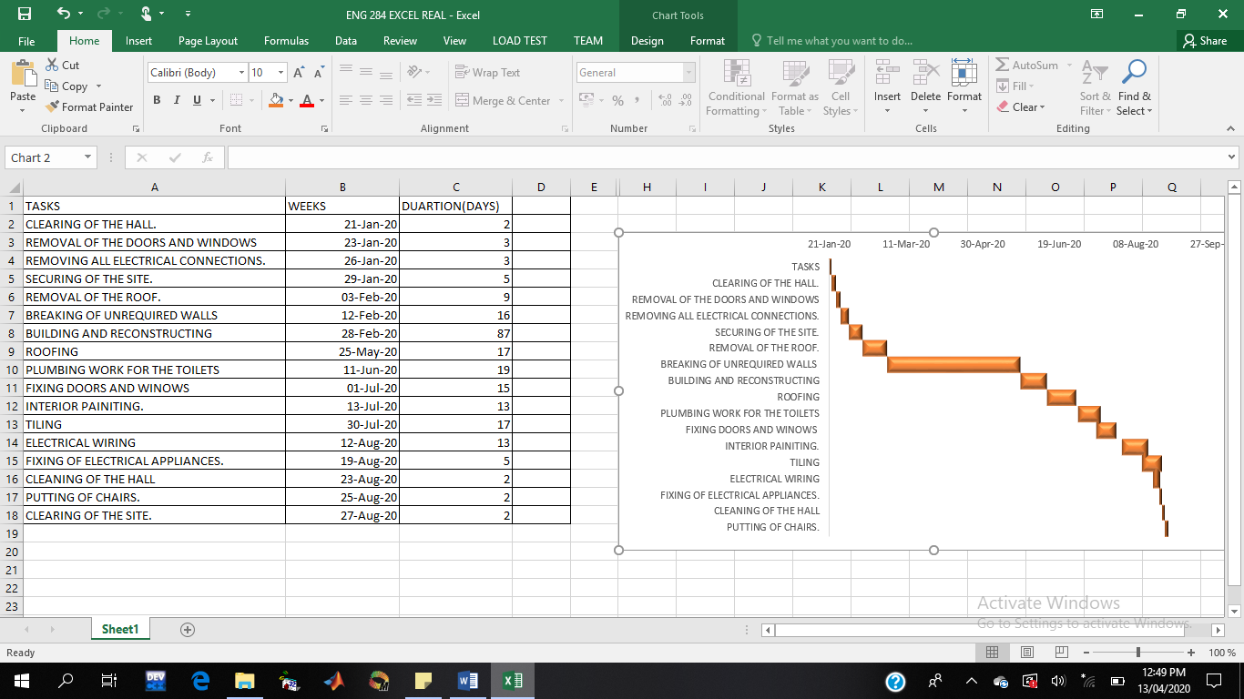

- Human resources refers to the personnel of a business or organization, regarded as a significant asset in terms of skills and abilities. So on this particular project, the project team includes the;

- The Architect.
- Civil / Structural Engineer.
- Contractor.
- Electrical Engineers.
- Artisans.
- Electricians.
- Builders.
- Plumbers.
- Those that will roof.
- Painters.
- Tilers
- Carpenters.
The Architect; An architect is someone who loves to design, and is specifically trained and licensed to work on the planning and design of buildings shall mean the professional architectural firm. This is the Prime Consultant and the Team Leader on building projects. He initiates, conceives and produces the Architectural Design, coordinates the input of other consultants and manages the project.
Civil / Structural Engineer; Civil engineering is a professional engineering discipline that deals with the design, construction, and maintenance of the physical and naturally built environment, including public works such as roads, bridges, canals, dams, airports, sewerage systems, pipelines, structural components of buildings, and railways. Structural engineers analyse, design, plan, and research structural components and structural systems to achieve design goals and ensure the safety and comfort of users or occupants. They are usually "Specialist Consultant" as well as Electrical Engineering, Quantity Surveying, Town Planning, relevant to the project other than Architecture.
Contractor; The contractor oversees and manages the construction of the building for the client, following the Architect and Engineer’s designs. The work is delivered under a contractual agreement
Artisans; is a skilled craft worker who makes or creates material objects partly or entirely by hand. They are the ones that usually do the manual labor.

- On a general note, a construction or building site is always made secure in case of vandalism, theft and sometimes terrorism. This building site was made secure because, a construction site usually can be hazardous and dangerous the moment safety measures are ignored thereby serving as a threat to life. So it was made secure so as to prevent unauthorized individuals (the students and staff of the institution) from wandering there and hurting themselves because, this site is located where civilians are. It also creates a boundary for dropping or placing various materials that are being used or removed the building.

5. TOTAL ESTIMATED COST IS 250,000,000 (BEME TABLE)
S/N | ITEMS | SPECIFICATION | QUANTITY | UNIT COST (#) | ESTIMATED TOTAL COST
1 | CEMENT | DANGOTE(50KG BAG) | 6000 | 2600 | 16,000,000
2 | PLANKS | 1 BY 12 | 700 | 1000 | 700,000
3 | STAINLESS STEEL | RAILINGS | 850 | 4500 | 3,825,000
4 | GRANITE | TRIPS OF 30 TONNES TRUCKS | 25 | 210,000 | 5,250,000
5 | SAND | TRIPS OF 30 TONNES TRUCKS | 35 | 60,000 | 2,100,000
6 | MOULDED BLOCKS | 9 INCHES BLOCK | 15000 | 250 | 3,750,000
7 | IRON RODS | 16MM RODS | 1500 | 4500 | 6,750,000
8 | ROOFING SHEETS |  |  |  | 5,450,000
9 | IRON BEAMS |  |  |  | 10,000,000
10 | ALUMINIUM ZINC |  |  |  | 1,095,000
11 | SUSPENDED CEILINGS | 2FT SQUARE | 200 | 400 | 80,000
12 | WIRES | FOR WIRING |  |  | 15,000,000
13 | TILES | FOR BATHROOMS AND MAIN HALL FLOOR | DEPENDS |  | 35,000,000
14 | PIPES | BOTH PLUMBING AND ELECTRICAL | DEPENDS |  | 1,000,000
15 | TOOLS | HANDTOOLS AND MACHINE TOOLS |  |  | 2,000,000
16 | LABOUR | 1.2 PERCENT OF TEC |  |  | 3,000,000
17 | MISCELLANEOUS | 10 PERCENT OF TEC |  |  | 25,000,000
18 | CONSULTANCY FEE | 15 PERCENT OF TEC |  |  | 37,500,000
19 | CLEARING OF SITE | 5 PERCENT OF TEC |  |  | 12,500,000
20 | TRANSPORT | 12 PERCENT OF TEC |  |  | 30,000,000
21 | PROFIT | 20 PERCENT OF TEC |  |  | 50,000,000
 | TOTAL ESTIIMATED COST |  |  |  | 250,000,000

6
 | PAYMENT SCHEDULE OF ALFA BELGORE HALL
 | TOTAL ESTIMATED COST(TEC) |  | 50,000,000
1 | MOBILIZATION=30% OF TEC |  | 15,000,000
 | 10% RETENTION ON MOBILIZATION |  | 1,500,000
 | AMOUNT PAID |  | 13,500,000
2 | 50% PROJECT COMPLETION= 30% OF TEC= |  | 15,000,000
 | 10% RETENTION ON SECOND PAYMENT = 10% OF 50% PROJECT COMPLETION= |  | 1,500,000
 | AMOUNT PAID |  | 13,500,000
3 | PROJECT COMPLETION AND HANDOVER=40% OF TEC= |  | 20,000,000
 | 10% RETENTION ON FINAL PAYMENT=10% OF PROJECT COMPLETION AND HANDOVER |  | 2,000,000
 | AMOUNT PAID= |  | 18,000,000
 | TOTAL RETENTION FOR 6 MONTHS DEFECT LIABILITY |  | 5,000,000
 | CHECK
 | TOTAL ESTIMATED COST (TEC)=TOTAL PAYMENT + RETENTION
 | TOTAL PAYMENTS= |  | 45,000,000
 | RETENTIONS |  | 5,000,000
 | TEC= |  | 50,000,000

7
A. Bill of Engineering Measurement and Evaluation (BEME); Bill of Engineering Measurement and Evaluation (BEME) also referred to as 'Bill'; is a tool. used before, during and post-construction to assess and value the cost of construction works
B. Defect liability period;A defect liability period is a period of time following practical completion during which a contractor remains liable under the building contract for dealing with any defects which become apparent A defects liability period is usually a period of around six or 12 months but it can vary depending on the contract used. Any defects or faults which arise during this period (for example - due to defective materials or workmanship) must be put right by the contractor at its own expense. It should be noted, however, that defects liability periods will only arise if they are included in the contract. Contractors therefore need to be aware that they do not have an automatic right to return to site to rectify a defect.
C. Lead consultants; are in charge of supervising a team of junior consultants. The lead consultant is the consultant that directs the work of the consultant team and is the main point of contact for communication between the client and the consultant team, except for on significant design issues where the lead designer may become the main point of contact.
D. Project Life Cycle; The Project Life Cycle refers to the step by step process that is followed by nearly all project managers when moving through stages of project completion. It usually includes; concept phase, design phase, procurement phase, construction phase and operation phase.
E. Environmental impact assessment; An environmental impact assessment (EIA) is a process to predict the environmental consequences of a project's development. By evaluating the project through the EIA, we can assess the environmental effects of each plan and select the plan that will suit our needs the most. It is a process of evaluating the likely environmental impacts of a proposed project or development, taking into account inter-related socio-economic, cultural and human-health impacts, both beneficial and adverse.

