AFE BABALOLA UNIVERSITY, ADO EKITI (ABUAD)

A TERM PAPER ON SOIL PERMEABILITY AND SOIL CAPILLARITY

BY: UDOBANG, ODOTEKOM PETER
MATRIC NO: 17/ENG03/052

A TERM PAPER SUBMITTED TO: ENGR. EMEKA NNOCHIRI OF THE CIVIL ENGINEERING DEPARTMENT, COLLEGE OF ENGINEERING, ABUAD, IN RELATION TO CVE 306, SOIL MECHANICS.

DATE: 14TH APRIL, 2020
ABSTRACT
In soil mechanics and the civil engineering field of learning, one must be familiar with how water enters, moves and how much water is flowing through a soil in unit time. This knowledge is essential to design earth dams, determine the quantity of seepage under hydraulic structures such as aqueducts and drainage trenches etc. and dewater before and during the construction of foundations.

TABLE OF CONTENTS
- INTRODUCTION
- SOIL PERMEABILITY
- IMPORTANCE OF SOIL PERMEABILITY
- FACTORS AFFECTING PERMEABILITY
- TEST FOR SOIL PERMEABILITY
- DARCY’S LAW
- SOIL CAPILLARITY
- SOIL SURFACE TENSION
- CAPILLARY RISE IN DIFFERENT SOILS
- RELATIONSHIP BETWEEN SOIL PERMEABILITY AND CAPILLARITY

INTRODUCTION
The amount, distribution, and the movement of water in soil have an important bearing on the properties and behaviour of soil. The civil engineer involved in any structural project should know the principles of fluid flow, as groundwater conditions are regularly encountered on construction projects. Soil Mechanics is the application of laws of mechanics and hydraulics to engineering problems dealing with sediments and other unconsolidated accumulations of solid particles, which are produced by the mechanical and chemical disintegration of rocks, regardless of whether or not they contain an admixture of organic constituents and clay minerals.
Soil consists of different phases of solid, liquid, and gas and its characteristics depend on the interacting behavior of these phases, and on the stress applied. The solid phase includes clay, non-clay minerals, and organic matter. These elements are categorized by their size as clay, sand, and gravel. The liquid phase is composed of water that contains organic compounds available from chemical spills, wastes, and ground water, while the gas phase is normally air.
The size, form, chemical properties, compressibility, and load carrying capability of the soil particles are determined by soil mineralogy, which is a science related with the chemistry, structure, and physical properties of minerals. The structure of a soil depends upon the arrangement of particles, particle groups, pore spaces, and the composition.
These basic characteristics determine the type of structure to be built and what external support measures, if any, has to be taken to make the structure last long and bear the effects of earthquake, water seepage, and other external factors. Water pressure is always measured relative to atmospheric pressure, and water table is the level at which the pressure is atmospheric. Soil mass is divided into two zones with respect to the water table:
- below the water table (a saturated zone with 100% degree of saturation) and
- (ii) just above the water table (called the capillary zone with degree of saturation ≤100%).
Below the water table, the pore water may be static or seeping through the soil under hydraulic potential. This chapter and the next have been devoted to give an accurate and complete knowledge of the water condition in the soil.
Soil is a particulate material and has pores that provide a passage for water. Such passages vary in size and are tortuous and interconnected. A sufficiently large number of such paths of flow are grouped to act together, and the average rate of flow is considered to represent a property of the soil. This property is termed permeability of the soil and may be defined as the capacity of a soil to permit water to pass through its interconnected void spaces.

SOIL PERMEABILITY
Soil permeability can be simply defined as the ease with which liquids, gases and plant roots pass through or penetrate through a bulk mass of soil or a certain layer of soil. The property of the soil by which it permits the flow of fluid through it is called permeability of the soil, the porosity in the soil material is contributed by the presence of gaps within it. The property of permeability emerges when these gaps are connected, bringing a pathway for the movement of fluids and gases as well, then generally, the soil is said to be porous and permeable in nature.

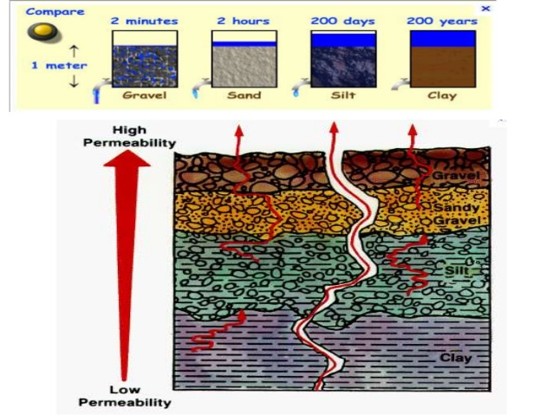

Permeability rates of different soils.

IMPORTANCE OF SOIL PERMEABILITY
- Permeability of soil influences the rate of settlement of a saturated soil under load during construction of underground or related structures such as tunnels, shafts or basements.

- The stability of slopes and structures such as dams and retaining walls can be greatly affected by the permeability of the soil involved in the aspect of sizing, foundation and positioning.

- The design and construction of earth dams is very much based upon the permeability of the soil involved as the integrity and strength of the structure might be compromised without knowledge of the soil permeability property

- Filters made of soils are designed based upon their permeability as it is essential to know the rate of movement of liquids through the interstices of soils used in water filters to remove impurities.

- Soil permeability is important as to determining the suitable residential areas where buildings and structures can be constructed and what methods to use.

FACTORS AFFECTING PERMEABILITY
For a civil engineer dealing with soils, the permeant is water, whose variation in property may be presumed to be very less. Thus, soil characteristics may have to be given more importance. The coefficient of permeability of a soil depends basically on the characteristics the soil medium. The major properties include; particle size, void ratio, composition, soil structure, and degree of saturation

Particle Size:

Permeability varies according to size of soil particle. If the soil is coarse grained, permeability is more and if it is fine grained, permeability is low. Therefore, the permeability of a bulk of gravel is more that that of a clay due to the sizes of the various soil unit particles.

- Void Ratio:
Permeability increases with void ratio but it is not applicable to all types of soils. Clay has high void ratio than any other types of soil but permeability for clays is very low. This is due to, the flow path through voids in case of clays is extremely small such that water cannot permit through this path easily. Different linear relationships have been attempted, relating void ratio and permeability like, k ∝ e3(1 + e), k ∝ e2, and log k ∝ e. These relationships have been found to indicate a straight-line relationship in non-cohesive soils but not in fine-grained soils.

- Soil Structure:

Structure of any two similar soil masses at same void ratio are not the same, it varies according to the level of compaction applied. If a soil contains flocculated structure, the particles are random and permeability is more in this case. If the soil contains dispersed structure, the particles are arranged hence, permeability is very low. The permeability of stratified soil deposits also varies according to the flow direction, if the flow is parallel, permeability is more but if it is perpendicular, permeability is less.
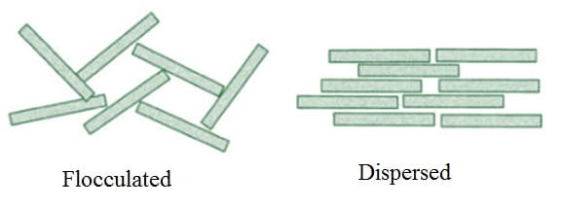
Soil Structures

- Degree of Saturation:
Partially saturated soil contains air voids which are formed due to entrapped air or gas released from the percolating fluid or water. This air will block the flow path thereby reduces the permeability, fully saturated soil is more permeable than partially saturated soil.

- Composition:
The effect of soil composition is more predominant in clayey soils than in silts and sands. Depending on the type of clay mineral and the exchangeable cation present in the clay, the permeability varies from 10–6 to 10–10 m/s, and accordingly the variation of void ratio is from 16 to 1. The effect of exchangeable ion on permeability is less for low ion exchange capacity of a soil.

TEST FOR SOIL PERMEABILITY

CONSTANT HEAD PERMEABILITY TEST:
The constant head permeability test is a laboratory experiment conducted to determine the permeability of soil. The soils that are suitable for this test are sand and gravels, soils with silt content cannot be tested with this method. The test can be employed to test granular soils either reconstituted or disturbed.

OBJECTIVE AND SCOPE;
The objective of constant head permeability test is to determine the coefficient of permeability of a soil.
Coefficient of permeability helps in solving issues related to:
- Yield of water bearing strata
- Stability of earthen dams
- Embankments of canal bank
- Seepage in earthen dams
- Settlement Issues
COEFFICIENT OF PERMEABILITY;
The coefficient of permeability, k is defined as the rate of flow of water under laminar flow conditions through a porous medium area of unit cross section under unit hydraulic gradient. The coefficient of permeability (k) is obtained from the relation;
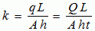
, Where q= discharge, Q=total volume of water, t=time period, h=head causing flow, L= length of specimen, A= cross-sectional area.

TEST PROCEDURE;
- Through the top inlet of the constant head reservoir, the specimen is connected.
- The bottom outlet is opened and a steady flow is established
- For a particular time interval, the quantity of flow can be collected.
- Measure the difference of head (h) in levels between the constant head reservoir and the outlet in the base.
- For the same interval, this is repeated three times.
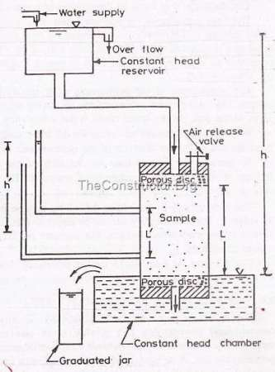
OBSERVATION: Initially, the flow is very slow. It later increases and will become constant. The constant head permeability test is best for cohesionless soils.

DARCY’S LAW
Darcy’s law states that the rate of fluid flow through porous medium is proportional to the potential energy gradient within that fluid. The constant of proportionality is the Darcy’s permeability of soil. Darcy’s permeability is a property of both porous medium and the fluid moving through the porous medium. Darcy’s flow velocity for laminar flow is defined as the quantity of fluid flow along the hydraulic gradient per unit cross sectional area. Velocity of flow through a porous media is directly proportional to the hydraulic gradient responsible for flow.
V = Ki = $K\frac{∆h}{L}$
Here,
- V = discharge velocity or superficial velocity
- k = coefficient of permeability or hydraulic conductivity
- i= hydraulic gradient
- = fall in total head
- L = length of soil specimen

VALIDITY OF DARCY’S LAW
Darcy’s law is valid only for slow and viscous flow, fortunately most groundwater flow cases fall in this category. Typically, any flow with a Reynolds number less than 1 is clearly laminar and it would be valid to apply Darcy’s law.

SOIL CAPILLARITY
Capillarity is the phenomenon by which water rises in a cylindrical column. The narrower the column the higher the capillarity; similarly, the denser the substratum present in the column, the higher the capillary effect. Capillarity is the phenomenon by which water rises in a cylindrical column. The narrower the column the higher the capillarity; similarly, the denser the substratum present in the column, the higher the capillary effect.
Soil Capillarity is the primary force that enables the soil to retain water, as well as to regulate its movement through out the layers of soil on the earth’s crust and through the roots and stems of plants from the soil which they reside on. In soil, there are millions of vertical channels/pipes called "capillary tubes". Whenever there is a downpour, excess water runs underground through these capillary tubes and when it is dry, these same tubes transport water to the surface.
Trees have their roots in these capillary tubes which also contain threads of fungi which are hygroscopic (attracting water) and with their lateral roots, they soak up capillary water when it is hot and dry. This is how a tree survives heat and drought. Even in rocks, minuscule and invisible fissures function as capillary tubes. Water molecules behave in two ways;
- Cohesion Force: Because of cohesion forces, water molecules are attracted to one another. Cohesion causes water molecules to stick to one another and form water droplets.
- Adhesion Force: This force is responsible for the attraction between water and solid surfaces. For example, a drop of water can stick to a glass surface as the result of adhesion.

CAPILLARY ACTION:
  - Capillary action, also referred to as capillary motion or capillarity, is a combination of cohesion/adhesion and surface tension forces.
  - Capillary action is demonstrated by the upward movement of water through a narrow tube against the force of gravity.
  - Capillary action occurs when the adhesive intermolecular forces between a liquid, such as water, and the solid surface of the tube are stronger than the cohesive intermolecular forces between water molecules.
  - As the result of capillarity, a concave meniscus (or curved, U-shaped surface) forms where the liquid is in contact with a vertical surface.
  - Capillary rise is the height to which the water rises within the tube, and decreases as the width of the tube increases. Thus, the narrower the tube, the water will rise to a greater height.
Capillarity in different sizes of tubes

SOIL SURFACE TENSION
Interconnected pore space in soils hold water due to surface tension effects. The pores in a soil act like capillaries that absorb and retain water, the smaller the pore, the larger the energy with which water is retained in the soil (large pores are easy to drain, and small ones are difficult to drain).
Water surfaces behave in an unusual way because of cohesion. Since water molecules are more attracted to other water molecules as opposed to air particles, water surfaces behave like expandable films. This phenomenon is what makes it possible for certain insects to walk along water surfaces.

CAPILLARY RISE IN DIFFERENT SOILS
The phenomenon of capillarity also occurs in the soil. In the same way that water moves upwards through a tube against the force of gravity; water moves upwards through soil pores, or the spaces between soil particles.
- The height to which the water rises is dependent upon pore size. As a result, the smaller the soil pores, the higher the capillary rise.
- Finely-textured soils typically have smaller pores than coarsely-textured soils. Therefore finely-textured soils have a greater ability to hold and retain water in the soil in the inter-particle spaces. We refer to the pores between small clay particles as micropores. In contrast, the larger pore spacing between lager particles, such as sand, are called macropores.
- In addition to water retention, capillarity in soil also enables the upward and horizontal movement of water within the soil profile, as opposed to downward movement caused by gravity. This upward and horizontal movement occurs when lower soil layers have more moisture than the upper soil layers and is important because it may be absorbed by roots.
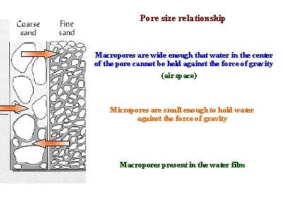

RELATIONSHIP BETWEEN SOIL PERMEABILITY AND CAPILLARITY
The size of the soil pores is of great importance with regard to the rate of infiltration (movement of water into the soil) and to the rate of percolation (movement of water through the soil). Pore size and the number of pores closely relate to soil texture and structure, and also influence soil permeability and capillarity as shown above.
The permeability of individual soil horizons may be evaluated by the visual study of particular soil characteristics which have been shown by soil scientists to be closely related to permeability classes. The most significant factor in evaluating permeability is structure: its type, grade, and aggregation characteristics, such as the relationship between the length of horizontal and vertical axes of the aggregates and the direction and amount of overlap, since the soil capillarity deals with the vertical movement of water molecules through the soil capillary pores against gravity, we can say that the greater the permeability of a soil sample, the less the capillarity of the soil sample.
Higher permeability means wider pores within the soil sample, therefore the surface tension existing will be less rather than more in a soil sample with less permeability. Hence, we can say that soil permeability is inversely proportional to capillarity.
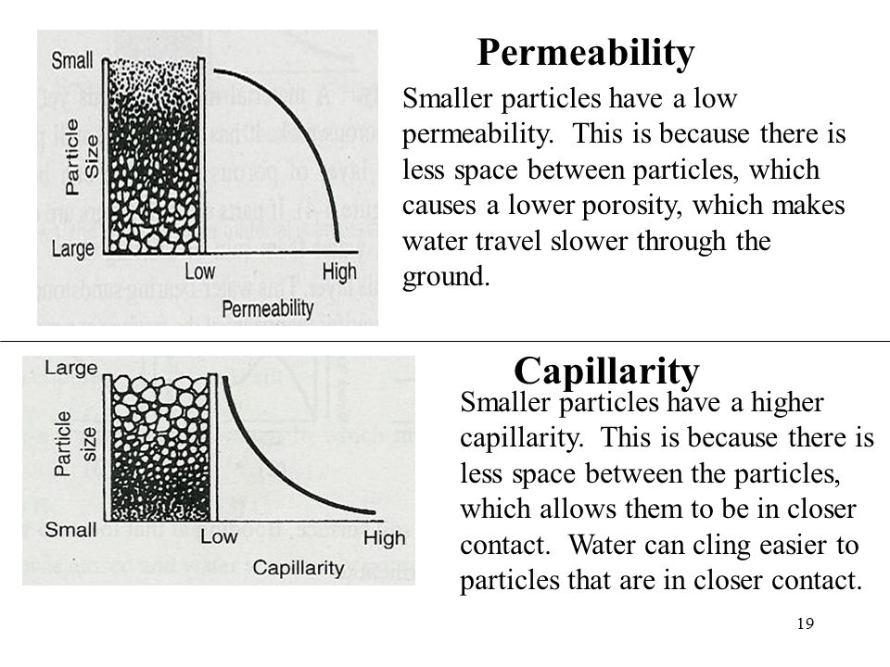

THANK YOU!

