A
TECHNICAL TERM PAPER REPORT
ON THE TOPIC
SOIL PEMEABILITY AND SOIL CAPILLARITY
BY
ADEPOJU, MARY ABIMBOLA
(17/ENG03/004)
SUBMITTED TO
ENGR. EMEKA
FROM THE
DEPARTMENT OF CIVIL ENGINEERING
COLLEGE OF ENGINEERING

CERTIFICATION

This is to certify that this TERM PAPER was carried out by ADEPOJU, MARY ABIMBOLA with matriculation number 17/ENG03/004 of the department of Civil Engineering, College of Engineering, AfeBabalola University, Ado Ekiti, Ekiti State; in partial fulfilment of the requirements for the award of Bachelor of Engineering (B.Eng) Degree in Civil Engineering.

DEDICATION
This technical TERM PAPER report is dedicated to God almighty, the maker of life. I would also like to dedicate it to my wonderful parents and family for their support.

ABSTRACT
This report is a detailed account made on the topic SOIL PERMEABILITY AND SOIL CAPILLARITY.

Contents

INTRODUCTION 6
CHAPTER ONE 7
SOIL PERMEABILITY 7
FACTORS AFFECTING PERMEABILITY OF SOILS 8
COEFFICIENT OF PERMEABILITY (HYDRAULIC CONDUCTIVITY) 9
IMPERMEABILITY 9
IMPORTANCE OF PERMEABILITY 10
CHAPTER TWO 11
CAPILLARITY OF SOILS 11
CAPILLARY RISE 13
FACTORS USED TO DETERMINE CAPILLARY RISE 13
IMPORTANCE OF CAPILLARITY 14
CHAPTER THREE 15
RELATIONSHIP BETWEEN SOIL PERMEABILITY AND SOIL CAPILLARITY 15
DIFFERENCE BETWEEN SOIL PERMEABILITY AND SOIL CAPILLARITY 15
CONCLUSION 16
REFERENCES 17

INTRODUCTION

Soil are permeable materials because of the presence of interconnected voids that permit the flow of fluids from location of high energy to locations of low energy.
The amount, distribution, and movement of soil have an important bearing I the properties and behaviour of soil. The engineer should know the principles of fluid flor, as groundwater conditions are frequently encontered on construction projects.
The ability of various soils and rocks to allow water to move up through them is capilarity. Capillarity dependson a rock’s porosity and permeability. The forces involvrd in capillarity are gravity pulling downward on the water, and attraction between water molecules and the molecules of the rock.

CHAPTER ONE
- SOIL PERMEABILITY

Permeability is the property of soils that allowa water to pass through them at some rate.
Soil permeability is a soil property which allows the seepage of fluid through its interconnected void spaces. The more permeable the soil, the greater the seepage. Some soil is so permeable and seepage is so great that it is not possible to build a structure without special construction technique.

FIG1.1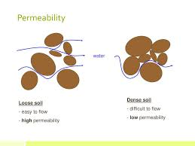
Soils are generally made up of layers and soil quality often varies greatly from one layer to another. Before any construction, it is important to determine the relative position of the permeable layers and impermeable layers. For example, the design of a pond should be planned to avoid having a permeable layer at thebottom to prevent excess water loss into the subsoil by seepage.

PERMEABILITY VARIATION IN SOILS
SOIL | K(CM/SEC) | DEGREE OF PERMEABILITY
Coarse gravel | >1 | High
Fine Gravel- Fine sand | 1 to 10⁻² | Medium
Silt-sand admixtures, loose silts, rock flour and loess | 10⁻² to 10⁻⁴ | Low
Dense silt, clay slit admixtures, non-homogenous clays | 10⁻⁴ to 10⁻⁶ | Very low
Homogenous clays | <10⁻⁶ | Impervious

  - FACTORS AFFECTING PERMEABILITY OF SOILS

There are a number of factors affecting the permeability of soils. They include:
- Particle size: permeability of coarse grained soil is very large as compared to that of fine grained soil.
- Impurities in water: the presence of impurities in soil decreases the permeability of soil.
- Void ratio: the greater the void ratio, the higher the value of the coefficient of permeability.
- Degree of saturation: the permeability of partially saturated soil is considerably smaller than that of fully saturated soil
- Absorbed water: permeability of soil reduces when there is an obtruction to the flow of water in pores.
- Entrapped air and organic matter: air entrapped in the soil and organic matter block the passage of water through the soil,hence permeability decreases.

  - COEFFICIENT OF PERMEABILITY (HYDRAULIC CONDUCTIVITY)

The coefficient of permeability is defined as the rate of flow per unit area of soil under init hydraulic gradient, it has the dimensions of velocity (L/T) such (cm/sec or ft/sec).
The coefficient of permeability is directly propotional to the square of particle sizes.
  - IMPERMEABILITY

Impermeability is a property which does not allow water or liquids to pass through a substance. An example of an impermeable substance is a rock (such as granite).
FIG1.2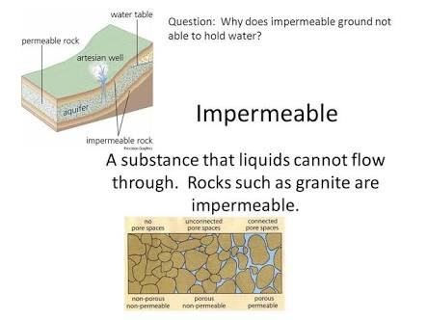

  - IMPORTANCE OF PERMEABILITY

The following are the importance of permeability in geotechnical design:
- The design of earth dams is very much based upon the permeability of the soils used.
- The stability of slopes and retaining structures can be greatly affected by the permeability of the soils involved.
- Filters made of soils are designed based upon their permeability.
- The rate of settlement of a saturated soil under land is influenced by permeability.

CHAPTER TWO
  - CAPILLARITY OF SOILS

Capillary action is the same effect that causes porous materials to soak up liquids. Capillary action is the movement of a liquid through or along another material against an opposing force such as gravity.
Capillarity is the primary force that enables soil to retain water as well as regulate its movement. Capillarity is a combination of cohesion/adhesion and surface tension force.
The phenomenon of capillarity also occurs in the soil. In the same way that water moves upwards through a tube against the force of gravity; water moves upwards through soil pores, or the spaces between soil particles. The height towhich rises is dependent upon pore size. As a result, the smaller the soil pores, the higher the capillary rise.
Finely-textured soils, like in maui, typically have smaller pores than coarsely-textured soils. Therefore finely-textured soils have a greater ability to hold and retain water in the soil in their inter- particle spaces. The pores between smaller particles, such as clay, are called micropores. However, pores between larger particles, such as sand, are called macropores.
FIG1.3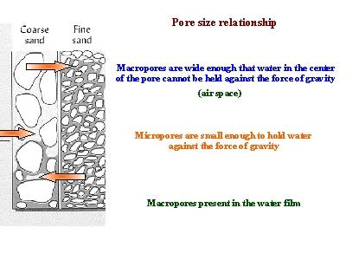

CAPILLARY RISE IN DIFFERENT SEDIMENTS
SEDIMENTS | UNIFORM GRAIN DIAMETER(cm) | PORES RADIUS(cm) | CAPILLARY RISE(cm)
Fine silt | 0.0008 | 0.0002 | 750
Coarse silt | 0.0025 | 0.0005 | 300
Very fine sand | 0.0075 | 0.0015 | 100
Fine sand | 0.015 | 0.003 | 50
Medium sand | 0.03 | 0.006 | 25
Coarse sand | 0.05 | 0.01 | 15
Very coarse sand | 0.2 | 0.04 | 4
Fine gravel | 0.5 | 0.1 | 1.5

  - CAPILLARY RISE

Capillary rise is a well known unsaturated soil phenomenon that describes the movement of pore water from lower elevation to higher elevation driven by the hydraulic head gradient acting across the couved air/pore water interface. Three fundamental practical characteristics related to capillary rise are of primary practical concern:
- The maximum height of capillary rise.
- The fluid storage capacity of capillary rise.
- The rate of capillary rise.

  - FACTORS USED TO DETERMINE CAPILLARY RISE

The factors needed for determining capillary rise includes:
- Diameter of capillary tube, which represents the diameter of pores in a soil.
- Density of the liquid.
- Viscosity of the liquid.
- Surface tension.

  - IMPORTANCE OF CAPILLARITY

The following are some importance of capillarity:
- Capillarity enables the soil to be able to regulate its movement through water retaining.
- Capillarity enables the upward movement and horizontal movement ofwater with the soil profile, as opossed to downward movement caused by gravity.
- Capillarity rise is important in the construction industry.

CHAPTER THREE
  - RELATIONSHIP BETWEEN SOIL PERMEABILITY AND SOIL CAPILLARITY

Permeability of soil and capillarity of soil both involves the presence of fluids contained in a soil. Soil permeability is a property that allows the seepage of fluids through its interconnected void spaces whereas, capillarity of soil is the property that enables fluids to be retained in the soil. Both soil capillarity and soil permeability are very important in the construction industry.

  - DIFFERENCE BETWEEN SOIL PERMEABILITY AND SOIL CAPILLARITY
The main difference between soil permeability and soil capillarity is that soil permeability increases as particle size increases whereas, soil capillarity increases as particle size decreases.

CONCLUSION
In conclusion, soil permeability and soil capillarity are both important properties in different kinds of soil. This property is very important to the construction industry.

REFERENCES
- www.wikipedia.org
- www.images.googles.com.ng
- www.google.com
- www.tutapoint.com
- www.geoteach.com

