KUNDE SHARON SEPINEN

17/ENG03/032

CIVIL ENGINEERING

CVE 306

SOIL MECHANICS

TERM PAPER

DEDICATION
This technical TERM PAPER is dedicated to God almighty. I would also like to dedicate it to my wonderful parents and family for their support.

ABSTRACT

Contents
INTRODUCTION 5
CHAPTER ONE 6
SOIL PERMEABILITY 6
FACTORS AFFECTING PERMEABILITY OF SOILS 7
COEFFICIENT OF PERMEABILITY (HYDRAULIC CONDUCTIVITY) 7
IMPORTANCE OF PERMEABILITY 9
CHAPTER TWO 10
CAPILLARITY OF SOILS 10
CAPILLARY RISE 11
FACTORS USED TO DETERMINE CAPILLARY RISE 12
CHAPTER THREE 13
RELATIONSHIP BETWEEN SOIL PERMEABILITY AND SOIL CAPILLARITY 13
CONCLUSION 14
REFERENCES 15

INTRODUCTION

Soil are permeable materials because of the presence of interconnected voids that permit the flow of fluids from locations of higher energy to locations of lower energy. Proper evaluation of soil permeability is required for calculatig the seepage under hydraulic structures and water quantities during dewatering activities. Soil permeability is affected by several factors.
Capillarity dependson a rock’s porosity and permeability.The ability of various soils and rocks to allow water to move up through them is capilarity. The forces involvrd in capillarity are gravity pulling downward on the water, and attraction between water molecules and the molecules of the rock.

CHAPTER ONE
- SOIL PERMEABILITY

Soil permeability :
Soil permeability is the soil property which allows the seepage of fluid through its interconnected void spaces. The more permeable the soil, the greater the seepage. Permeability is the flowof liquid medium (water) through the rock.
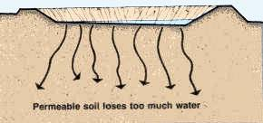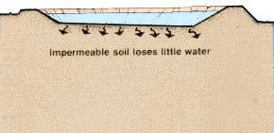
FIG1.1
Soils are permeable materials because of interconnected voids that permit the flow of fluids from locations of high energy to locations of low energy.

  - FACTORS AFFECTING PERMEABILITY OF SOILS

- Particle size:
Permeability of coarse grained soil is very large as compared to that of fine grained soil.
- Degree of saturation:
The permeability of partially saturated soil is considerably smaller than that of fully saturated soil
- Absorbed water:
Permeability of soil reduces when there is an obtruction to the flow of water in pores.
- Entrapped air and organic matter:
Air entrapped in the soil and organic matter block the passage of water through the soil,hence permeability decreases.
- Impurities in water:
The presence of impurities in soil decreases the permeability of soil.
- Void ratio:
The greater the void ratio, the higher the value of the coefficient of permeability.

  - COEFFICIENT OF PERMEABILITY (HYDRAULIC CONDUCTIVITY)

The coefficient of permeability is defined as the rate of flow per unit area of soil under init hydraulic gradient, it has the dimensions of velocity (L/T) such (cm/sec or ft/sec).
The coefficient of permeability is directly propotional to the square of particle sizes.

PERMEABILITY VARIATION IN SOILS
SOILS OR ROCK FORMATION | RANGE OF COEFFICIENT OF PERMEABILITY, K(cm/s)
Gravel | 1-5
Clean sand | 10⁻³ - 10⁻²
Medium-coarse sand | 10⁻³ - 10⁻¹
Very fine-fine sand | 10⁻⁴ - 10⁻³
Silty sand | 10⁻⁵ – 10⁻²
Homogenous clays | 10⁻⁹ – 10⁻⁷
Shale | 10⁻¹¹ – 10⁻⁷
Sandstone | 10⁻⁸ – 10⁻⁴
Limestone | 10⁻⁷ – 10⁻⁴
Fractured rocks | - – 10⁻²

1.4 IMPORTANCE OF PERMEABILITY

The following are the importance of permeability in geotechnical design:
- Permeability of soils is important in the design of earth dams
- The stability of slopes and retaining structures can be greatly affected by the permeability of the soils involved.
- Permeability of soils is used to make filters made of soils.
- The rate of settlement of a saturated soil under land is influenced by permeability.

CHAPTER TWO
- CAPILLARITY OF SOILS

Capillary action is also referred to as capillary motion. It is a combination of cohesion/adhesion and surface tension forces. Capillary action is demostrated by an upward movement of water through a narrow tube against the force of gravity.
Capillarity is the primary force that enables soil to retain water as well as regulate its movement. Capillarity is a combination of cohesion/adhesion and surface tension force.
The phenomenon of capillarity also occurs in the soil. In the same way that water moves upwards through a tube against the force of gravity; water moves upwards through soil pores, or the spaces between soil particles. The height towhich rises is dependent upon pore size.

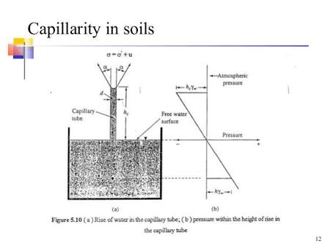

CAPILLARY RISE IN DIFFERENT SEDIMENTS
SEDIMENTS | GRAIN DIAMETER(mm) | EFFECTIVE PORES DIAMETER(mm) | CAPILLARY RISE(m)
Fine gravel | 5 | 2 | 0.015
Coarse sand | 0.5 | 0.2 | 0.15
Medium sand | 0.3 | 0.12 | 0.25
Fine sand | 0.15 | 0.06 | 0.50
Very fine sand | 0.075 | 0.03 | 1.0
Coarse silt | 0.025 | 0.01 | 3.0
Fine silt | 0.008 | 0.004 | 7.5
Coarse gravel | 0.002 | 0.0008 | 37.5
Fine clay | 0.0002 | 0.00008 | 375.0

  - CAPILLARY RISE

Capillary rise is the height to which the water rises within the tube, and decreases as the width of the tube increases.
Three fundamental practical characteristics related to capillary rise are of primary practical concern:
- The maximum height of capillary rise.
- The fluid storage capacity of capillary rise.
- The rate of capillary rise.

  - FACTORS USED TO DETERMINE CAPILLARY RISE

- Surface tension.
- Density of the liquid.
- Diameter of capillary tube, which represents the diameter of pores in a soil.
- Viscosity of the liquid.

CHAPTER THREE
- RELATIONSHIP BETWEEN SOIL PERMEABILITY AND SOIL CAPILLARITY

Permeability of soil and capillarity of soil both involves the presence of fluids contained in a soil. Soil permeability is a property that allows the seepage of fluids through its interconnected void spaces whereas, capillarity of soil is the property that enables fluids to be retained in the soil. Both soil capillarity and soil permeability are very important in the construction industry.

CONCLUSION

REFERENCES
- www.wikipedia.org
- www.images.googles.com.ng
- www.google.com

