NAME: OKORE KALU NNAMDI ERIC
MATRIC NO: 15/ENG03/020
COURSE: CVE 506

THE ESSENTIALS/FUNDAMENTALS OF THE TRANSPORTATION PLANNING PROCESS AND THE SOCIOECONOMIC IMPLICATIONS OF EACH OF THESE FUNDAMENTALS IN RELATION TO NATIONAL DEVELOPMENT.

Planning for effective development in the various sectors of Nigeria is a herculean task. Especially in the aspect of transportation which forms avital part of living. Transportation systems in Nigeria over the years and since independence has continued on a relatively slow pace and experienced a lot of problems. Inadequacies in this sector has grossly affected urban centres across the nation and as such greatly influenced the country’s economic and social growth.
It is imperative to note that transportation is a key element and major driver of development –economically and socially among other benefits. This view held by transportation engineers, scholars and professionals is clearly illustrated in the growth of developed countries. The economic status of advanced countries such as the United States of America, Germany and other African countries such South Africa is being examined to show the impact of effective transportation planning to economic and social development.
This paper explores the transportation planning process and the importance of transportation planning to the social and economic environment in Nigeria. It ventures further into the definition, structure and form of transport infrastructure in other countries relating them to the prevailing situation in Nigeria and thus by extension examines the problems of urban transit systems in the country as well as factors that impede growth and development in the sector. Strategies for addressing urban transportation systems in Nigeria would be treated stressing the importance of participation by the government and public (commuters)

THE TRANSPORTATION PLANNING PROCESS
Transportation planning is the development of a comprehensive plan for the construction and operation of transportation facilities. It is a cooperative process involving users of the system–business community, community groups, environmental organisations, commuters, freight operators, and the general public through a proactive public participatory process.
This dynamic and continuous process should be methodical as opposed to political, where decisions on construction and operation of transportation facilities are taken by political functionaries to gain short term popularity which often leads to piecemeal if not stale growth and development as is seen in Nigeria today. The process comprises of various elements as is found in the model planning process. Although similar, the model comprises of elements which are unique to transportation. The process as described in the fig. 1 illustrated below comprises of; statement of goal sand objectives, identification of needs, generation of alternatives, evaluation of alternatives and implementation of alternatives. It looks simple yet it is complex because it contains sub-issues that must be considered to achieve optimum success.
Transportation is intended to help cities and other areas anticipate problems and avoid them. Some of these problems of utmost importance include; congestion, economic development and safety. The model transportation planning process as explained by Department of Transportation, United States; must include a comprehensive study and analysis of the existing conditions, forecast of future population, employment growth, and identification of growth avenues in the city or area. Thirdly, long term plans and short-term programs of alternative capital improvement and operational strategies for moving people and goods must be developed. The next step involves estimating the impact of recommended future improvements to the transportation system on environmental features including air quality. Lastly, a financial plan for securing sufficient revenues to cover costs of implementation strategy must be developed.
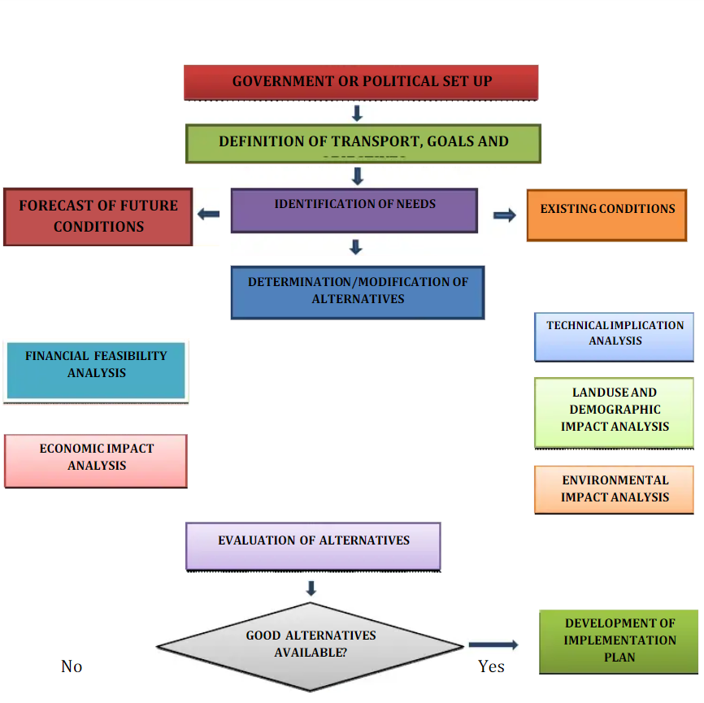
Figure 1 Transportation planning process

TRANSPORTATION AND ECONOMIC OPPORTUNITIES
Since the inception of the industrial revolution notable transportation developments have been linked to growing economic opportunities.
Transport modes have been developed human societal development. The first trade routes established a basic system of distribution and transact ions that would eventually be expanded by longdistance maritime shipping networks and the setting of the first multinational corporations thus showing that economic growth comes as a result of the composition of a variety of transport systems working in sync. Major flows of international migration that occurred since the 18thcentury were linked with the expansion of international and continental transport systems that radically shaped emerging economies such as in North America and Australia. Transport has played a catalytic role in these migrations, transforming the economic and social geography of many nations. Concomitantly, transportation has been a tool of territorial control and exploitation, particularly during the colonial era where resource based transport systems supported the extraction of commodities in the developing world and forwarded them to the industrializing nations of the timely, port development, particularly container ports, has been of strategic interest as a tool of integration to the global economy as illustrated in the case of china. While some regions benefit from the development of transport systems, marginalization sets in for others through a set of conditions in which inadequate transportation plays a role. It is pertinent to note that transportation in itself is not development but, the lack of transport infrastructures is a constraint on development. As is the case in developing countries, lack of transportation infrastructures and
regulatory impediments jointly affect economic development by conferring higher transport costs, among other issues. A poor transport service level can also negatively affect the competition between regions and corporations and thus have a negative impact on the regional added value and employment.
Investment in transport infrastructures is therefore a tool of regional development, particularly in developing countries and for the road sector. The standard assumption is that transportation investmentstend to be more wealth producing as opposed to wealthconsuming investments such as services. Still, several transportationinvestments can be wealth consuming if they merely provide convenience, such as parking and sidewalks, or service a market size well below any possible economic return, with for instance projects labelled "bridges to nowhere". In such a context, transport investment projects can be counter-productive by draining the resources of an economy instead creating wealth and additional opportunities. Efficient and sustainable transport markets and systems play a key role in regional development although the direction of causality between transport and wealth generation is not always clear. In a number of regions around the world, transport markets and related transport infrastructure networks are seen as key drivers in the promotion of a more balanced and sustainable development of the region or even the entire continent, particularly by improving accessibility and the situation of weaker regions and disadvantaged social groups. There is also a tendency for transport investments to have declining marginal returns. While initial infrastructure investments tend to have a high return since they provide an entirely new range of mobility options, the more the system is developed the more likely additional investment would result in lower returns. At some point, the marginal returns can be close to zero or even negative, implying a shift of transport investments from wealth producing to wealth consuming. A common fallacy is assuming that additional transport investments will have a similar multiplying effect than the initial investments had, which can lead to capital misallocation. This means quite understandably that the economic impacts of transport investments tend to be significant when infrastructures were previously inexistent or deficient and marginal when an extensive network is already present. Therefore, each development project must be considered independently.
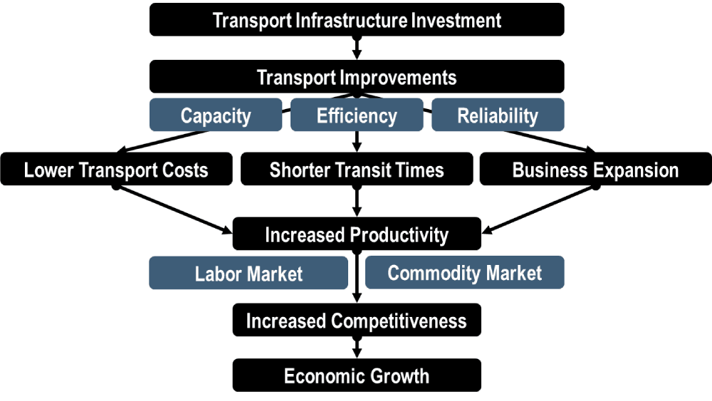
Figure 2 Transportation and economic development

TRANSPORTATION AND SOCIAL DEVELOPMENT
Access to essential products of society such as health care, education and employment are related to personal mobility and access to adequate transportation. Communities lacking mobility options are seen as less developed. This makes it even more difficult for them to access support and opportunities and makes it more difficult for governments to achieve the Millennium Development Goals, particularly reducing global poverty, combating epidemic diseases, reducing child mortality rates and introducing universal primary education. Access to goods and services depends not only on the physical availability of infrastructure (such as tracks, roads, and bridges) but also on access to vehicles and transport services, both public and private. Factors affecting access include location, cost, and frequency of services, journey time and physical accessibility. Transport provisions and social development is often seen as working inharmony based on its relationship when formulating transport policies, planning, procurement, monitoring and evaluation. Social development in the transport sector focuses generally on:
- Improving access to transport for everyone
- Mitigating the negative impacts of transport on society and communities (such as involuntary resettlement, pollution etc.) while maximising the opportunities that transport can present i.e. access to jobs, markets, education, etc.
- Using transport to promote and achieve social inclusion and cohesion
- Reducing the social and health risks and dangers associated with transport
- Sharing the social, economic and cultural benefits of transport more equally;
- Improving the design of transport systems and equipment so that they meet the needs of all, including users with specific needs (such as women, children, poor people, handicapped people, etc.);
- Ensuring public participation and representation in transport planning and decision-making.

In summary, transportation as a means to an end and not an end in itself enables people and businesses to access services and a whole lot of other interests while creating a more sustainable economy and healthy environment. Advances in transportation technology have had a very substantial impact on long distance and less regular travel. With the advents of the railways, intercity buses, air services and private cars, travel at long distance is now common, not only for extended vacations but even for a single day of weekend trips As mobility increases, the ability to Travel long distances has enabled people to travel to other sections of the country and even to other countries which have different cultures, dominant industries and patterns of living undoubtedly causing a very considerable effect in the level of understanding of different groups and the mutual respect of one socio-economic group for another. This has also helped to bring nations with multiple cultural heritages together. The increase in speed of transportation and the reduction in the costs of transportation have resulted in a much wider variety of special patterns for human activities. The world has been reduced into a global village as a result of development in transportation technology. Economic activities on the other hand are primarily concerned with the production, distribution and consumption of goods and services, which are of value to human. People must use the natural resources of the earth to satisfy the necessity of life, to provide food, clothing and shelter to the teeming population of the country not only for these basic necessities but also to use the resources to make life more pleasant, comfortable and rewarding. These resources are not usually found all in one place and no location is well endowed with all the resources. Thus, there is the universal need to transport some of these natural resources from places where they are abundantly available to areas where they are needed but not available. Most communities now consume food items produced in distance places because the cost of transportation is low. Such communities may exchange these distant products with the ones they produce locally. As a result of reduced cost of transportation, there have been some substantial shifts in the location or points of extraction of raw material. For example, the location of Kaduna Refinery in Nigeria, far away from the oil producing areas is economically attractive because of the cheapness of transportation.

