SOIL PERMEABILITY AND CAPILLARITY
BY MKPOUTO UBONG OBOT
MATRIC NO: 17/ENG03/015
A TERM PAPER SUBMITTED TO: THE DEPARTMENT OF CIVIL ENGINEERING, COLLEGE OF ENGINEERING, ENG. NNOCHIRI, EMEKA SEGUN

ABSTRACT
Soils are permeable materials because of the existence of interconnected voids that allow
the flow of fluids when a difference in energy head exists. A good knowledge of soil permeability is needed for estimating the quantity of seepage under dams and dewatering to facilitate underground construction. Soil permeability, also termed hydraulic conductivity, is measured using several methods that include constant and falling head laboratory tests on intact or reconstituted specimens. Alternatively, permeability may be measured in the field using insitu borehole permeability testing, and field pumping tests. A less attractive method is to empirically deduce the coefficient of permeability from the results of simple laboratory tests such as the grain size distribution.
Capillarity is a particularly important fluid property of groundwater flow and is important in determining the movement of contaminants above the water table.

TABLE OF CONTENT

Introduction…………………………………… 5

Soil permeability……………………………… 6

Factors affecting soil permeability……………………… 6

Permeability variations according to soil texture………. 7

Types of Permeability………………………………….. 7

Ways to determine Permeability……………………….. 7

Soil Capillarity……………………………….. 8

Application of soil capillarity………………………….. 8

Conclusion………………………………….... 9

References…………………………………… 10

FIGURES
Figure 1……………………………………………………………. 6
Figure 2……………………………………………………………. 8

TABLE
Table 1……………………………………………………………. 6

INTRODUCTION
Soils are permeable materials because of the presence of interconnected voids that permit the flow of fluids from locations of high energy to locations of low energy. Proper measurement/evaluation of soil permeability is required for calculating the seepage under hydraulic structures and water quantities during dewatering activities. Soil permeability is affected by several factors including voids ratio, distribution of inter-granular pores, and degree of saturation. The discussion presented
herein is limited to evaluating the coefficient of permeability of saturated soils. The coefficient of permeability exhibits a wide range of values up to 10 orders of magnitude from coarse to very fine grained soils. Furthermore, previous studies on the coefficient of permeability show that the coefficient of permeability is highly variable within the same deposit with a coefficient of variation as high as 240%. Laboratory constant and falling head permeability tests are easy to perform. However, it is very difficult and expensive to obtain undisturbed samples from granular soil deposits. Accordingly, these tests are typically performed on specimens reconstituted to relative densities ‘‘close” to those from the field. Thus, the measured permeability may not be representative of the field permeability because the soil fabric is destroyed due to sampling techniques. Field permeability tests offer another technique for measuring permeability without sample disturbance.
The phenomenon of capillarity results from two opposing forces: liquid adhesion to solid surfaces, which tends to spread the liquid; and the cohesive surface tension force of liquids, which acts to reduce liquid-gas interfacial area. The resulting liquid-gas interface configuration under equilibrium reflects a balance between these forces. The phenomenon of capillarity is thus dependent on solid and liquid interfacial properties such as surface tension, contact angle, a solid surface roughness and geometry.

SOIL PERMEABILITY
Soil permeability is the property of the soil to transmit water and air.
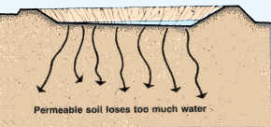
Figure 1

FACTORS AFFECTING SOIL PERMEABILITY
Many factors affect soil permeability. Sometimes they are extremely localized, such as cracks and holes, and it is difficult to calculate representative values of permeability from actual measurements. A good study of soil profiles provides an essential check on such measurements. Observations on soil texture, structure, consistency, color/mottling, layering, visible pores and depth to impermeable layers such as bedrock and clay pan form the basis for deciding if permeability measurements are likely to be representative.
The size of the soil pores is of great importance with regard to the rate of infiltration (movement of water into the soil) and to the rate of percolation (movement of water through the soil). Pore size and the number of pores closely relate to soil texture and structure, and also influence soil permeability.

PERMEABILITY VARIATIONS ACCORDING TO SOIL TEXTURE

Soil | Texture | Permeability
Clayey soil | Fine | From very slow to very rapid
Loamy soil | Moderately fine  Moderately coarse | From very slow to very rapid
Sandy soil | Coarse | From very slow to very rapid

TYPES OF PERMEABILITY
- Absolute permeability
- Effective permeability
- Relative permeability

WAYS TO DETERMINE PERMEABILITY
- Flow rate
- Downstream pressure
- Viscosity of air at test temperature
- Core cross sectional area
- Core length
- Upstream pressure

Coefficient of permeability is the rate of flow under laminar flow conditions through a unit cross sectional area of porous medium under unit hydraulic gradient.

SOIL CAPILLARITY
Capillarity is the ability of a liquid to flow in a narrow space without the assistance of, or even in opposition to, external forces like gravity.
Capillary action of soil is the attraction of water molecules to soil particles.
Clay soil has the highest capillarity, followed by loam soil and then sandy soil. Clay soil has the highest capillarity because capillarity depends on the size of the spaces between soil particles. The smaller the spaces, the higher the water rises in the soil. This means that clay soil allows water to rise highest compared to sand soil and loam soil. Water tends to rise very fast in sand soil but after a while, it slows down.
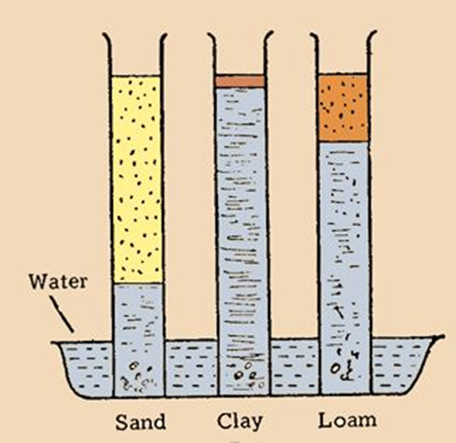
Figure 2

APPLICATION OF SOIL CAPILLARITY
- The rise and fall of liquid in capillary tube.
- Oil rising in the long narrow spaces between the threads of the wick.
- Towels soak water on account of capillarity.

CONCLUSION
Permeability was measured using field falling head permeability and full scale pumping tests. The recorded values of permeability exhibited natural variability within the expected range of 240%. The falling head test measures the permeability at specific depths yielding a detailed permeability profile versus depth. Conversely, the pumping test provides an average permeability for the soil stratum. The measured permeability values lie within the typical ranges for sands and silty sands. The permeability profiles from both field tests demonstrate that the permeability decreases with depth, which reflects the effects of increasing soil compactness and cementation with depth. The coefficient of permeability was also empirically evaluated using the cone penetration test results based on the mechanical response of the soil during penetration. In general, the permeability values obtained using the CPT were in agreement with the field measured values. The CPT was used to estimate permeability in the top uncommented sand layer as the cone penetrometer could not penetrate the cemented sand layers.

REFERENCES
[1] ASTM D2434, Standard Test Method for Permeability of
Granular Soils (Constant Head), 2006.
[2] J. Hvorslev, Time lag and soil permeability in ground water
observations, in: US Waterways Experiment Station Bulletin,
US Army Corps of Engineers, Vicksburg, 1951, 36 pages.
[3] BS 5930, Code of Practice for Site Investigations, British
Standards Institution, 1999, 191 pages.
[4] ASTM D6391, Standard Test Method for Field Measurement of
Hydraulic Conductivity Using Borehole Infiltration, 2011.
[5] W.D. Reynolds, A generalized variable-head borehole
permeameter analysis for saturated, unsaturated, rigid or
deformable porous media, Eng. Geol. 185 (2015) 10–19.
[6] A. Ufuk Sahin, A new parameter estimation procedure for
pumping test analysis using a radial basis function collocation
method, Environ. Earth Sci. 75 (2016) 200.
[7] BS 6316, Code of Practice for test pumping of water wells,
British Standards Institution, 1992.
[8] A. Hazen, Some Physical Properties of Sands and Gravels, with
Special Reference to their Use in Filtration, 24th Annual
Report, Massachusetts State Board of Health, Pub. Doc. No.
34, 1892, pp. 539–556.
[9] P.C. Carman, Flow of Gases through Porous Media,
Butterworths Scientific Publications, London, 1956.
[10] W.D. Carrier, Goodbye, Hazen; Hello, Kozeny-Carman, J.
Geotech. Geoenviron. Eng. (2003) 1054–1056.

