“A TERM PAPER ON SOIL PERMEABILITY AND CAPILLARITY”
PREPARED BY
OKIEMUTE WATERWAY
(17/ENG03/056)
SUBMITTED TO
ENGR. NNOCHIRI, EMEKA SEGUN
DEPARTMENT OF CIVIL ENGINEERING,
AFE BABALOLA UNIVERSITY, ADO-EKITI, EKITI, NIGERIA.

SOIL MECHANICS - CVE 306

ABSTRACT
The permeability of soil is defined as how water and air are able to move through the soil. In the case of rainfall or irrigation, water moves very easily through highly permeable soils and very slowly through soils with low permeability. The permeability of a soil can be determined by calculating its infiltration rate. A good knowledge of soil permeability is needed for estimating the quantity of seepage under dams and dewatering to facilitate underground construction. Soil permeability, also termed hydraulic conductivity, is measured using several methods that include constant and falling head laboratory tests on intact or reconstituted specimens.

INTRODUCTION
What is Permeability?
Permeability is the capacity of a soil to allow water pass through it. Soil are permeable due to the existence of interconnected voids through which water flows form one point of higher energy to a point of lower energy. Proper measurement/evaluation of soil permeability is required for calculating the seepage under hydraulic structures and water quantities during dewatering activities. Soil permeability is affected by several factors including voids ratio, distribution of inter-granular pores, and degree of saturation. The discussion presented herein is limited to evaluating the coefficient of permeability of saturated soils. The coefficient of permeability exhibits a wide range of values up to 10 orders of magnitude from course to very fine grained soils.

Importance of permeability
- Permeability influences the rate of settlement of a saturated soil under load
- The design of earth dams is based on the permeability of the soil used.
- The stability of sloped and retaining structure can be greatly affected by the permeability of the soils involved.
- Filters made of soil are designed based on permeability.

Factors Affecting Soil Permeability
- Void Ratio
- Particle size
- Temperature of the soil
- Shape of particles of the soil
- Properties of pore fluids
- Structure of mass of the soil
- Water absorbed
- Degree of saturation

- Void Ratio: It is the ratio of the volume of voids to the volume of solids. Increase in void ratio increases the area available for flow hence permeability increases for critical conditions
- Particle size: The Permeability varies approximately as the square of grain size. It depends on the effective diameter of the grain size.
- Temperature of the soil: As the viscosity of the pore fluid decreases with the temperature, permeability increases with temperature.
- Shape of particles of the soil: Permeability is inversely proportional to specific surface e.g. as angular soil have more specific surface area compared to the round soil therefore, the soil with angular particle is less permeable than soil of rounded particles.
- Properties of pore fluids: Pore fluids are fluids that occupy spaces in a soil or a rock
- Structure of mass of the soil: For same void ratio the permeability is more for flocculent structure as compared to the dispended structure.
- Water absorbed: Absorbed water means a thin microscopic film of water surrounding individual soil grains. The water is not free to move and hence reduces the effective pore space as thus decreases coefficient of permeability.
- Degree of saturation: The permeability of partially saturated soil is less than that of fully saturated soil.

Permeability Test
There are two main ways to perform the soil permeability test: the constant head and falling head methods. The constant head permeability test is best performed on highly granular soils without much sand or silt, and can yield accurate results even if the sample has been disturbed or reconstituted. The falling head method, on the other hand, is better for fine-grained soils like silts and clays, and is most accurate when applied to undisturbed samples.

CONSTANT HEAD TEST PROCEDURE
The constant head test is performed using a test apparatus with a reservoir on the top and bottom one for holding de-aired water and another for holding the water that permeated the soil sample. The hydraulic conductivity of these samples will be rather quick since they have larger grains. After a set amount of time, the coefficient of permeability can be calculated using the height and cross section of the soil sample, as well as the pressure measurements and the volume of water that flowed through the sample during the set time interval. Repeat the test at least three times to find an average coefficient.

FALLING HEAD TEST PROCEDURE
Rather than reservoirs, the falling head permeability test is performed using a standpipe and a relatively small soil sample. The reason for the small sample size is because the hydraulic conductivity will be slower due to the closer texture of the clays, silts or sands being tested. The soil sample is placed in a container and saturated with water, then it is attached to standpipes filled with de-aired water to a specific level. A lower water level is also determined, and once the water in the standpipe has reached that level, the coefficient of permeability can be calculated using the size of the soil sample, the cross section of the standpipe, the change in water level and the time it took to reach that level.
Formula and Determination of hydraulic conductivity
There are relatively simple and inexpensive laboratory tests that may be run to determine the hydraulic conductivity of a soil: constant-head method and falling-head method.

Constant-head method
Use a permeameter to conduct a Constant-Head Test, the most commonly used test to determine the saturated hydraulic conductivity of coarse-grained soils in the laboratory. Subject a cylindrical soil sample of cross-sectional area A and length L is to a constant head (H2 - H1) flow. The volume (V) of the test fluid that flows through the system during time (t), determines the saturated hydraulic conductivity K of the soil:
K=VL ÷ [At (H2-H1)]
For best results, test several times using different head differences

Falling head method
Use the Falling-head test to determine the K of fine-grained soils in the laboratory. Connect a cylindrical soil sample column of cross-sectional area (A) and length (L) to a standpipe of cross-sectional area (a), in which the percolating fluid flows into the system. Measure the change in head in the standpipe (H1 to H2) at intervals of time (t) to determine the saturated hydraulic conductivity from Darcy's Law:
K= (aL ÷ At) ln (H1 ÷ H2)

What is Soil Capillarity?
Capillarity is the phenomenon by which water rises in a cylindrical column. The narrower the column the higher the capillarity; similarly, the denser the substratum present in the column, the higher the capillary effect. This is the reason why clayey and loamy soils are better options when it comes to growing healthy plants; along with being rich in nutrients it also retains moisture and helps water reach the transport channels of plants thereby helping them grow well.
Capillary action is the same effect that causes porous materials, such as sponges, to soak up liquids.
- Capillarity is the primary force that enables the soil to retain water, as well as to regulate its movement.
  - The phenomenon of capillarity also occurs in the soil. In the same way that water moves upwards through a tube against the force of gravity; water moves upwards through soil pores, or the spaces between soil particles.
  - The height to which the water rises is dependent upon pore size. As a result, the smaller the soil pores, the higher the capillary rise.
  - Finely-textured soils, like in Maui, typically have smaller pores than coarsely-textured soils. Therefore, finely-textured soils have a greater ability to hold and retain water in the soil in the inter-particle spaces. We refer to the pores between small clay particles as microspores. In contrast, the larger pore spacing between lager particles, such as sand, are called macrospores.
  - In addition to water retention, capillarity in soil also enables the upward and horizontal movement of water within the soil profile, as opposed to downward movement caused by gravity. This upward and horizontal movement occurs when lower soil layers have more moisture than the upper soil layers and is important because it may be absorbed by roots.
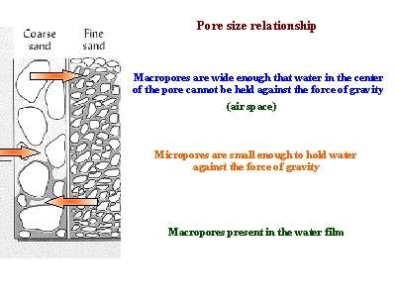
Surface Tension in Soils
Interconnected pore space in soils hold water due to surface tension effects. The pores in a soil act like capillaries that absorb and retain water. The smaller the pore, the larger the energy with which water is retained in the soil (large pores are easy to drain, and small ones are difficult to drain). The Figure shows soil moisture content versus retention energy. Note how soil texture influences shape of the curve. Soils with large pores tend to hold less water and drain quicker than soils with fine textures.
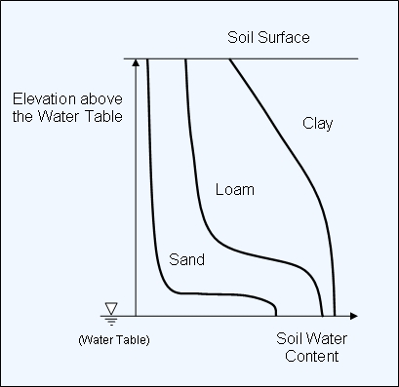
Soils are porous media that can be viewed as bundles of complex capillary tubes of different sizes. The coarser the texture of the soil the larger the pores. Thus, one can expect that in coarse texture soils capillary rise will be smaller than in fine texture soils. If soil moisture is measured from the surface of a water table upwards it can be seen that texture has an important effect on it's distribution.

Capillary rise
The combination of adhesion forces, between water molecules and solid wall, and cohesion forces, between water molecules, causes water to rise in capillary tubes and soil pores above the free water level. The adhesion forces cause the rise in capillary, and the cohesion brings all the water molecules together to follow the upward pull. The analyses by several researchers show that the wall of the capillary tube exerts an upward force on the water through the surface free energy difference(T T_{SV} 𝞱 _{SW}), where T_{SV} and T_{SW} are the interfacial surface tension between solid-vapor and solid-water respectively. As mentioned before, the concave curvature indicates the presence of pressure difference across the meniscus. The pressure below the meniscus will be smaller than the atmospheric pressure, above the meniscus. This is because the water in the capillary tube is suspended from the meniscus, which in turn is attached to the walls by hydrogen bonds. Therefore, the water is under tension, which is defined as “negative pressure”. According to several other researchers, the pressure difference across the meniscus in the capillary is responsible for the rise of water in capillary tube.
Capillary rise is also explained in terms of the surface forces around the periphery of the meniscus. The straight-wall capillary due to upward force from the meniscus πdTcos𝞱 is balanced by the weight of the water column. The height of the capillary tube, h_{c}, can be expressed from this force equilibrium as
4Tcos𝞱
h_{c} = (3.2)
pgd
which can also be derived after substituting h_{c}pg in Eq. (1) for the gauge water pressure. The contact length between the top of the water column and the tube is proportional to the diameter of the tube, while the weight of the liquid column is proportional to the square of the tube's diameter. Thus, a narrow tube will draw a liquid column higher than a wider capillary tube as shown in Fig. 3.5. The capillary water can rise up to several meters above the free water level when the capillary diameter is very small, which is typical in clay soils where the capillary rise extends several tens of meters above the water table.
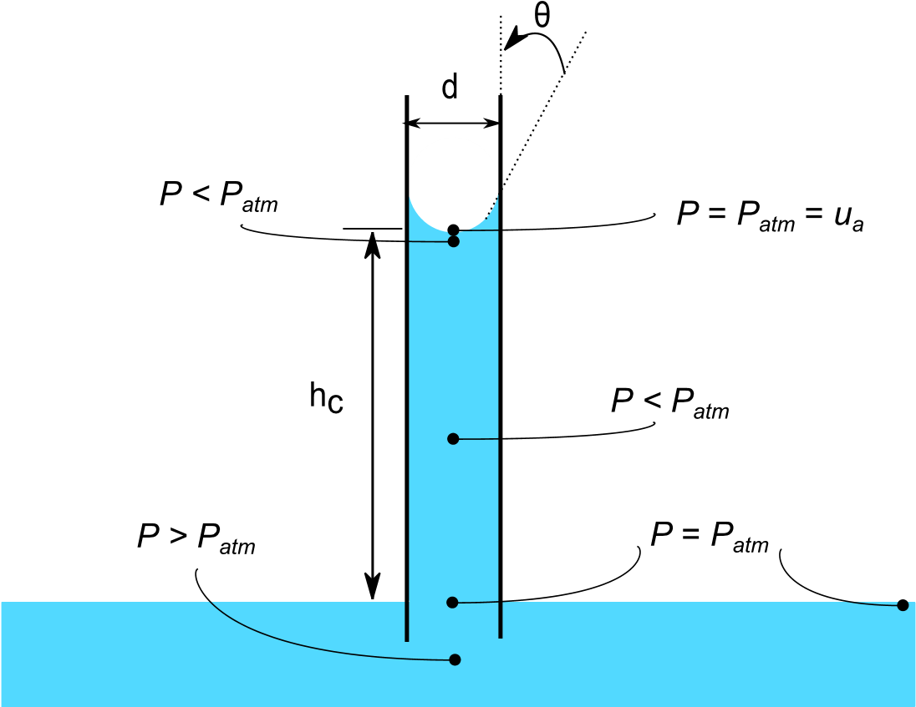
Fig. 3.4. Capillary rise

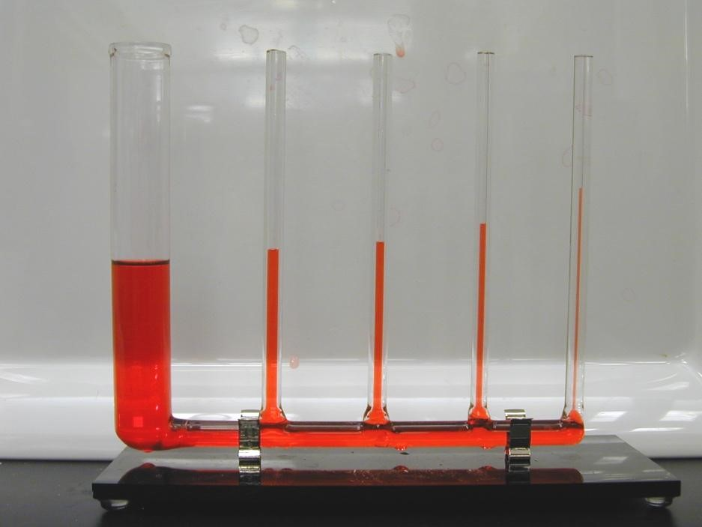

Fig. 3.5. . An illustration of capillary rise in tubes containing different diameters

The concept of capillary rise is very important in unsaturated soil mechanics for understanding the natural moisture levels within the soil above the water table. Several models have been proposed by earlier researchers for predicting the ultimate height and rate of capillary rise in unsaturated soils based on the statistical variations in the pore geometries and hydraulic conductivities.

Conclusion

Permeability - The permeability of rock is its capacity for transmitting a fluid. ... Porosity determines how much water rock material or soil is able to store (hold). Capillarity - The action by which a fluid, such as water, is drawn up in small pore spaces as a result of surface tension

