NAME: SANNI ABDULRAHMAN O.

MAT NO: 17/ENG03/050

COURSE: CVE 306 (SOIL MECHANICS)

TABLE OF CONTENT
- Introduction……………………………………………………………1
- Soil permeability……………………………………………………..1
- Importance of soil permeability……………………………….1-2
- Factors affecting soil permeability……………………………..2-4
- Hydraulic conductivity………………………………………………….4-5
- Soil capillary…………………………………………………………………..5-9
- Relationship between soil permeability and capillary……….9
- Summary…………………………………………………………………………10

Soil permeability is the property of the soil to transmit water and air and is one of the most important qualities to consider for fish culture. A pond built in impermeable soil will lose little water through seepage. The more permeable the soil, the greater the seepage. Permeability refers to the movement of air and water through the soil, which is important because it affects the supply of root-zone air, moisture, and nutrients available for plant uptake

IMPORTANCE OF SOIL PERMEABILITY
- Soil permeability is the property of the soil to transmit water and air and is one of the most important qualities to consider for fish culture.

- The more permeable the soil, the greater the seepage. Some soil is so permeable and seepage so great that it is not possible to build a pond without special construction techniques.

- A pond built in impermeable soil will lose little water through seepage. While if a pond is built on a permeable soil won’t lose water.

- Soils are generally made up of layers and soil quality often varies greatly from one layer to another. Before pond construction, it is important to determine the relative position of the permeable and impermeable layers. The design of a pond should be planned to avoid having a permeable layer at the bottom to prevent excessive water loss into the subsoil by seepage.

- For agriculture and conservation uses, soil permeability classes are based on permeability rates, and for civil engineering, soil permeability classes are based on the coefficient of permeability.

FACTORS AFFECTING SOIL PERMEABILITY

A number of factors affect the permeability of soils, from particle size, impurities in the water, void ratio, the degree of saturation, and adsorbed water, to entrapped air and organic material. Sometimes they are extremely localized, such as cracks and holes, and it is difficult to calculate representative values of permeability from actual measurements. A good study of soil profiles provides an essential check on such measurements. Observations on soil texture, structure, consistency, colour/mottling, layering, visible pores and depth to impermeable layers such as bedrock and clay pan* form the basis for deciding if permeability measurements are likely to be representative.

TEST FOR SOIL PERMEABILITY
The constant head permeability test is a laboratory experiment conducted to determine the permeability of soil. The soils that are suitable for this tests are sand and gravels. Soils with silt content cannot be tested with this method. The test can be employed to test granular soils either reconstituted or disturbed.

A simple field test for estimating soil permeability
- Dig a hole as deep as your waist
- Early in the morning, fill it with water to the top
- By the evening, some of the water will have sunk into the soil
- Fill the hole with water to the top again, and cover it with boards or leafy branches
- If most of the water is still in the hole the next morning, the soil permeability is suitable to build a fish-pond here
- Repeat this test in several other locations as many times as necessary, according to the soil quality.

A more precise field test for measuring permeability rates
- On the basis of texture and structure, determine which soil horizons seem to have the slowest permeability
- Dig a hole approximately 30 cm in diameter until you reach the uppermost least permeable horizon
- Thoroughly smear the sides of the hole with heavy wet clay or line them with a plastic sheet, if available, to make them waterproof
- Pour water into the hole to a level of about 10 cm
- At first, the water will seep down rather quickly, and you will have to refill as it disappears. When the pores of the soil are full of water, seepage will slow down. You are then ready to measure the permeability of the soil horizon at the bottom of the hole
- Make sure that the water in the hole is about 10 cm deep as before. If it is not, add water to reach that level
- Put a measuring stick into the water and record the exact water depth
- Check the water level in the hole every hour for several hours. Record the rate of seepage for each hourly period. If the water disappears too rapidly, add water to bring the level up to 10 cm again. Measure the water depth very carefully
- When your hourly measurements become nearly the same, the rate of permeability is constant and you may stop measuring
- If there are great differences in seepage each hour, continue pouring water into the hole to keep the level at 10 cm until the rate of seepage remains nearly the same;
- If the permeability rate is faster than 5 mm/h, this may be owing to a strongly developed structure in the soil. In such cases, you try to reduce the permeability rate by destroying the structure.
- Puddle the bottom soil of the hole as deep as you can
- Repeat the more precise permeability test until you can measure a nearly constant value for seepage

HYDRAULIC CONDUCTIVITY
Hydraulic conductivity, symbolically represented as K, is a property of vascular plants, soils and rocks, that describes the ease with which a fluid (usually water) can move through pore spaces or fractures. It depends on the intrinsic permeability of the material, the degree of saturation [disambiguation needed], and on the density and viscosity of the fluid. Saturated hydraulic conductivity, K, describes water movement through saturated media. By definition, hydraulic conductivity is the ratio of velocity to hydraulic gradient indicating permeability of porous media.

METHODS OF DETERMINATION
There are two broad categories of determining hydraulic conductivity:
- Empirical approach by which the hydraulic conductivity is correlated to soil properties like pore size and particle size (grain size) distributions, and soil texture
- Experimental approach by which the hydraulic conductivity is determined from hydraulic experiments using Darcy's law
The experimental approach is broadly classified into:
- Laboratory tests using soil samples subjected to hydraulic experiments
- Field tests (on site, in situ) that are differentiated into:
  - small scale field tests, using observations of the water level in cavities in the soil
  - Large scale field tests, like pump tests in wells or by observing the functioning of existing horizontal drainage systems.
The small scale field tests are further subdivided into:
- infiltration tests in cavities above the water table
- slug tests in cavities below the water table
The methods of determination of hydraulic conductivity and other related issues are investigated by several researchers.

SOIL CAPILLARITY
Capillary action is the same effect that causes porous materials, such as sponges, to soak up liquids. Capillarity is the primary force that enables the soil to retain water, as well as to regulate its movement.
Capillary action is the ability of a liquid to flow in narrow spaces without the assistance of ... drive capillary action in soil.

CAPILLARY RISE
Capillary rise is a well-known unsaturated soil phenomenon that describes the movement of pore water from lower elevation to higher elevation driven by the hydraulic head gradient acting across the curved pore air/pore water interface.
A rigorous closed-form analytical solution is developed for analyzing the rate of capillary rise in soils. The new solution can be reduced to Terzaghi’s classical solution if the nonlinearity in the hydraulic conductivity with changing soil suction is ignored. Results obtained using the new solution are compared with Terzaghi’s classical solution and a series of previously documented experimental data from open-tube capillary rise tests. The new solution is a significant improvement over the previous solution, thus providing more realistic and practical predictions for the rate of capillary rise in unsaturated soils.
Capillarity can be measured by the speed at which water rises in the soil and the extent to which the water rises.
Capillarity depends on the size of the spaces between soil particles.
The smaller the spaces, the higher the water rises in the soil.
This means that clay soil allows water to rise highest compared to Sand soil and Loam soil.
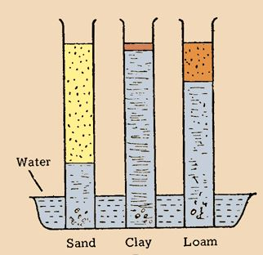
Water tends to rise very fast in sand soil but after a while, it slows down.
The water does not rise so high.
Clay soil allows water to rise slowly but higher.
Capillarity helps in making groundwater rise above the ground surface.
The following set up can be used to determine a sample soil's drainage:
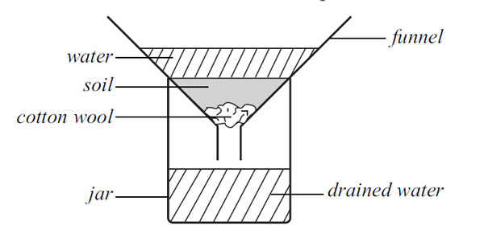

An illustration of drainage in different soils.
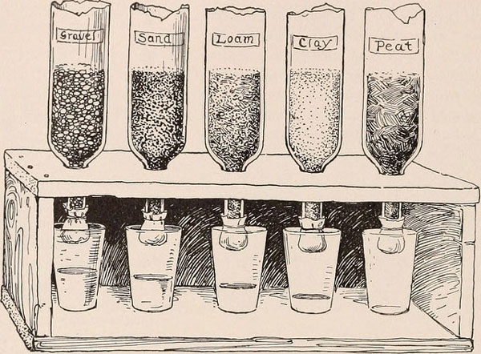
These are 5 inverted cut bottles with different soils:
(Gravel, Sand, Loam, Clay, and Peat)

- The piece of cloth is tied at the mouth of the bottle to let out water at the same rate as the piece of cotton wool in the previous diagram.
- Soil that is very porous holds very little water and therefore allows too much water to pass through it.
- From the above, gravel has very large particles,it allows too much water to pass through it meaning it holds little water.
- Peat has more fine particles than Clay Soil, hence holds more water than Clay. It therefore allows very little water to pass through it.

Capillary action is the same effect that causes porous materials, such as sponges, to soak up liquids.
- Capillarity is the primary force that enables the soil to retain water, as well as to regulate its movement.
  - The phenomenon of capillarity also occurs in the soil. In the same way that water moves upwards through a tube against the force of gravity; water moves upwards through soil pores, or the spaces between soil particles.
  - The height to which the water rises is dependent upon pore size. As a result, the smaller the soil pores, the higher the capillary rise.
  - Finely-textured soils, like in Maui, typically have smaller pores than coarsely-textured soils. Therefore, finely-textured soils have a greater ability to hold and retain water in the soil in the inter-particle spaces. We refer to the pores between small clay particles as micropores. In contrast, the larger pore spacing between lager particles, such as sand, are called macropores.
  - In addition to water retention, capillarity in soil also enables the upward and horizontal movement of water within the soil profile, as opposed to downward movement caused by gravity. This upward and horizontal movement occurs when lower soil layers have more moisture than the upper soil layers and is important because it may be absorbed by roots.
The calculation of capillary rise height of soils: It can be written as follows:
(4) i = h c − z z where, h_{c} is the maximum height of capillary rise and z is the elevation of the wetting front above the water table. The soil profile in ground can be separated into two distinct primary zones by air entry head, h_{a}.

Relationship between soil permeability and capillarity
Permeability - The permeability of rock is its capacity for transmitting a fluid. ... Porosity determines how much water rock material or soil is able to store (hold).
Capillarity - The action by which a fluid, such as water, is drawn up in small pore spaces as a result of surface tension. Syn: capillary action.

SUMMARY
By definition, permeability is a MEASURE OF EASE with which fluids will flow though a porous rock, soil or sediment. ... For example, clay has high porosity but low permeability.
Capillarity, in physics, is a phenomenon caused by surface tension and that causes a series of distortion of liquid surface.

