A TERM PAPER ON
SOIL PERMEABILITY AND CAPILARITY
BY
IDOWU OLAGOKE SAMUEL
17/ENGO3/025
TO
CVE 306: SOIL MECHANICS
CIVIL ENGINEERING DEPARTMENT
ABUAD
ON
APRIL 13TH, 2020.

ABSTRACT
The permeability of a soil describes how water or any other liquid and air are able to move through the soil. In case of rainfall or irrigation, water moves very easily through high permeable soils and slowly through soils with low permeability. The permeability of a soil can be determined by calculating its infiltration rate.
The phenomenon of capillarity also occurs in soil. In the same way that water moves upwards through a tube against the force of gravity, water moves upward through pores than coarsely textured soils. Therefore, finely-textured soils have a greater ability to hold and retain water in the soil.

Contents
ABSTRACT 2
INTRODUCTION 4
IMPORTANCE OF WATER IN SOIL 4
SOIL PERMEABILITY 5
Permeability in different soils: 5
IMPORTANCE OF PERMEABILITY 6
Factors Affecting Soil Permeability 7
Darcy‘s Law 8
SOIL CAPILARITY 9
CAPILARITY AND EFFECTIVE STRESS 11
SOIL CAPILLARY FRINGES 12
CONCLUSION 14

INTRODUCTION

IMPORTANCE OF WATER IN SOIL
In nutrient management, a proper balance between soil water and soil air is critical since both water and air are required by most processes that release nutrients into the soil. Soil water is particularly important in nutrient management. In addition to sustaining all life on Earth, soil water provides a pool of dissolved nutrients that are readily available for plant uptake. Therefore, it is important to maintain proper levels of soil moisture.
Soil water is important for three special reasons:
- The presence of water is essential for the all life on Earth, including the lives of plants and organisms in the soil.
- Water is a necessary for the weathering of soil. Areas with high rainfall typically have highly weathered soils. Since soils vary in their degree of weathering, it is expected that soils have been affected by different amounts of water.
- Soil water is the medium from which all plant nutrients are assimilated by plants. Soil water, sometimes referred to as the soil solution, contains dissolved organic and inorganic substances and transports dissolved nutrients, such as nitrogen, phosphorus, potassium, and calcium, to the plant roots for absorption.
The amount of water in the soil is dependent upon two factors:
- First, soil water is intimately related to the climate, or the long term precipitation patterns, of an area.
- Secondly, the amount of water in the soil depends upon how much water a soil may hold.

SOIL PERMEABILITY
Permeability (k) in fluid mechanics and earth sciences is a measure of the ability of a porous material to allow fluids to pass through it. The permeability of a medium is related to porosity, but also to the shapes of the pores in the medium and their level of connectedness.
Soil permeability also known as hydraulic conductivity is a property of soil that describes the ease with which a fluid (usually water) can move through pore spaces or fractures. It depends on the intrinsic permeability of the material, the degree of saturation, and on the density and viscosity of the liquid. Saturated hydraulic K_{sat} , describes water movement through a saturated media. By definition, hydraulic conductivity is the ratio of velocity to hydraulic gradient indicating permeability of porous media.
Soils are permeable due to the existence of interconnected voids through which water flows from points of high energy to points of low energy.

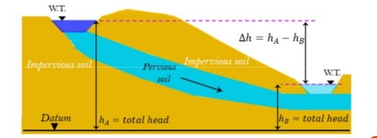

Permeability in different soils:
- A soil is highly pervious when water can flow though it easily(i.e. gravels),
- In an impervious soil, the permeability is very low and water cannot easily flow through it (clays).
- Rocks are impermeable.
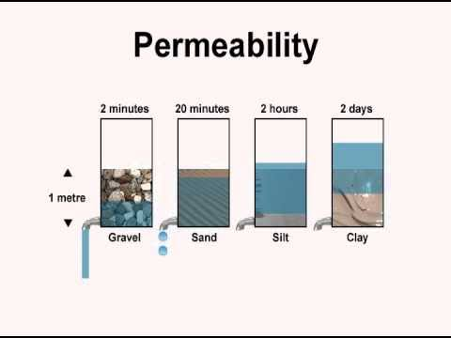

Relative Permeability | K value  (cm/sec) | Soil
Highly Permeable | 1 × 10⁻¹ | Gravel and sand
Medium Permeable | 10⁻¹ -10⁻³ | Sand with fines
Low Permeable | 10⁻³ – 10⁻⁵ | Silts and silty sand
Very low Permeable | 10⁻⁵ -10⁻⁷ | Fine silts
Impermeable | <10⁻⁷ | Clay

IMPORTANCE OF PERMEABILITY
The following are the importance of permeability in geotechnical design:
- Permeability influences rate of settlement under applied loads
- The design of earth dams is very much based upon the permeability of the soils used.
- Filters made of soils are designed based on their permeability.
- The stability of slopes and retaining structure is affected by the permeability of soil involved.

Factors Affecting Soil Permeability
- Particle Size.
- Impurities in water.
- Void ratio (e)
- Degree of saturation
- Absorbed water.
- Entrapped air and organic matter
- Temperature
- Stratification of soil.
- Structure of soil mass.
- Properties of pore fluid

- Particle Size; the permeability of soil varies approximately as the square of grain size.
- Void Ratio; increase in the void ratio increases the area available for flow hence permeability increases for critical conditions.
- Impurities in Water: The presence of impurities in soil decreases the permeability of soil.
- Degree of Saturation; If the soil is not fully saturated, it contains air pockets. The permeability is reduced due to the presence of air which causes a blockage to the passage of water.
- Absorbed Water: means a thin microscopic film of water surrounding individual film of soil grains. This water is not free to move and hence reduces the effective pore space and thus decreases coefficient of permeability.
- Entrapped Air and Organic Matter: the organic impurities and entrapped air obstruct the flow and coefficient of permeability is reduced due to their presence.
- Temperature: As the viscosity of the pore fluid decrease with the temperature, permeability increase with temperature. As unit weight does not change much in temperature.
The two types of water flow are: laminar flow, turbulent flow.

Darcy‘s Law
Darcy’s law states that: the flow of water through porous media is directly proportional to the head loss and inversely proportional to the length of flow path.
Therefore,
V=k $\left(\frac{∆h}{L}\right)$
OR V=ki
Where;
K= permeability coefficient or hydraulic conductivity.
V=discharge velocity (average velocity)
Discharge velocity: is the quantity of total water flowing in unit time, (q) through a unit cross sectional area (A) pf soil at right angle to the direction of flow. V= $\frac{q}{A}$
Darcy’s law is stable in character as long as the four basic conditions are always satisfied:
- The steady state is laminar flow.
- Hundred percent saturation.
- Flow fulfilling continuity conditions,
- No volume changes occurs during or as a result of flow.
Water Flow Through soils
To determine the quantity of flow, two parameters are needed. They are:
- k= hydraulic conductivity (i.e. how permeable is the soil medium)
- i= Hydraulic gradient (i.e. how large is the driving head )

How to determine ‘k’:
- laboratory Testing (constant head test and falling head test)
- Field Testing.
- Empirical Equations.
Determination of ‘i’; flow nets, from head loss and geometry.

SOIL CAPILARITY
The phenomenon of capillarity in porous media results from two opposing forces: liquid and the cohesive forces which acts to reduce liquid-gas interfacial area. The resulting liquid-gas interface configuration under equilibrium reflects a balance between these forces. The phenomenon of capillarity is thus independent on solid and liquid interfacial properties such as surface tension, contact angle solid surface roughness and geometry.
Soil capillarity refers to how well water rises up in the soil capillarity can be measured by the speed at which water rises in the soil. It depends on the size of the spaces between the soil particles. The smaller the spaces, the higher the water rises in the soil. This means that clay soil allows water to rise highest compared to sand soil and loamy soil.
Water tends to rise very fast in sand soil but after a while, kit slows down, the water does not rise so high. Clay soil allows water to rise slowly but higher.
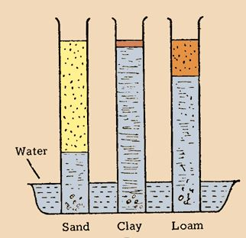
The height to which the water rises is dependent upon pore size. As a result, the smaller the soil pores, the higher the capillary rise. Finely-textured soils, like in Maui, typically have smaller pores than coarsely-textured soils. Therefore, finely-textured soils have a greater ability to hold and retain water in the soil in the inter-particle spaces. We refer to the pores between small clay particles as micro pores. In contrast, the larger pore spacing between lager particles, such as sand, are called macro pores.
In addition to water retention, capillarity in soil also enables the upward and horizontal movement of water within the soil profile, as opposed to downward movement caused by gravity. This upward and horizontal movement occurs when lower soil layers have more moisture than the upper soil layers and is important because it may be absorbed by roots.
In soil water is able to rise above the water table by moving through the inter-connected void spaces by capillary action. The height of capillary rise depends primarily on soil particle size, becoming higher as the size gets smaller. Thus, capillary action may be significant for silt and clay size particles. Capillary rise may be estimated from:
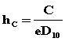
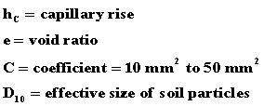
The pore water pressure in the capillary zone will be negative and may be determined from:
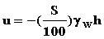
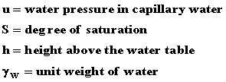
- The porewater pressure at the water table is zero.
- Below the water table the soil is saturated and the water is called free water. The water pressure is positive (compression) and increases with depth below the water table.
- Above the water table up to the height of capillary rise is the capillary zone and the water is called capillary water. The water pressure is negative (less than atmospheric) in the capillary zone.

CAPILARITY AND EFFECTIVE STRESS
Capillary rise in the soil strata may saturate the soil and it has the effect of the effective stress. If the water table is below the soil strata saturated due to the capillary action then the effective stress is increased by an amount equal to the depth of the water table multiplied by the density of the water risen to that soil strata. So the water pressure becomes negative here so, instead of decreasing the effective stress, this increase the effective stress in the saturated region by an amount equal to the surcharge weight of the water of the same depth.
If 'h' is the capillary rise of water above the water table, then the soil will have its effective stress increased by an amount equal to "h.dw".. Where dw is the density of the water. If the water table reaches the soil strata, the capillary meniscus gets destroyed and so the negative water pressure will disappear. The capillary water rises against gravity and is held by the surface tension. Therefore the capillary water exerts a tensile force on the soil .however the free water exerts a pressure due to its own weight which is always compressive.
Hence the effect of capillarity is same as that of surcharge (q=h*yw)
Yw= density of water
and it helps in increasing effective stress.

SOIL CAPILLARY FRINGES
Capillary fringes have been mostly studied in soils because water together travels with the nutrients from the atmosphere to the soil system and through the plants back to the atmosphere. Capillarity in soils is as a result of two major causes, underground water is stored naturally below many feats from the soil surface and precipitation and seepage causes soil water to move continuously downward until it joins the aquifer.
Water could stop moving when it meets a densic, lithic, paralithic surface or a hard pan and may continue moving very slowly downwards, in a condition known as endosaturation. From the point where endosaturation occurred, capillary fringes due to greater surface tension than gravitation forces might begin because of evapotranspiration. Usually, the water we notice on soils is as a result of capillarity from an aquifer or soil water on a downward free fall or water as a result of an endosaturation. This could rather be considered as the truth if the soils contain only the mineral grains. Organic matter can cause angles of contact between water and dry soil mineral particles to be greater than zero, and when this happens, the entry of water especially in dry sandy soils becomes affected and this could result in a capillary retention. The water held in the glass tube of a small radius, r, at an equilibrium height H, above the free water surface is an example of capillary retention. In a three-phase system of soil solid, water and air, the water column is held up by a force 2πrTcosθ, where T = surface tension of water, θ = contact angle of water with soil solid (or a glass tube). Because of the air surface tension interface from the atmosphere, the height of rise of water to the soil surface could be expressed as;
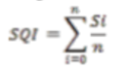
Where:
h = height of rise of water, m
T = surface tension in KgS-2
r = radius (if we use a cylinder as an instance for a vertical flow),
m = density of water, Kgm-3
g = acceleration due to gravity, ms-2
Capillary water is defined as water held in the soil at tensions between that of the field capacity and permanent wilting points. At permanent wilting point, the suction or energy of the drag force is -33 KPa while at the field capacity it is less than -10 KPa. During capillarity, soil water is sufficient and available for optimum performance and growth of the crop plants. Soil quality is the fitness of a given soil for a given ecosystem use and the capacity of the soil to function within its ecosystem boundaries in performing the given ecosystem function which may be provision of support for the trees, as a store for the solute and water from where water moves into the plants, as a filter of the underground water or as medium for fitting other anthropogenic needs like soil quality, as related to use of the soil for sanitary facilities management and for various construction purposes (engineering function of the soil).

CONCLUSION
In this term paper, the importance of soil water was discussed. Along with the permeability and capillarity of soil. Soil permeability and the time water would take to pass through each soil like clay, rock, sand was also extensively discussed. The phenomenon of capillarity was and capillarity fringes was discussed.

