NAME: CHINEDUM PRUDENCE ESE
DEPT: CHEMICAL ENGINEERING
LEVEL:300L
MAT NO: 17/ENG01/007
COURSE TITLE: ENGINEERING LAW AND MANAGERIAL ECONOMICS
COURSE CODE: ENG384
ASSIGNMENT
1. PATENT
A patent is a form of intellectual property that gives the owner the legal right to exclude others from making, using, selling and importing an invention for a limited period of years, in exchange for publishing an enabling public disclosure of the invention. In most countries patent rights fall under civil law and the patent holder needs to sue someone infringing the patent in order to enforce his or her rights. In some industries patents are an essential form of competitive advantage; in others they are irrelevant.
The procedure for granting patents, requirements placed on the patentee, and the extent of the exclusive rights vary widely between countries according to national laws and international agreements. Typically, however, a patent application must include one or more claims that define the invention. A patent may include many claims, each of which defines a specific property right. These claims must meet relevant patentability requirements, such as novelty, usefulness, and non-obviousness.
Under the World Trade Organization's (WTO) TRIPS Agreement, patents should be available in WTO member states for any invention, in all fields of technology, provided they are new, involve an inventive step, and are capable of industrial application.[4] Nevertheless, there are variations on what is patentable subject matter from country to country, also among WTO member states. TRIPS also provides that the term of protection available should be a minimum of twenty years.
GOVERNING LAWS OF PATENT
The grant and enforcement of patents are governed by national laws, and also by international treaties, where those treaties have been given effect in national laws. Patents are granted by national or regional patent offices. A given patent is therefore only useful for protecting an invention in the country in which that patent is granted. In other words, patent law is territorial in nature. When a patent application is published, the invention disclosed in the application becomes prior art and enters the public domain (if not protected by other patents) in countries where a patent applicant does not seek protection, the application thus generally becoming prior art against anyone (including the applicant) who might seek patent protection for the invention in those countries.

Commonly, a nation or a group of nations forms a patent office with responsibility for operating that nation's patent system, within the relevant patent laws. The patent office generally has responsibility for the grant of patents, with infringement being the remit of national courts.
Process to register a Patent in Nigeria
To make a patent application in Nigeria, the first step is to ensure the invention has not already been patented, by conducting a search. If the result of the search is positive, then the application is made:
- A petition or request for a patent signed by the applicant or his agent and containing the applicant’s full name and address;
- a specification, including a claim or claims in duplicate; plans and drawings, if any, in duplicate;
- where appropriate, a declaration signed by the true inventor requesting that he be mentioned as such in the patent and giving his name and address;
- a signed power of attorney or authorization of agent if the application is made by an agent;
- an address for service in Nigeria if the applicant’s address is outside Nigeria; and payment of the prescribed fee.
Once granted, a patent is valid for 20 years.
Who can register a Patent?
Under Nigerian law, only accredited individuals/companies can register patents on behalf of inventors. So if you are interested in registering your patent, you will need to hire the services of accredited agents for this process.
In Nigeria, the primary legislation that governs the grant of patents is the Patents and Designs Act. The Government agency that manages the grant of patents is the Trademarks, Patents And Designs Registry, Commercial Law Department, Federal Ministry Of Industry, Trade And Investment. Applications are made to the Registrar of Patents and Copyrights.

SYMBOLS
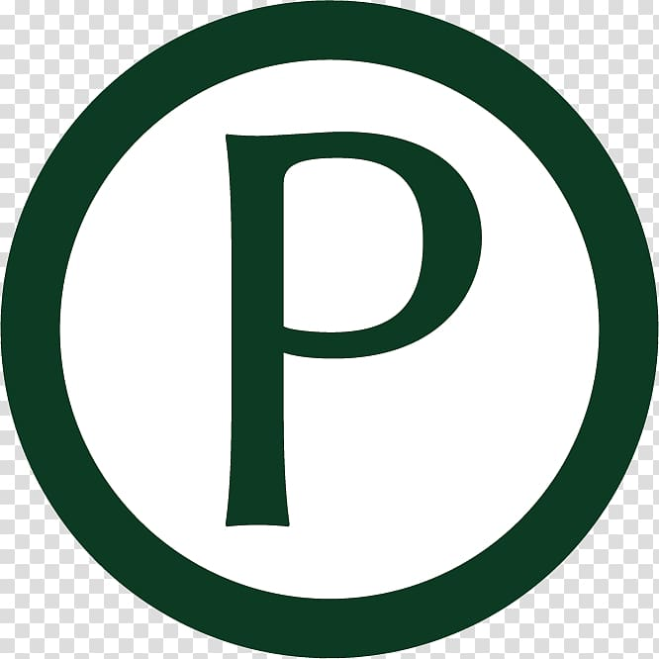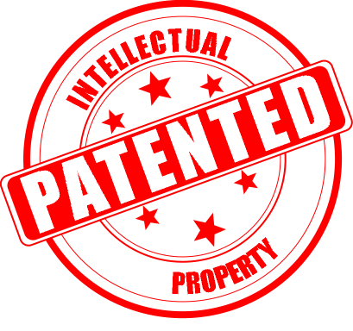

2.COPYRIGHT
Copyright is the exclusive right given to the creator of a creative work to reproduce the work, usually for a limited time. The creative work may be in a literary, artistic, educational, or musical form. Copyright is intended to protect the original expression of an idea in the form of a creative work, but not the idea itself. A copyright is subject to limitations based on public interest considerations, such as the fair use doctrine in the United States. Some jurisdictions require "fixing" copyrighted works in a tangible form. It is often shared among multiple authors, each of whom holds a set of rights to use or license the work, and who are commonly referred to as rights holders. These rights frequently include reproduction, control over derivative works, distribution, public performance, and moral rights such as attribution.

Copyrights can be granted by public law and are in that case considered "territorial rights". This means that copyrights granted by the law of a certain state, do not extend beyond the territory of that specific jurisdiction. Copyrights of this type vary by country; many countries, and sometimes a large group of countries, have made agreements with other countries on procedures applicable when works "cross" national borders or national rights are inconsistent.

Typically, the public law duration of a copyright expires 50 to 100 years after the creator dies, depending on the jurisdiction. Some countries require certain copyright formalities to establishing copyright, others recognize copyright in any completed work, without formal registration.

Economic rights
With any kind of property, its owner may decide how it is to be used, and others can use it lawfully only if they have the owner's permission, often through a license. The owner's use of the property must, however, respect the legally recognised rights and interests of other members of society. So the owner of a copyright-protected work may decide how to use the work, and may prevent others from using it without permission. National laws usually grant copyright owners exclusive rights to allow third parties to use their works, subject to the legally recognised rights and interests of others.^{[53]} Most copyright laws state that authors or other right owners have the right to authorise or prevent certain acts in relation to a work. Right owners can authorise or prohibit:
- reproduction of the work in various forms, such as printed publications or sound recordings;
- distribution of copies of the work;
- public performance of the work;
- broadcasting or other communication of the work to the public;
- translation of the work into other languages; and
- adaptation of the work, such as turning a novel into a screenplay.

COPYRIGHT PROTECTION IN NIGERIA
In Nigeria, copyright is governed by the Copyright Act, and the body charged with the enforcement and protection of copyright is the Nigerian Copyright Commission (NCC).
The ownership of copyright is vested in the creator of a copyright work, usually referred to as the “author” of the work. He/she owns the copyright in the work in the first instance. However, the author is at liberty to transfer his rights to a third party. In such a case, the person who has obtained the right by transfer or other legal means becomes the owner of copyright.

WHAT IS ELIGIBLE FOR COPYRIGHT PROTECTION?
- Literary works;
- Musical works;
- Artistic works;
- Cinematograph works;
- Sound recording; and
- Broadcasts
For it to be eligible for protection, the work must be sufficiently original, and must be in a form which is expressed e.g. in writing, a painting, a musical recording etc. You can’t have copyright protection over something in your head, which has not been expressed. Originality and expression are the key pillars for eligibility

COPYRIGHT REGISTRATION PROCESS
You can register a copyright with the NCC by submitting a completed registration form, along with two (2) copies of the work, and evidence of payment of the prescribed fee. Registration can be done online or physically at the NCC office.
SYMBOL

3.TRADEMARK
A trademark (also written trade mark or trade-mark) is a type of intellectual property consisting of a recognizable sign, design, or expression which identifies products or services of a particular source from those of others, although trademarks used to identify services are usually called service marks. The trademark owner can be an individual, business organization, or any legal entity. A trademark may be located on a package, a label, a voucher, or on the product itself. For the sake of corporate identity, trademarks are often displayed on company buildings. It is legally recognized as a type of intellectual property.
The first legislative act concerning trademarks was passed in 1266 under the reign of Henry III, requiring all bakers to use a distinctive mark for the bread they sold. The first modern trademark laws emerged in the late 19th century. In France the first comprehensive trademark system in the world was passed into law in 1857. The Trade Marks Act 1938 of the United Kingdom changed the system, permitting registration based on "intent-to-use”, creating an examination based process, and creating an application publication system. The 1938 Act, which served as a model for similar legislation elsewhere, contained other novel concepts such as "associated trademarks", a consent to use system, a defensive mark system, and non claiming right system.
The symbols ™ (the trademark symbol) and ® (the registered trademark symbol) can be used to indicate trademarks; the latter is only for use by the owner of a trademark that has been registered.
USAGE
A trademark identifies the brand owner of a particular product or service. Trademarks can be used by others under licensing agreements; for example, Bullyland obtained a license to produce Smurf figurines; the Lego Group purchased a license from Lucasfilm in order to be allowed to launch Lego Star Wars; TT Toys Toys is a manufacturer of licensed ride-on replica cars for children.The unauthorized usage of trademarks by producing and trading counterfeit consumer goods is known as brand piracy.
The owner of a trademark may pursue legal action against trademark infringement. Most countries require formal registration of a trademark as a precondition for pursuing this type of action. The United States, Canada and other countries also recognize common law trademark rights, which means action can be taken to protect an unregistered trademark if it is in use. Still, common law trademarks offer to the holder, in general, less legal protection than registered trademarks.
DESIGNATION
A trademark may be designated by the following symbols:
- ™ (the "trademark symbol", which is the letters "TM" in superscript, for an unregistered trademark, a mark used to promote or brand goods)
- ℠ (which is the letters "SM" in superscript, for an unregistered service mark, a mark used to promote or brand services)
- ® (the letter "R" surrounded by a circle, for a registered trademark)

SYMBOLS
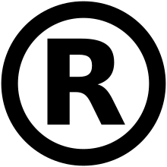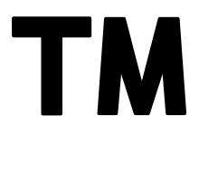

STYLES
A trademark is typically a name, word, phrase, logo, symbol, design, image, or a combination of these elements. There is also a range of non-conventional trademarks comprising marks which do not fall into these standard categories, such as those based on colour, smell, or sound (like jingles). Trademarks which are considered offensive are often rejected according to a nation's trademark law.
The term trademark is also used informally to refer to any distinguishing attribute by which an individual is readily identified, such as the well-known characteristics of celebrities. When a trademark is used in relation to services rather than products, it may sometimes be called a service mark, particularly in the United States.

HOW TO REGISTER A TRADEMARK IN NIGERIA
What is eligible for registration?
- Device, brand, heading, label, ticket, name, signature, word, letter, numeral, or any combination thereof;
For it to be eligible for registration in NIgeria it must contain or consist of at least one of the following essential particulars –
- the name of a company, individual, or firm, represented in a special or particular manner;
- the signature of the applicant for registration or some predecessor in his business;
- an invented word or invented words;
- a word or words having no direct reference to the character or quality of the goods, and not being according to its ordinary signification a geographical name or a surname;
- any other distinctive mark

Requirements for Trademark registration in Nigeria
- Applicant’s details
- Trademark Information
- The full range of goods covered or proposed to be covered by the trademark.
- Power of Attorney/Authorization of Agent

Process for Trademark Registration in Nigeria
The Trademark registration process can be broken into 3 general stages:
- Availability Search – You conduct a search to determine whether there are registered marks that are similar to your proposed mark. The outcome of the search will help you determine whether the proposed mark may be registered or not.
- Trademark Application – If there is no similar mark, you may apply for registration. If the application is deemed registrable, the registry issues a Letter of Acceptance that serves as an approval in principle. After the acceptance has been issued, the mark is advertised in the Trademarks journal published by the Trademarks Office.
- Application for Certificate – Once the proposed mark has been advertised, an interested party may oppose the registration of the mark within 2 months of the advertised journal. If the mark is not opposed within 2 months, you may then apply to the Registrar for a Trademark Certificate.
- Issuance of Certificate – If there are no objections received, the Registrar will issue the applicant with a certificate of registration. When issued, the Registration Certificate will reflect the date of initial filing as date of registration.
A trademark is valid in Nigeria for an initial period of 7 years, and then for further renewable 14-year periods. An application for renewal should be made not less than three (3) months from the due date.
A trademark in Nigeria may be registered either plainly (black and white) or in colour. However, where a trademark is registered in colour, the protection afforded is limited to the colour(s) registered. On the other hand, a plain (black and white) registration affords protection to all colours of presentation of the trademark.

4. TRADE SECRET
Trade secrets are a type of intellectual property that comprise formulas, practices, processes, designs, instruments, patterns, or compilations of information that have inherent economic value because they are not generally known or readily ascertainable by others, and which the owner takes reasonable measures to keep secret.^{[1]} In some jurisdictions, such secrets are referred to as confidential information.
The precise language by which a trade secret is defined varies by jurisdiction, as do the particular types of information that are subject to trade secret protection. Three factors are common to all such definitions:
A trade secret is information that
- is not generally known to the public;
- confers economic benefit on its holder because the information is not publicly known; and
- where the holder makes reasonable efforts to maintain its secrecy.
In international law, these three factors define a trade secret under article 39 of the Agreement on Trade-Related Aspects of Intellectual Property Rights, commonly referred to as the TRIPS Agreement.
Similarly, in the United States Economic Espionage Act of 1996, "A trade secret, as defined under 18 U.S.C. § 1839(3)(A),(B) (1996), has three parts: (1) information; (2) reasonable measures taken to protect the information; and (3) which derives independent economic value from not being publicly known."

VALUES
Trade secrets are an important, but invisible component of a company's intellectual property (IP). Their contribution to a company's value, measured as its market capitalization, can be major. Being invisible, that contribution is hard to measure. Patents are a visible contribution, but delayed, and unsuitable for internal innovations. Having an internal scoreboard provides insight into the cost of risks of employees leaving to serve or start competing ventures.

PROTECTION
In contrast to registered intellectual property, trade secrets are, by definition, not disclosed to the world at large. Instead, owners of trade secrets seek to protect trade secret information from competitors by instituting special procedures for handling it, as well as technological and legal security measures. Legal protections include non-disclosure agreements (NDAs), and work-for-hire and non-compete clauses. In other words, in exchange for an opportunity to be employed by the holder of secrets, an employee may sign agreements to not reveal their prospective employer's proprietary information, to surrender or assign to their employer ownership rights to intellectual work and work-products produced during the course (or as a condition) of employment, and to not work for a competitor for a given period of time (sometimes within a given geographic region). Violation of the agreement generally carries the possibility of heavy financial penalties which operate as a disincentive to reveal trade secrets. However, proving a breach of an NDA by a former stakeholder who is legally working for a competitor or prevailing in a lawsuit for breaching a non-compete clause can be very difficult. A holder of a trade secret may also require similar agreements from other parties he or she deals with, such as vendors, licensees, and board members.
As a company can protect its confidential information through NDA, work-for-hire, and non-compete contracts with its stakeholders (within the constraints of employment law, including only restraint that is reasonable in geographic- and time-scope), these protective contractual measures effectively create a perpetual monopoly on secret information that does not expire as would a patent or copyright. The lack of formal protection associated with registered intellectual property rights, however, means that a third party not bound by a signed agreement is not prevented from independently duplicating and using the secret information once it is discovered, such as through reverse engineering.
Therefore, trade secrets such as secret formulae are often protected by restricting the key information to a few trusted individuals. Famous examples of products protected by trade secrets are Chartreuse liqueur and Coca-Cola.^{[8]}
Because protection of trade secrets can, in principle, extend indefinitely, it therefore may provide an advantage over patent protection and other registered intellectual property rights, which last only for a specific duration. The Coca-Cola company, for example, has no patent for the formula of Coca-Cola and has been effective in protecting it for many more years than the 20 years of protection that a patent would have provided. In fact, Coca-Cola refused to reveal its trade secret under at least two judges' orders.^{[9]}

