BUGE PETER KIRAH

17/ENG03/013

CIVIL ENGINEERING

CVE 306

SOIL MECHANICS

TERM PAPER
DEDICATION
This TERM PAPER is dedicated to God almighty and to my family for their non- stop support.

ABSTRACT
This report is a detailed term paper based on the topic SOIL PERMEABILITY AND SOIL CAPILLARITY. It contains a insight of soil permeability and soil capillarity; its definition, importance, properties and so on.

Contents
INTRODUCTION 5
CHAPTER ONE 6
SOIL PERMEABILITY 6
WHAT IS PERMEABILITY? 6
WHAT IS SOIL PERMEABILITY? 6
FACTORS AFFECTING PERMEABILITY OF SOILS 7
COEFFICIENT OF PERMEABILITY (HYDRAULIC CONDUCTIVITY) 8
IMPORTANCE OF PERMEABILITY 9
CHAPTER TWO 10
CAPILLARITY OF SOILS 10
WHAT IS CAPILLARY ACTION? 10
WHAT IS CAPILLARITY? 10
CAPILLARY RISE 12
FACTORS USED TO DETERMINE CAPILLARY RISE 12
CONCLUSION 13
REFERENCES 14

INTRODUCTION

Soil are permeable materials because of the presence of interconnected voids that permit the flow of fluids from location of high energy to locations of low energy.
Capillarity is the ability of various soils and rocks to allow water to move up through a tube. Capillarity dependson a rock’s porosity and permeability. The forces involved in capillarity are gravity pulling downward on the water, and attraction between water molecules and the molecules of the rock.

CHAPTER ONE
- SOIL PERMEABILITY

WHAT IS PERMEABILITY?
Permeability is the property of soils that allowa water to pass through them at some rate.
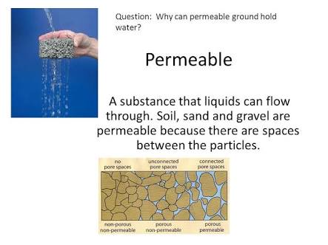

WHAT IS SOIL PERMEABILITY?
Soil permeability is a soil property which allows the seepage of fluid through its interconnected void spaces.
Some soil is so permeable and seepage is so great that it is not possible to build a structure without special construction technique.
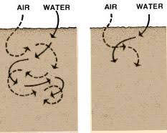
Before any construction, it is important to determine the relative position of the permeable layers and impermeable layers.

  - FACTORS AFFECTING PERMEABILITY OF SOILS

There are a number of factors affecting the permeability of soils. They include:
- Absorbed wate
- Particle size
- Void ratio
- Degree of saturation
- Entrapped air
- Organic matter
- Impurities in water
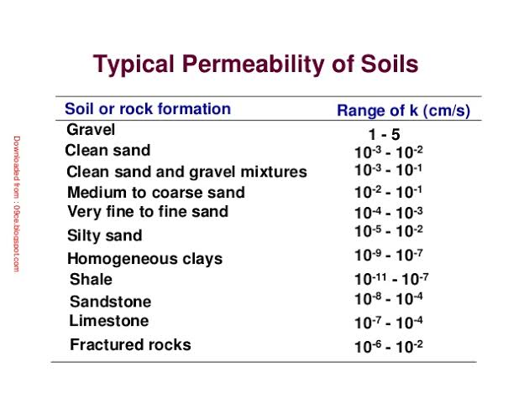

COEFFICIENT OF PERMEABILITY (HYDRAULIC CONDUCTIVITY)

The coefficient of permeability is defined as the rate of flow per unit area of soil under init hydraulic gradient, it has the dimensions of velocity (L/T) such (cm/sec or ft/sec).
The coefficient of permeability is directly propotional to the square of particle sizes.

  - IMPORTANCE OF PERMEABILITY

The following are the importance of permeability in geotechnical design:
- The design of earth dams is very much based upon the permeability of the soils used.
- The stability of slopes and retaining structures can be greatly affected by the permeability of the soils involved.
- Filters made of soils are designed based upon their permeability.
- The rate of settlement of a saturated soil under land is influenced by permeability.

CHAPTER TWO

- CAPILLARITY OF SOILS

WHAT IS CAPILLARY ACTION?

Capillary action is the same effect that causes porous materials to soak up liquids. Capillary action is the movement of a liquid through or along another material against an opposing force such as gravity. Capillary action occurs when the adhesive intermolecular forces between liquid, such as water, and the solid surface of the tube is stronger than cohesive intermolecular forces between water molecules.

WHAT IS CAPILLARITY?
Capillarity is the primary force that enables soil to retain water as well as regulate its movement. Capillarity is a combination of cohesion/adhesion and surface tension force.
The phenomenon of capillarity also occurs in the soil. In the same way that water moves upwards through a tube against the force of gravity; water moves upwards through soil pores, or the spaces between soil particles. The height towhich rises is dependent upon pore size. As a result, the smaller the soil pores, the higher the capillary rise.

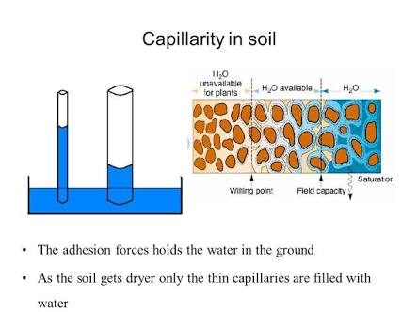

CAPILLARY RISE IN DIFFERENT SEDIMENTS
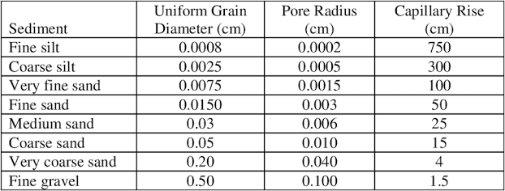

  - CAPILLARY RISE

Capillary rise is a well known unsaturated soil phenomenon that describes the movement of pore water from lower elevation to higher elevation driven by the hydraulic head gradient acting across the couved air/pore water interface. Capillary rise is the height to which the water rises within the tube, and decreases as the width of the tube increases. Three fundamental practical characteristics related to capillary rise are of primary practical concern:
- The maximum height of capillary rise.
- The fluid storage capacity of capillary rise.
- The rate of capillary rise.

  - FACTORS USED TO DETERMINE CAPILLARY RISE

The factors needed for determining capillary rise includes:
- Diameter of capillary tube.
- Density of the liquid.
- Viscosity of the liquid.
- Surface tension.

CONCLUSION
In conclusion, soil permeability and soil capillarity are both important properties in different kinds of soil. This property is very important to the construction industry. However there is a slight difference between soil permeability and soil capillarity.
REFERENCES
- www.wikipedia.org
- www.images.googles.com.ng

