NAME: Erereoghene Patricia Ayenor
Matric Number:19/law01/045
Course code: SOC 102
Course title: Introduction to Sociology II
1 What is family
2 Discuss the functions of the Family
3 Discuss the African Traditional family
4 Discuss your Nuclear family
5 Draw your family tree

1 What is family-

According to Wikipedia “, a family (from Latin: familia) is a group of people related either by consanguinity (by recognized birth) or affinity (by marriage or other relationship).” This is to say that for a group of people to be called a family they must be related by birth, marriage or any other form of relationship. Émile Durkheim who is one of the major social theories regarded the family as” one of the most important of social institutions.”

2 Discuss the functions of the family

A family is the first social community in the life of any person or group of persons. It is from this that an individual attach and understands the values of culture, assimilates the first social roles and acquires the experience of social behaviour. In the family, this person takes their first steps, experiences the first joys and sorrows, and then, leaves the family and faces a big world. Then the person returns when he feels uncomfortable out there.

A Emotional function
The emotional function of the family is realized in satisfying its members' needs for sympathy, respect, recognition, emotional support, psychological protection. The pleasant emotional atmosphere in a family allows each of its members not to hide their emotional state, share joys, talk about failures and grievances. Besides, they can get advice on important issues, restore and replenish their physical and mental strengths and thus maintain a good vitality.
B In the society
Functions of the family in sociology play an important role. The function of primary social control is to ensure the implementation of social norms and rules by family members. Nobody can ignore the fact that the family establishes relationships and maintains links with state institutions, public organizations, labour collectives, and other families or individuals (relatives, friends, neighbours). This area of its life activity relates to the representative function’s realization. It is a result of this function that the family interacts with the social world. It establishes economic, ideological, legal, cultural, emotional and other relations with other social communities and presents itself as the primary unit of society.
C Reproductive function
One of the most important family functions is a reproductive one. There are three types of family reproductive systems. Children need not only be reproduced but also educated and brought into the complex world of human relations. Besides reproductive, essential importance is given to the educational function of the family. The individual needs of each spouse in maternity or fatherhood, contacts with children, and their personal formation are satisfied.
D Educational function
In the course of fulfilling the educational function, the family, first, ensures the primary socialization of a child. In addition, it provides the development of his or her mental (intellectual) traits and personal qualities until they attain social maturity. One of the family education features is the emotional form of the relationship between parents and children and love. It should be born in mind that family has a systematic educational impact on each of its members throughout their life. It's not just the parents that influence children but also the children's action reflect on the parents and other adult members of the family, encouraging them to self-improvement.

3 Discuss the African traditional family
Family is considered a basic cell of the society. All social and cultural practices find their connection with a notion of family, either supporting or distorting it.
It is in this light that one should consider the phenomenon of polygamy which is of course the main point where traditional African marriage has most frequently departed from the norm of the natural law.
Having noted that the incidence of polygamy is much less than many westerners would seem to think (it varies from tribe to tribe, but in practice some 20% to 30% of African marriages have been polygamous, with a norm of two wives per marriage), it is important to underline that the main factor behind polygamy is not sexual incontinence, but the overriding desire and, as it were, necessity of having children. This can be seen, for instance, in the fact that the taking of a second wife is so often the simple consequence of the barrenness of the first and in some areas a sign of pride. Although polygamy still has its defenders, most Africans readily understand that the Christian and natural norm of monogamous marriage is essential for upholding the dignity of woman. Given the rapid cultural changes operating in Africa, it seems likely that, within a decade or two, polygamy as a pastoral problem will be replaced by western style divorce and remarriage.
In traditional African society, men guarded the home and the cattle, or went to war. The women worked, caring for the house, the crops, the children. So used were the women to work that a polygamous situation would at times be provoked by the first wife's asking her husband to take a second wife who could be a help to her in her work. It could be remarked in passing that the tradition of women being much more industrious than men has accelerated the current process of equalization between the sexes, since the African woman in the modern working situation will generally outdo the man.

4 Discuss your nuclear family
My name is Erereoghene ayenor and I come from a family of six people. This is my dad, my mum, my two brothers which are 19 and 7 respectively then my sister too who is also 19. she and my eldest brother are twins then me as the third born then my youngest brother of seven. My dad is a hardworking engineer who works at shell company Lagos and my mum is a businesswoman. We all live in Lagos. unlike my sister and I my brother is studying engineering in covenant university awhile my sister and I are studying medcine and law in Afebabalola University Ado Ekiti.
5 Draw your family tree
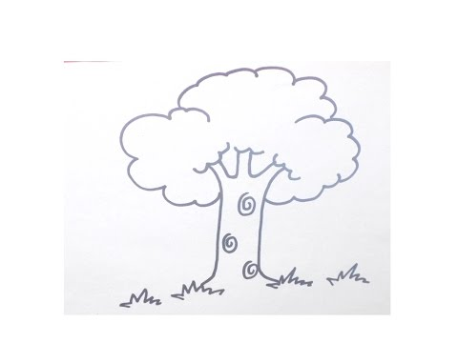
MUM
DAD

ME (ERERE)
SISTER (ERUS)
BROTHER(FEJIRO)
BROTHER (EFE)

