A TERM PAPER
ON
SOIL PERMEABILITY AND CAPILARITY
PRESENTED BY
OHWO JAMES OTAOGHENE
17/ENG 03/039
SUBMITTED TO
COLLEGE OF ENGINEERING,
AFE BABALOLA UNIVERSITY, ADO-EKITI, EKITI STATE, NIGERIA.
IN PARTIAL FULFILMENT OF THE REQUIREMENTS FOR THE AWARD OF THE BACHELOR OF ENGINEERING (B. ENG.) DEGREE IN CIVIL ENGINEERING.
ABSTRACT
Water pressure is and should always be measured relative to atmospheric pressure, and water table is the level at which the pressure is atmospheric. The amount, distribution, and movement of water in soil have an important bearing on the properties and behavior of soil as it aids in carrying out engineering works.

TABLE OF CONTENT
TITLE
Abstract

CHAPTER 1
- WHAT IS SOIL PERMEABILTY
- DARCY’S LAW OF PERMEABILITY; ASSUMPTIONS AND LIMITATIONS
- COEFFICIENT OF PERMEABILITY OF DIFFERENT SOILS
- IMPORTANCE OF SOIL PERMEABILTY
- PROPERTIES OF SOIL PERMEABILTY
- FACTORS AFFECTING SOIL PERMEABILITY
- TEST FOR SOIL PERMEABILTY

CHAPTER 2
- WHAT IS SOIL CAPILLARITY
- RELATIONSHIP BETWEEN PERMEABILITY AND CAPILLARITY

CHAPTER ONE

WHAT IS SOIL PERMEABILITY?
Soil permeability is the property of the soil to transmit water and air and is one of the most important qualities to consider for fish culture. A pond built in impermeable soil will lose little water through seepage. The more permeable the soil, the greater the seepage. A soil with high porosity has high permeability. A soil with a smaller value of permeability is categorized as impervious.
A soil with high porosity has high permeability. A soil with a smaller value of permeability is categorized as impervious. Here some basic features related to soil permeability are explained. Permeability is one of the most important engineering properties of the soil that is a solution for a number of engineering problems encountered in construction. Some of them are:
1. Settlement of foundation and buildings
2. Seepage below the earth structures
3. Seepage through the earth structures
4. The Yield of the wells
5. Control of Hydraulic Stability of masses
6. For designing filter in hydraulic structures in order to prevent piping

Darcy’s Law;
In 1856, French hydraulic engineer Henry Darcy published a report on the water supply of the city of Dijon in France. In that report, Darcy described the result of an experiment designed to study the flow of water through a porous medium. Darcy’s experiment resulted in the formulation of mathematical law that describes fluid motion in porous media. Darcy’s law states that the rate of fluid flow through porous medium is proportional to the potential energy gradient within that fluid. The constant of proportionality is the Darcy’s permeability of soil. Darcy’s permeability is a property of both porous medium and the fluid moving through the porous medium. In fact, Darcy’s law is the empirical equivalent of the Navier-Strokes equation. Darcy’s flow velocity for laminar flow is defined as the quantity of fluid flow along the hydraulic gradient per unit cross sectional area. Velocity of flow through a porous media is directly proportional to the hydraulic gradient responsible for flow.
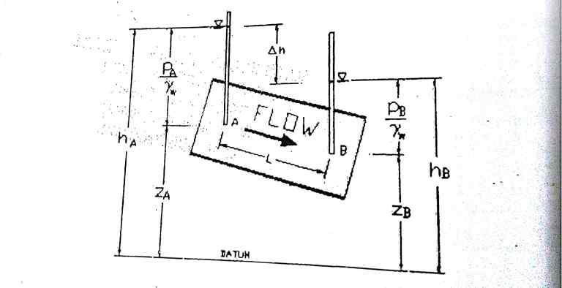

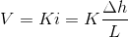
Here,

V = discharge velocity or superficial velocity
k = coefficient of permeability or hydraulic conductivity
i = hydraulic gradient
L = length of soil specimen

Assumptions of Darcy’s Law
- Soil is fully saturated.
- Temperature during testing is 27°C.
- Flow through soil is laminar
- Entire cross sectional area is available for flow
- Flow is continuous and steady.
Limitations of Darcy’s Law
Darcy’s law can be applied to many situations but do not correspond to these assumptions.
- Unsaturated and Saturated flow.
- Flow in fractured rocks and granular media.
- Transient flow and steady-state flow.
- Flow in aquitards and aquifers.
- Flow in Homogeneous and heterogeneous systems.
Coefficient of Permeability for Different Soil Types
Serial.no | Type of Soil | Coefficient of Permeability (mm/sec) | Drainage Properties
1 | Clean Gravel |  | Very Good
2 | Coarse and Medium Sand |  | Good
3 | Fine sand, loose silt |  | Fair
4 | Dense silt, clayey silts |  | Poor
5 | Silky clay and clay |  | Very poor
The coefficient of permeability is dependent on the particle size, structure of soil mass; void ratio, properties of water, the shape of the particle, etc.

FACTORS AFFECTING SOIL PERMEABILTY
A number of factors affect the permeability of soils, from particle size, impurities in the water, void ratio, the degree of saturation, and adsorbed water, to entrapped air and organic material. Following are factors effecting permeability of soils.
1. Size of soil particle
2. Specific Surface Area of Soil Particle
3. Shape of soil particle
4. Void ratio
5. Soil structure
6. Degree of saturation
7. Water properties
8. Temperature
9. Adsorbed water
10. Organic Matter

TEST FOR SOIL PERMEABILITY
Constant Head Permeability Test; the constant head permeability test is a laboratory experiment conducted to determine the permeability of soil. The soils that are suitable for these tests are sand and gravels. Soils with silt content cannot be tested with this method. The test can be employed to test granular soils either reconstituted or disturbed. Objective and Scope The objective of constant head permeability test is to determine the coefficient of permeability of a soil. Coefficient of permeability helps in solving issues related to:
1. Yield of water bearing strata
2. Stability of earthen dams
3. Embankments of canal bank
4. Seepage in earthen dams
5. Settlement Issues

Apparatus for Constant Head Permeability Test
1. Permeameter mould, internal diameter = 100mm, effective height =127.3 mm, capacity = 1000ml.
2. Detachable collar, 100mm diameter, 60mm height
3. Dummy plate, 108 mm diameter, 12mm thick,
4. Drainage base, having porous disc
5. Drainage cap having porous disc with a spring attached to the top.
6. Compaction equipment such as Proctor’s rammer or a static compaction equipment, as specified in IS:2720 (Part VII)-1965.
7. Constant head water supply reservoir
8. Vacuum pump
9. Constant head collecting chamber
10. Stop watch
11. Large funnel
12. Thermometer
13. Weighing balance accuracy 0.1g
14. Filter paper.

CHAPTER TWO

WHAT IS CAPILARITY?
Capillarity is the primary force that enables the soil to retain water, as well as to regulate its movement.
The phenomenon of capillarity also occurs in the soil. In the same way that water moves upwards through a tube against the force of gravity; water moves upwards through soil pores, or the spaces between soil particles.
The height to which the water rises is dependent upon pore size. As a result, the smaller the soil pores, the higher the capillary rise.
The effect can be seen in the drawing up of liquids between the hairs of a paint-brush, in a thin tube, in porous materials such as paper and plaster, in some non-porous materials such as sand and liquefied carbon fiber, or in a biological cells. It occurs because of intermolecular forces between the liquid and surrounding solid surfaces. If the diameter of the tube is sufficiently small, then the combination of surface tension (which is caused by cohesion within the liquid) and adhesive forces between the liquid and container wall act to propel the liquid.
In addition to water retention, capillarity in soil also enables the upward and horizontal movement of water within the soil profile, as opposed to downward movement caused by gravity. This upward and horizontal movement occurs when lower soil layers have more moisture than the upper soil layers and is important because it may be absorbed by roots.
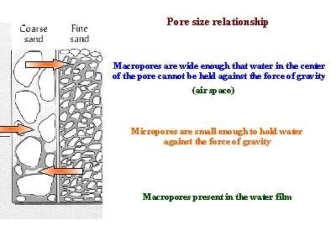
This picture shows how more water may be held between finer particles against the force of gravity, as compared to coarser particles. As a result, finer-textured soils have greater water holding capacities.

RELATIONSHIP BETWEEN SOIL PERMEABILITY AND CAPILLARITY
Permeability is the capacity of the rock or body of sediment for transmitting a fluid. This ability is dependent upon pore spaces between sediments, be they sediments comprising soil or those compacted and cemented within a classic sedimentary rock. Optimum permeability exists where sediments are rounded and large. Pore spaces are also large and water easily passes in between sediments. Permeability is poorest when sediments are of mixed sizes and shapes.
Igneous and metamorphic rocks, with their grown crystals, are too dense to allow water infiltration unless they have many interconnected cracks. In such a situation, water can enter these cracks. Clastic sedimentary rocks, on the other hand may have pore spaces between sediments that comprise the rock and so water may infiltrate some specimens belonging to this rock group.
Capillarity is the action by which water actually moves against the downward pull of gravity. Water is able to travel upwards and sideways within the rock material. Surface tension created by the forces of cohesion (attraction between water molecules) and adhesion (attraction between water molecules and the rock material) allow slow migration within pore spaces between rock particles
Capillarity is worst when sediment is poorly sorted with angled particles and mixed sizes and shapes present. The angled particles prevent ample pore space between rock fragments so there is no space available through which water can migrate. Capillarity is not present in igneous and metamorphic rocks nor is it at its best within the structure of Clastic sedimentary rocks. It is most prevalent and most important in unconsolidated (loose) sediments as would be present in soils.

REFRENCES
Civilengineeringnotes.com
Byjus.com
Sciencefairadventure.com
Ctahr.hawaii.com

