NAME: OGUNLEYE ADEDAPO ALMARTEEN
DEPARTMENT: CIVIL ENGINEERING
MATRIC NUMBER: 17/ENG03/038
COURSE NAME: SOIL MECHANICS
COURSE CODE: CVE 306
LECTURER: DR. EMEKA NNOCHIRI

LIST OF FIGURES
Fig 1-Variable head permeability test configuration

TABLE OF CONTENTS
- Title page
- List of figures
- Table of content
- Abstract
- Introduction
- Soil
- CHAPTER ONE
- Soil permeability
- Importance of soil permeability
- Factors affecting soil permeability
- Test for soil permeability
- Formula and determination of hydraulic conductivity(K)
- CHAPTER TWO
- Soil capillarity
- Surface tensions in soils
- Relationship between soil permeability and capillarity

ABSTRACT
The transition of water in soil has an important bearing on the properties and behaviour aspect of the soil. A sound engineer should know the principles of fluid flow, as groundwater conditions are frequently encountered and inevitable on construction projects of any type. Water pressure is always measured relative to atmospheric pressure, and water table is the level at which the pressure is atmospheric.

INTRODUCTION
SOIL
Soil as a civil engineering material, may be defined as all naturally occurring, loose/uncemented/weakly-cemented/relatively unconsolidated mineral particles, organic or inorganic in character lying over the bedrock which is formed by weathering (disintegration of rocks).

CHAPTER ONE
SOIL PERMEABILTY
Soil permeability is the property of the soil to transmit water and air and the more permeable the soil, the greater the seepage (the slow escape of a liquid or gas through porous materials or small holes)
IMPORTANCE OF SOIL PERMEABILTY
Permeability influences the rate of settlement of a saturated soil under load. The stability of slopes and retaining structures can be greatly affected by the permeability involved. The design of earth dams is very much based upon the permeability of soil used.
- Permeability influences the rate of settlement of a saturated soil under load.
- The stability of slopes and retaining structures can be greatly affected by the permeability involved.
- The design of earth dams is very much based upon the permeability of soil used.
- Filters made of soils are designed based upon their permeability.

PROPERTIES OF SOIL PERMEABILITY
- Solving problems involving pumping seepage water from construction excavation.
- Estimating the quantity of underground seepage.
- Stability analysis of earth structures and earth retaining walls subjected to seepage forces.

FACTORS AFFECTING SOIL PERMEABILITY
- Grain size
The permeability varies approximately as the square of grain size and it depends on the effective diameter of the grain size (D₁₀)
K=C (D₁₀)².
C is constant and generally lies between 100 to 150
- Organic matter
Presence of organic matter decreases the permeability.. this is due to blockage of voids by the organic matter

- Temperature
As the viscosity of the pore fluid decreases with the temperature, permeability increases with temperature, as unit weight of pore fluid does not change much with change in temperature.
- Void ratio
Increase in the void ratio increases the area available for flow hence permeability increases for critical conditions.
- Stratification of soil
Stratified soils are those soils that are formed by layer upon layer of the earth or dust deposited on each other. If the flow is parallel to the layers of stratification, the permeability is maximum while the flow in perpendicular direction occur with minimum permeability.
- Entrapped air and organic impurities
The organic impurities and entrapped air obstruct the flow and coefficient of permeability is reduced to their presence.
- Adsorbed water
This is the water layer formed around the soil particle especially in the case of fine-grained soils. This reduces the size of void space by about 10%. Hence permeability reduces.
- Degree of saturation
Partially saturated soil contain air voids which are formed due to entrapped air or gas released from the percolating fluid or water. This air will block the flow path thereby reducing the permeability. Fully saturated soil is more permeable than partially saturated soil.
- Shape of particles
Rounded particles will have more permeability than angular shaped. It is due to specific surface area of angular particles is more compared to rounded particles
- Soil structure
Structure of any two similar soil masses at same void ratio need not be the same. It varies according to the level compaction applied. If a soil contains flocculated structure, the particles are in random orientation and permeability is more in this case.
If the soil contains a dispersed structure, the particles are in face-to-face orientation, hence permeability is very low.
The permeability of stratified soil deposits varies according to the flow direction; if the flow is parallel, then permeability is more and if it is perpendicular, permeability is less.
TEST FOR SOIL PERMEABILITY
VARIABLE HEAD PERMEABILITY TEST
Variable head permeability test is one of several techniques by which the permeability of soil is determined. It is used to evaluate the permeability of fairly less previous soil. Permeability is the measure of the ability of soil to allow water to flow its pores or voids. Permeability is one of the most crucial soil properties of interest to geotechnical engineers. This is because it affects the rate of settlement of saturated soil under loads, the design of earth dam is mostly based on the permeability of soil used, and it greatly influences the stability of retaining structures and slopes. Soil permeability is also significant for estimation of underground seepage and stability analysis of earth structures suffered from seepage forces.
APPARATUS
- Mould Assembly
The mould assembly including drainage base and drainage cap which need to be conform to IS: 11209-1985

- Compaction Hammer

- Set of Stand Pipes

- Glass stand pipes varying in diameter from 5 to 20 mm, suitably mounted on stand or otherwise fixed on wall.

- Constant Head Tank

A suitable water reservoir capable or supplying water to the permeameter under constant head for constant head test arrangement.

- Miscellaneous Apparatus
For instance, IS sieves, mixing pan, graduated cylinder, meter scale, stop watch, 75micron wire gauge, thermometer, and a source of de-aired water.
DISTURBED SOIL SAMPLE

- Take 2.5-kg soil from a thoroughly mixed air-dried or oven-dried material and evaluate its moisture content.
- Remove the collar of the mould. Measure the internal dimensions of the mould. Weigh the mould with dummy plate to the nearest gram.
- Apply a little grease on the inside to the mould.
- Clamp the mould between the base plate and the extension collar and place the assembly on a solid base.
- Place soil specimen in the mould, and compact it at the required dry density using a suitable compacting device.
- Take a small specimen of the soil in a container for the water content determination.
- Remove the collar and base plate. Trim the excess soil level with the top of the mould.
- Clean the outside of the mould and the dummy plate.
- Find the mass of the soil in the mould.
- The mould with the sample is now placed over the permeameter. This will have drainage and cap discs properly saturated
UNDISTURBED SOIL SAMPLE
- Trim the specimen in a form of cylinder not larger than 85cm in diameter, and having a height equal to that of the mould.
- Place the specimen over porous disc of the drainage base fixed to the mould.
- Use impervious material like cement slurry to fill the space between mould and the specimen.
- Fix the drainage cap over the top of the mould.
PROCEDURE
- Connect the specimen to the selected stand-pipe through the top inlet.
- Open the bottom outlet and record the time interval required for the water level to fall from a known initial head to a known final head as measured above the center of the outlet.
- Refill the stand-pipe with water and repeat the test till three successive observations give nearly same time interval; the time intervals being recorded for the drop in head from the same initial to final values, as in the first determination.
- Alternatively, after selecting the suitable initial and final heads, h1, and h2, respectively, observe the time intervals for the head to fall from h1 to (h1*h2)^0.5, and similarly from (h1*h2)^0.5 to h2.
The time intervals should be the same; otherwise the observation shall be repeated after refilling the stand-pipe.

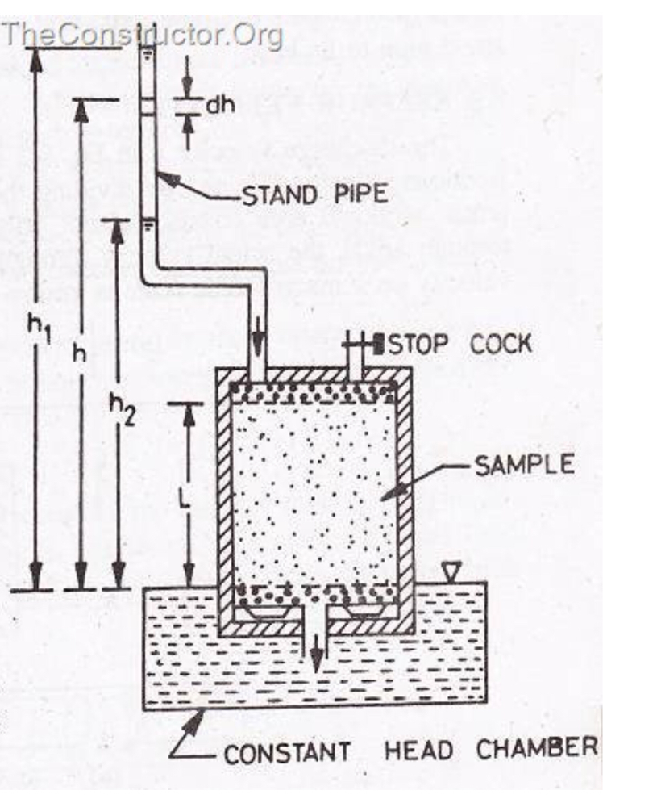
Fig 1-Variable head permeability test configuration
Constant Head Permeability Test
The constant head permeability test is a laboratory experiment conducted to determine the permeability of soil. The soils that are suitable for this tests are sand and gravels. Soils with silt content cannot be tested with this method. The test can be employed to test granular soils either reconstituted or disturbed.
Objective and Scope
The objective of constant head permeability test is to determine the coefficient of permeability of a soil.
Coefficient of permeability helps in solving issues related to:
- Yield of water bearing strata
- Stability of earthen dams
- Embankments of canal bank
- Seepage in earthen dams
- Settlement Issues
Apparatus for Constant Head Permeability Test
- Permeameter mould, internal diameter = 100mm, effective height =127.3 mm, capacity = 1000ml.
- Detachable collar, 100mm diameter, 60mm height
- Dummy plate, 108 mm diameter, 12mm thick,
- Drainage base, having porous disc
- Drainage cap having porous disc with a spring attached to the top.
- Compaction equipment such as Proctor’s rammer or a static compaction equipment, as specified in IS:2720 (Part VII)-1965.
- Constant head water supply reservoir
- Vacuum pump
- Constant head collecting chamber
- Stop watch
- Large funnel
- Thermometer
- Weighing balance accuracy 0.1g
- Filter paper.

FORMULA AND DETERMNINATION OF HYDRAULIC CONDUCTIVITY
Hydraulic conductivity is a physical property which measures the ability of the material to transmit fluid through pore spaces and fractures in the presence of an hydraulic agent; it is denoted as K
DETERMINATION OF HYDRAULIC CONDUCTIVITY
There are two broad categories of determining hydraulic conductivity:
- Empirical approach by which the hydraulic conductivity is correlated to soil properties like pore size and particle size (grain size)distributions, and soil texture
- Experimental approach by which the hydraulic conductivity is determined from hydraulic experiments using Darcy's law
The experimental approach is broadly classified into:
- Laboratory tests using soil samples subjected to hydraulic experiments
- Field tests (on site, in situ) that are differentiated into:

- small scale field tests, using observations of the water level in cavities in the soil
- large scale field tests, like pump tests in wells or by observing the functioning of existing horizontal drainage systems.
The small scale field tests are further subdivided into:
- infiltration tests in cavities above the water table
- slug tests in cavities below the water table
The methods of determination of hydraulic conductivity and other related issues are investigated by several researchers.

CHAPTER TWO
SOIL CAPILLARITY
The tendency of a liquid in a capillary tube or absorbent material to rise or fall as a result of surface tension is known as capillarity. Soil capillarity is the primary force that enables the soil to retain water as well as regulate to its environment
SURFACE TENSION
The cohesive forces between liquid molecules are responsible for the phenomenon known as surface tension.
RELATIONSHIP BETWEEN SOIL PERMEABILITY AND CAPILLARITY
Permeability is the capacity of the rock or body of sediment for transmitting a fluid. This ability is dependent upon pore spaces between sediments, be they sediments comprising soil or those compacted and cemented within a classic sedimentary rock. Optimum permeability exists where sediments are rounded and large. Pore spaces are also large and water easily passes in between sediments. Permeability is poorest when sediments are of mixed sizes and shapes.
Igneous and metamorphic rocks, with their grown crystals, are too dense to allow water infiltration unless they have many interconnected cracks. In such a situation, water can enter these cracks. Clastic sedimentary rocks, on the other hand may have pore spaces between sediments that comprise the rock and so water may infiltrate some specimens belonging to this rock group.
Capillarity is the action by which water actually moves against the downward pull of gravity. Water is able to travel upwards and sideways within the rock material. Surface tension created by the forces of cohesion (attraction between water molecules) and adhesion (attraction between water molecules and the rock material) allow slow migration within pore spaces between rock particles
Capillarity is worst when sediment is poorly sorted with angled particles and mixed sizes and shapes present. The angled particles prevent ample pore space between rock fragments so there is no space available through which water can migrate. Capillarity is not present in igneous and metamorphic rocks nor is it at its best within the structure of Clastic sedimentary rocks. It is most prevalent and most important in unconsolidated (loose) sediments as would be present in soils

