NAME: CHINEDUM PRUDENCE ESE
DEPT: CHEMICAL ENGINEERING
LEVEL:300L
MAT NO: 17/ENG01/007
COURSE TITLE: PROCESS INSTRUMENTATION
COURSE CODE: CHE312
ASSIGNMENT
QUESTION ONE
A. WHAT IS INSTRUMENTATION?
Instrumentation is a collective term for measuring instruments that are used for indicating, measuring and recording physical quantities. The term has its origins in the art and science of scientific instrument-making.
Instrumentation can refer to devices as simple as direct-reading thermometers, or as complex as multi-sensor components of industrial control systems. Today, instruments can be found in laboratories, refineries, factories and vehicles, as well as in everyday household use (e.g., smoke detectors and thermostats)

B. EXPLAIN SUCCINTLY THE MOBILE AND STATIONARY PHASE IN GAS CHROMATOGRAPHY
MOBILE PHASE
In gas chromatography, the mobile phase (or "moving phase") is a carrier gas, usually an inert gas such as helium or an unreactive gas such as nitrogen. Helium remains the most commonly used carrier gas in about 90% of instruments although hydrogen is preferred for improved separations.
STATIONARY PHASE
The stationary phase is a microscopic layer of liquid or polymer on an inert solid support, inside a piece of glass or metal tubing called a column (a homage to the fractionating column used in distillation). The instrument used to perform gas chromatography is called a gas chromatograph (or "aerograph", "gas separator").

C. HIGHLIGHT FOUR REASONS WHY MOISTURE MEASUREMENT ARE GERMANE IN PROCESS INDUSTRIES AND LIST FOUR METHODS OF MOISTURE MEASUREMENT
Moisture measurement are important in the process industry because
i. they can affect product
ii. they can poison reactions
iii. they can damage equipments
iv. they can cause explosions.
Methods of moisture measurement
i. Absolute Measurement Method
ii. Relative Humidity Method
iii. Capacitance Method
iv. Oxide Sensor

QUESTION TWO
A. State four cogent reasons for measuring and controlling process variables.
i. Measurement of process variables are important in controlling a process.
ii. The process variable is a dynamic feature of the process which may change rapidly.
iii. Accurate measurement of process variables is important for the maintenance of accuracy in a process.
B. Magnetic flow meters are highly important in process industries. Mention three typical applications of magnetic flow meters.
i. They are mechanically obstruction-less and can be equipped with abrasion-resistant liners, making them effective for measuring slurries and other erosive fluids.
ii. They are capable of dealing with most kinds of acids and bases, as well as water and water-based solutions, due to lining materials that are both insulators and corrosion resistant.
iii. They can measure both very low flows and very high volume flow rates, with a minimum diameter of roughly 0.125 inches and a maximum volume of up to 10 cubic feet.

C. With the aid of diagram briefly describe the working principle of any three pressure measuring devices.

1. The Barometer:
The barometer is a device meant for measuring the local atmospheric pressure. Fig. 2.18 shows a mercury barometer which consists of a 1 metre long glass tube closed at one end and completely filled with mercury and kept inverted in a bowl of mercury. A small quantity of mercury will drop into the bowl and thus a vacuum forms at the upper end of the tube.
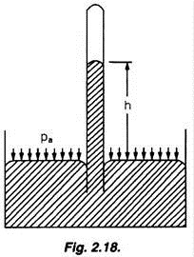
The atmospheric pressure acting on the surface of mercury in the bowl will support a mercury column in the tube. Let h be the height of mercury column in the tube measured above the surface of mercury in the bowl.
Let P_{a} be the atmospheric pressure intensity
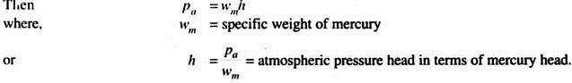
The height of the mercury column at sea level, is approximately 760 mm of mercury.

2. Piezometer or Pressure Tube:
The piezometer is used to measure the static pressure head of a liquid flowing at any section of a pipe. It consists of a tube whose open lower end is mounted flush with the inside wall of the pipe. The other end of the tube is exposed to the atmosphere. In the arrangement shown in Fig. 2.21 and 2.22 the height h to which the liquid rises in the tube represents the pressure head at the level A where the tube is connected to the pipe.
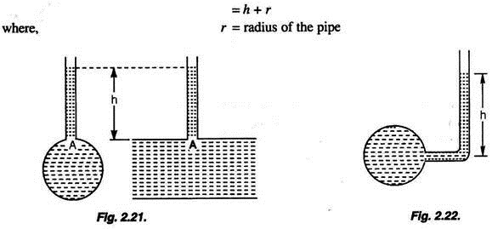
The piezometer may also be so shaped and connected to the pipe so that the pressure head at the level of the centre of the pipe may be directly obtained.

3. Manometers:
i. The U-Tube Manometer (The Double Column Manometer):
Manometers are pressure gauging devices using columns of different liquids. The fluid whose pressure is to be determined is called the metered fluid while the other fluid is called the manometer fluid. The manometer fluid may be of higher density or lower density than that of the metered fluid. These devices can be used to gauge pressures of liquids as well as gases. Manometers have connecting U-shaped tubes containing different fluids.
In a manometer when one limb of the device is open to the atmosphere it records the pressure of the source connected to the other limb. When both the limbs are connected to pressure sources, the manometer records the difference of pressure between the two pressure sources. Accordingly, these manometers are called simple manometer and differential manometer.
The pressure of a fluid in a pipe may be measured by using a glass U-tube containing a heavier liquid which does not mix with the fluid in the pipe.
Suppose the pipe contains water, and mercury is used as the measuring liquid. Let the level EF correspond to the surface of contact of the two liquids. Let X be the centre of the pipe.
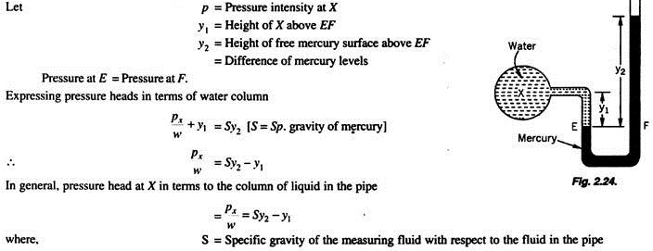

4. The Bourdon Gauge:
This device consists of a metallic tube of elliptical section closed at one end A, the other end B being fitted to the gauge point where the pressure is to be measured. As the fluid enters the tube, the tube tends to straighten.
By using a pinion-sector arrangement the small elastic deformation of the tube is communicated to a pointer in an amplified manner. The pointer moves over a graduated dial. The device is calibrated by subjecting it to various known pressures.
The Bourdon gauge is suitable for measuring not only high pressures such as those in a steam boiler or a water main but also negative or vacuum pressures. A gauge which is so devised to measure positive as well as negative pressures is called a compound gauge.
