

**Name Abdulsamad badamasi**

**Matric no 18/ ENG03/ 059**

**Department. Civil engineering**

**Soil mechanic CVE 306**

**Soil** **Permeability**

Soil permeability is the property of the soil to transmit water and air and is one of the most important qualities to consider for fish culture.

A pond built in impermeable soil will lose little water through seepage.The more permeable the soil, the greater the seepage. Some soil is so permeable and seepage so great that it is not possible to build a pond without special construction techniques. You will learn about these techniques in a later volume in this series.Soils are generally made up of layers and soil quality often varies greatly from one layer to another. Before pond construction, it is important to determine the relative position of the permeable and impermeable layers. The design of a pond should be planned to avoid having a permeable layer at the bottom to prevent excessive water loss into the subsoil by seepage.

The dikes of the pond should be built with soil which will ensure a good water retention. Again, soil quality will have to be checked with this in mind.

**factors** **affect** **soil** **permeability**?

Many factors affect soil permeability. Sometimes they are extremely localized, such as cracks and holes, and it is difficult to calculate representative values of permeability from actual measurements. A good study of soil profiles provides an essential check on such measurements. Observations on soil texture, structure, consistency, colour/mottling, layering, visible pores and depth to impermeable layers such as bedrock and claypan* form the basis for deciding if permeability measurements are likely to be representative.

Note: you have already learned that soil is made up of a number of horizons, each of them usually having different physical and chemical properties. To determine the permeability of soil as a whole, each horizon should be studied separately.

**Soil** **permeability** **relates** **to** **soil** **texture** **and** **structure**

The size of the soil pores is of great importance with regard to the rate of infiltration (movement of water into the soil) and to the rate of percolation (movement of water through the soil). Pore size and the number of pores closely relate to soil texture and structure, and also influence soil permeability.

Permeability variation according to soil texture

Usually, the finer the soil texture, the slower the permeability, as shown below:

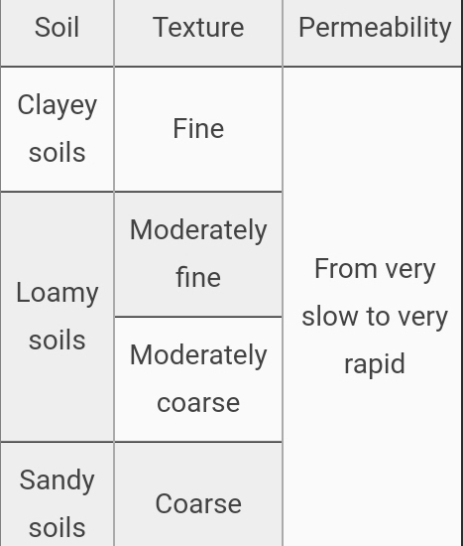

**Capillarity**.

This refers to how well water rises up in the soil. ... Capillarity depends on the size of the spaces between soil particles. The smaller the spaces, the higher the water rises in the soil. This means that clay soil allows water to rise highest compared to Sand soil and Loam soil.

**Soil** **permeability**

is the property of the soil to transmit water and air and is one of the most important qualities to consider for fish culture. A pond built in impermeable soil will lose little water through seepage. The more permeable the soil, the greater the seepage.

**Types of soil permeability**

**Absolute, effective, and relative permeability**

**Reservoirs contain water and oil or gas in varying amounts. Each interferes with and impedes the flow of the others.**

**Important of soil permeability**

**Permeability refers to the movement of air and water through the soil, which is important because it affects the supply of root-zone air, moisture, and nutrients available for plant uptake.**

**Measurement of soil permeability**

**Soil permeability, also termed hydraulic conductivity, is measured using several methods that include constant and falling head laboratory tests on intact or reconstituted specimens. Alternatively, permeability may be measured in the field using insitu borehole permeability testing (e.g. [2]), and field pumping tests.**

**Factors affecting permeability of soils.**

**A number of factors affect the permeability of soils, from particle size, impurities in the water, void ratio, the degree of saturation, and adsorbed water, to entrapped air and organic material.**