A TERM PAPER ON SOIL PERMEABILITY AND CAPILLARITY
BY
AKPORUERE DAVID 17/ENG03/010
CIVIL ENGINEERING

TO BE SUBMMITED TO THE LECTURER OF SOIL MECHANICS [CVE 306] IN THE DEPARTMENT OF CIVIL ENGINEERING AFE BABALOLA UNIVERSITY.

ABSTRACT
This paper is to educate us more about soil permeability and capillarity.

INTRODUCTION
Soil are permeable materials because of the presence of interconnected voids that permit the flow of fluids from location of high energy to locations of low energy.
Capillarity is the ability of various soils and rocks to allow water to move up through a tube. Capillarity dependson a rock’s porosity and permeability. The forces involved in capillarity are gravity pulling downward on the water, and attraction between water molecules and the molecules of the rock.

WHAT IS SOIL PERMEABILITY?
Soil permeability is “the ease with which gases, liquids or plant roots penetrate or pass through a bulk mass of soil or a layer of soil.

IMPORTANCE OF SOIL PERMEABILITY
- It influences the rate of settlement of a saturated soil under load.
- The design of earth dams is very much based upon the permeability of the soils used.
- The stability of slopes and retaining structures can be greatly affected by the permeability of the soils involved.
- Filters made of soils are designed based upon their permeability.

FACTORS AFFECTING SOIL PERMEABILITY

A soil is said to be permeable when it allows water through it. There are various factors such as void ratio, size, and shape of the particle, degree of saturation os soil etc. which are affecting permeability property of soils and these factors are briefly discussed in this article.
Before going to know about these factors, take a look at the general expression for coefficient permeability which is derived from the comparison of poiseuille’s law with Darcy’s law.
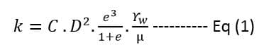
Where k = Coefficient of permeability
C = Shape constant
D = Effective grain size
e = Void ratio
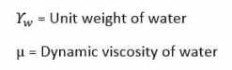
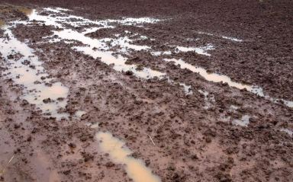Fig 1: Water Percolating into Soil

Factors Effecting Permeability of Soils
Following are factors effecting permeability of soils.
- Size of soil particle
- Specific Surface Area of Soil Particle
- Shape of soil particle
- Void ratio
- Soil structure
- Degree of saturation
- Water properties
- Temperature
- Adsorbed water
- Organic Matter

1. Size of Soil Particle
Permeability varies according to size of soil particle. If the soil is coarse grained, permeability is more and if it is fine grained, permeability is low. The relation between coefficient of permeability (k) and particle size (D) can be shown from equation (1) as follows.
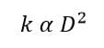

2. Specific Surface Area of Particles
Specific surface area of soil particles also effects the permeability. Higher the specific surface area lower will be the permeability.
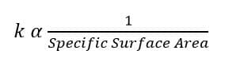

3. Shape of Soil Particle
Rounded Particles will have more permeability than angular shaped. It is due to specific surface area of angular particles is more compared to rounded particles.

4. Void Ratio
In general, Permeability increases with void ratio. But it is not applicable to all types of soils. For example, Clay has high void ratio than any other types of soil but permeability for clays is very low. This is due to, the flow path through voids in case of clays is extremely small such that water cannot permit through this path easily.
The relation between coefficient of permeability and void ratio can be expressed from equation (1) as
For Clay
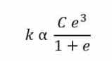
Where, C = Shape of the flow path,
e = Void ratio.
For coarse grained soil, “C” can be neglected. Hence
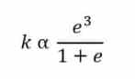

5. Soil Structure
Structure of any two similar soil masses at same void ratio need not be same. It varies according to the level of compaction applied. If a soil contains flocculated structure, the particles are in random orientation and permeability is more in this case.
If the soil contains dispersed structure, the particles are in face to face orientation hence, permeability is very low. The permeability of stratified soil deposits also varies according to the flow direction. If the flow is parallel, permeability is more. If it is perpendicular, permeability is less.
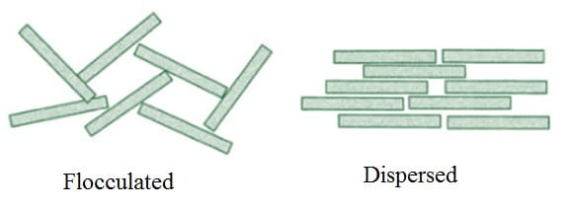Fig 2: Soil Structures

6. Degree of Saturation
Partially saturated soil contain air voids which are formed due to entrapped air or gas released from the percolating fluid or water. This air will block the flow path thereby reduces the permeability. Fully saturated soil is more permeable than partially saturated soil.

7. Water Properties
Various properties of water or fluid such as unit weight and viscosity also effects the permeability. However, unit weight of water will not affect much since it does not change much with temperature.
But when temperature is increased viscosity decreases rapidly. From equation (1), permeability increase when viscosity decreases.
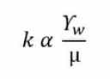

8. Temperature
Temperature also affects the permeability in soils. From equation (1), permeability is inversely proportional to the viscosity of the fluid. It is known that viscosity varies inversely to the temperature. Hence, Permeability is directly related to temperature.
Greater the temperature, higher will be the permeability. That is the reason, seepage is more in summer seasons than in winter.
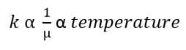

9. Adsorbed Water
Adsorbed water is the water layer formed around the soil particle especially in the case of fine-grained soils. This reduces the size of the void space by about 10%. Hence, permeability reduces.

10. Organic matter
Presence of organic matter decreases the permeability. This is due to blockage of voids by the organic matter.

TEST FOR SOIL PERMEABILITY
There are two methods in testing for soil permeability, the constant head method and the falling head method

A. CONSTANT HEAD

OBJECTIVE
To determine the coefficient of permeability of a soil using constant head method.

need and Scope
�The knowledge of this property is much useful in solving problems involving yield of water bearing strata, seepage through earthen dams, stability of earthen dams, and embankments of canal bank affected by seepage, settlement etc.
Planning and organization
1. Preparation of the soil sample for the test
2. Finding the discharge through the specimen under a particular head of water.
Definition of coefficient of permeability
The rate of flow under laminar flow conditions through a unit cross sectional are of porous medium under unit hydraulic gradient is defined as coefficient of permeability.
Equipment
1.Permeameter mould of non-corrodible material having a capacity of 1000 ml, with an internal diameter of 100 0.1 mm and internal effective height of 127.3 0.1 mm.
2.The mould shall be fitted with a detachable base plate and removable extension counter.
3.Compacting equipment: 50 mm diameter circular face, weight 2.76 kg and height of fall 310 mm as specified in I.S 2720 part VII 1965.
4.Drainage bade: A bade with a porous disc, 12 mm thick which has the permeability 10 times the expected permeability of soil.
5.Drainage cap: A porous disc of 12 mm thick having a fitting for connection to water inlet or outlet.
6.Constant head tank: A suitable water reservoir capable of supplying water to the permeameter under constant head.
7. Graduated glass cylinder to receive the discharge.
8. Stop watch to note the time.
9.A meter scale to measure the head differences and length of specimen.
Preparation of Specimen for testing
A. Undisturbed Soil Sample
1.Note down the sample number, bore hole number and its depth at which the sample was taken.
2.Remove the protective cover (paraffin wax) from the sampling tube.
3.Place the sampling tube in the sample extraction frame, and push the plunger to get a cylindrical form sample not longer than 35 mm in diameter and having height equal to that of mould.
4.The specimen shall be placed centrally over the porous disc to the drainage base.
5.The angular space shall be filled with an impervious material such as cement slurry or wax, to provide sealing between the soil specimen and the mould against leakage from the sides.
6.The drainage cap shall then be fixed over the top of the mould.
7.Now the specimen is ready for the test.
Disturbed Soil Sample
1.A 2.5 kg sample shall be taken from a thoroughly mixed air dried or oven dried material.
2.The initial moisture content of the 2.5 kg sample shall be determined. Then the soil shall be placed in the air tight container.
3.Add required quantity of water to get the desired moisture content.
4.Mix the soil thoroughly.
5.Weigh the empty permeameter mould.
6.After greasing the inside slightly, clamp it between the compaction base plate and extension collar.
7.Place the assembly on a solid base and fill it with sample and compact it.
8.After completion of a compaction the collar and excess soil are removed.
9.Find the weight of mould with sample.
10.Place the mould with sample in the permeameter, with drainage base and cap having discs that are properly saturated.
Test Procedure
1.For the constant head arrangement, the specimen shall be connected through the top inlet to the constant head reservoir.
2.Open the bottom outlet.
3.Establish steady flow of water.
4.The quantity of flow for a convenient time interval may be collected.
5.Repeat three times for the same interval.
Observation and Recording
The flow is very low at the beginning, gradually increases and then stands constant. Constant head permeability test is suitable for cohesionless soils. For cohesive soils falling head method is suitable.
Computation
Coefficient of permeability for a constant head test is given by
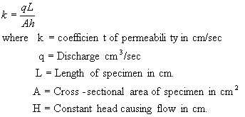
b. Falling Head Method
Objective
To determine the coefficient of permeability of the given soil sample, using falling head method.
Need and scope
The test results of the permeability experiments are used:
1.To estimate ground water flow.
2.To calculate seepage through dams.
3.To find out the rate of consolidation and settlement of structures.
4.To plan the method of lowering the ground water table.
5.To calculate the uplift pressure and piping.
6.To design the grouting.
7.And also for soil freezing tests.
8.To design pits for recharging.
�����Thus the study of seepage of water through soil is very important, with wide field applications.
�����The falling head method of determining permeability is used for soil with low discharge, where as the constant head permeability test is used for coarse-grained soils with a reasonable discharge in a given time. For very fine-grained soil, capillarity permeability test is recommended.
Principle of the Experiment
The passage of water through porous material is called seepage. A material with continuous voids is called a permeable material. Hence permeability is a property of a porous material which permits passage of fluids through inter connecting conditions.
Hence permeability is defined as the rate of flow of water under laminar conditions through a unit cross-sectional area perpendicular to the direction of flow through a porous medium under unit hydraulic gradient and under standard temperature conditions.
The principle behind the test is Darcy�s law for laminar flow. The rate of discharge is proportional to (i x A)
q= kiA
where q= Discharge per unit time.
A=Total area of c/s of soil perpendicular to the direction of flow.
i=hydraulic gradient.
k=Darcys coefficient of permeability =The mean velocity of flow that will occur through the cross-sectional area under unit hydraulic gradient.
Planning and Organization
The tools and accessories needed for the test are:
1.Permeameter with its accessories.
2.Standrd soil specimen.
3.Deaires water.
4.Balance to weigh up to 1 gm.
5.I.S sieves 4.75 mm and 2 mm.
6.Mixing pan.
7.Stop watch.
8.Measuring jar.
9.Meter scale.
10.Thermometer.
11.Container for water.
12. Trimming knife etc.
Knowledge of Equipment
(a) The permeameter is made of non-corrodible material with a capacity of 1000 ml, with an internal diameter of 1000.1 mm and effective height of 127.3 0.1 mm.
(b) The mould has a detachable base plate and a removable exterior collar.
(c) The compacting equipment has a circular face with 50 mm diameter and a length of 310 mm with a weight of 2.6 kg.
(d) The drainage base is a porous disc, 12 mm thick with a permeability 10 times that of soil.
(e) The drainage cap is also a porous disc of 12 mm thickness with an inlet/outlet fitting.
(f) The container tank has an overflow valve. There is also a graduated jar to collect discharge.
(g) The stand pipe arrangements are done on a board with 2 or 3 glass pipes of different diameters.
Preparation of the Specimen
The preparation of the specimen for this test is important. There are two types of specimen, the undisturbed soil sample and the disturbed or made up soil sample.
A. Undisturbed soil specimen
It is prepared as follows:
1. Note down-sample no., borehole no., depth at which sample is taken.
2.Remove the protective cover (wax) from the sampling tube.
3.Place the sampling tube in the sample extract or and push the plunger to get a cylindrical shaped specimen not larger than 85 mm diameter and height equal to that of the mould.
4.This specimen is placed centrally over the drainage disc of base plate.
5.The annular space in between the mould and specimen is filled with an impervious material like cement slurry to block the side leakage of the specimen.
6.Protect the porous disc when cement slurry is poured.
7.Compact the slurry with a small tamper.
8.The drainage cap is also fixed over the top of the mould.
9.The specimen is now ready for test.
B. Disturbed Specimen
The disturbed specimen can be prepared by static compaction or by dynamic compaction.
(a)Preparation of statically Compacted (disturbed) specimen.
1.Take 800 to 1000 gms of representative soil and mix with water to O.M.C determined by I.S Light Compaction test. Then leave the mix for 24 hours in an airtight container.
2.Find weight �W� of soil mix for the given volume of the mould and hence find the dry
3.Now, assemble the permeameter for static compaction. Attach the 3 cm collar to the bottom end of 0.3 liters mould and the 2 cm collar to the top end. Support the mould assembly over 2.5 cm end plug, with 2.5 cm collar resting on the split collar kept around the 2.5 cm- end plug. The inside of the 0.3 lit. Mould is lightly greased.
4.Put the weighed soil into the mould. Insert the top 3 cm �end plug into the top collar, tamping the soil with hand.
5.Keep, now the entire assembly on a compressive machine and remove the split collar. Apply the compressive force till the flange of both end plugs touch the corresponding collars. Maintain this load for 1 mt and then release it.
6.Then remove the top 3 cm plug and collar place a filter paper on fine wire mesh on the top of the specimen and fix the perforated base plate.
7.Turn the mould assembly upside down and remove the 2.5 cm end plug and collar. Place the top perforated plate on the top of the soil specimen and fix the top cap on it, after inserting the seating gasket.
8.Now the specimen is ready for test.
(b) Preparation of Dynamically Compacted Disturbed sample:
1.Take 800 to 1000 gms of representative soil and mix it with water to get O.M.C, if necessary. Have the mix in airtight container for 24 hours.
2.Assemble the permeameter for dynamic compaction. Grease the inside of the mould and place it upside down on the dynamic compaction base. Weigh the assembly correct to a gram (w). Put the 3 cm collar to the other end.
3.Now, compact the wet soil in 2 layers with 15 blows to each layer with a 2.5 kg dynamic tool. Remove the collar and then trim off the excess. Weigh the mould assembly with the soil (W₂).
4.Place the filter paper or fine wore mesh on the top of the soil specimen and fix the perforated base plate on it.
5.Turn the assembly upside down and remove the compaction plate. Insert the sealing gasket and place the top perforated plate on the top of soil specimen. And fix the top cap.
6.Now, the specimen is ready for test.
Experimental Procedure
1.Prepare the soil specimen as specified.
2.sturate it. Deaired water is preferred.
3.assemble the permeameter in the bottom tank and fill the tank with water.
4.Inlet nozzle of the mould is connected to the stand pipe. Allow some water to flow until steady flow is obtained.
5.Note down the time interval �t� for a fall of head in the stand pipe �h�.
6.Repeat step 5 three times to determine �t� for the same head.
7.Find �a� by collecting �q� for the stand pipe. weigh it correct to 1 gm and find �a� from q/h=a.
Therefore the coefficient of permeability
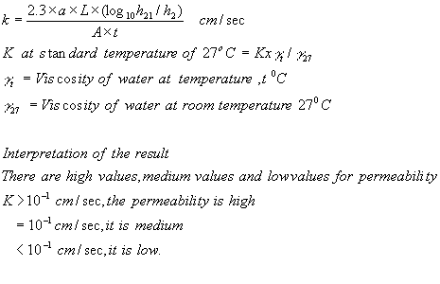
Observation and Recording:

WHAT IS CAPILLARY ACTION?

Capillary action is the same effect that causes porous materials to soak up liquids. Capillary action is the movement of a liquid through or along another material against an opposing force such as gravity. Capillary action occurs when the adhesive intermolecular forces between liquid, such as water, and the solid surface of the tube is stronger than cohesive intermolecular forces between water molecules.

WHAT IS CAPILLARITY?
Capillarity is the primary force that enables soil to retain water as well as regulate its movement. Capillarity is a combination of cohesion/adhesion and surface tension force.
The phenomenon of capillarity also occurs in the soil. In the same way that water moves upwards through a tube against the force of gravity; water moves upwards through soil pores, or the spaces between soil particles. The height towhich rises is dependent upon pore size. As a result, the smaller the soil pores, the higher the capillary rise.

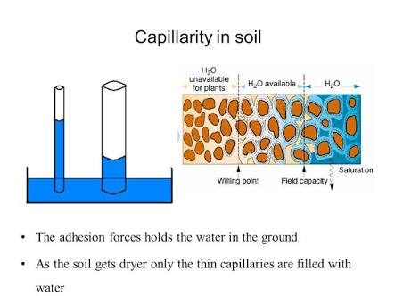

CAPILLARY RISE IN DIFFERENT SEDIMENTS
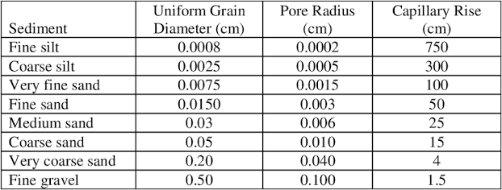

CAPILLARY RISE

Capillary rise is a well known unsaturated soil phenomenon that describes the movement of pore water from lower elevation to higher elevation driven by the hydraulic head gradient acting across the couved air/pore water interface. Capillary rise is the height to which the water rises within the tube, and decreases as the width of the tube increases. Three fundamental practical characteristics related to capillary rise are of primary practical concern:
- The maximum height of capillary rise.
- The fluid storage capacity of capillary rise.
- The rate of capillary rise.

FACTORS USED TO DETERMINE CAPILLARY RISE

The factors needed for determining capillary rise includes:
- Diameter of capillary tube.
- Density of the liquid.
- Viscosity of the liquid.
- Surface tension.

CONCLUSION
In conclusion, soil permeability and soil capillarity are both important properties in different kinds of soil. This property is very important to the construction industry. However there is a slight difference between soil permeability and soil capillarity.

