**AFE BABALOLA UNIVERSITY ADO-EKITI**

**ALFA BELGORE REHABILITATION PROJECT**

ADEDEJI KEHINDE MUBARAK

18/ENG05/004

**TABLE OF CONTENT**

LIST OF TABLES i

LIST OF FIGURES i

1. SCOPE OF WORK 1

2. PROJECT GANNT CHART 2

3. HUMAN RESOURCES AND PROJECT TEAM 4

4. SITE SECUREMENT 4

5. BEME DEVELOPMENT 4

6. PAYMENT SCHEDULE 6

7. DEFINITION 7

7.1. BEME 7

7.2. DEFECT LIABILITY PERIOD 7

7.3. LEAD CONSULTANT 7

7.4. PROJECT LIFE CYCLE 8

7.5. ENVIRONMENT IMPACT ASSESSMENT (EIA) 9

# LIST OF TABLES

Table 1. BEME Development 5

Table 2. Payment Schedule. 6

# LIST OF FIGURES

Figure 1. Estimated Task and Gantt Chart for Alfa Belgore Rehabilitation Project. 2

Figure 2. Gantt Chart for Alfa Belgore Rehabilitation Project. 3

Figure 3. Project Life Cycle. 9

As the designated student Consulting Engineer on the Alfa Belgore Rehabilitation project, the following are expected.

# SCOPE OF WORK

The project scope of work for the project is outlined as follows:

1. Mark-out of area that require rehabilitation.
2. Mark-out of area for demolition.
3. Demolition of existing.
4. Concrete work: casting concrete in locations around the building to get it ready for the waterproofing.
5. Form works: This work concerns building new walls and also reconstruction of demolished walls.
6. Plastering work: This work concerns plastering new walls and also walls where plastering was removed by various factors.
7. Tiling / marble work: This concern part of the floor where tiles are cracked or broken, new separations in bathrooms and kitchen.
8. Painting works: This general and will be applied to the interior and exterior of the building
9. Doors, windows and metal works: All the doors and windows are to be replaced in wood or Metallic as stipulated in the Bill of Quantities.
10. Plumbing and Sanitary works: The work consists of restoration of the whole water and sanitation / drainage system which are broken.
11. Air-conditioning works: Nothing does exist within the two building. So new AC system us required for the two buildings.
12. Electrical installation: In addition to the electrical installation boxes in old wall. New installation is required and hooked to the existing network.

# PROJECT GANNT CHART

The project Gannt chart is shown on Figure 1 and Figure 2 below.

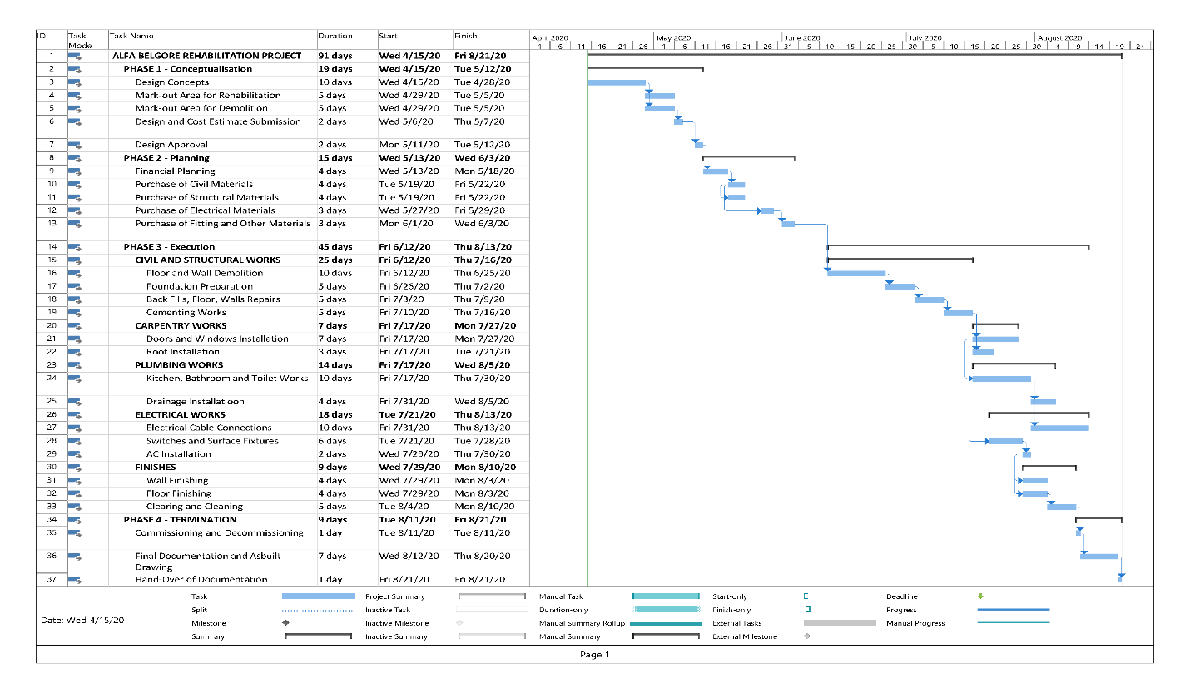

Figure 1. Estimated Task and Gantt Chart for Alfa Belgore Rehabilitation Project.

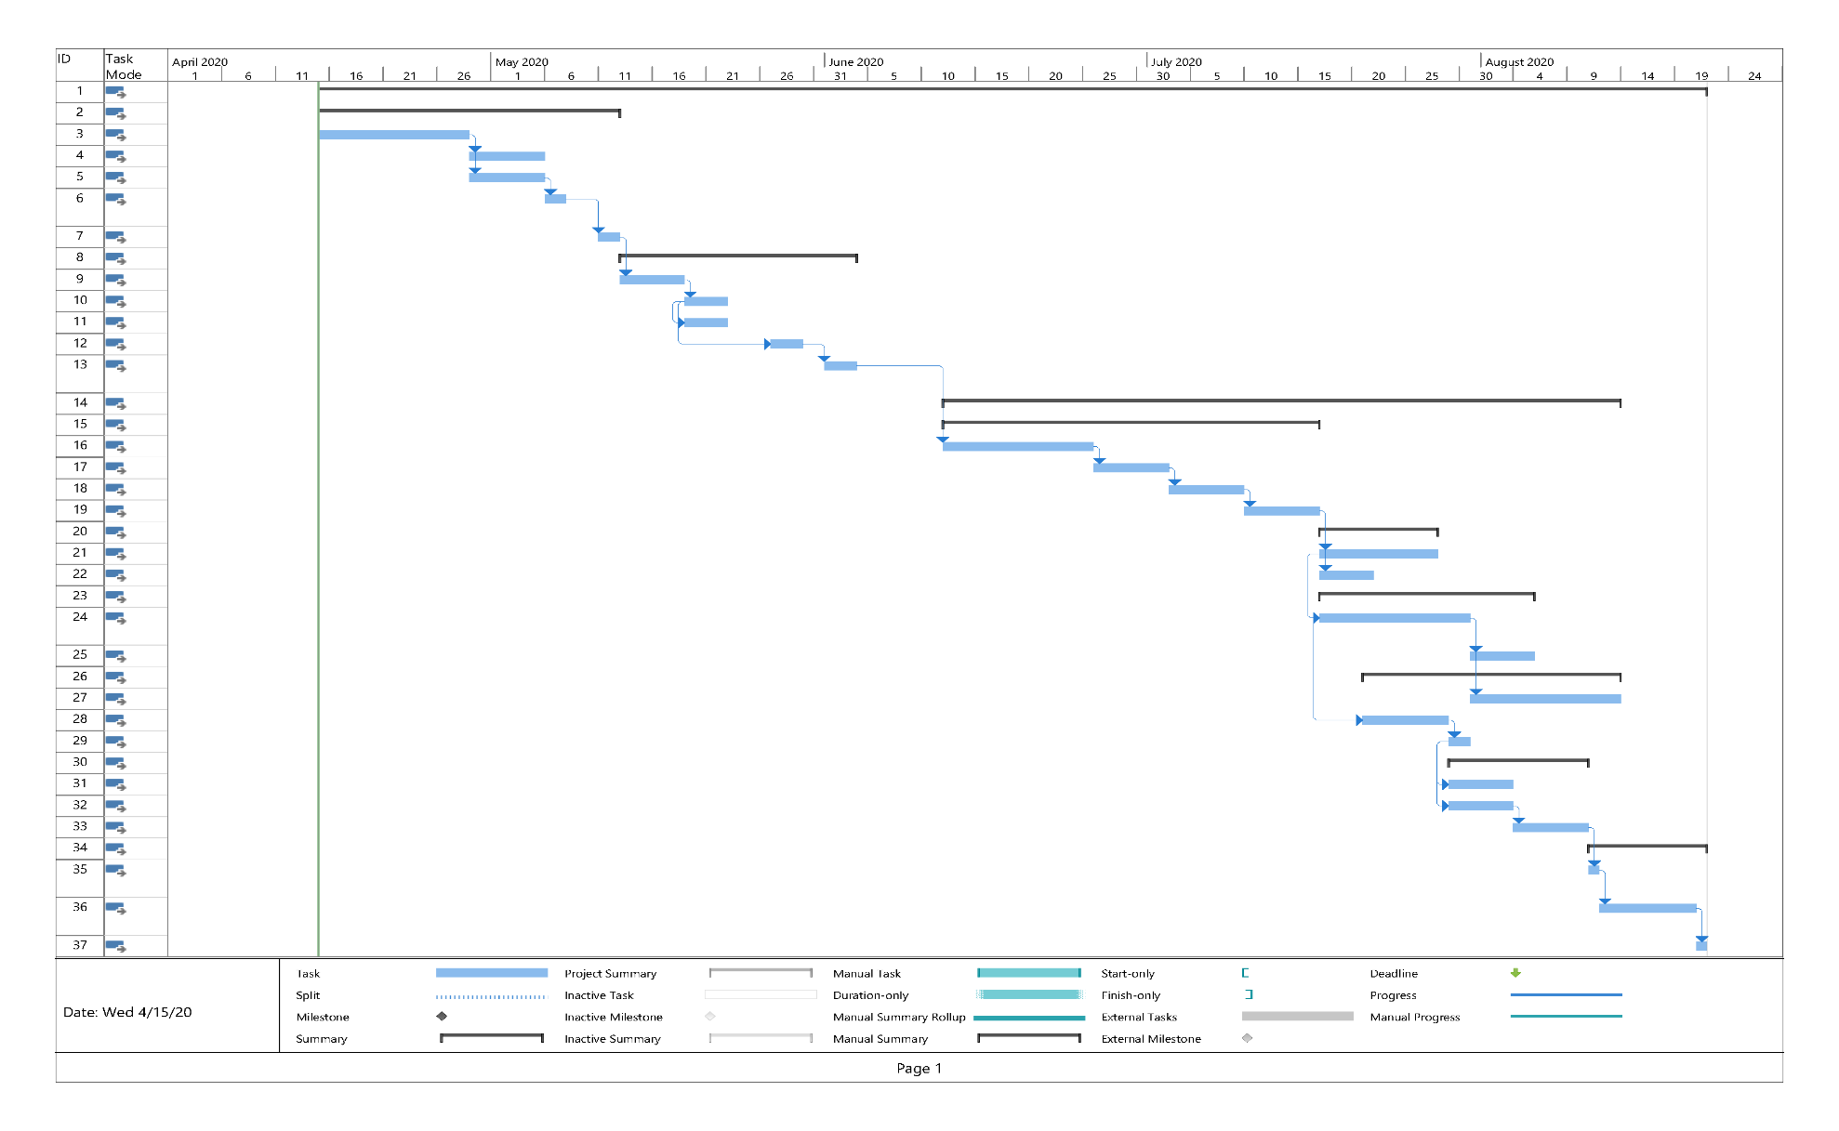

Figure 2. Gantt Chart for Alfa Belgore Rehabilitation Project.

# HUMAN RESOURCES AND PROJECT TEAM

The list of human resources needed and the project team with lead consultant includes the following:

1. Project Manager
2. Architect – Lead Consultant
3. Design Engineer
4. Civil Engineer
5. Electrical Engineer
6. Structural Engineer
7. Quantity Surveyor
8. Geotechnical Engineer
9. Construction Manager
10. Mechanical Engineer
11. Social / Environmental Specialist
12. Site Engineer

# SITE SECUREMENT

The site was secured to prevent cases of theft of construction materials in store during preparation and construction. It is also required to monitor the movement of personnel and construction workers in and out of the construction site.

# BEME DEVELOPMENT

Development of BEME for the project by lump sum projections including:

1. 10% of the total estimated cost (tec) as miscellaneous,
2. 15% tech as consultancy fee,
3. 5% tec for site preparations and clearing after completion,
4. 12% of tec for transport cost,
5. 20% tec as profit

Table 1. BEME Development

|  |  |  |  |  |  |  |
| --- | --- | --- | --- | --- | --- | --- |
| Item No. | Description | Unit | Quantity | Material Rate (₦) | Labour Rate (₦) | Cost (₦) |
| 1 | Cement | Bags | 500 | 2,550.00 | 38,250.00 | 1,313,250.00 |
| 2 | Blocks |  | 2800 | 200.00 | 16,800.00 | 576,800.00 |
| 3 | Sand | Truck (6-Tons) | 6 | 23,000.00 | 4,140.00 | 142,140.00 |
| 4 | Granite | Truck (6-Tons) | 3 | 40,000.00 | 3,600.00 | 123,600.00 |
| 5 | Water | Trips (6-Tons) | 10 | 5,000.00 | 1,500.00 | 51,500.00 |
| 6 | Steel Rod (10 mm) | Tons | 1 | 165,000.00 | 4,950.00 | 169,950.00 |
| 7 | Binding Wire | Rolls | 8 | 7,000.00 | 1,680.00 | 57,680.00 |
| 8 | Doors |  | 8 | 100,000.00 | 24,000.00 | 824,000.00 |
| 9 | Windows |  | 8 | 10,000.00 | 2,400.00 | 82,400.00 |
| 10 | Kitchen Fixtures |  | 4 | 60,000.00 | 7,200.00 | 247,200.00 |
| 11 | Bathroom Fixtures |  | 4 | 110,000.00 | 13,200.00 | 453,200.00 |
| 12 | Roof | sqm | 120 | 3,200.00 | 11,520.00 | 395,520.00 |
| 13 | Air Conditioning Unit |  | 5 | 110,000.00 | 16,500.00 | 566,500.00 |
| 14 | Tiles | sqm | 200 | 2,000.00 | 12,000.00 | 412,000.00 |
| 15 | Electrical Wires | Rolls | 10 | 15,000.00 | 4,500.00 | 154,500.00 |
| 16 | Electrical Fixtures |  | 2 | 50,000.00 | 3,000.00 | 103,000.00 |
| 17 | Plumbing Fixtures |  | 8 | 40,000.00 | 9,600.00 | 329,600.00 |
| 18 | Wood |  | 20 | 3,000.00 | 1,800.00 | 61,800.00 |
| 19 | Wall Finishes |  | 10 | 40,000.00 | 12,000.00 | 412,000.00 |
| 20 | Painter |  | 4 |  | 20,000.00 | 20,000.00 |
| 21 | Electrician |  | 5 | - | 30,000.00 | 30,000.00 |
| 22 | Plumber |  | 4 | - | 20,000.00 | 20,000.00 |
| 23 | Carpenter |  | 4 | - | 20,000.00 | 20,000.00 |
| 24 | **TOTAL MATERIAL & LABOUR COST** | | | | | **6,566,640.00** |
| 25 | **Miscellaneous** | 10% |  |  |  | 656,664.00 |
| 26 | **Consultancy Fee** | 15% |  |  |  | 984,996.00 |
| 27 | **Site Preparation and Clearing After Completion** | 5% |  |  |  | 328,332.00 |
| 28 | **Transport Cost** | 12% |  |  |  | 787,996.80 |
| 29 | **Profit** | 20% |  |  |  | 1,313,328.00 |
|  | **TOTAL COST** | | | | | **10,637,956.80** |

# PAYMENT SCHEDULE

Table 2 shows the payment schedule with assumption that the total payment is ten (10) million Four thousand Eight Hundred and Sixty Naira and Eighty Kobo and based on

1. 30% tec for Mobilisation,
2. Next 30% tec at 50% completion,
3. Final Payment of 40% tec at completion and handover

Table 2. Payment Schedule.

|  |  |  |  |  |  |
| --- | --- | --- | --- | --- | --- |
| **PAYMENT SCHEDULE** | | | | | |
| **S/N** | **ITEM**  **DESCRIPTION** | **DATE** | **TOTAL SUM** | **%** | **TOTAL PRICE  (NGN)** |
| 1 | Mobilization | 15-04-2020 | 10,637,956.80 | 30% | 3,191,387.04 |
| 2 | Payment at 50% Completion | 12-05-2020 | 30% | 3,191,387.04 |
| 3 | Final Payment at Completion and Handover | 18-06-2020 | 40% | 4,255,182.72 |
|  | **TOTAL SUM** | | **10,637,956.80** | | |
| **AMOUNT IN WORDS:** | | | **Ten Million Six Hundred and Thirty Seven Thousand Nine Hundred and Fifty Six Naira and Eighty Kobo Only** | | |

# DEFINITION

## BEME

BEME is simply stands for “Bill of Engineering Measurements and Evaluation. BEME is a list of work items, their estimated quantities and cost prepared based on specification and drawings presented for a project. It is an important tool that is used to assess and estimate the cost before, during and post-construction of the project works. The items evaluated will normally include the following:

1. Cost of materials,
2. Labour cost,
3. Equipment cost, etc.

which are resources required for the successful completion of the construction based on the pre-determined scope and specification.

These are necessary to provide sufficient information during construction planning, tendering and contracting. In addition, they are required to make comparison of rates and cost of items required in the project.

## DEFECT LIABILITY PERIOD

Defects liability period (DLP) is a fixed period of time, starting from the date of practical completion, during which the contractor has an express contractual right to return to the site to rectify defects. This period is sometimes referred to as rectification period or defects correction period.

Typically, during this period, the contractor has the right to return to the site to rectify defects or complete unfinished work; the principal is entitled to continue holding security, to secure the contractor’s obligations in respect of incomplete or defective work; and the superintendent continues to remain involved in the project.

## LEAD CONSULTANT

The lead consultant is simply an entity (company or personnel) appointed by the client to manage and administer the services of all consultants on multi-disciplinary projects where more than one professional service provider is appointed on a project. In multi-disciplinary engineering projects where these services are provided they are often called "Engineering Management Services".

In other words, the lead consultant is the consultant that directs the work of the consultant team and is the main point of contact for communication between the client and the consultant team, except for on significant design issues where the lead designer may become the main point of contact.

## PROJECT LIFE CYCLE

Project life-cycle refers to the different phases in a project from the conceptualization / start-up / initiation phase to the termination / close-out phase of the project. A typical project life-cycle will normally include the following phases:

**Conceptualisation Phase:**

This phase is sometimes referred to as the initiation or start-up phase where the project objectives are defined and the conceptual aspects of the project agreed. This may be the phase where a problem is identified, potential solutions suggested and the scope of work is defined. The business contract and cases are created at this phase.

**Planning Phase:**

This phase is where the project is broken down into manageable areas of work and planned in terms of time, cost and resources. This phase will involve determining resource availability, creating a project budget and allocation of tasks to certain resources. This is a continuous process and will extend throughout the execution phase of the project.

**Execution Phase:**

This is when the actual work of the project is performed / implemented. Required materials, tools, and resources are controlled, monitored and transformed to reach the project goals. During this phase, performance is continually measured to ensure the project is successful.

**Termination Phase:**

The termination phase is the final phase which is also referred to as the “Close-out phase”. This phase involves closing out and demobilisation, where resources are reassigned, the project is handed over and the post-project review is carried out.

Figure 3. Project Life Cycle.

## ENVIRONMENT IMPACT ASSESSMENT (EIA)

Environmental Impact Assessment (EIA) is a systematic analysis tool used to identify and evaluate the likelihood of environmental impacts as a result of a proposed project or development, taking into account inter-related socio-economic, cultural and human-health impacts, both beneficial and adverse. It aims to predict environmental impacts at an early stage in project planning and design, find ways and means to reduce adverse impacts, shape projects to suit the environment and present the predictions and options to decision-makers.