CIVIL ENGINEERING EDUCATION IN NIGERIA.
A TERM PAPER ON SOIL PERMEABILITY AND CAPILLARITY
PREPARED BY
UJIAGBE ANTHONY OSAGIE
17/ENG03/053
CIVIL ENGINEERING
SUBMITTED TO
THE DEPARTMENT OF CIVIL ENGINEERING,
COLLEGE OF ENGINEERING,
AFE BABALOLA UNIVERSITY, ADO-EKITI, EKITI STATE,
NIGERIA,
IN PARTIAL FULFILMENT OF REQUIREMENT FOR THE
AWARD OF BACHELOR OF ENGINEERING (B. ENG)
DEGREE IN CIVIL ENGINEERING.
APRIL 2020.

SOIL PERMEABILITY AND CAPILLARITY
INTRODUCTION:
The ability of soil to allow flow of water through it is called as permeability of soil. It is very important factor for the structures which are in contact with water. Flow of water in soil takes place through void spaces, which are interconnected. Water does not flow in a straight line, but in a winding path. However in soil mechanics flow is considered to be in a straight line at an effective velocity. The velocity of flow depends on size of pores.

Importance of Soil Permeability
- Permeability influences the rate of settlement of a saturated soil under load.
- The stability of slopes and retaining structures can be greatly affected by the permeability involved.
- The design of earth dams is very much based upon the permeability of soil used.
- Filters made of soils are designed based upon their permeability.

Properties of soil Permeability
- Solving problems involving pumping seepage water from construction excavation.
- Estimating the quantity of underground seepage.
- Stability analysis of earth structures and earth retaining walls subjected to seepage forces.

Factors Affecting soil Permeability
- Grain size or Particle size
The above equation is given by Alan Hazen. Permeability depends on shape and soil of soil particles.Permeability varies with square of particle size diameter.
- Void Ratio
If the presence of voids is more then the permeability is also more.
$$k= \frac{e^3}{1+3}$$

- Composition
For gravels, sand and silts presence of mica can decrease the permeability of soil. For clay, water attracted between clay particles reduces the permeability.
- Structural Arrangement
Remolding of natural soil reduces permeability. If soil contains more rounded particles, the permeability is more.
- Stratification
When flow of water is parallel to strata, permeability will be more when compared with flow perpendicular to strata.
- Presence of foreign particles and entrapped air
This affects the permeability as it reduces void space and it blocks the inter-connectivity between the pores.
- Degree of saturation
If the soil is dry or partly saturated the permeability of soil is always less

Permeability Range of Different Soil Mass
- Gravel – ${10}^{0}$ cm/s
- Sand – ${10}^{0}$ – ${10}^{-2}$ cm/s
- Silt – – cm/s
- Clay – – cm/s
Formula and determining of hydraulic conductivity (k)
To determine the flow of a fluid through a porous media, Darcy’s Law is used. Darcy’s Law is derived from the popular Navier-Stokes equation, which basically makes use of Newton’s Second Law to study fluid substances. The formula used to determine permeability is given below:Q=-kA [(Pb-Pa) / (µ.L)
Q- Discharge, µ- Viscosity, k- Coefficient of permeability of the medium

Darcy’s Law
In 1856, french hydraulic engineer Henry Darcy published a report on the water supply of the city of Dijon in France. In that report, Darcy described the result of an experiment designed to study the flow of water through a porous medium. Darcy’s experiment resulted in the formulation of mathematical law that describes fluid motion in porous media. Darcy’s law states that the rate of fluid flow through porous medium is proportional to the potential energy gradient within that fluid. The constant of proportionality is the Darcy’s permeability of soil. Darcy’s permeability is a property of both porous medium and the fluid moving through the porous medium. In fact, Darcy’s law is the empirical equivalent of the Navier-Strokes equation. Darcy’s flow velocity for laminar flow is defined as the quantity of fluid flow along the hydraulic gradient per unit cross sectional area. Velocity of flow through a porous media is directly proportional to the hydraulic gradient responsible for flow.
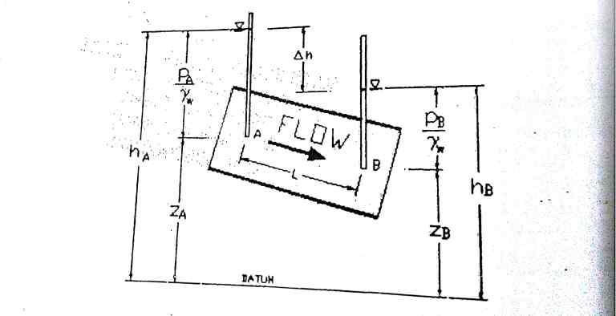

$$v=ki=k\frac{∆h}{L}$$
Here,
- V = discharge velocity or superficial velocity
- k = coefficient of permeability or hydraulic conductivity
- i = hydraulic gradient
- = fall in total head
- L = length of soil specimen

Assumptions of Darcy’s Law
- Soil is fully saturated.
- Temperature during testing is 27°C.
- Flow through soil is laminar
- Entire cross sectional area is available for flow
- Flow is continuous and steady.
Test for Soil Permeability
The constant head permeability test is a laboratory experiment conducted to determine the permeability of soil. The soils suitable for this tests are sand and gravels. Soils with slit content cannot be tested with this method. The test can be employed to test granular soils either reconstituted or disturbed.
CAPILLARITY
Introduction;
Capillarity is the phenomenon by which water rises in a cylindrical column. The narrower the column the higher the capillarity; similarly, the denser the substratum present in the column, the higher the capillary effect.
The tendency of liquid in a capillary tube or absorbent material to rise or fall as a result of surface tension.
CAPILLARITY IN SOIL
a proper balance between soil water and soil air is critical since both water and air are required by most processes.
Before we discuss the capacity of soils to hold water, we must understand the concept of capillarity.
Capillarity
- Water molecules behave in two ways:
  - Cohesion Force: Because of cohesion forces, water molecules are attracted to one another. Cohesion causes water molecules to stick to one another and form water droplets.
  - Adhesion Force: This force is responsible for the attraction between water and solid surfaces. For example, a drop of water can stick to a glass surface as the result of adhesion.
- Water also exhibits a property of surface tension:
  - Water surfaces behave in an unusual way because of cohesion. Since water molecules are more attracted to other water molecules as opposed to air particles, water surfaces behave like expandable films. This phenomenon is what makes it possible for certain insects to walk along water surfaces.
- Capillary Action:
  - Capillary action, also referred to as capillary motion or capillarity, is a combination of cohesion/adhesion and surface tension forces.
  - Capillary action is demonstrated by the upward movement of water through a narrow tube against the force of gravity.
  - Capillary action occurs when the adhesive intermolecular forces between a liquid, such as water, and the solid surface of the tube are stronger than the cohesive intermolecular forces between water molecules.
  - As the result of capillarity, a concave meniscus (or curved, U-shaped surface) forms where the liquid is in contact with a vertical surface.
  - Capillary rise is the height to which the water rises within the tube, and decreases as the width of the tube increases. Thus, the narrower the tube, the water will rise to a greater height.
Capillary action is the same effect that causes porous materials, such as sponges, to soak up liquids.
- Capillarity is the primary force that enables the soil to retain water, as well as to regulate its movement.
  - The phenomenon of capillarity also occurs in the soil. In the same way that water moves upwards through a tube against the force of gravity; water moves upwards through soil pores, or the spaces between soil particles.
  - The height to which the water rises is dependent upon pore size. As a result, the smaller the soil pores, the higher the capillary rise.
  - Finely-textured soils, like in Maui, typically have smaller pores than coarsely-textured soils. Therefore, finely-textured soils have a greater ability to hold and retain water in the soil in the inter-particle spaces. We refer to the pores between small clay particles as micropores. In contrast, the larger pore spacing between lager particles, such as sand, are called macropores.
  - In addition to water retention, capillarity in soil also enables the upward and horizontal movement of water within the soil profile, as opposed to downward movement caused by gravity. This upward and horizontal movement occurs when lower soil layers have more moisture than the upper soil layers and is important because it may be absorbed by roots.
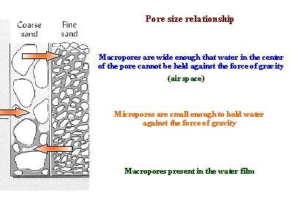

The picture above shows how more water may be held between finer particles against the force of gravity, as compared to coarser particles. As a result, finer-textured soils have greater water holding capacities.
Since water is held within the pores of the soil, the water holding capacity depends on capillary action and the size of the pores that exist between soil particles. Sandy soils have large particles and large pores. However, large pores do not have a great ability to hold water. As a result, sandy soils drain excessively. On the other hand, clayey soils have small particles and small pores. Since small pores have a greater ability to hold water, clayey soils tend to have high water holding capacity.

