NAME: AZUBUIKE JULIA .C. 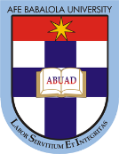
MATRIC NO: 16/SMS04/005
COURSE CODE/ TITLE: CMS 414 (SPECIAL TOPICS IN P.R AND ADVERTISING)

SOCIAL MEDIA AND PROLIFERATION OF FAKE NEWS, DODGY HEALTH ADVISES AND FAKE CURES OF COVID 19
Health misinformation is nothing new to Nigeria and in the case of the novel Coronavirus; it certainly would not be an exception. The worldwide COVID-19 epidemic is happening at a time when it is increasingly difficult to tell apart truths from fables. In Nigeria, a wave of misinformation as well as desensitization has complemented the virus’ spread, hence initiating fear. While a good number of Nigerians have simply refused to believe in the disease’s existence, some people have taken it upon themselves to become self-acclaimed experts and specialists on matters concerning the virus, thereby promoting all sorts of hazardous information to the public.
SOCIAL MEDIA/ FAKE NEWS PROLIFRATION ON COVID 19
With the rise in number of Coronavirus cases, people are in the rush to try everything to protect themselves from getting infected with this fatal virus. Also, a good number of people these days rely on social media platforms as their primary information source. As a result, Social media activists, influencers and self-styled warriors are using their social media platforms and fringe websites to proliferate misinformation, propagate conspiracy theories and promote the denial of COVID-19. Sometimes their motivation is simply to grow their online followership.

This is becoming a pertinent trend, seeing that at the height of the Ebola epidemic in 2014, false news swirled around the country. This included advice, allegedly from the Atta of Igala, that bathing in and ingesting saltwater could stop you getting the disease. This false information led to two deaths. Ebola itself killed eight people in Nigeria.
This pattern has already re-emerged during the COVID-19 outbreak. According to Lagos Health Officials, three people have been hospitalized after overdosing on chloroquine. This was as a result of rumors, publicly endorsed by US President Donald Trump, that the drug could treat the virus. Social Media Content Creators are to be responsible enough to know that a fear of the unknown and an influx of information in the digital spaces like Social Media Platforms create a fertile ground for fake news. Nigerians may be particularly vulnerable not because they are uniquely gullible, but because of weak communications between the government and the governed, high reverence for miracle healing and a decrepit health care system.
Below is a perfect instance of Fake News Proliferation via Social Media Platforms:
- The controversial blogger Kemi Olunloyo tweeted that President Muhammadu Buhari is sick with a persistent cough and that a makeshift ICU had been set up to treat him. Within hours, the tweet had been liked 3,300 times and retweeted more than 2,000 times.
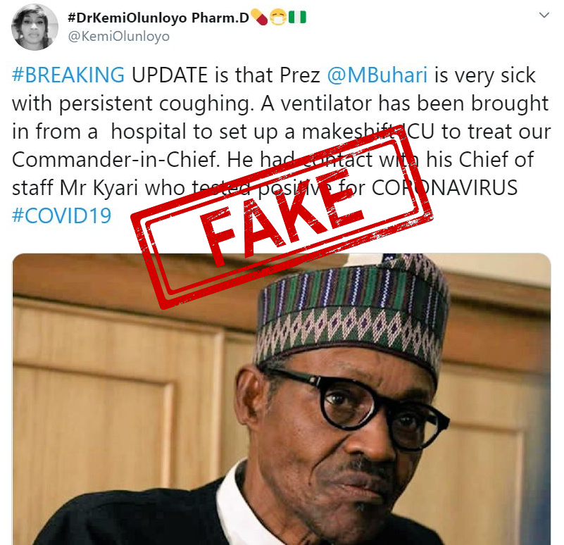
Evidently, the threat of fake news is even greater in 2020 than in 2014. False information is more sophisticated than ever and its potential spread much wider. In 2015, Nigeria had 76 million internet subscribers. By 2019, this had increased to 122 million. Sadly, this means the already over-burdened Nigerian Centre for Disease Control (NCDC) does not just have to combat COVID-19 but also fake news. A review suggests that purveyors of fake news have sought to incite panic and panic buying, proffer fake cures, undermine medical advice, promote hate speech particularly individuals of Chinese origin, and promote division along political lines.
DODGY HEALTH ADVISES AND FAKE CURES OF COVID 19
False information about ways to prevent or cure COVID-19 is also rife, causing confusion about how to best protect yourself against the virus. The NCDC has reported that it has uncovered 14 new cases of fake or unlicensed COVID 19 medication being sold online. Some devious sellers are trying to exploit the coronavirus pandemic by publicizing dishonest or unproven coronavirus medicines and tests online.
Publicity around existing drugs, such as the anti-malarial Chloroquine – currently being tested as potential treatments for coronavirus – has added fuel to the fire, as people try to get hold of these as-yet unproven ‘cures’.
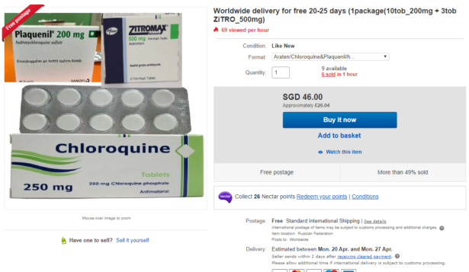
An Example of One of the unproven drugs that claim to prevent and cure the Coronavirus.
Some of the claims floating around include:
1. Drinking water will ‘flush out’ the virus
While drinking plenty of water and staying hydrated is always important, the idea that you can remove a virus this way is unscientific. The virus can find its way into the cells of the respiratory system, as well as transmitting through the nostrils or eyes.
2. Gargling with salt water or disinfectant will kill the virus
Advice that was incorrectly attributed to a London hospital says that gargling with disinfectant ‘removes the virus before it goes down to the trachea and then to the lungs’. This is a fundamental misunderstanding of the virus, which affects the entire respiratory system and doesn’t just lurk in the throat.
3. If you can hold your breath for 10 seconds, you don’t have COVID-19
This claim says that if you can hold your breath for 10 seconds without coughing, you’re in the clear. It also suggests you do this daily, and that by the time you have the officially recognized symptoms it’s ‘too late’. This is nonsense. While shortness of breath and coughing are (sometimes) symptoms of COVID-19, the ability to hold your breath for 10 seconds will vary from person to person, for a myriad of reasons. It isn’t an indicator that you do or don’t have the virus.
4. The virus is killed by the sun
Claims that the new coronavirus ‘hates the sun’, and that therefore sunbathing can prevent you catching it, are unfounded. Given the global spread of the virus so far in both hot and cold climates, there is no evidence for this. We don’t yet know if COVID-19 is a seasonal flu.
5. Drinking hot water and avoiding ice or cold drinks will help
Working on the same flawed logic of the myth above, some advice recommends constantly drinking hot drinks and avoiding ice or cold drinks. But drinking hot drinks will not change your body temperature. You cannot kill the virus once it’s in the body – your immune system just needs to fight it off
6. Turmeric can cure COVID-19
Turmeric is considered as a natural antiseptic and has health benefits. However, consuming or applying Turmeric does not cure or prevent COVID -19. There has been no evidence that suggests turmeric as a cure, WHO advises to eat a regular balanced diet and drinking 8 glasses of water as usual.
7. Drinking cow urine can cure COVID-19
Drinking cow urine does not cure or protect you from COVID – 19. There has been no evidence that suggests cow urine as a cure for COVID – 19.
8. Gargling with bleach does not prevent COVID – 19.
Bleach or Sodium Hypochlorite is harmful and should not be consumed under any circumstances as it can cause very serious damage to internal organs.
9. Lemon juice is rich in Vitamin – C and Iron but its consumption does not cure or prevent COVID – 19.
A normal healthy body can only absorb the nutrients it requires rest is disposed of. Eating a well-balanced diet is the way to go to maintain all the nutrients your body requires.
10. Holding your breath is not a way to test for COVID – 19.
Difficulty breathing is just one of the symptoms of COVID-19 that some of the patients have shown. However, it is not necessary for all patients to show identical symptoms.
According to the W.H.O., if you see anywhere claiming to have a cure or treatment for coronavirus, don’t be tempted. There is currently no proven treatment or cure for COVID-19. In conclusion, to rapidly and effectively counter disinformation and misinformation, the Nigerian government must engage in a sustained two-way communication with its citizens. There is an urgent need in Nigeria and beyond to counter the scourge of fake news around coronavirus. As we’ve seen around the world, tackling the disease requires everyone to follow advice and do their part. Accurate information is critical. Without clear and immediate action to tackle false information, the accompanying pandemic of fake news will make the COVID-19 pandemic much more challenging.
SOURCES
- ABP Live 2020, Coronavirus myths and fake news, viewed 13 April 2020, <https://news.abplive.com/health/coronavirus-myths-fake-news-covid-19-cure-social-media-whatsapp-fact-check-1185035/>.

African Arguments 2020, The other COVID-19 pandemic: Fake news, viewed 13 April 2020, <https://africanarguments.org/2020/03/26/the-other-covid-19-pandemic-fake-news/>.

- Which? 2020, Fake coronavirus medicines and dodgy health advice, viewed 13 April 2020, <https://www.which.co.uk/news/2020/04/beware-dodgy-coronavirus-health-advice-and-fake-cures/>.

