NAME: ILEGOGIE DANIEL
DEPARTMENT: ELECTRICAL/ELECTRONICS ENG
MATRIC NO: 17/ENG04/032
COURSE TITLE: ELECTRICAL MACHINES II
COURSE CODE: EEE 326
TUTORIAL
Question1
1a) - A single phase induction motor does not have a self-starting torque
- During light load conditions, the power factor of the load drops to a very low value
- The speed control of an induction motor is very hard to attain.
- Due to poor starting torque the motor cannot be used for applications which requires high starting torque.
1b) According to double field revolving theory, we can resolve any alternating quantity into two components. Each component has a magnitude equal to the half of the maximum magnitude of the alternating quantity, and both these components rotate in the opposite direction to each other. For example – a flux, φ can be resolved into two components
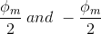
each of these components rotates in the opposite direction i. e if one φ_{m}/2 is rotating in a clockwise direction then the other φ_{m} / 2 rotates in an anticlockwise direction.
When we apply a single phase AC supply to the stator winding of single phase induction motor, it produces its flux of magnitude, φ_{m}. According to the double field revolving theory, this alternating flux, φ_{m} is divided into two components of magnitude φ_{m}/2. Each of these components will rotate in the opposite direction, with the synchronous speed, N_{s}.
Let us call these two components of flux as forwarding component of flux, φ_{f} and the backward component of flux, φ_{b}. The resultant of these two components of flux at any instant of time gives the value of instantaneous stator flux at that particular instant.
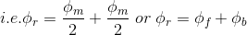
Now at starting condition, both the forward and backward components of flux are exactly opposite to each other. Also, both of these components of flux are equal in magnitude. So, they cancel each other and hence the net torque experienced by the rotor at the starting condition is zero. So, the single phase induction motors are not self-starting motors.

1c) Constructional features of a single phase IM
All the single phase induction motor have one construction feature in common, viz, the auxiliary starting winding. The starting winding is provided so that, together with the main or working winding, the motor can stimulate a two phase motor to develop torque at start. In the case of the permanent capacitor the auxiliary winding remains in the circuit after starting and thus closely approximates a two-phase motor also when it is operating under load. Hence the term ‘split phase’ may rightly be applied to all the single phase induction motors
Principle of operation single phase induction motor
Under stationary rotor conditions (i.e, when speed N = 0 or slip s = 1), the two rotating fields slip pass the rotor at the same slip, s = 1 and inducing equal currents in the squirrel cage rotor. The two rotating fields are of the same strength and develop equal and opposite electro-magnetic torques resulting in net torque of zero value. Thus the starting torque is zero and the single phase induction motor is non- self-starting. Further, the two rotating fields induce a resultant EMF in the stator which balances the applied voltage assuming low leakage impedance of the stator winding.
1d) Torque Slip Characteristics of Single Phase Induction Motor
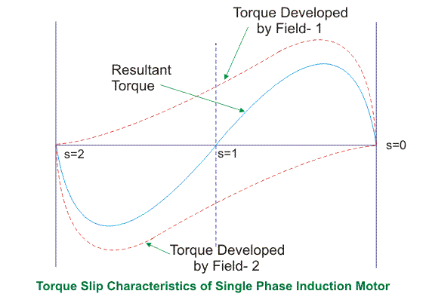
From the figure, we see that at a slip of unity, both forward and backward field develops equal torque but the direction of which are opposite to each other so the net torque produced is zero hence the motor fails to start. From here we can say that these motors are not self-starting unlike the case of three phase induction motor. There must be some means to provide the starting torque. If by some means, we can increase the forward speed of the machine due to which the forward slip decreases the forward torque will increase and the reverse torque will decrease as a result of which motor will start.
From here we can conclude that for starting of single phase induction motor, there should be a production of difference of torque between the forward and backward field. If the forward field torque is larger than the backward field than the motor rotates in forward or anti clockwise direction. If the torque due to backward field is larger compared to other, then the motor rotates in backward or clockwise direction. They are not self-starting because in induction machine a rotating magnetic field is required to produce torque. A rotating magnetic field can produced if we have balanced three phase supply and each phase is electrically spaced 120 to each other OR we have required minimum two phase but in single phase induction motor there is single phase supply to the stator of motor. A single phase supply cannot produce a rotating magnetic field but it produce a pulsating magnetic field which does not rotate. Due to this pulsating magnetic field torque cannot produce so motor is not self-start.
1e) - Split phase induction motor.
- Capacitor start induction motor
- Capacitor start capacitor run induction motor
- Permanent split capacitor motor
- Shaded pole induction motor

Shaded Pole Single Phase Induction Motors
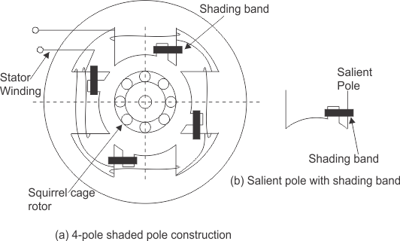
The stator of the shaded pole single phase induction motor has salient or projected poles. These poles are shaded by copper band or ring which is inductive in nature. The poles are divided into two unequal halves. The smaller portion carries the copper band and is called as shaded portion of the pole.
ACTION: When a single phase supply is given to the stator of shaded pole induction motor an alternating flux is produced. This change of flux induces emf in the shaded coil. Since this shaded portion is short circuited, the current is produced in it in such a direction to oppose the main flux. The flux in shaded pole lags behind the flux in the unshaded pole. The phase difference between these two fluxes produces resultant rotating flux.
We know that the stator winding current is alternating in nature and so is the flux produced by the stator current. In order to clearly understand the working of shaded pole induction motor consider three regions-
    - When the flux changes its value from zero to nearly maximum positive value.
    - When the flux remains almost constant at its maximum value.
    - When the flux decreases from maximum positive value to zero.
1stREGION:
When the flux changes its value from zero to nearly maximum positive value –
In this region, the rate of rise of flux and hence current is very high. According to Faraday’s law whenever there is change in flux emf gets induced. Since the copper band is short circuited the current starts flowing in the copper band due to this induced emf. This current in copper band produces its own flux. Now according to Lenz’s law the direction of this current in copper band is such that it opposes its own cause i.e rise in current. So the shaded ring flux opposes the main flux, which leads to the crowding of flux in the unshaded part of stator and the flux weaken in shaded part. This non uniform distribution of flux causes magnetic axis to shift in the middle of the unshaded part.
2ndREGION:
When the flux remains almost constant at its maximum value-
In this region, the rate of rise of current and hence flux remains almost constant. Hence there is very little induced emf in the shaded portion. The flux produced by this induced emf has no effect on the main flux and hence distribution of flux remains uniform and the magnetic axis lies at the center of the pole.
3rdREGION:
When the flux decreases from maximum positive value to zero –
In this region, the rate of decrease in the flux and hence current is very high. According to Faraday’s law whenever there is change in flux emf gets induced. Since the copper band is short circuit the current starts flowing in the copper band due to this induced emf. This current in copper band produces its own flux. Now according to Lenz’s law the direction of the current in copper band is such that it opposes its own cause i.e decrease in current. So the shaded ring flux aids the main flux, which leads to the crowding of flux in shaded part of stator and the flux weaken in unshaded part. This non uniform distribution of flux causes magnetic axis to shift in the middle of the shaded part of the pole.This shifting of magnetic axis continues for negative cycle also and leads to the production of rotating magnetic field. The direction of this field is from unshaded part of the pole to the shaded part of the pole.

Split Phase Induction Motor
In addition to the main winding or running winding, the stator of single phase induction motor carries another winding called auxiliary winding or starting winding. A centrifugal switch is connected in series with auxiliary winding. The purpose of this switch is to disconnect the auxiliary winding from the main circuit when the motor attains a speed up to 75 to 80% of the synchronous speed. We know that the running winding is inductive in nature. Our aim is to create the phase difference between the two winding and this is possible if the starting winding carries high resistance. Let us say
I_{run} is the current flowing through the main or running winding,
I_{start} is the current flowing in starting winding,
and V_{T} is the supply voltage.
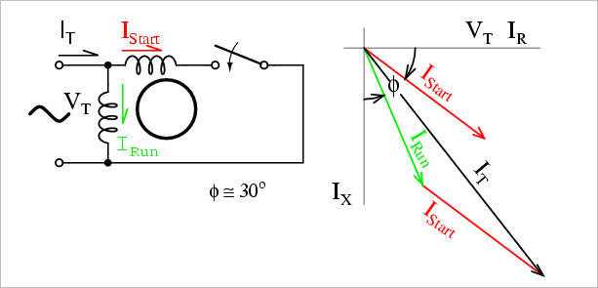
We know that for highly resistive winding the current is almost in phase with the voltage and for highly inductive winding the current lag behind the voltage by large angle. The starting winding is highly resistive so, the current flowing in the starting winding lags behind the applied voltage by very small angle and the running winding is highly inductive in nature so, the current flowing in running winding lags behind applied voltage by large angle. The resultant of these two current is I_{T}. The resultant of these two current produce rotating magnetic field which rotates in one direction. In split phase induction motor the starting and main current get split from each other by some angle so this motor got its name as split phase induction motor.

1f) Under stationary rotor conditions (i.e, when speed N = 0 or slip s = 1), the two rotating fields slip pass the rotor at the same slip, s = 1 and inducing equal currents in the squirrel cage rotor. The two rotating fields are of the same strength and develop equal and opposite electro-magnetic torques resulting in net torque of zero value. Thus the starting torque is zero and the single phase induction motor is non- self-starting. Further, the two rotating fields induce a resultant EMF in the stator which balances the applied voltage assuming low leakage impedance of the stator winding.

QUESTION 2
2a) A universal motor is a special type of motor which is designed to run on either DC or single phase AC supply . It can be applied in the following areas
- Hair dryers
- Wind trimmers
- Blenders
- Drills
- Vacuum cleaners

2b) Construction of Universal Motor:
Construction of a universal motor is very similar to the construction of a DC machine. It consists of a stator on which field poles are mounted. Field coils are wound on the field poles.

Non-Compensated Universal Motor:
The Non-compensated motor has two salient poles and it is laminated as shown in figure below.
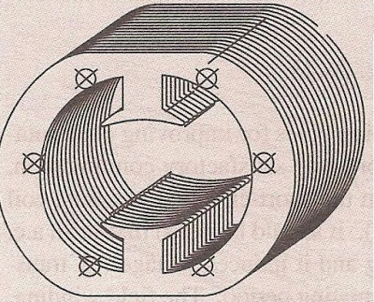
The armature is of wound type and the laminated core is either straight or skewed slots. The leads of the armature winding are connected to the commutator. High resistance brushes are used along with this type of motor to help better commutation. An equivalent Non-compensated type Universal Motor is shown in figure below.
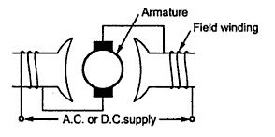

Compensated Type with Distributed Field:
The compensated type Universal Motor consists of distributed field winding and the stator core is similar to that of split-phase motor. We know that split phase motors consist of an auxiliary winding in addition to main winding. Similar to the split phase motors, the compensated type also consists of an additional winding. The compensating winding helps in reducing the reactance voltage which is caused due to alternating flux, when the motor runs with the AC supply.
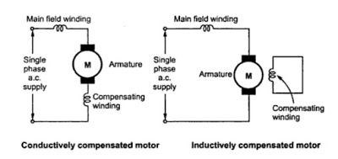
An equivalent compensated type universal motor is shown above
2c) There is actually no difference between the two in reference to their additional features. A universal motor has its rotor and stator windings connected in series, and it can run on both AC and DC that is why it’s called universal, or sometimes a DC series motor. It is usually used in home appliances, electric tools and so on. Because it has a high speed.

QUESTION 3

3a) Principle of Operation of 3-Phase Induction Motor
The stator of the motor consists of overlapping winding offset by an electrical angle of 120 . When we connect the primary winding, or the stator to a 3 phase AC source, it establishes rotating magnetic ﬁeld which rotates at the synchronous speed. Secrets Behind the Rotation: According to Faraday’s law an emf induced in any circuit is due to the rate of change of magnetic ﬂux linkage through the circuit. As the rotor winding in an induction motor are either closed through an external resistance or directly shorted by end ring, and cut the stator rotating magnetic ﬁeld, an emf is induced in the rotor copper bar and due to this emf a current ﬂows through the rotor conductor.
Here the relative speed between the rotating ﬂux and static rotor conductor is the cause of current generation; hence as per Lenz’s law, the rotor will rotate in the same direction to reduce the cause, i.e., the relative velocity.
Thus from the working principle of three phase induction motor, it may be observed that the rotor speed should not reach the synchronous speed produced by the stator. If the speeds become equal, there would be no such relative speed, so no emf induced in the rotor, and no current would be ﬂowing, and therefore no torque would be generated. Consequently, the rotor cannot reach the synchronous speed. The difference between the stator (synchronous speed) and rotor speeds is called the slip. The rotation of the magnetic ﬁeld in an induction motor has the advantage that no electrical connections need to be made to the rotor.
3b) Advantages
- Power delivered is constant
- They are self starting and more efficient
- They have a higher power factor

Disadvantages
- Unbalanced loading ( can cause voltage fluctuations )
- Complex System (requires symmetrical components for analysis and operation )
- Phase Sequence needed to be kept in mind while making connections
- Poor starting torque

3c) The equivalent motor resistance referred to stator =
R₀₁= $R_{1}+\frac{R_{2}}{X_{2}}$ = 0.06+0.06 = 0.12Ω.
The equivalent motor reactance referred to stator,
X₀₁ = $X_{1}+\frac{X_{2}}{k^{2}}$ = 0.2+0.22 = 0.42Ω
Motor impedance
Z₀₁ = $\sqrt{\left(R_{01}^{2}\right)+\left(X_{01}^{2}\right)}$ = $\sqrt{{(0.12)}^{2}+{(0.42)}^{2}}$ = 0.437Ω.
s =
$$\frac{\frac{R_{2}}{K^{2}}}{\frac{R_{2}}{K^{2}}+Z_{01}}$$=
$$\frac{0.06}{0.06+0.437}$$= 0.12
Maximum gross power output
=
$$\frac{3V^{2}}{2(R_{01}+Z_{01}}$$=
$$\frac{3×\left(\frac{400}{\sqrt{3}}\right)\underset{←}{2}}{2(0.12+0.437)}$$
= 143,626w or 143.63kw

3d)
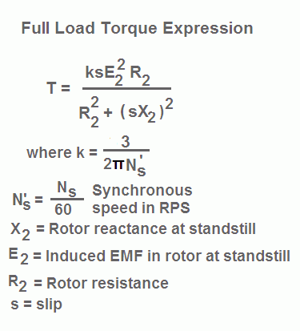
Thus, at low values of slip, torque is approximately proportional to slip s and the torque slip characteristics of induction motor is a straight line as shown in the figure. The region (from s = 0 to s = sm) is called the stable region of operation and operating point of the motor should be in this region. In the stable region, the value of slip is small. Hence this region is also called as the low slip region.

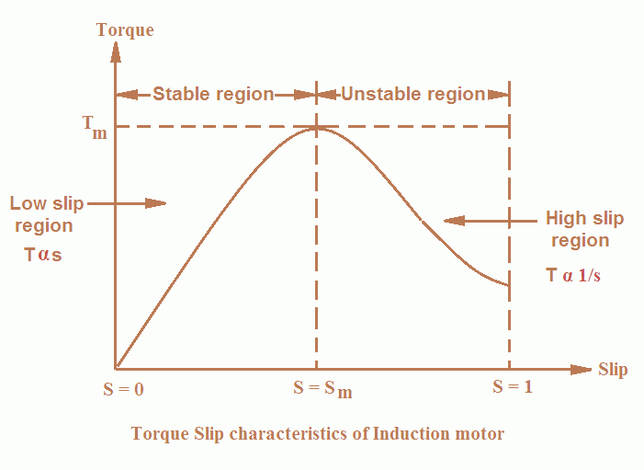
As the slip increases torque increases and attains its maximum value when s = R2/X2. This maximum value of torque is also known as break down or pull out torque. When a further increase in slip occurs due to increase in load beyond the point maximum torque
Thus at higher values of slip (i.e. the slip beyond that corresponding to maximum torque) torque is approximately inversely proportional to slip, s and the torque slip characteristics of induction motor is rectangular hyperbola as shown in the figure. The region (extending from s = sm to s = 1) is called unstable region. In this region with the increase in load, slip increases but torque decreases. The result is that the motor could not pick up the load and slows down and eventually stops. In the unstable region, the value of slip is large so this region is also called as the high-slip region.
3e)
20 Rps = rpm = 20 x 60 = 1200rpm
15rps = rpm = 15 x 60 = 900 rpm
Ns =$\frac{120f}{p}$
$$\frac{120 ×60}{1200}=6poles$$
$$\% slip= \left\lfloor \frac{Ns-Nr}{Ns}\right\rfloor ×100$$
=
$$\left\lfloor \frac{1200-900}{1200}\right\rfloor ×100=25\%$$
F’= sf
F’= 0.25 x 60 = 15Hz
Ns-Nr = 1200 -900 = 300
F’= SF
0.1 X 60 = 6Hz

Question 4
- 4a) – Changing the number of stator poles
- By injecting emf in rotor circuit
- Changing the applied voltage
- Changing the applied frequency
- Constant v/f control of induction motor
4b)
- Direct On-Line Starter (DOL)
- Rotor resistance starting
- Stator resistance starting
- Star Delta starting

4c) STATOR RESISTANCE STARTING
In this method, external resistances are connected in series with each phase of stator winding during starting. This causes voltage drop across the resistances so that voltage available across motor terminals is reduced and hence the starting current. The starting resistances are gradually cut out in steps (two or more steps) from the stator circuit as the motor picks up speed. When the motor attains rated speed, the resistances are completely cut out and full line voltage is applied to the rotor. This method suffers from two drawbacks. First, the reduced voltage applied to the motor during the starting period lowers the starting torque and hence increases the accelerating time. Secondly, a lot of power is wasted in the starting resistances. Thus while the starting current reduces by a fraction x of the rated-voltage starting current (Isc), the starting torque is reduced by a fraction x2 of that obtained by direct switching. The reduced voltage applied to the motor during the starting period lowers the starting current but at the same time increases the accelerating time because of the reduced value of the starting torque. Therefore, this method is used for starting small motors only.
DIRECT ON-LINE STARTER
This method of starting in just what the name implies; the motor is started by connecting it directly to 3-phase supply. The impedance of the motor at standstill is relatively low and when it is directly connected to the supply system, the starting current will be high (4 to 10 times the full-load current) and at a low power factor. Consequently, this method of starting is suitable for relatively small (up to 7.5 kW) machines. Note that starting current is as large as ﬁve times the full-load current but starting torque is just equal to the full-load torque. Therefore, starting current is very high and the starting torque is comparatively low. If this large starting current ﬂows for a long time, it may overheat the motor and damage the insulation.
QUESTION 5
5a) There could be many reasons to test an induction motor.
- To find out if it works.
- To test for reliability
- To see how much performance margin it has
- . To see if it works according to its specifications
5b) SIMILARITIES
- In the slip ring motor, the rotor winding is short circuited through the slip rings.
- the shaft of the motor is locked so that it can’t move and the rotor winding is short circuited.

DIFFERENCES
- in a short circuit test as the motor is no load the power factor is very low whch is less than 0.5 while the block rotor test is conducted at low voltage because if the applied voltage was normal voltage then the current flowing through the stator windings were high enough to overheat the windings and damage them
- in a blocked rotor test the rotor is blocked so that it can’t move, a voltage is applied to the motor, and the resulting voltage, current and power are measured while in a short circuit test the test is performed at a rated frequency and with balanced polyphase voltages applied to the stator terminal
5c) SIMILARITIES
- The open circuit and no load test are performed for determining the parameter of the transformer like their efficiency, voltage regulation, circuit constant
- Open circuit test or no load test on a transformer is performed to determine 'no load loss (core loss)' and 'no load current

DIFFERENCES
- A open circuit test is conducted when the secondary of the transformer is kept in open condition without connecting any load with it. Thus there will not be any current in the secondary coil. While A no load test is conducted shorting the secondary terminals. Thus there will be huge current flow in the secondary coil when voltage is applied in the primary.
- The purpose of the open circuit test is to determine the no-load current and losses of the transformer because of which their no-load parameter are determined. While the no load test determines the copper loss occur on the full load. The copper loss is used for finding the efficiency of the transformer.

- 5d) Ac motor winding continuity test
- power supply test
- Insulation resistance test
- Ac motor winding resistance test
Power Supply Test
For three phase motors, the expected voltage for a 230/400V system is 230V phase to neutral and 400V between each of the three phase supply lines. Check that the correct voltage is applied to the motor using a multimeter. Ensure the terminal for power supply is in good condition. Check the connection bar for terminal (U, V, and W). three phase motors, connection type is either Star (Y) or Delta.

5d)Applied Voltage per phase, V= 400V, No load line current=3A
No load phase current=3/√3= √3A, Input on no load= 645W
Stator copper loss=45W, windage and friction loss=183W
Total stator core loss= 645-45-183=417W
No load p.f, cosᶲ=$\frac{p_{1}}{3VI_{0}}=\frac{417}{3×400×√3}$=0.2
No load line current on energy= $I_{lo}×cos∅=3×0.2=0.6A$
Magnetizing component of no load line current,
$$I_{lm}=\sqrt{{(I_{lo})}^{2}-{(I_{le})}^{2}}=\sqrt{3^{2}-{0.6}^{2}}=2.94A$$
Energy component or no load phase current,
$$I_{e=}I_{0}cos∅=1.732×0.2=0.3464A$$
No load resistance,
$$R_{0}=\frac{V}{I_{e}}=\frac{400}{0.3464}=1.155Ω$$
No load phase current,
$$I_{m}=\frac{2.94}{√3}=1.7A$$
No load reactance,
$$X_{0}=\frac{V}{I_{m}}=\frac{400}{1.7}=236 Ω$$
Short Circuit Voltage=200V, short circuit stator line current=12.0A
Short Circuit stator phase current=6.928A, Input on short circuit= 1660W
Equivalent resistance per phase as referred to the primary,
$$R_{0}=\frac{P_{s}}{{{3I}_{s}}^{2}}=\frac{1660}{3×{(6.928)}^{2}}=11.53 Ω$$
Equivalent reactance per phase as referred to the primary,
$$Z_{0}=\frac{V_{s}}{I_{s}}=\frac{200}{6.928}=28.87Ω/phase$$
$$X_{0}=\sqrt{{Z_{0}}^{2}-{R_{0}}^{2}}=\sqrt{{(28.87)}^{2}-{(11.53)}^{2}}=26.5Ω$$
Power factor on short circuit,
$$cos∅_{s}=\frac{P_{S}}{{3VI}_{s}}=\frac{1660}{3×200×6.928}=0.4$$
Short Circuit current with normal voltage applied of 400 V across the stator,
$$I_{sc}=\frac{I_{s}×V}{V_{s}}=\frac{12×400}{200}=24A$$
Question 6
6a) The principle of operation of synchronous generator is electromagnetic induction. If there exists a relative between the flux and conductors, then an emf is induced in the conductors. If the rectangular turn rotates in clockwise direction against axis a-b as shown in the below completing 90 degrees rotation the conductor sides AB and CD comes in front of the respectively. Thus, now we can say that the conductor tangential motion is perpendicular to from north to south pole. So, here rate of flux cutting by the conductor is maximum and induces current in the conductor, the induced current can be determined using Fleming’s right hand rule. Thus, we can say that from A to B and from C to D. If the conductor is rotated in a clockwise direction for another 90 come to a vertical position. Now, the position of conductor and magnetic flux lines are parallel to each other and thus, no flux is cutting and no current will be induced in the conductor. Then, while the conductor rotates clockwise for another 90 degrees, then rectangular turn comes to a horizontal position as shown in the below fig conductors AB and CD are under the N-pole and S-pole respectively. By applying Fleming current induces in conductor AB from point B to A and current induces in a conductor CD from. So, the direction of current can be indicated as A – D – C – B and direction of current for the position of rectangular turn is A – B – C – D. If the turn is again rotated towards vertical position, then the induced current again reduces to zero. Thus, for one complete revolution of rectangular turn the current in the conductor reaches to maximum & reduces to zero and then in the opposite direction it reaches to maxim to zero. Hence, one complete revolution of rectangular turn produces one full sine wave of cu conductor which can be termed as the generation of alternating current by rotating a turn inside a magnetic field. Now, if we consider a practical synchronous generator, then field magnets rotate between the stationary armature conductors. The synchronous generator rotor and shaft or turbine blades are mechanically coupled and rotates at synchronous speed. Thus, the magnetic flux cutting produces an induced emf which causes the current flow in armature conductors. Thus, for each winding the current flows in one direction for the first half cycle and current flows in the other direction for the second half cycle with a time lag of 12 displaced by 120 degrees).
6b)S/MVA rating=10MVA,$V_{line}=11KV$, p.f=0.8, $X_{s}=15Ω$, f=50Hz, number of poles=2
Induced emf is given as;
$$I_{a(line)}=\frac{V_{t(lines)}}{√3}$$
So;
$$\left|E_{f(phase)}\right|=\sqrt{\left(V_{t\left(phase\right)}Cosφ^{2}\right)+(I_{a}X_{a}+Sinφ^{2})}=12,741KW$$

$$\left(Cosφ+δ\right)=\frac{V_{t\left(phase\right)}Cosφ}{E_{f(phase)}}=\frac{(6351)(0.8)}{12,741}=0.399$$
$$φ+δ=\cos^{-1}\left(0.399\right)={66.5}^{0}$$
Recall;
$$Cosφ=0.8$$
$$φ=\cos^{-1}{(0.8)}$$
$$φ=36.90$$
Hence,
$$δ=66.5-36.9={29.6}^{0}$$

ii.) maximum power,
$$P_{max}=\frac{3\left|V_{t}\right|\left|E_{f}\right|}{X_{s}}=\frac{3(12,741)(6351)}{15}=16,138,618.22W$$
iii.) Maximum torque,
$$T_{max}=\frac{P_{max}}{2πf}=\frac{16,138,618.22}{2×3.142×50}=51,507.4Nm$$

6c) Parallel operation of generators is by far the most common form of operation. Generators may be operated in parallel on a small scale, e.g. two or three generators operating in parallel to provide power to a remote community, or large scale, e.g. the north american power grid
Benefits of parallel operation include
- Redundancy: failure of one unit does not affect the integrity of the power supply, generators may be taken out of service for preventative maintenance
- Scaling: many units can combine to provide a power demand, rather than requiring fewer very large generators
- Resource management: generators can be located and operated to best meet the generating conditions, instead of having to be located and operated to meet the requirements of a local load. An example of this may be a nuclear power plant, which may take many weeks to bring up to full operating conditions. Using a nuclear generating station at full power to meet a "base load" with smaller more rapid response generators is one way to supply fluctuating load requirements.
- Efficiency: Generators operating at full load are more efficient than those operating at low loads. It is more efficient to meet a changing load by adding or removing smaller generators than having a single large generator operating inefficiently.

