NAME: ODILI BLOSSOM ONYINYECHI

MAT NO: 18/ENG01/014

DEPT: CHEMICAL ENGINEERING

PROJECT: REHABILITATION OF ALFA BEGORE HALL

QUESTIONS

The Alfa Belgore Rehabilitation project is ongoing. As a designated student consulting engineer you are expected to do the following.

* Outline the scope of work in details in order of occurrence.

CONTENT OF SCOPE OF WORK

1. Introduction
2. Problems of the hall
3. Goals and objective
4. Stages
5. Professionals involved
6. Timeline

SCOPE OF WORK

Introduction

The alfa belgore hall also known as ABU AD multipurpose hall is the biggest hall in ABUAD and has been existing since 2009. The hall has been used for so many yearly events such as; congress, dinners, convocation, matriculation, parties, etc. No doubt that the hall has served the school for a very long time and therefore is need of rehabilitation. The rehabilitation of the hall will be discussed as we commence in this project.

PROBLEMS STATEMENT

As said earlier on alfa belgore hall is ABUAD’s largest multipurpose hall, as time went on the school population increased. As the population kept on increasing, the hall wasn’t enough to contain all the students, yet alone the parents and relative that would like to attend special events such as convocation, matriculation and the likes.

GOALS OF REHABILITATION OF ALFA BELGORE HALL

Alfa belgore hall has just one floor, the goal is to make it a one story building. This will increase the amount of people that the hall can contain.

STAGES

The rehabilitation of any building has the following stages:

1. Planning and surveying stage: under this stage we have the following process;
2. Survey the land and building: this the first and it very important step. This is the work of the civil engineers as they will check out the building and ensure that the foundation will still be able to carry the extra weight being added to it.
3. Drawing of the plan: in this process the architect will draw the plan of the building based on goal for the rehabilitation of the building (one story building).
4. Clearing and demolition stage: under this step we have the following process;
5. Clearing and evacuation of the hall: the bookshop, ICT center and any activity that takes place in the hall will be relocated to other venues. After which all equipment(air conditioner, projector, stage lights, speakers, microphones etc), furniture (chairs, tables, toilet, doors, windows, decorations etc)
6. Fencing of the construction area: this is a security measure in other to stop people(students and staff) from entering in other to avoid injure.
7. Roof removal: in other to achieve our goal(to make the hall a one story building), the roof of the hall has to be removed.
8. Reconstruction and fixing stage: under this step we have the following process;
9. Elevation of the hall: this is to say that the bricklayers can start building the first floor according to plan.
10. Reroofing of the hall
11. Finishing touches by the bricklayers: in this process the bricklayers will plaster the hall with cement.
12. Plumbing: in this process the plumbers will come and install the plumbing system, fix the toilets etc.
13. Wiring: this will be done by the electrical engineers as the will wire and earth the whole building.
14. Fixing of windows and doors
15. Design and decoration stage: this stage is about putting finishing touches in the hall. Decoration of the hall, fixing of equipment and putting of the furniture.
16. Cleaning and clearing stage: this is the final stage as the hall and the environment will be cleared and clean for people to be able to start using the hall.

PROFESSIONALS INVOLED

In the rehabilitation of the hall, a lot of professionals from various occupation would be involved. The following are the list of various professionals involved;

1. Land surveyors: They determine the relative positions of the land with measurement of points, elevation, location latitude and longitude, property boundary shape, the area of the landed property size, and establish the beacon on site to define boundaries. All this would be represented in the survey plan.
2. Architects: They deal with the building designs, develop structural concepts. He is responsible for the overseeing of the project.
3. Draftsperson: he will prepare technical drawings under the direction of the architect.
4. Geotechnical engineer: his responsibility is to analyze the subterranean rock and soil to determine its suitability to purport extreme loads.
5. Civil engineers (structural engineers): they design the structural members of the building. They ensure that the building will be both stable and strong.
6. Electrical engineers: they are responsible for wiring of the building.
7. Tradespeople: in rehabilitation of the hall, it will require an excavator, electrician, plumber& drainer, carpenter, bricklayer, plaster, roofer, tiler, floor sander, painter and landscaper.

TIMELINE: this involves the duration in which each stage will last. The timeline for each will be listed below:

|  |  |  |
| --- | --- | --- |
| STAGES | | DURATION |
| 1. Planning and surveying stage | | 1 month |
| 2. Clearing and demolition stage | | 3 weeks |
| 3. Reconstruction and fixing stage | | 2months and 2weeks |
| 4. Design and decoration stage | | 1month 2 weeks |
| Cleaning and clearing stage | 2 week | |
| TOTAL TIME DURATION | 6 months | |

***QUESTION 2:*** Prepare a Gant Chart

GANT’S CHART



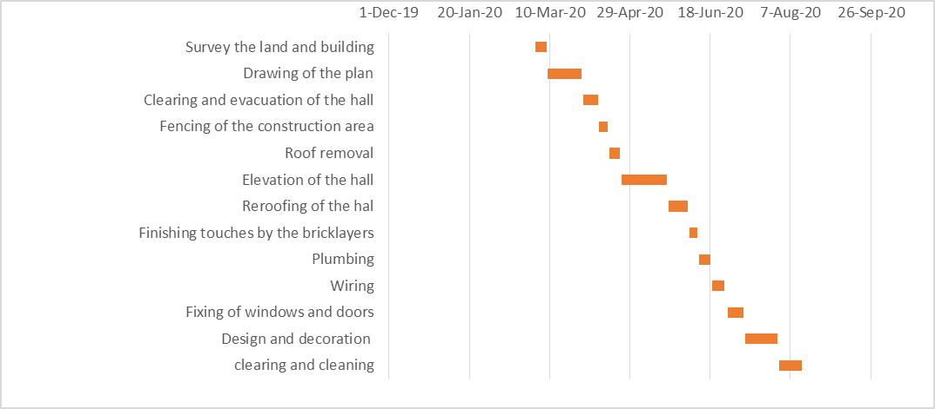

***QUESTION 3 :***  list all the human resources needed and constitute the project team stating who the lead consultant is.

The construction responsible for this project is Moiner Construction Company (Nigeria) Limited. The lead consultant for this project is Engr Prof Oladokun David. The following are the list of other professionals that will be working on this project;

A. Land surveyors: They determine the relative positions of the land with measurement of points, elevation, location latitude and longitude, property boundary shape, the area of the landed property size, and establish the beacon on site to define boundaries. All this would be represented in the survey plan.

B. Architects: They deal with the building designs, develop structural concepts. He is responsible for the overseeing of the project.

C. Draftsperson: he will prepare technical drawings under the direction of the architect.

D. Geotechnical engineer: his responsibility is to analyze the subterranean rock and soil to determine its suitability to purport extreme loads.

E. Civil engineers (structural engineers): they design the structural members of the building. They ensure that the building will be both stable and strong.

F. Electrical engineers: they are responsible for wiring of the building.

G. Tradespeople: in rehabilitation of the hall, it will require an excavator, electrician, plumber& drainer, carpenter, bricklayer, plaster, roofer, tiler, floor sander, painter and landscaper.

***QUESTION 4***: Explain why the site was secured.

Construction site security is the keep of the site safe from intruder, prevent theft and detect vandalism or wilful damage and also for the safety of the workers. The following are the importance of site security;

1. Access control: site security helps to limit the amount and the type of people that enters so that not just anyone can enter.
2. For the purpose of safety of people in that environment: putting up of a bound (fence), this will help the safety of people living around; to protect them from harm.
3. Safe guarding of machines and equipment: securing the site will help to keep the machines and equipment safe as not just anyone can enter the site.

***QUESTION 5:***  Develop a BEME for the project by lump sum projection including 10% of the total estimated cost (TEC) as miscellaneous, 15% TEC as consultant fee, 5% TEC for site preparations and clearing after completion, 12% of TEC for transport cost, 20% TEC as profit.

BEME

Total estimated cost =₦50,000,000

10% of TEC for miscellaneous = (10/100)* 50000000= ₦5,000,000

15% of TEC as consultant fee = (15/100)*50000000 = ₦7,500,000

5% of TEC for site preparation and clearing after completion = (5/100)*50000000 = ₦2,500,000

12% of TEC for transport cost = (12/100)*50000000 = ₦6,000,000

20% of TEC as profit = (20/100)*50000000 = ₦10,000,000

***QUESTION 6:*** prepare a payment schedule as follows

1. 30% TEC mobilization
2. Next 30% TEC at 50% completion
3. Final payment of 40% TEC at the completion and hand over. Retain 10% TEC for a 6 months defect liability period.



**QUESTION *7***: What is BEME, Defect Liability Period, Lead Consultant, Project Life Cycle, Environment Impact Assessment (EIA).

What is BEME?

BEME stands for Bill of Engineering Measurement and Evaluation. For all engineering works, it is required to know beforehand the portable cost of construction known as estimated cost. The BEME is also referred to as ‘Bill’; is a tool used before, during and post-construction to access and value the cost of construction works. This includes the cost of materials, labor, equipment and all/any other resources required for the success of any construction endeavor based on a pre-determined scope and specification.

What is Defect Liability Period?

A defect liability period is a period of time following practical completion during which a contractor remains liable under the building contract for dealing with any defects which becomes apparent. It may also be referred to as a rectification period or defects correction period. It is important to note that the defect liability period is not a chance to correct problems apparent at practical completion, it is a period during which the contractor may be recalled to rectify defects which appear .if there are defects apparent before practical completion, then these should be rectified before certificate of practical completion is issued.

Who is a Lead Consultant?

A lead consultant is the consultant that directs the work of the consultant team and is the main point of contact for communication between the client and the consultant team, except for on significant design issues where the lead designer may become the main point of contact.

What is Project Life Cycle?

The project life cycle refers to the four step process that is followed by nearly all project managers when moving through stages of project completion. The four phases that mark the life of the project are: conception/start, planning, execution/implementation and closure.

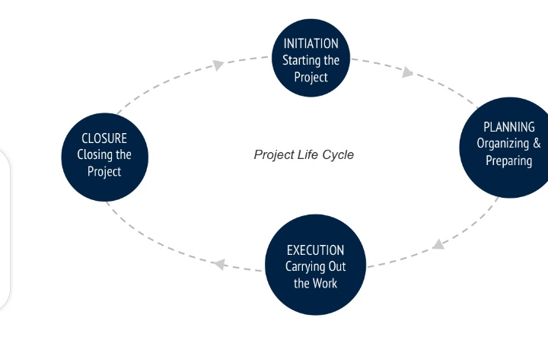

What is Environment Impact Assessment (EIA)?

Environment Impact Assessment (EIA) is a process of evaluating the likely environmental impacts of a proposed project or development, taking into account inter-related socio-economic, cultural and human-health impacts, both beneficial and adverse. It aims to predict environmental impacts at an early stage in project planning and design, find ways and means to reduce adverse impacts, shape project to suit the local environment and present the prediction and options to decision makers.

